**PROGRAM 1:**

**reverse.java**

**import** java.util.*;

**public** **class** reverse {

**static** Scanner *sc* =**new** Scanner(System.***in***);

**public** **static** **void** main(String[] args) {

// **TODO** Auto-generated method stubS

String w,k = "";

System.***out***.println("Enter a word:");

w=*sc*.nextLine();

System.***out***.println("=======REVERSE==========="+"\n"+w.length());

**for**(**int** i=w.length()-1;i>=0;i--) {

k=k+w.charAt(i);

}

System.***out***.println(k);

}

}

**Output**

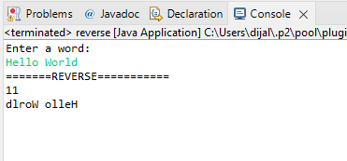

**PROGRAM 2**

**strfn.java**

**import** java.util.Scanner;

**public** **class** reverse1 {

**static** Scanner *sc* = **new** Scanner(System.***in***);

**public** **static** **void** main(String[] args) {

// **TODO** Auto-generated method stubS

String w, k = "are";

System.***out***.println("Enter a word:");

w = *sc*.nextLine();

System.***out***.println("length:"+w.length());

**if** (w.equals("who are you")) {

System.***out***.println("matching.......!");

}

**if** (w.contains("you")) {

System.***out***.println("word found");

}

String y = w.replace("w", "m");

System.***out***.println(y);

y = w.concat(k);

System.***out***.println(y);

*sc*.close();

}

}

**Output**

