**How to create a multinode Hadoop, Spark and Cassandra culster on a Laptop**

This guide provides step by step process for setting up a three node Hadoop, Spark and Cassandra cluster on a laptop for learning. This cluster is made up of one host machine and two virtual machines hosted on Oracle VirtualBox.

**Operating Systems:**

1. Fedora 30 desktop on the laptop for the Spark master

2. Light Ubuntu for 2 Spark slave nodes(lesser machines)

**Softwares used:**

1. Java 1.8

2. Oracle VirtualBox 5.2

3. Hadoop from Apache foundation

4. Spark 2.3 from Apache foundation

5. Cassandra 3.11.5 from Apache foundation

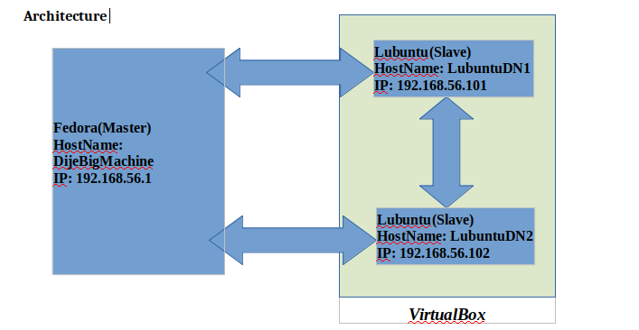

**Preparation:**

1. Java: Download Java (<https://www.java.com/en/download/>) and place it at on your har sdrive. Setup .bashrc with the following environment variables.

*#JAVA HOME*

*export JAVA_HOME=/home/dijender/Java/jdk1.8.0_14*

*export CLASSPATH=$JAVA_HOME*

*export PATH=$PATH:$JAVA_HOME/bin*

Save .bashrc and source it using the following command from your home directory.

source .bashrc

To verify if Java is setup and setup with the correct version issue the following command.

[dijender@DijeBigMachine ~]$ java -version

java version "1.8.0_141"

Java(TM) SE Runtime Environment (build 1.8.0_141-b15)

Java HotSpot(TM) 64-Bit Server VM (build 25.141-b15, mixed mode)

So now our Java is setup.

2. VirtualBox: VirtualBox is a visualization software freely distributed by Oracle. Install it using the instructions given on the VirtualBox website (<https://www.virtualbox.org/>)

After successful installation, open it see if everything is setup correctly.

3. Light Ubuntu on VirtualBox: OS selected for nodes on the VirtualBox was chosen on purpose to be light as we are only operating with 16 GB of total RAM. The process to install Lubuntu is straight forward. Download the .iso file for the Lubuntu you want to install and then on the VirtualBox, select the .iso file to start installing. Please remember to set up a user and remember the password for that user.

Below are the details for of the Virtual Machine. Don’t worry about the network setting, we’ll discuss that later in a different section.

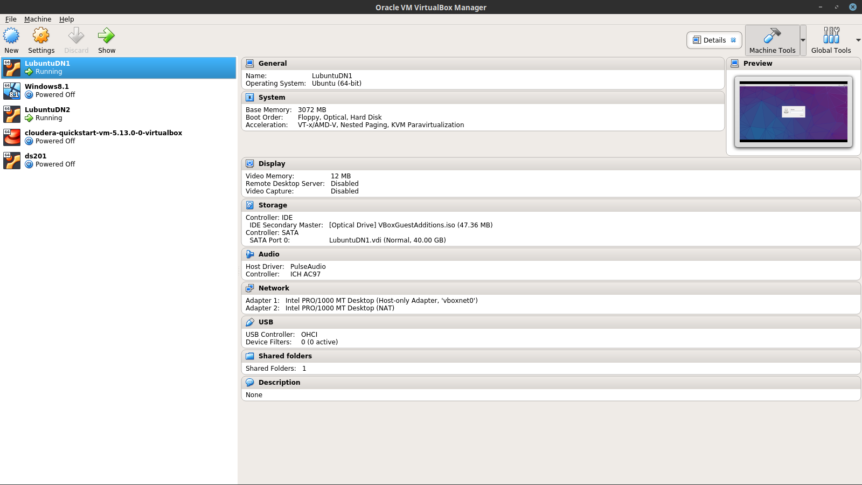

4. Clone the VM to create another VM with the same configuration. See image below.

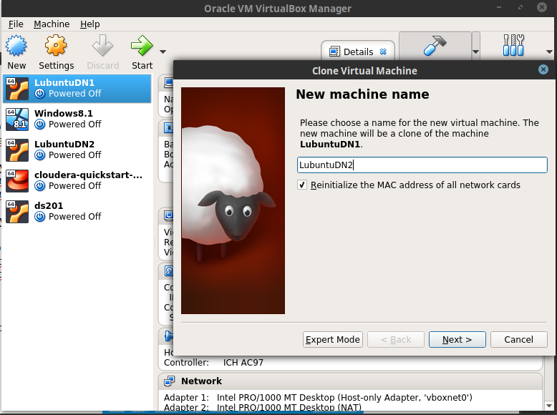

5. Setup Host names for all three machines:

hostnamectl set-hostname <HostName>

Host Fedora Machine name: DijeBigMachine

Virtual Machine1: LubuntuDN1

Virtual Machine2: LubuntuDN2

6. Network setting: This is one the most crucial step in setting up a cluster. There are few considerations that we need to make while creating our cluster.

1. All machines should be able to communicate with each other i.e. all machine should have two way communication enabled
2. All communication should be free of password. As all nodes need to communication continuously, machines needs to trust each other. We’ll see that in the section **“Setting up trusted machines in a network”.**
3. IP addresses can be changed everytime we start a machine and for virtual machines the IP addresses with be picked from a pool and machines can be allocated different ones depending on the order in which they are fired up. We’ll setup fixed IP s for all our machines. We’ll see that in the section **“Setting up fixed IP addresses”.**
4. After the IP addresses have been fixed we need to update */etc/hosts* file in each machine with the fixed IP addresses.

[[dijender@DijeBigMachine](mailto:dijender@DijeBigMachine) ~]$ cat /etc/hosts

127.0.0.1 localhost.localdomain localhost

192.168.56.1 DijeBigMachine

192.168.56.101 LubuntuDN1

192.168.56.102 LubuntuDN2

**Setting up hostnames and fixed IP on trusted machines**

1. Setting up fixed IP on the Host machine(DijeBigMachine)

First find the network name of your computer by using the command ifconfig.

[dijender@DijeBigMachine ~]$ ifconfig

**eno1**: flags=4099<UP,BROADCAST,MULTICAST> mtu 1500

ether d4:be:d9:60:d5:0f txqueuelen 1000 (Ethernet)

RX packets 0 bytes 0 (0.0 B)

RX errors 0 dropped 0 overruns 0 frame 0

TX packets 0 bytes 0 (0.0 B)

TX errors 0 dropped 0 overruns 0 carrier 0 collisions 0

device interrupt 20 memory 0xf7e00000-f7e20000

As seen above, the name of the network is **eno1**. Edit /etc/sysconfig/network-scripts/ifcfg-eno1 to put the static IP address 192.168.56.1 in it.

[dijender@DijeBigMachine ~]$ cat /etc/sysconfig/network-scripts/**ifcfg-eno1**

HWADDR=D4:BE:D9:60:D5:0F

TYPE=Ethernet

BOOTPROTO=static

DEFROUTE=yes

PEERDNS=yes

PEERROUTES=yes

IPV4_FAILURE_FATAL=no

IPV6INIT=yes

IPV6_AUTOCONF=yes

IPV6_DEFROUTE=yes

IPV6_PEERDNS=yes

IPV6_PEERROUTES=yes

IPV6_FAILURE_FATAL=no

NAME=eno1

UUID=8d557efd-839e-418d-8be8-62f5a5cf5014

**IPADDR=192.168.56.1**

NETMASK=255.255.255.0

BROADCAST=192.168.56.255

NETWORK=192.168.56.0

ONBOOT=yes

Restart your machine.

2. Setting up two way communication on the virtual machines(LubuntuDN1 and LubuntuDN2).

**On VirtualBox application -**

Go to File->Preference->Network->Host-Only Adapter(tab)

add a Host-Only Adapter

Don't enable DHCP server

**On VM -**

Settings->Network

Adapter 1 - Host-Only network(Select the Host-only adapter as seen above)

Adapter 2 – NAT

Start the VM

See the Adapter names using the commands --

ls /sys/class/net

ifconfig -all

Make sure which one is Host-only and which one is NAT.

I got

enp0s3 enp0s8 lo

enp0s3 -> Host only

enp0s8 -> NAT

Now edit /etc/network/interfaces and it should look like this with static IP set as 192.168.56.101

------------------------------------------------------------

dijender@LubuntuDN1:~$ cat /etc/network/interfaces

# This file describes the network interfaces available on your system

# and how to activate them. For more information, see interfaces(5).

source /etc/network/interfaces.d/*

# The loopback network interface

auto lo

iface lo inet loopback

#Host-only interface

auto enp0s3

iface enp0s3 inet static

**address 192.168.56.101**

netmask 255.255.255.0

network 192.168.56.0

broadcast 192.168.56.255

#NAT interface

auto enp0s8

iface enp0s8 inet dhcp

restart networking busing command - /etc/init.d/networking restart

**Setting up trusted machines in a network**

1. Generate public using command - ssh-keygen

2. Copy the generated key in cat ~/.ssh/id_rsa.pub

3. Paste it in the .ssh/authorized_keys file on the machine you want to connect to.

4. This needs to be done between all pair of machines.

5. After machines have shared the public key, you should be able to login using ssh to each other without the password as seen below.

[dijender@DijeBigMachine ~]$ ssh LubuntuDN1

Welcome to Ubuntu 15.10 (GNU/Linux 4.2.0-30-generic x86_64)

* Documentation: https://help.ubuntu.com/

123 packages can be updated.

91 updates are security updates.

Last login: Sat Jun 24 17:37:13 2017 from 192.168.56.102b

dijender@LubuntuDN1:~$

For details refer to https://www.digitalocean.com/community/tutorials/how-to-configure-ssh-key-based-authentication-on-a-linux-server

After this, our machines are all setup in one network and we are ready to install our software on them.

**Installation**

For installation of all softwares, I have a separate folder which I use to keep all related softwares. I call it /home2/BigData

**1. Hadoop**

We start with installation of Hadoop. This includes HDFS and yarn. Download latest Hadoop distribution from Apache foundation(<https://hadoop.apache.org/release/2.10.0.html>) and untar it at a location on your harddrive.

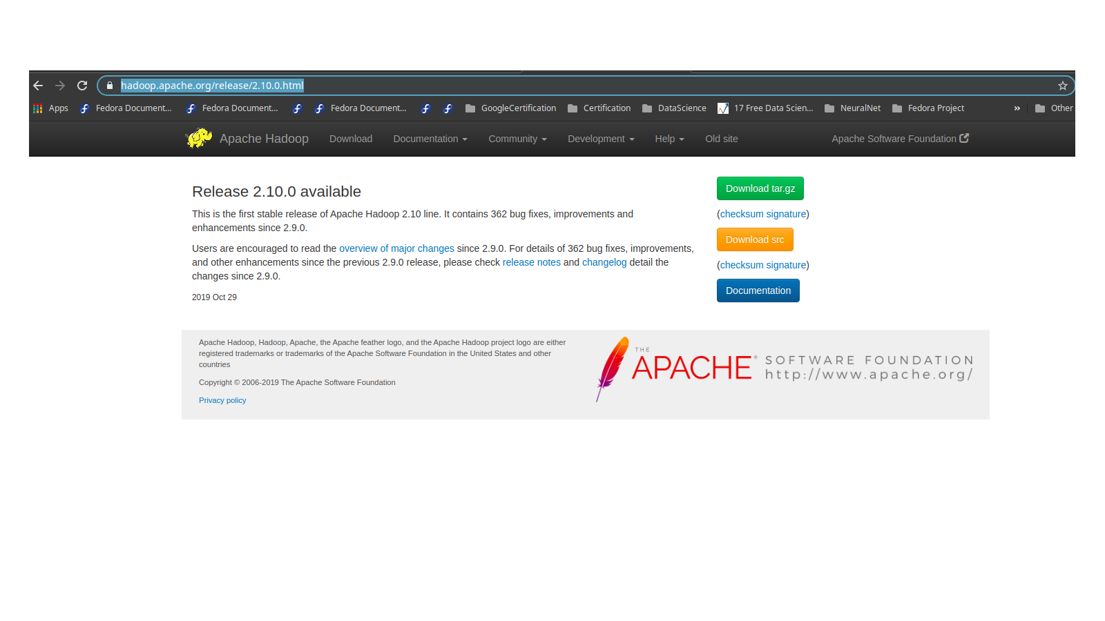

I place it at */home2/BigData*/*Hadoop*.

I also create */home2/BigData/hadoop_store/hdfs/namenode* and */home2/BigData/hadoop_store/hdfs/datanode* folders for name node and data node files. These values go in the configuration file hdfs-site.xml.

Update .bashrc as shown below

*# HADOOP VARIABLES START*

*export HADOOP_INSTALL=/home2/BigData/hadoop*

*export HADOOP_HOME=$HADOOP_INSTALL*

*export HADOOP_CONF_DIR=$HADOOP_HOME/etc/hadoop*

*export PATH=$PATH:$JAVA_HOME/bin:$HADOOP_INSTALL/bin*

*export PATH=$PATH:$HADOOP_INSTALL/sbin*

*export HADOOP_MAPRED_HOME=$HADOOP_INSTALL*

*export HADOOP_COMMON_HOME=$HADOOP_INSTALL*

*export HADOOP_HDFS_HOME=$HADOOP_INSTALL*

*export YARN_HOME=$HADOOP_INSTALL*

*export HADOOP_COMMON_LIB_NATIVE_DIR=$HADOOP_INSTALL/lib/native*

*export HADOOP_OPTS="-Djava.library.path=$HADOOP_INSTALL/lib/native"*

*export HADOOP_CLASSPATH=$HADOOP_CLASSPATH:$HADOOP_HOME/share/hadoop/common/\**

*export HADOOP_CLASSPATH=$HADOOP_CLASSPATH:$HADOOP_HOME/share/hadoop/common/lib/\**

*export HADOOP_CLASSPATH=$HADOOP_CLASSPATH:$HADOOP_HOME/share/hadoop/mapreduce/*:$HADOOP_HOME/share/hadoop/mapreduce/lib/\**

*export HADOOP_CLASSPATH=$HADOOP_CLASSPATH:$HADOOP_HOME/share/hadoop/yarn/*:$HADOOP_HOME/share/hadoop/yarn/lib/\**

*export HADOOP_CLASSPATH=$HADOOP_CLASSPATH:$HADOOP_HOME/share/hadoop/hdfs/*:$HADOOP_HOME/share/hadoop/hdfs/lib/\**

Source .bashrc by running

[dijender@DijeBigMachine ~]$ source .bashrc

Update core-site.xml at the location $HADOOP_HOME/etc/hadoop and set

*<property>*

*<name>fs.defaultFS</name>*

*<value>hdfs://DijeBigMachine:9000</value>*

*</property>*

Update hdfs-site.xml at $HADOOP_HOME/etc/hadoop and set the following properties.

1. Replication factor:

*<property>*

*<name>dfs.replication</name>*

*<value>3</value>*

*</property>*

*2. Namenode location:*

*<property>*

*<name>dfs.namenode.name.dir</name>*

*<value>file:/home2/BigData/hadoop_store/hdfs/namenode</value>*

*</property>*

*3. Datanode location:*

*<property>*

*<name>dfs.datanode.data.dir</name>*

*<value>file:/home2/BigData/hadoop_store/hdfs/datanode</value>*

*</property>*

Create a file called workers at $HADOOP_HOME/etc/hadoop with name of the nodes.

*[dijender@DijeBigMachine hadoop]$ cat workers*

*DijeBigMachine*

*LubuntuDN1*

*LubuntuDN2*

Source the .bashrc file and test if you can start hadoop by running

start-dfs.sh followed by start-yarn.sh

If you don’t see any errors, try checking the hadoop file system by running

*hadoop fs -mkdir /testDir*

*hadoop fs -ls /*

If you see /testDir created. Your Hadoop is correctly setup.

To stop Hadoop, run the following

stop-dfs.sh

stop-yarn.sh

**2. Spark**

Download Spark from Apache foundation as seen in image below.

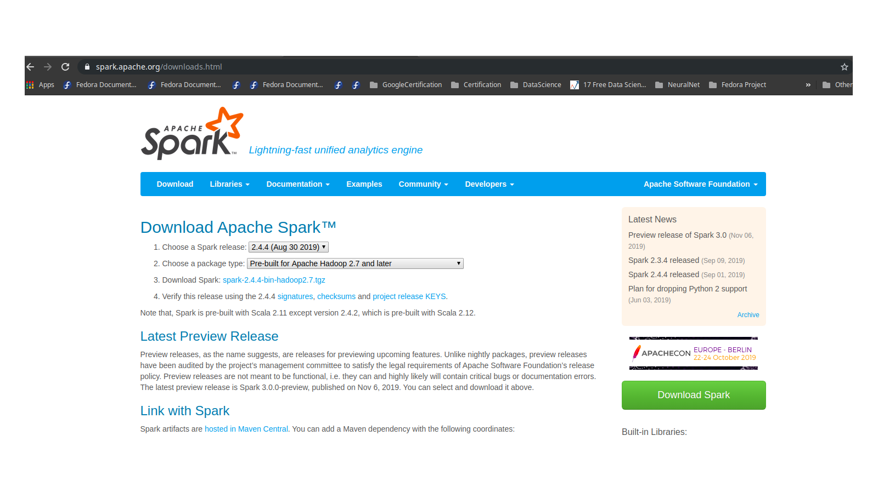

Un-tar it at a location in your hard drive. I untar it at /home2/Bigdata/spark.

Set up .bashrc as follows

*#Add Spark path*

*export SPARK_HOME=/home2/BigData/spark*

*export SPARK_CONF_DIR=$SPARK_HOME/conf*

*export SPARK_JAR=$SPARK_HOME/jars/\**

*export PATH=$PATH:$SPARK_HOME/bin:$SPARK_HOME/sbin*

Create master and slaves files and put master and slaves host names in them.

*[dijender@DijeBigMachine conf]$ pwd*

*/home2/BigData/spark/conf*

*[dijender@DijeBigMachine conf]$ cat master*

*#*

*# Licensed to the Apache Software Foundation (ASF) under one or more*

*# contributor license agreements. See the NOTICE file distributed with*

*# this work for additional information regarding copyright ownership.*

*# The ASF licenses this file to You under the Apache License, Version 2.0*

*# (the "License"); you may not use this file except in compliance with*

*# the License. You may obtain a copy of the License at*

*#*

*# http://www.apache.org/licenses/LICENSE-2.0*

*#*

*# Unless required by applicable law or agreed to in writing, software*

*# distributed under the License is distributed on an "AS IS" BASIS,*

*# WITHOUT WARRANTIES OR CONDITIONS OF ANY KIND, either express or implied.*

*# See the License for the specific language governing permissions and*

*# limitations under the License.*

*#*

*# A Spark Master will be started on each of the machines listed below.*

***DijeBigMachine***

*[dijender@DijeBigMachine conf]$ cat slaves*

*#*

*# Licensed to the Apache Software Foundation (ASF) under one or more*

*# contributor license agreements. See the NOTICE file distributed with*

*# this work for additional information regarding copyright ownership.*

*# The ASF licenses this file to You under the Apache License, Version 2.0*

*# (the "License"); you may not use this file except in compliance with*

*# the License. You may obtain a copy of the License at*

*#*

*# http://www.apache.org/licenses/LICENSE-2.0*

*#*

*# Unless required by applicable law or agreed to in writing, software*

*# distributed under the License is distributed on an "AS IS" BASIS,*

*# WITHOUT WARRANTIES OR CONDITIONS OF ANY KIND, either express or implied.*

*# See the License for the specific language governing permissions and*

*# limitations under the License.*

*#*

*# A Spark Worker will be started on each of the machines listed below.*

***DijeBigMachine***

***LubuntuDN1***

***LubuntuDN2***

I keep everything else as default in the configuration file.s For testing and using purpose it works good. Feel free to fiddle with the values in the config file and see the impact.

Verify the installation

You don’t need to run anything on the worker nodes. We will start Hadoop and Spark on the master node.

1. Fire up both the Lubuntu VMs.

2. On the master machine(Fedora), run the following commands to start HDFS and Yarn.

[dijender@DijeBigMachine ~]$ **start-dfs.sh**

Starting namenodes on [DijeBigMachine]

Starting datanodes

Starting secondary namenodes [DijeBigMachine]

[dijender@DijeBigMachine ~]$

[dijender@DijeBigMachine ~]$ **start-yarn.sh**

Starting resourcemanager

Starting nodemanagers

[dijender@DijeBigMachine ~]$

[dijender@DijeBigMachine hadoop]$ **hdfs dfsadmin -report**

Configured Capacity: 570065395712 (530.91 GB)

Present Capacity: 186425126912 (173.62 GB)

DFS Remaining: 180737851392 (168.33 GB)

DFS Used: 5687275520 (5.30 GB)

DFS Used%: 3.05%

Replicated Blocks:

Under replicated blocks: 0

Blocks with corrupt replicas: 0

Missing blocks: 0

Missing blocks (with replication factor 1): 0

Pending deletion blocks: 0

Erasure Coded Block Groups:

Low redundancy block groups: 0

Block groups with corrupt internal blocks: 0

Missing block groups: 0

Pending deletion blocks: 0

-------------------------------------------------

Live datanodes (3):

Name: 192.168.56.101:9866 (LubuntuDN1)

Hostname: LubuntuDN1

Decommission Status : Normal

Configured Capacity: 38970851328 (36.29 GB)

DFS Used: 1895112704 (1.76 GB)

Non DFS Used: 7607930880 (7.09 GB)

DFS Remaining: 27464609792 (25.58 GB)

DFS Used%: 4.86%

DFS Remaining%: 70.47%

Configured Cache Capacity: 0 (0 B)

Cache Used: 0 (0 B)

Cache Remaining: 0 (0 B)

Cache Used%: 100.00%

Cache Remaining%: 0.00%

Xceivers: 1

Last contact: Thu Nov 14 12:15:59 IST 2019

Last Block Report: Thu Nov 14 11:57:32 IST 2019

Num of Blocks: 51

Name: 192.168.56.102:9866 (LubuntuDN2)

Hostname: LubuntuDN2

Decommission Status : Normal

Configured Capacity: 38970851328 (36.29 GB)

DFS Used: 1895112704 (1.76 GB)

Non DFS Used: 8426008576 (7.85 GB)

DFS Remaining: 26646532096 (24.82 GB)

DFS Used%: 4.86%

DFS Remaining%: 68.38%

Configured Cache Capacity: 0 (0 B)

Cache Used: 0 (0 B)

Cache Remaining: 0 (0 B)

Cache Used%: 100.00%

Cache Remaining%: 0.00%

Xceivers: 1

Last contact: Thu Nov 14 12:16:00 IST 2019

Last Block Report: Thu Nov 14 11:57:33 IST 2019

Num of Blocks: 51

Name: 192.168.56.1:9866 (DijeBigMachine)

Hostname: DijeBigMachine

Decommission Status : Normal

Configured Capacity: 492123693056 (458.33 GB)

DFS Used: 1897050112 (1.77 GB)

Non DFS Used: 338594594816 (315.34 GB)

DFS Remaining: 126626709504 (117.93 GB)

DFS Used%: 0.39%

DFS Remaining%: 25.73%

Configured Cache Capacity: 0 (0 B)

Cache Used: 0 (0 B)

Cache Remaining: 0 (0 B)

Cache Used%: 100.00%

Cache Remaining%: 0.00%

Xceivers: 1

Last contact: Thu Nov 14 12:15:58 IST 2019

Last Block Report: Thu Nov 14 11:56:53 IST 2019

Num of Blocks: 51

We can see we have 3 datanodes live.

Start spark using the following commands on the Master machine. To start the master and workers.

[dijender@DijeBigMachine ~]$ **start-master.sh**

starting org.apache.spark.deploy.master.Master, logging to /home2/BigData/spark/logs/spark-dijender-org.apache.spark.deploy.master.Master-1-DijeBigMachine.out

[dijender@DijeBigMachine ~]$ **start-slaves.sh**

LubuntuDN1: starting org.apache.spark.deploy.worker.Worker, logging to /home2/BigData/spark/logs/spark-dijender-org.apache.spark.deploy.worker.Worker-1-LubuntuDN1.out

LubuntuDN2: starting org.apache.spark.deploy.worker.Worker, logging to /home2/BigData/spark/logs/spark-dijender-org.apache.spark.deploy.worker.Worker-1-LubuntuDN2.out

DijeBigMachine: starting org.apache.spark.deploy.worker.Worker, logging to /home2/BigData/spark/logs/spark-dijender-org.apache.spark.deploy.worker.Worker-1-DijeBigMachine.out

[dijender@DijeBigMachine ~]$ **jps**

77953 ResourceManager

77313 SecondaryNameNode

78112 NodeManager

76692 NameNode

81462 Master

81627 Worker

76909 DataNode

81695 Jps

[dijender@DijeBigMachine ~]$

Verify Spark is installed correctly in the browser.

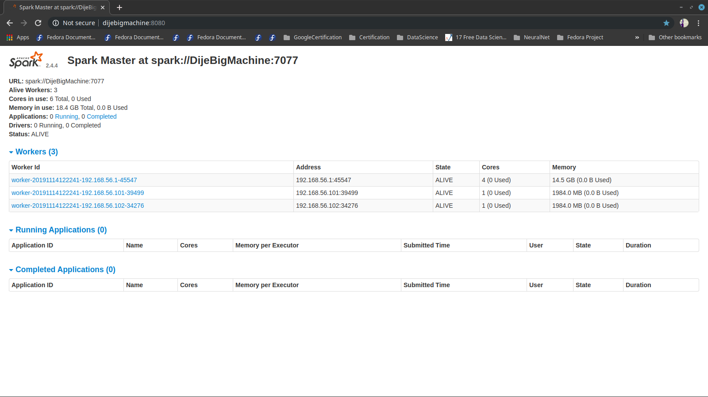

Running Spark code using spark-shell to verify that installation is working fine. Run spark-shell on the command prompt.b

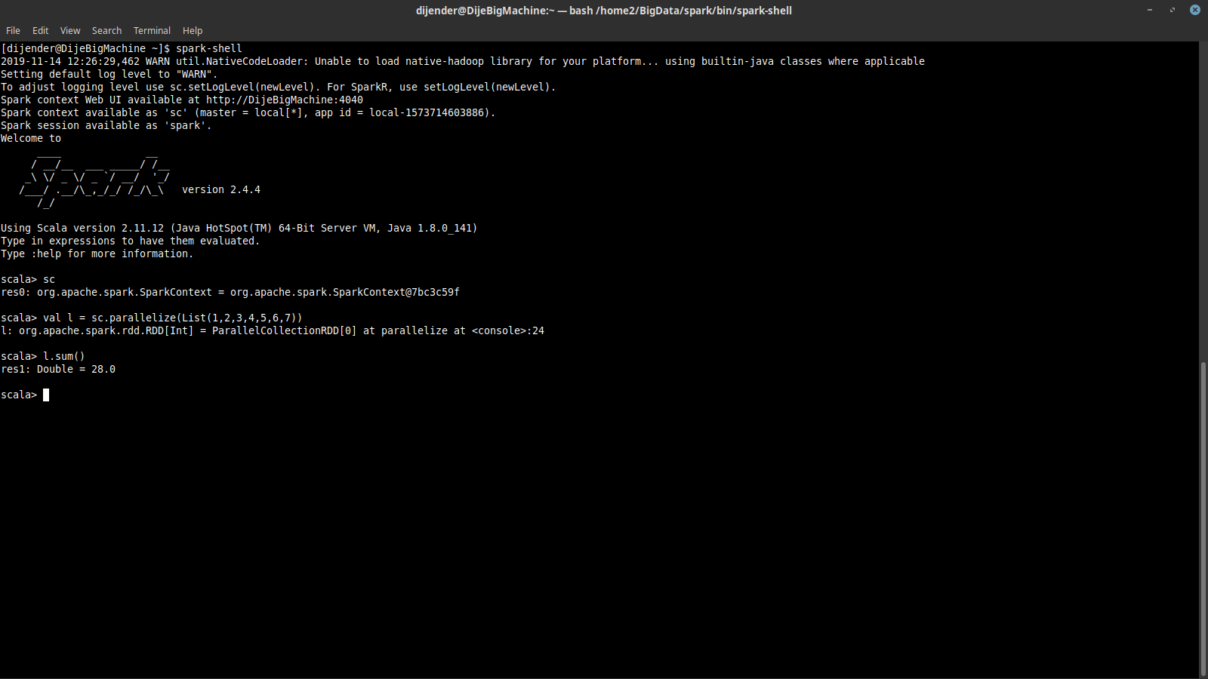

As you can see, we created a simple RDD and ran a sum on the list of number.

**3. Cassandra**

1. Download Cassandra tar ball from Apache foundation.

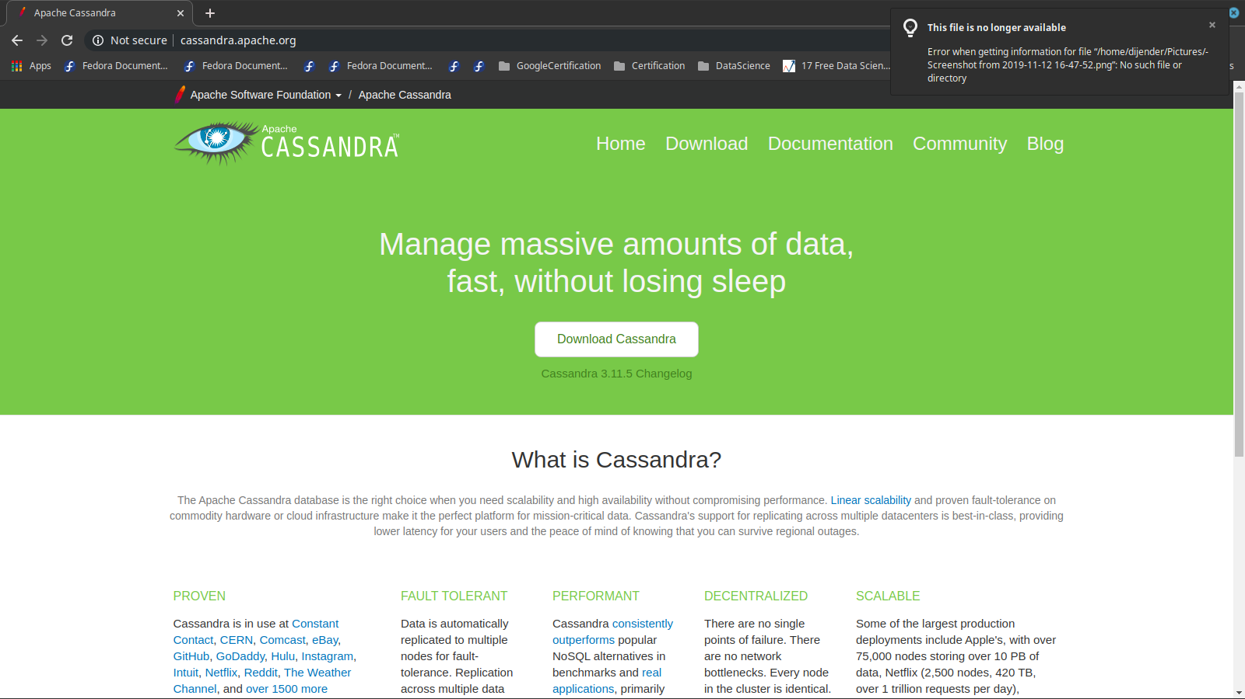

2. Extract it at a location. I have extracted it at /home2/BigData/apache-cassandra-3.11.5

3. Setup .bashrc as shown below and source it.

#Cassandra

export CASSANDRA_HOME=/home2/BigData/apache-cassandra-3.11.5

export PATH=$PATH:$CASSANDRA_HOME/bin

4. Extract the tar ball on the VMs as well and setup .bashrc as shown above.

5. We only need to setup **cassandra.yaml** to make Cassandra work

[dijender@DijeBigMachine ~]$ cd $CASSANDRA_HOME

[dijender@DijeBigMachine apache-cassandra-3.11.5]$ cd conf

[dijender@DijeBigMachine conf]$ ls -l

total 160

-rw-r--r--. 1 dijender dijender 18250 Oct 24 22:13 cassandra-env.ps1

-rw-r--r--. 1 dijender dijender 12535 Oct 24 22:13 cassandra-env.sh

-rw-r--r--. 1 dijender dijender 148 Oct 24 22:13 cassandra-jaas.config

-rw-r--r--. 1 dijender dijender 1200 Oct 24 22:13 cassandra-rackdc.properties

-rw-r--r--. 1 dijender dijender 1358 Oct 24 22:13 cassandra-topology.properties

-rw-r--r--. 1 dijender dijender 58539 Nov 12 11:08 **cassandra.yaml**

-rw-r--r--. 1 dijender dijender 2082 Oct 24 22:13 commitlog_archiving.properties

-rw-r--r--. 1 dijender dijender 6360 Oct 24 22:13 cqlshrc.sample

-rw-r--r--. 1 dijender dijender 2757 Oct 24 22:13 hotspot_compiler

-rw-r--r--. 1 dijender dijender 9956 Oct 24 22:13 jvm.options

-rw-r--r--. 1 dijender dijender 1195 Oct 24 22:13 logback-tools.xml

-rw-r--r--. 1 dijender dijender 3809 Oct 24 22:13 logback.xml

-rw-r--r--. 1 dijender dijender 1603 Oct 24 22:13 metrics-reporter-config-sample.yaml

-rw-r--r--. 1 dijender dijender 291 Oct 24 22:13 README.txt

drwxr-xr-x. 2 dijender dijender 4096 Nov 11 23:04 triggers

[dijender@DijeBigMachine conf]$

6. As there’s no Master-Slave concept in Cassandra so all the nodes will be setup in the same manner.

**Seeds: "192.168.56.101"** (You need to add any one machine in the node here, with the gossip protocol it would be known to all nodes in the ring).

**rpc_address: 127.0.0.1**

**listen_address: 192.168.56.1** (This would be the node’s own IP address).

7. Once Cassandra.yaml is setup, we need to start Cassandra in all the machines. This is different from Spark where we need to start process only on the master. Start cassandra using cassandra command.

8. Once Cassansdra is started on all machine, you can verify that all nodes are up and running using the following command.

[dijender@DijeBigMachine conf]$ **nodetool status**

Datacenter: datacenter1

=======================

Status=Up/Down

|/ State=Normal/Leaving/Joining/Moving

-- Address Load Tokens Owns (effective) Host ID Rack

UN 192.168.56.1 277.83 KiB 256 69.8% 848e362e-009e-4b74-a8e1-a8c34526632b rack1

UN 192.168.56.101 235.76 KiB 256 67.5% e0c411bb-5bc2-412f-808f-652ee7bb56fc rack1

UN 192.168.56.102 303.24 KiB 256 62.7% 2df44d96-af2b-4e90-a024-18d903eeee69 rack1

Now we have a HDFS, Spark and Cassandra all up and running on the three nodes.