COMMANDS:
1.PWD
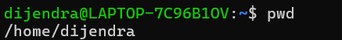
2.CLEAR
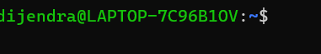
3.HISTROY
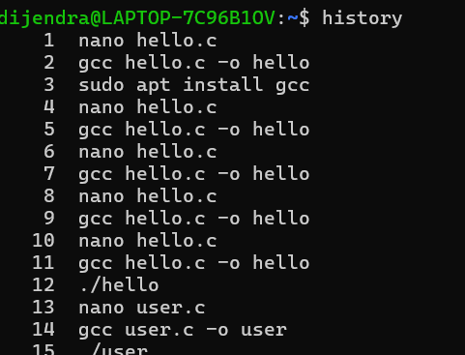
4.WHOAMI
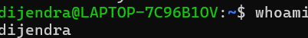
5.DATE
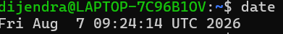
6.HOSTNAME
7.UNAME -A
8.LS
9.LS -L
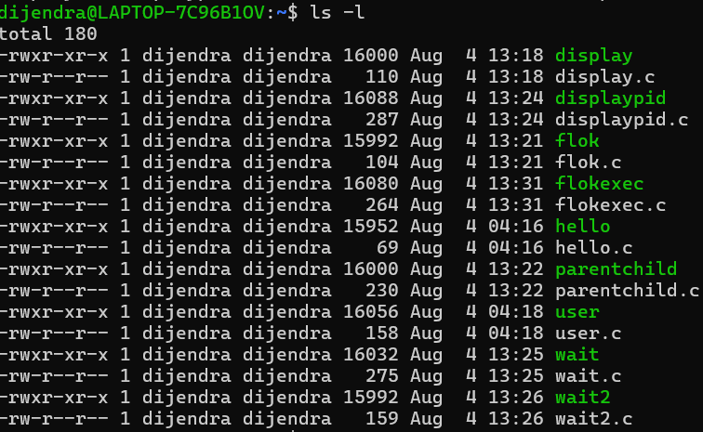
10.LS -A
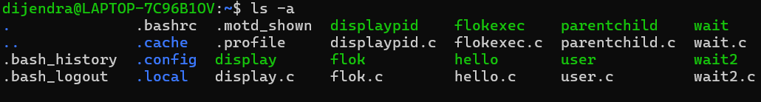
11.CD ..
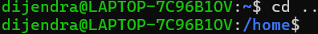
12.MKDIR
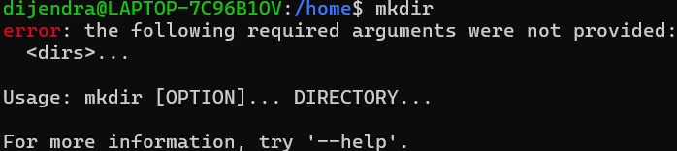
13.RMDIR
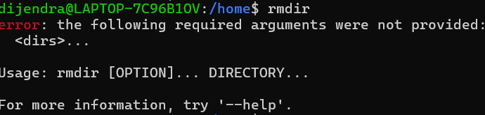
14.FIND
