PROGRAM:virtual address
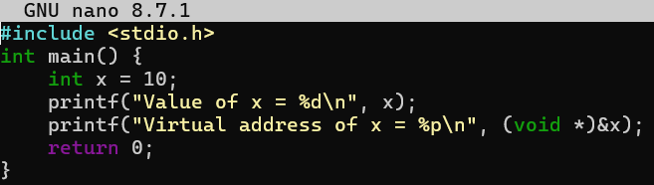

OUTPUT:
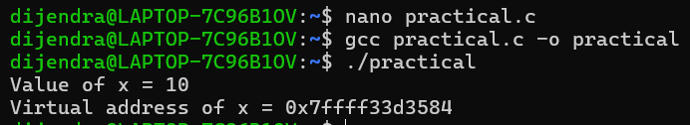

PROCESSSPACES
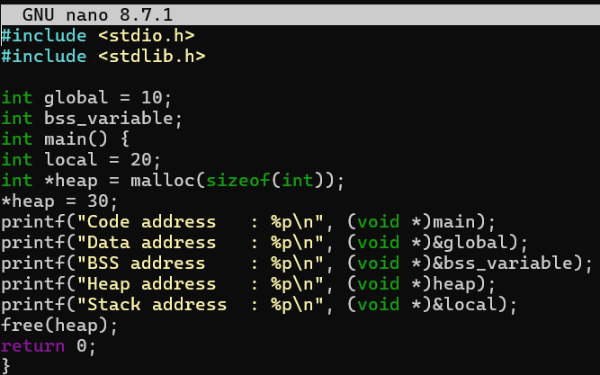
OUTPUT
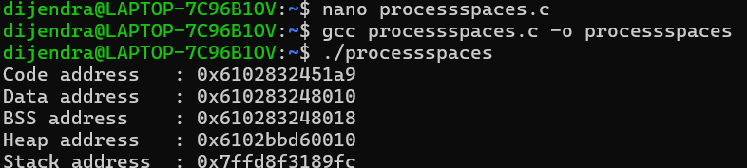
DEMANDPAGING
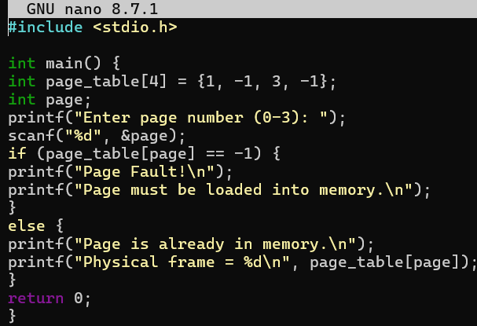
OUTPUT
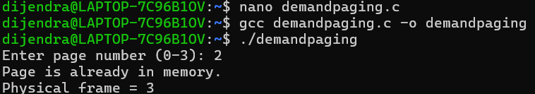
ADDRESSTRANSLATION
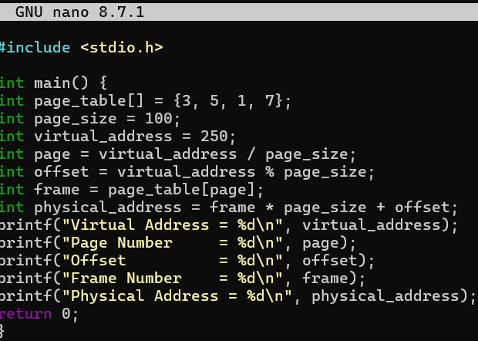
OUTPUT
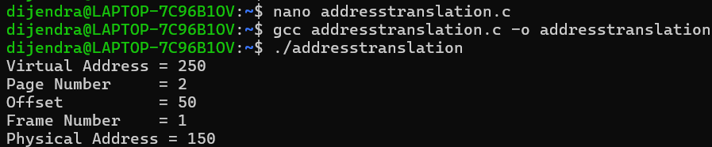
MEMORYALLOCATION
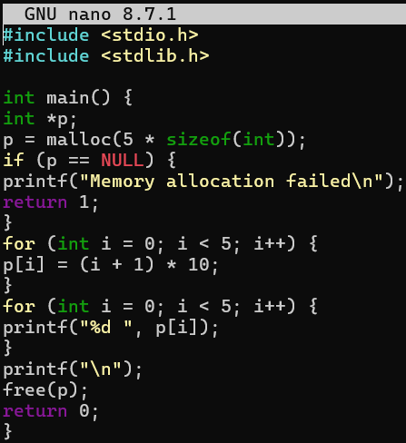
OUTPUT
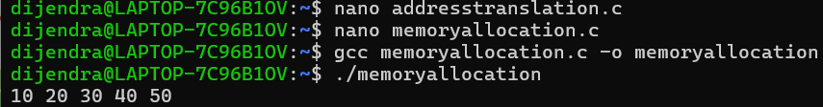
SEGMENTATIONFAULT
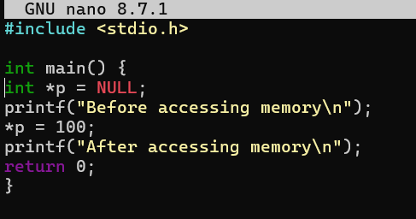
OUTPUT
