PROGRAM:

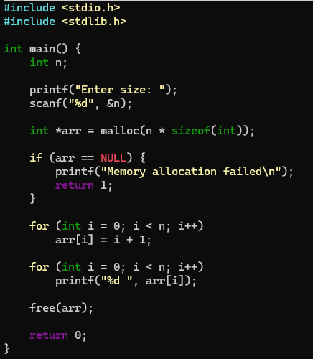
OUTPUT:
