PROGRAM:

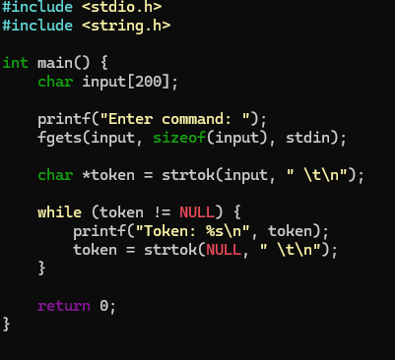

OUTPUT:

