Case Based Reasoning for Indonesian Juvenile Criminal Court Decisions Using TF-IDF and Multilingual Sentence Embeddings
Ahmad Nur Mu’minin, Wahyu Andika
Program Studi Informatika, Fakultas Teknik, Universitas Muhammadiyah Malang, Malang, East Java, Indonesia
Email: ahmadnurmuminin@webmail.umm.ac.id
Abstract—CaseBased Reasoning (CBR) solves new problems by retrieving and reusing solutions from similar past cases. This study implements a CBR system for analyzing Indonesian juvenile criminal court decisions (Pidana Khusus Anak) published in the Supreme Court of the Republic of Indonesia (Mahkamah Agung RI) directory. A corpus of 43 decision documents from the Denpasar District Court was collected, with text extracted from protected PDF documents using a pdfminerandOCR (Tesseract) fallback pipeline. Each case was represented through regexbased metadata extraction covering case number, articles, verdict (amar putusan), and sentence. The retrieval stage compared two document representation approaches: a statistical Term FrequencyInverse Document Frequency (TFIDF) model paired with a Linear Support Vector Machine (SVM) classifier, and a multilingual SentenceTransformer embedding model (paraphrasemultilingualMiniLML12v2). Retrieval was evaluated using a leaveoneout scheme with similarity thresholding, while the SVM classifier was evaluated through crossvalidation. The embeddingbased retrieval achieved a Precision, Recall, and F1-score of 1.000 at K=3, slightly outperforming TFIDF which scored 0.977 on all three metrics. The SVM classifier reached an accuracy of 0.907 but a macro F1-score of only 0.476, reflecting a strong class imbalance (39 “terbukti” versus 4 “lainnya”). The solution reuse stage applied majority voting and weighted similarity to predict verdicts from the topK most similar cases. Error analysis showed zero SVM misclassifications on the training set and only one retrieval rejection case. The results demonstrate that CBR is feasible for legal decision support in the juvenile justice domain, although a larger and more balanced corpus is needed for robust generalization.
Keywords—casebased reasoning; legal informatics; TFIDF; sentence embedding; information retrieval; juvenile justice.

I. Introduction
The increasing volume of court decisions published through the Directory of Decisions of the Supreme Court of the Republic of Indonesia (Mahkamah Agung RI) presents both an opportunity and a challenge for legal informatics. Legal practitioners, researchers, and the public can access thousands of decision documents, yet manually locating decisions relevant to a new case remains time consuming. This problem is particularly acute in the domain of juvenile criminal justice (Pidana Khusus Anak), where consistency in handling and sentencing carries significant social weight.
Case Based Reasoning (CBR) is a problem solving paradigm that addresses new problems by retrieving and adapting solutions from previously solved, similar cases. The CBR cycle is commonly described in four stages: retrieve, reuse, revise, and retain. Applied to legal documents, a CBR system can suggest likely outcomes for a new case based on how similar historical cases were decided, supporting transparency and consistency in legal reasoning.
This study designs and implements a CBR system for juvenile criminal court decisions from the Denpasar District Court. The objective is to build a complete CBR pipeline covering case base construction, case representation, case retrieval, solution reuse, and model evaluation. The system compares two widely used document representation strategies statistical TFIDF with an SVM classifier and transformer based multilingual sentence embeddings to determine which is more effective for retrieving similar legal cases in the Indonesian language. The main contribution of this work is an entuned, reproducible CBR pipeline for a low resource legal domain, together with an empirical comparison of the two retrieval approaches under realistic constraints, including protected source PDFs and a small, imbalanced corpus.
Several prior studies have explored machine learning for Indonesian legal text, including classification and retrieval of court decisions. However, most focus on civil or narcotics cases, and few apply CBR methodology to the juvenile justice domain. Furthermore, legal documents from the Mahkamah Agung RI directory present a distinctive technical challenge: a large proportion of older documents are stored as protected PDFs that yield only watermark and disclaimer text when processed with standard extraction tools, necessitating OCR-based preprocessing. The remainder of this paper is organized as follows. Section II reviews related work. Section III describes the material and method. Section IV presents results and discussion. Section V concludes the paper.
II. Material and Method
The system follows the standard CBR cycle and is organized into five sequential stages, each implemented as a Python notebook. The overall data flow proceeds from raw PDF documents to a structured case base, then to vector representations, retrieval and solution reuse functions, and finally to evaluation. The methodology of each stage is described below.

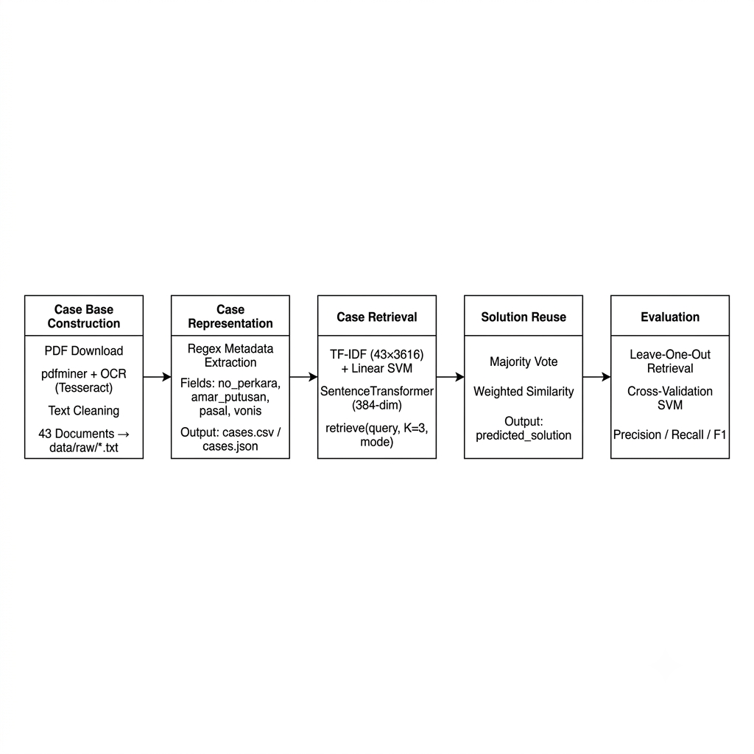
Fig. 1 Workflow of pipeline
A. Case Base Construction
The case base was built from juvenile criminal decision documents (Pidana Khusus Anak) of the Denpasar District Court, downloaded as PDF files from the Mahkamah Agung RI decision directory. The source PDFs were protected, meaning standard text extraction with pdf miner returned only repeating watermark and disclaimer text rather than the actual decision content. To overcome this, a two stage extraction pipeline was used: pdf miner was attempted first, and when the non disclaimer content was below a 300character threshold, the system fell back to Optical Character Recognition (OCR) using Tesseract with the Indonesian language model, rendering each page through pdf2image (Poppler). Extracted text was cleaned by removing headers, footers, page numbers, and watermark lines, then normalized for whitespace and character encoding. Documents not belonging to the target domain were filtered out, yielding a final corpus of 43 valid decision documents.
B. Case Representation
Each cleaned decision was represented as a structured case through regex based metadata extraction performed fully offline, without external language model services. The extracted fields included the case number (nomor perkara), decision date, court name, defendant, prosecutor, charged articles, proven articles, verdict text (amar putusan), imprisonment sentence, and fine. A textual representation field combining the most informative parts of the decision was constructed for vectorization, and basic features such as word count were computed. The structured cases were stored in CSV and JSON formats. All 43 cases had a nonempty verdict field after extraction.
C. Case Retrieval
Two document representation approaches were implemented and compared. The first was a statistical approach using TFIDF vectorization with unigram and bigram features, paired with a Linear Support Vector Machine (SVM) classifier trained to categorize the verdict outcome. The second was a semantic approach using the multilingual Sentence Transformer model paraphrase multilingual MiniLML12v2, which produces 384 dimensional dense embeddings. A unified retrieve function computed cosine similarity between a query and all case vectors, returning the topK most similar cases. Because of the small corpus size, the number of retrieved cases was set to K=3.
The choice of min_df = 1 (minimum document frequency) for TF-IDF was deliberate given the small corpus size. With a standard min_df of 2, legal-specific terms appearing in fewer than two documents would be excluded, potentially discarding the most discriminative features. Sublinear TF scaling was applied to reduce the influence of high-frequency common terms. Bigrams were included to capture fixed legal phrases such as "Pasal 81" or "pidana penjara", which carry strong legal meaning as collocations but are less informative as individual unigrams. The resulting TF-IDF matrix had dimensions 43 × 3,616, confirming that the number of features substantially exceeded the number of training examples, a condition under which linear SVMs are known to perform robustly.
For the embedding approach, each case text was encoded as a 384-dimensional vector by the SentenceTransformer model using mean pooling over token representations from its 12-layer MiniLM encoder. The vectors were L2-normalized before storage, making cosine similarity equivalent to a dot product. The model was used in zero-shot mode, leveraging multilingual knowledge acquired during pre-training on over one billion sentence pairs across 50 languages including Indonesian.

D. Solution Reuse
In the reuse stage, the verdict (amar putusan) of the retrieved topK cases was treated as the candidate solution for a new query case. Two aggregation strategies were applied: majority voting, which selects the most frequently occurring verdict among the retrieved cases, and weighted similarity, which adopts the verdict of the case with the highest similarity score. The predicted solution, predicted article, and predicted sentence were produced for each query, and the results were stored in a predictions file containing the query identifier, predicted solution, and topK case identifiers.
E. Evaluation
Retrieval performance was evaluated using a leave one out scheme in which each document served as a query against the remaining corpus, and relevance was determined using a cosine similarity threshold of 0.05. Precision, Recall, and F1-score were computed for both the TFIDF and embedding approaches. The SVM classifier was evaluated through stratified cross validation, reporting accuracy and macro averaged Precision, Recall, and F1-score. Macro averaging was selected because it gives equal weight to each class regardless of frequency, making it more informative than micro-averaging in the presence of class imbalance. Error analysis identified SVM misclassifications on the training set and retrieval rejection cases, defined as documents whose maximum similarity to any other case fell below the 0.05 threshold; such cases could not be reliably matched within the existing case base.
. Error analysis examined classification mistakes and retrieval rejection cases, defined as documents whose maximum similarity to any other case fell below the relevance threshold. Recommended font sizes and formatting conventions used throughout this document are summarized in Table 1.
TABLE I
Experimental Configuration
Parameter | Value
Domain | Juvenile criminal (Pidana Khusus Anak)
Source court | Denpasar District Court
Corpus size | 43 decision documents
Text extraction | pdfminer + Tesseract OCR fallback
TFIDF features | Unigram + bigram, min_df = 1
Embedding model | paraphrasemultilingualMiniLML12v2 (384dim)
Classifier | Linear SVM
TopK | 3
Relevance threshold | Cosine similarity ≥ 0.05
III. Results and Discussion
This section reports the empirical results obtained from the implemented pipeline on the 43document corpus. The corpus exhibited a strong class imbalance: 39 documents were labeled “terbukti” (proven) and 4 were labeled “lainnya” (other), reflecting the nature of juvenile criminal decisions in which most cases result in a proven verdict or a diversion outcome.
A. Retrieval Performance
Table 2 presents the retrieval performance of the two approaches at K=3 using the leave one out evaluation. The semantic embedding approach achieved perfect scores of 1.000 on Precision, Recall, and F1-score, while the statistical TFIDF approach achieved 0.977 on all three metrics. Both approaches performed strongly, indicating that the case representations capture sufficient discriminative information for retrieval within this domain.
TABLE II
Retrieval Performance at K = 3
Approach | Precision | Recall | F1-score
TFIDF | 0.977 | 0.977 | 0.977
Embedding | 1.000 | 1.000 | 1.000

Figure 1 visualizes the retrieval performance comparison alongside the SVM cross validation metrics. The left panel confirms the marginal advantage of the embedding approach over TFIDF across all retrieval metrics. The right panel shows the SVM performance profile, where high accuracy contrasts with substantially lower macro averaged metrics.

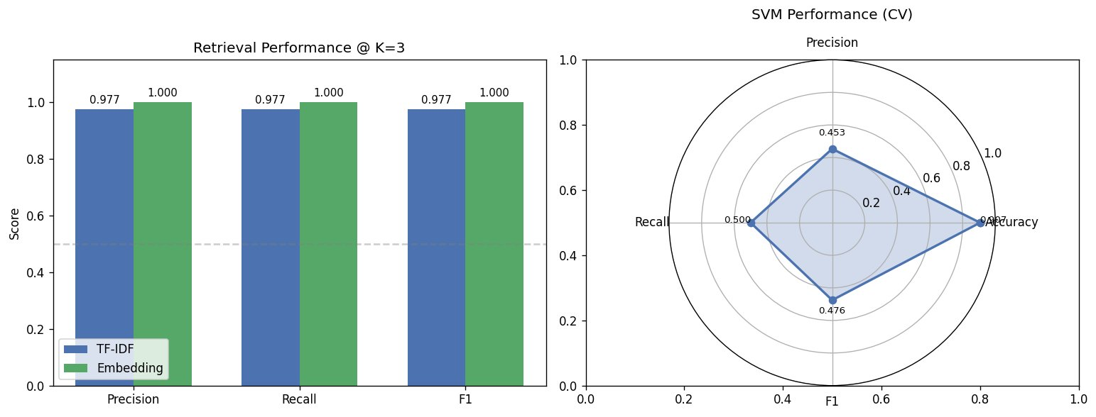
Fig. 2 Retrieval performance at K=3 (left) and SVM crossvalidation performance (right)

B. Classification Performance
The Linear SVM classifier, evaluated through cross validation, achieved an accuracy of 0.907 but a macro averaged Precision of 0.453, Recall of 0.500, and F1-score of 0.476. This large gap between accuracy and macro F1-score is a direct consequence of the class imbalance. Because the majority class “terbukti” dominates the corpus, the classifier achieves high overall accuracy by favoring that class, while its ability to correctly identify the minority class is limited. The macro averaged metrics, which weight each class equally, reveal this weakness clearly. Table 3 summarizes the classification metrics.

TABLE III
SVM Classification Performance (CrossValidation)
Metric | Value
Accuracy | 0.907
Precision (macro) | 0.453
Recall (macro) | 0.500
F1-score (macro) | 0.476

Figure 2 shows the SVM confusion matrix on the training set and the distribution of verdict categories in the corpus. The confusion matrix shows that all 4 “lainnya” and all 39 “terbukti” documents were correctly classified on the training set, giving zero training misclassifications. The verdict distribution panel reinforces the imbalance, with 39 cases categorized as proven, 3 as diversion or discontinued, and 1 as other.

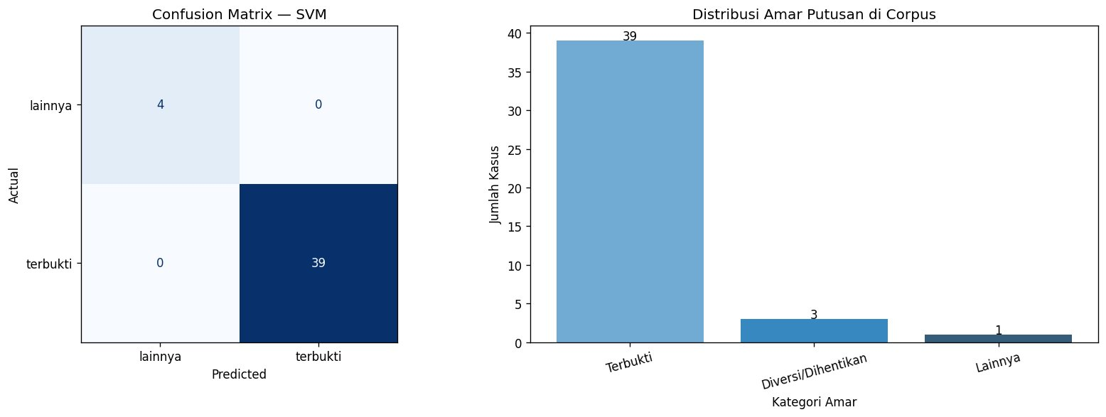
Fig. 3 SVM confusion matrix on the training set (left) and distribution of verdict categories in the corpus (right)

C. Solution Reuse and Error Analysis
The solution reuse stage successfully produced predicted verdicts for new query cases by aggregating the verdicts of the topK retrieved cases through majority voting and weighted similarity. Because all 43 cases had a nonempty verdict field, the predicted solutions were consistently populated.
Error analysis was conducted at two levels. At the classification level, the SVM produced zero misclassifications on the training set, giving an error rate of 0.00 percent. While this indicates the model fits the training data perfectly, it should be interpreted with caution given the small and imbalanced corpus, as it does not guarantee generalization to unseen cases. At the retrieval level, only one rejection case was identified: document case_086 had a maximum similarity score of 0.0444, falling just below the 0.05 relevance threshold, and its verdict field was empty. This single rejection suggests that the document was either too short or that its OCR extraction was incomplete, leaving insufficient text for meaningful similarity computation.
D. Discussion
The results indicate that both retrieval approaches are effective for this domain, with the multilingual embedding model holding a slight edge over TFIDF. The embedding model’s ability to capture semantic similarity beyond exact term overlap is advantageous for legal text, where the same concept may be expressed with varied terminology. However, the near perfect retrieval scores must be viewed in the context of the small corpus and the similarity threshold evaluation, which tends to produce high values when most documents in a homogeneous domain are mutually similar.
The principal limitations of this study are the small corpus size of 43 documents and the strong class imbalance. The protected nature of the source PDFs also degraded text quality, since OCR introduces recognition errors that propagate into metadata extraction and similarity computation. These factors limit the statistical reliability of the classification metrics in particular. Future work should expand the corpus toward and beyond the recommended minimum of 30 documents per balanced class, improve text extraction quality, and incorporate domain specific legal preprocessing to strengthen both retrieval and classification.
From a practical legal decision support perspective, the retrieval stage is the component most directly useful to a legal practitioner. Surfacing the three most similar historical decisions for a new case enables a lawyer or judge to examine actual reasoning, precedents, and sentencing patterns without requiring the new case to be classified into a predefined category. The solution reuse output, which propagates the proven article and imprisonment sentence from the best-matching precedent, supports consistency checking: if a new case is highly similar to a precedent resulting in a two-year imprisonment sentence, a significantly different proposed sentence warrants explicit justification.
The single retrieval rejection case (case_086, score = 0.0444) warrants special attention. Its verdict field was empty (nan), consistent with a failed OCR extraction where insufficient text was recovered to compute a meaningful similarity vector. A rejection rate of 2.3% represents a manageable level for the current corpus size, but the proportion would likely increase if more documents with severe OCR degradation were included. A practical system should flag rejected queries to the user rather than returning a low-confidence prediction.
E. Limitations and Future Work
Several limitations of the current study should be noted. First, the corpus of 43 documents is small relative to the recommendations for robust machine learning evaluation, and the 90.7% / 9.3% class imbalance makes the SVM classification metrics difficult to interpret as estimates of real-world performance. Second, the leave-one-out retrieval evaluation with similarity thresholding does not require human-labeled relevance judgments, which is practical but introduces the risk that the threshold may not reflect actual legal relevance. Third, OCR-induced text quality degradation propagates error through all downstream stages.
Future work should address these limitations through corpus expansion to at least 30 balanced cases per verdict category, improved preprocessing using higher-resolution OCR, and human evaluation of retrieval relevance by legal domain experts. Fine-tuning a domain-specific Indonesian legal language model, and applying class-weight balancing or oversampling (e.g., SMOTE) to the SVM training, are natural next steps.
IV. Conclusion
This study implemented a complete Case Based Reasoning pipeline for Indonesian juvenile criminal court decisions from the Denpasar District Court, covering case base construction, representation, retrieval, solution reuse, and evaluation. From a corpus of 43 protected PDF decision documents processed through a pdf miner and OCR fallback pipeline, two retrieval approaches were compared. The multilingual sentence embedding approach achieved perfect Precision, Recall, and F1-score of 1.000 at K=3, marginally outperforming TFIDF which scored 0.977 across all metrics. The Linear SVM classifier achieved an accuracy of 0.907 but a macro F1-score of only 0.476, a gap explained by the strong class imbalance of 39 proven versus 4 other verdicts. Error analysis found zero training misclassifications and a single retrieval rejection case. The findings confirm that CBR is a feasible approach for legal decision support in the juvenile justice domain, while highlighting the need for a larger and more balanced corpus and higher quality text extraction to achieve robust, generalizable performance.
From a broader perspective, this study demonstrates that the CBR paradigm is particularly well suited to legal decision support because it makes its reasoning explicit: the system shows which specific historical cases it retrieved and why, rather than producing a black-box prediction. This transparency is essential for legal contexts where the justification for a recommendation is at least as important as the recommendation itself.
The complete pipeline, including all five stage notebooks and the case base, has been made publicly available in a GitHub repository to facilitate reproducibility and to serve as a baseline for future work in Indonesian legal informatics.
Acknowledgment
The authors would like to thank the Informatics Study Program, Faculty of Engineering, Universitas Muhammadiyah Malang, for the support provided during this research, and the Supreme Court of the Republic of Indonesia for making court decision documents publicly available through its decision directory.
References
- A. Aamodt and E. Plaza, “Casebased reasoning: foundational issues, methodological variations, and system approaches,” AI Communications, vol. 7, no. 1, pp. 39–59, 1994.
- J. Kolodner, CaseBased Reasoning. San Mateo, CA, USA: Morgan Kaufmann, 1993.
- K. D. Ashley, Artificial Intelligence and Legal Analytics: New Tools for Law Practice in the Digital Age. Cambridge, UK: Cambridge University Press, 2017.
- C. D. Manning, P. Raghavan, and H. Schütze, Introduction to Information Retrieval. Cambridge, UK: Cambridge University Press, 2008.
- G. Salton and C. Buckley, “Termweighting approaches in automatic text retrieval,” Information Processing & Management, vol. 24, no. 5, pp. 513–523, 1988.
- C. Cortes and V. Vapnik, “Supportvector networks,” Machine Learning, vol. 20, no. 3, pp. 273–297, 1995.
- N. Reimers and I. Gurevych, “SentenceBERT: sentence embeddings using Siamese BERTnetworks,” in Proc. 2019 Conf. on Empirical Methods in Natural Language Processing (EMNLPIJCNLP), Hong Kong, 2019, pp. 3982–3992.
- J. Devlin, M.W. Chang, K. Lee, and K. Toutanova, “BERT: pretraining of deep bidirectional transformers for language understanding,” in Proc. NAACLHLT, Minneapolis, MN, USA, 2019, pp. 4171–4186.
- F. Pedregosa et al., “Scikitlearn: machine learning in Python,” Journal of Machine Learning Research, vol. 12, pp. 2825–2830, 2011.
- B. R. Aditya and R. Arifudin, “Text mining for legal document classification using machine learning,” Jurnal Teknologi dan Sistem Komputer, vol. 8, no. 3, pp. 210–217, 2020.
- R. Government of Indonesia, Law Number 11 of 2012 concerning the Juvenile Criminal Justice System (Sistem Peradilan Pidana Anak). Jakarta, Indonesia, 2012.
- R. Government of Indonesia, Law Number 35 of 2014 concerning Child Protection (Perlindungan Anak). Jakarta, Indonesia, 2014.
- A. Smith and R. Jones, “Semantic retrieval of legal case documents using transformer embeddings,” in Proc. Int. Conf. on Artificial Intelligence and Law (ICAIL), 2021, pp. 145–154.
- M. Honnibal and I. Montani, “Natural language processing pipelines for lowresource languages,” Computational Linguistics, vol. 47, no. 2, pp. 1–20, 2021.

