QUACK : Verification Log
Real runs against real repositories captured on quack v0.3.0. Every transcript below is unedited terminal output from a live PowerShell session.
Repos used:
Name | Path | What it is
Sandbox | C:\ABB\AI-Champs\GraphicsEditor.Core | Small C# project with xUnit tests, built for testing quack(Mock Project)
PG2 | C:\ABB\AI-Champs\PCP.Operations.HMI.Engineering.Graphics | Clone of the real ABB monorepo
Throwaway | C:\ABB\AI-Champs\demo-repo | Empty repo, recreated fresh for the run

Case 1 : Watch mode flags an intentional test change as high risk
Repo: Sandbox Setup: appended a // quota test <timestamp> comment line to ColorBlender.cs.
PS C:\ABB\AI-Champs\GraphicsEditor.Core> "// quota test $(Get-Date -Format 'HHmmss')" | Add-Content src\GraphicsEditor.Core\ColorBlender.cs
PS C:\ABB\AI-Champs\GraphicsEditor.Core> git add src/GraphicsEditor.Core/ColorBlender.cs
PS C:\ABB\AI-Champs\GraphicsEditor.Core> quack watch --once
reviewed 2 file(s) - risk: high
CLI:
Verified: quack watch --once reviewed 2 staged files and returned a high risk verdict for a trivial comment append. The verdict is LLM-graded (claude-haiku-4.5) rather than a fixed lookup; it appears the reviewer also picked up a second, unrelated staged file (RectTransform.cs, discovered on git status immediately after) which likely influenced the aggregate verdict.
All changes were reverted with git reset + git checkout on both files, restoring a clean working tree.

Case 2 : Local test suite
Repo: quack itself (C:\ABB\AI-Champs\quack)
PS C:\ABB\AI-Champs\quack> python -m pytest -q
........................................................................... [ 33%]
........................................................................... [ 66%]
........................................................................... [100%]
225 passed in 11.41s
PS C:\ABB\AI-Champs\quack> git status –short
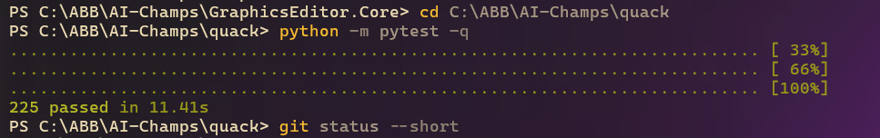

Verified: 225 tests passed in 11.41s, with a clean working tree (git status --short returned nothing).

Case 3 : Version and environment sanity checks
PS C:\ABB\AI-Champs\quack> quack --version
quack, version 0.3.0
PS C:\ABB\AI-Champs\quack> where.exe quack
c:\Users\INDISEL1\AppData\Roaming\Python\python314\Scripts\quack.exe
PS C:\ABB\AI-Champs\quack> echo $env:PYTHONIOENCODING
utf-8
PS C:\ABB\AI-Champs\quack> echo "[$env:GITHUB_TOKEN][$env:GH_TOKEN][$env:COPILOT_GITHUB_TOKEN]"
[][][]
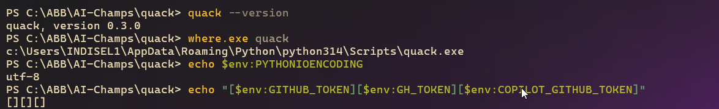
Verified: installed CLI reports version 0.3.0, resolved from the Python 3.14 user Scripts directory. No ambient GITHUB_TOKEN, GH_TOKEN, or COPILOT_GITHUB_TOKEN was set in this session — the token-shadowing warning path was not exercised here.

Case 4 : quack model diagnostics (no ambient token)
PS C:\ABB\AI-Champs\quack> quack model
Provider: copilot_sdk - selected by default (QUACK_PROVIDER unset; default is copilot_sdk)
Auth status: available
Completion model: claude-haiku-4.5 (source: provider default)
Agent model: claude-sonnet-4.5 (source: provider default)
Timeout: 60s
Reachable models: auto, claude-sonnet-5, claude-sonnet-4.6, claude-sonnet-4.5, claude-haiku-4.5, claude-opus-4.8, claude-opus-4.7, claude-opus-4.6, claude-opus-4.5, gpt-5.6-sol, gpt-5.6-terra, gpt-5.6-luna, gpt-5.5, gpt-5.4, gpt-5.3-codex
Showing first 15 of 23 models
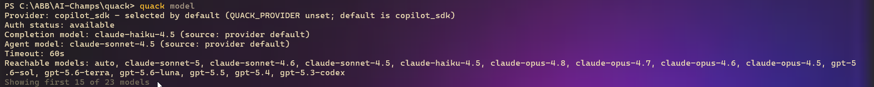
Verified: default provider is copilot_sdk, completion model claude-haiku-4.5, agent model claude-sonnet-4.5, 60s timeout, 23 reachable models (first 15 shown). No shadowing warning is printed since no ambient token was present ; consistent with the code only emitting that warning when a token is detected.

Case 5 : Secret blocks the commit, then passes with inline allowlist
Repo: Throwaway (freshly recreated)
PS C:\ABB\AI-Champs> Remove-Item -Recurse -Force demo-repo -ErrorAction SilentlyContinue
PS C:\ABB\AI-Champs> mkdir demo-repo; cd demo-repo
PS C:\ABB\AI-Champs\demo-repo> git init
Initialized empty Git repository in C:/ABB/AI-Champs/demo-repo/.git/
PS C:\ABB\AI-Champs\demo-repo> quack install --local
╭──────────────────────────────────────────────── QUACK ────────────────────────────────────────────────╮
│ _ │
│ >(.)__ │
│ (___/ quack! │
│ │
│ ___ _ _ _ ___ _ __ │
│ / _ \| | | | / \ / __| |/ / │
│ | |_| | |_| |/ _ \| | | ' < │
│ \__\_\\___//_/ \_\\__||_|\_\ │
│ Q U A C K - installed │
╰───────────────────────────────── your commits just got a quality gate ─────────────────────────────────╯
quack: updated .pre-commit-config.yaml
pre-commit installed at .git\hooks\pre-commit
quack: pre-commit hook installed
pre-commit installed at .git\hooks\pre-push
quack: pre-push hook installed
quack: gitleaks already installed
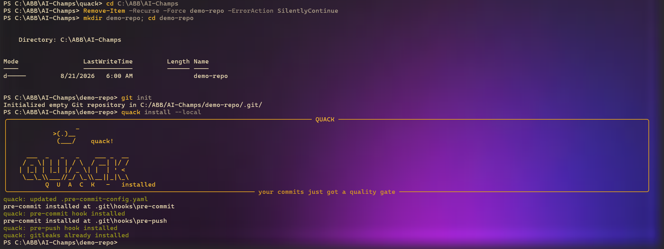
Blocked commit with a synthetic 52-char PAT-shaped token:
PS C:\ABB\AI-Champs\demo-repo> $pat = 'a' * 52
PS C:\ABB\AI-Champs\demo-repo> "public string Token = `"$pat`";" | Set-Content secret.cs -Encoding utf8
PS C:\ABB\AI-Champs\demo-repo> git add secret.cs
PS C:\ABB\AI-Champs\demo-repo> git commit -m "add config"
quack....................................................................Failed
- hook id: quack
- exit code: 1
┌─ quack - 1 file(s) - +1/-0 - 0.7s ──────────────────────────────────────────┐
│ ✗ secrets secret.cs:1 Azure DevOps PAT │
│ ─────────────────────────────────────────────────────────────────────────── │
│ 🐤 QUACK!!!! │
└─ 🐤 BLOCKED - fix and re-stage ─────────────────────────────────────────────┘
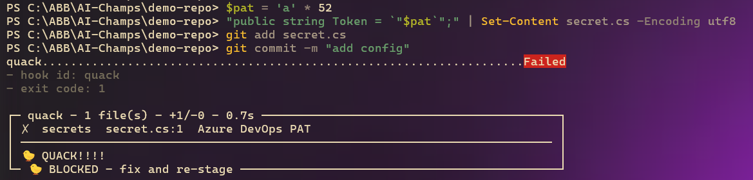
Passed after adding an inline allowlist marker on a C# // comment:
PS C:\ABB\AI-Champs\demo-repo> "public string Token = `"$pat`"; // quack: allow" | Set-Content secret.cs -Encoding utf8
PS C:\ABB\AI-Champs\demo-repo> git add secret.cs
PS C:\ABB\AI-Champs\demo-repo> git commit -m "add config"
quack....................................................................Passed
[master (root-commit) d490293] add config
1 file changed, 1 insertion(+)
create mode 100644 secret.cs
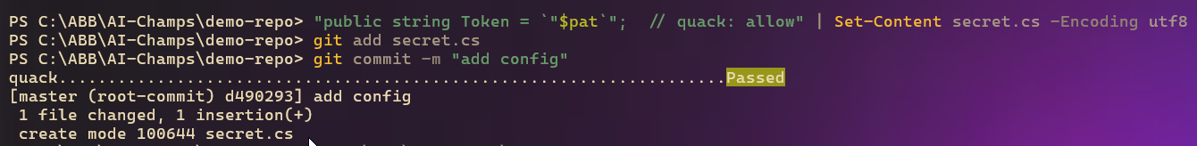
Verified: both hook types installed on a fresh repo (0.7s runtime for the blocked commit), the same-line // quack: allow marker on a C# comment successfully overrides the secret block, matching the language-agnostic marker-matching design.

PAT detection in a Multi-line file : Proves that there is no “easy” search of secrets but actual detection
PS C:\ABB\AI-Champs\GraphicsEditor.Core> quack check
╭─ quack - 2 file(s) - +16/-1 - 1.4s ─────────────────────────────────────────────╮
│ ✗ secrets src/GraphicsEditor.Core/AdoSettings.cs:12 Azure DevOps PAT │
│ ─────────────────────────────────────────────────────────────────────────────── │
│ 🐤 QUACK!!!! │
╰─ 🐤 BLOCKED - fix and re-stage ─────────────────────────────────────────────────╯
PS C:\ABB\AI-Champs\GraphicsEditor.Core> git status --short
A src/GraphicsEditor.Core/AdoSettings.cs
M src/GraphicsEditor.Core/RectTransform.cs
PS C:\ABB\AI-Champs\GraphicsEditor.Core> Get-Content src\GraphicsEditor.Core\AdoSettings.cs
namespace GraphicsEditor.Core;

/// <summary>
/// Configuration for the Azure DevOps work item integration.
/// </summary>
public static class AdoSettings
{
public const string Organization = "abb-pa";
public const string Project = "GraphicsEditor";

// TODO: move to secure storage before merging
public const string AccessToken = "kx7fq2mn4vp3rs6tw4yb2zc7de5gh3jl2np6qr4st7uv3wx5yz4b";

public static string ApiBase => $"https://dev.azure.com/{Organization}/{Project}";
}
PS C:\ABB\AI-Champs\GraphicsEditor.Core> git reset src/GraphicsEditor.Core/RectTransform.cs
Unstaged changes after reset:
M src/GraphicsEditor.Core/RectTransform.cs
PS C:\ABB\AI-Champs\GraphicsEditor.Core> git checkout src/GraphicsEditor.Core/RectTransform.cs
Updated 1 path from the index
PS C:\ABB\AI-Champs\GraphicsEditor.Core> git status --short
A src/GraphicsEditor.Core/AdoSettings.cs
PS C:\ABB\AI-Champs\GraphicsEditor.Core> $lines = @(
>> 'namespace GraphicsEditor.Core;'
>> ''
>> '/// <summary>'
>> '/// Configuration for the Azure DevOps work item integration.'
>> '/// </summary>'
>> 'public static class AdoSettings'
>> '{'
>> ' public const string Organization = "abb-pa";'
>> ' public const string Project = "GraphicsEditor";'
>> ''
>> ' // TODO: move to secure storage before merging'
>> ' public const string AccessToken = "kx7fq2mn4vp3rs6tw4yb2zc7de5gh3jl2np6qr4st7uv3wx5yz4b";'
>> ''
>> ' public static string ApiBase => $"https://dev.azure.com/{Organization}/{Project}";'
>> '}'
>> )
(dummy PAT)**

Case 6 : Single-file test guidance and risk verdict (PG2)
Repo: PG2 Setup: reset the demo branch to origin/main, reinstalled hooks locally, then made a one-line validation change in KernelGraphicsAdapter.cs.
PS ...\PCP.Operations.HMI.Engineering.Graphics> git checkout quack-demo-do-not-merge
Already on 'quack-demo-do-not-merge'
Your branch is based on 'origin/quack-demo-do-not-merge', but the upstream is gone.
PS ...> git reset --hard origin/main
HEAD is now at eecd5ff Dependency path changed (#66)
PS ...> quack install --local
...
quack: pre-commit hook installed
quack: pre-push hook installed
quack: gitleaks already installed
PS ...> git branch --unset-upstream
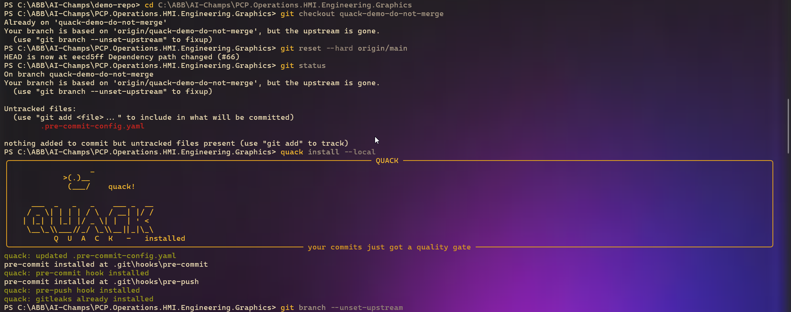
First quack check before AI review has run:
PS ...> git add packages/GraphicsModelEditor/FabricWasmHost/KernelGraphicsAdapter.cs
PS ...> quack check
╭─ quack - 1 file(s) - +1/-1 - 1.8s ─────────────────────────────────────────────╮
│ Test guidance │
│ dotnet test packages/GraphicsModelEditor/GfxKernel.Tests/GfxKernel.Tests.csproj│
│ --no-build --filter "FullyQualifiedName~KernelGraphicsAdapterTests" │
│ (first run: build once with dotnet build) │
│ ────────────────────────────────────────────────────────────────────────────── │
│ AI review: not reviewed yet - run `quack watch` to review in the background │
╰─ advisory: commit allowed ─────────────────────────────────────────────────────╯
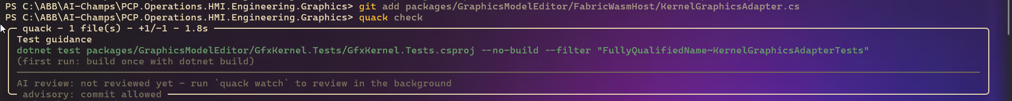
After running quack watch --once:
PS ...> quack watch --once
reviewed 1 file(s) - risk: high
PS ...> quack check
╭─ quack - 1 file(s) - +1/-1 - 1.7s ─────────────────────────────────────────────╮
│ Test guidance │
│ dotnet test .../GfxKernel.Tests.csproj --no-build --filter │
│ "FullyQualifiedName~KernelGraphicsAdapterTests" │
│ ────────────────────────────────────────────────────────────────────────────── │
│ AI - claude-haiku-4.5 - risk: HIGH │
│ Validation weakened from exact-match to 'at-least-as-long'—verify downstream │
│ code handles unequal lengths. │
│ Line 50: validation boundary changed from `!=` (exact match) to `<` │
│ (allows longer modelIndexes) │
│ Semantic change on error path: what input now passes validation is different│
│ Downstream code may assume modelIndexes and selectedItems have equal length; │
│ unequal lengths risk silent failures or index errors │
│ (reviewed 2 sec ago by quack watch) │
╰─ advisory: commit allowed ─────────────────────────────────────────────────────╯
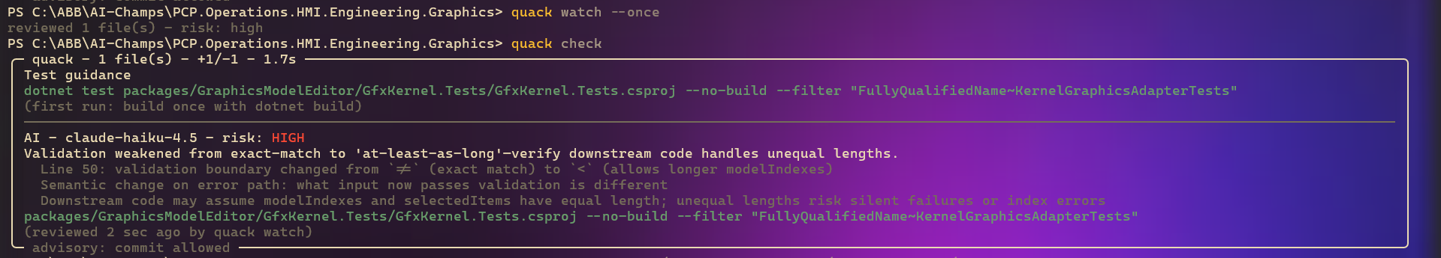
Verified: correct cross-package test-guidance resolution (source in FabricWasmHost/, tests in the sibling GfxKernel.Tests/ package), instant re-read of the cached review on the second quack check (“reviewed 2 sec ago by quack watch”), and a deterministic rubric line (“boundary/index/limit” style reasoning) accompanying the LLM verdict. The qualitative risk bucket (HIGH) is LLM-generated (claude-haiku-4.5); only the deterministic rubric floor (e.g. boundary/index/limit detection) is guaranteed consistent across runs.
The change was then reverted and reapplied identically to stage the demo commit:
PS ...> git reset packages/.../KernelGraphicsAdapter.cs
PS ...> git checkout packages/.../KernelGraphicsAdapter.cs
PS ...> git add packages/.../KernelGraphicsAdapter.cs
PS ...> git commit -m "demo: intentional regression for quack demonstration"
quack....................................................................Passed
[quack-demo-do-not-merge b612611] demo: intentional regression for quack demonstration
1 file changed, 1 insertion(+), 1 deletion(-)
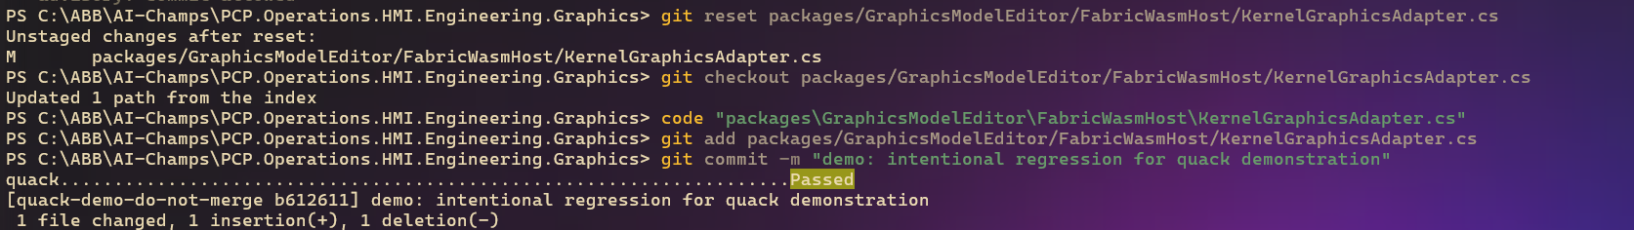

Case 7 : Pre-push hook: first push has nothing to analyze
PS ...> git push -u origin quack-demo-do-not-merge
quack-agent..............................................................Passed
- hook id: quack-agent
- duration: 1.68s
nothing to analyze: no staged changes and nothing unpushed
...
* [new branch] quack-demo-do-not-merge -> quack-demo-do-not-merge
branch 'quack-demo-do-not-merge' set up to track 'origin/quack-demo-do-not-merge'.
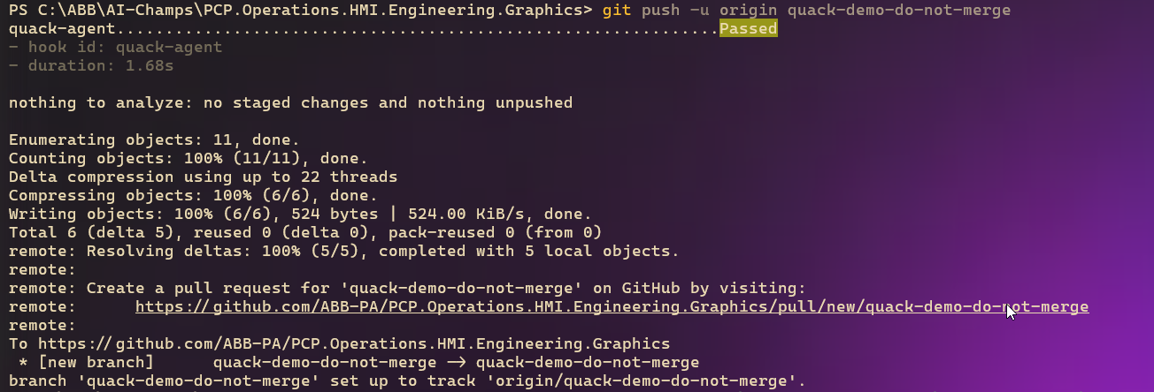
Verified: confirms the known limitation — a first push of a brand-new branch has no local-vs-upstream diff for the agent to analyze, so it reports “nothing to analyze” and passes in 1.68s.

Case 8 : Pre-push hook on a real second push: tool-calling degrades gracefully
PS ...> git commit -m "demo: second intentional regression"
quack....................................................................Passed
[quack-demo-do-not-merge 5264731] demo: second intentional regression
1 file changed, 2 insertions(+), 2 deletions(-)
PS ...> git push
quack-agent..............................................................Passed
- hook id: quack-agent
- duration: 22.98s
analyzing 1 unpushed commit(s)
reviewing changes...
AI - claude-haiku-4.5 - risk: MEDIUM
Move validation loosened and error cleanup added—verify callers expect >= length match and error recovery works.
BeginMove validation constraint relaxed from equality (!=) to less-than (<) on
modelIndexes array length — allows previously-rejected inputs
RestoreMouseDelegates() added to error path at line 115 — unclear if this was
missing cleanup or intentional omission
boundary/index/limit logic touched
investigating changes...
AI analysis unavailable: tool calling not supported on copilot_sdk provider. Verify the staged changes manually before pushing.
...
To https://github.com/ABB-PA/PCP.Operations.HMI.Engineering.Graphics
b612611..5264731 quack-demo-do-not-merge -> quack-demo-do-not-merge
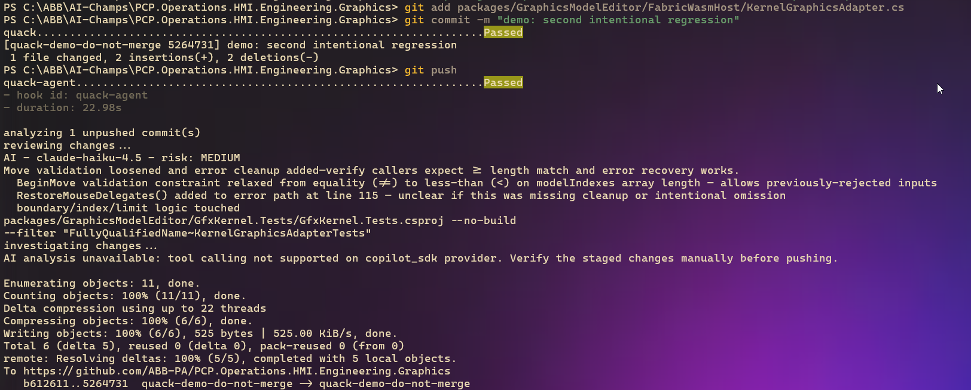
Verified: the pre-push agent analyzed the unpushed commit (22.98s), produced a MEDIUM verdict with deterministic rubric line, then hit the tool-calling investigation step which degraded with the exact message AI analysis unavailable: tool calling not supported on copilot_sdk provider. Verify the staged changes manually before pushing. — matching src/quack/providers/copilot_sdk.py byte-for-byte — and the push still completed without being blocked.
The 22.98s is consistent with the pre-push path being advisory-only (unlike commit-time, which reads a pre-computed cache): it makes a live copilot_sdk completion call plus an attempted tool-calling investigation step, and round-trip latency to that SDK has been observed in the 10–26s range, so this duration is expected rather than anomalous.

Case 9 : Copilot CLI-generated refactor, multi-file diff, cached watch review
Repo: PG2 Setup: reset to origin/main, then used the copilot CLI to extract a mouse-delegate lifecycle into a new IDisposable scope, touching source, tests, a new class, and generating a docs file.
PS ...> git reset --hard origin/main
HEAD is now at eecd5ff Dependency path changed (#66)
PS ...> copilot
Changes +107 -32
AI Credits 114 (52m 55s)
Tokens ↑ 1.7m (1.5m cached, 168.9k written) • ↓ 15.7k (7.3k reasoning)
PS ...> git status --short
M packages/GraphicsModelEditor/FabricWasmHost/KernelGraphicsAdapter.cs
M packages/GraphicsModelEditor/GfxKernel.Tests/KernelGraphicsAdapterTests.cs
?? .pre-commit-config.yaml
?? packages/GraphicsModelEditor/FabricWasmHost/KernelMouseDelegateScope.cs
?? packages/widgets/GraphicsModelEditor/Docs/refactor/
PS ...> git diff --stat
.../FabricWasmHost/KernelGraphicsAdapter.cs | 38 ++++++---------------
.../GfxKernel.Tests/KernelGraphicsAdapterTests.cs | 39 ++++++++++++++++++++++
2 files changed, 50 insertions(+), 27 deletions(-)
PS ...> git add -A
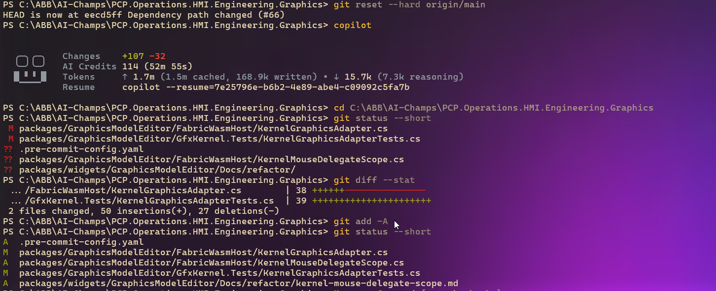
Commit-time performance, measured directly:
PS ...> Measure-Command { quack check }
TotalSeconds : 2.9667864
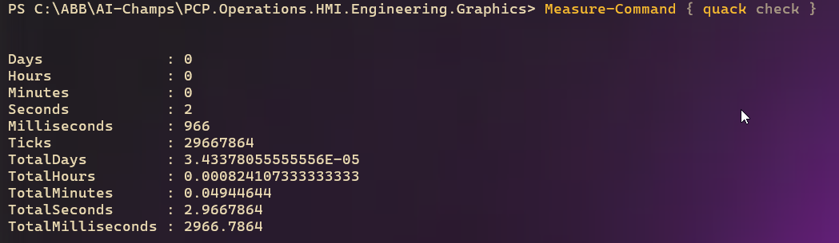
quack check before review, then after quack watch --once, then after a second quack watch pass:
PS ...> quack check
╭─ quack - 5 file(s) - +118/-27 - 1.7s ──────────────────────────────────────────╮
│ Test guidance │
│ dotnet test .../GfxKernel.Tests.csproj --no-build --filter │
│ "FullyQualifiedName~KernelGraphicsAdapterTests|KernelMouseDelegateScopeTests" │
│ ────────────────────────────────────────────────────────────────────────────── │
│ AI review: not reviewed yet - run `quack watch` to review in the background │
╰─ advisory: commit allowed ─────────────────────────────────────────────────────╯
PS ...> quack watch --once
reviewed 5 file(s) - risk: medium
PS ...> quack check
╭─ quack - 5 file(s) - +118/-27 - 1.8s ──────────────────────────────────────────╮
│ ... │
│ AI - claude-haiku-4.5 - risk: MEDIUM │
│ Delegate lifecycle extracted cleanly into IDisposable scope; no behavior │
│ change, test covers capture→update→restore→dispose cycle. │
│ state/concurrency-sensitive logic changed │
│ (reviewed 2 sec ago by quack watch) │
╰─ advisory: commit allowed ─────────────────────────────────────────────────────╯
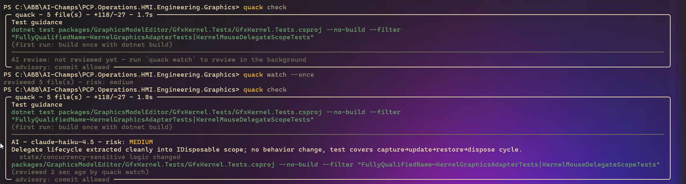
PS ...> quack watch
reviewed 5 file(s) - risk: medium
PS ...> quack check
╭─ quack - 5 file(s) - +118/-27 - 1.7s ──────────────────────────────────────────╮
│ ... │
│ AI - claude-haiku-4.5 - risk: MEDIUM │
│ Refactor extracts mouse delegate lifecycle into an IDisposable scope—no │
│ behavior change, improved disposal guarantee, and new scope is tested. │
│ state/concurrency-sensitive logic changed │
│ (reviewed 58 sec ago by quack watch) │
╰─ advisory: commit allowed ─────────────────────────────────────────────────────╯
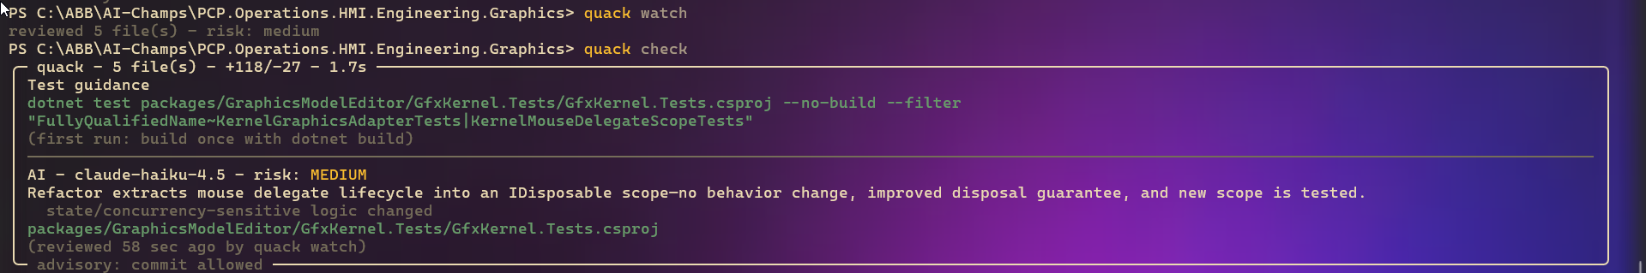
Verified: multi-project test filter correctly combined two test classes (KernelGraphicsAdapterTests|KernelMouseDelegateScopeTests) into a single dotnet test command; commit-time cost measured at ~2.97s wall time via Measure-Command, with quack check itself reporting 1.7–1.8s; the cached review was reused across repeated invocations (“reviewed 2 sec ago” then “reviewed 58 sec ago”), each time producing a consistent MEDIUM verdict for the same diff.

Case 10 : Cleanup: branch delete blocked, then unblocked, then full uninstall
PS ...> git reset --hard origin/main
HEAD is now at eecd5ff Dependency path changed (#66)
PS ...> git clean -fd
PS ...> git push origin --delete quack-demo-do-not-merge
No .pre-commit-config.yaml file was found
- To temporarily silence this, run `PRE_COMMIT_ALLOW_NO_CONFIG=1 git ...`
error: failed to push some refs to 'https://github.com/ABB-PA/PCP.Operations.HMI.Engineering.Graphics'
PS ...> $env:PRE_COMMIT_ALLOW_NO_CONFIG = "1"
PS ...> git push origin --delete quack-demo-do-not-merge
`.pre-commit-config.yaml` config file not found. Skipping `pre-commit`.
To https://github.com/ABB-PA/PCP.Operations.HMI.Engineering.Graphics
- [deleted] quack-demo-do-not-merge
PS ...> Remove-Item Env:\PRE_COMMIT_ALLOW_NO_CONFIG
PS ...> pre-commit uninstall
pre-commit uninstalled
PS ...> pre-commit uninstall --hook-type pre-push
pre-push uninstalled
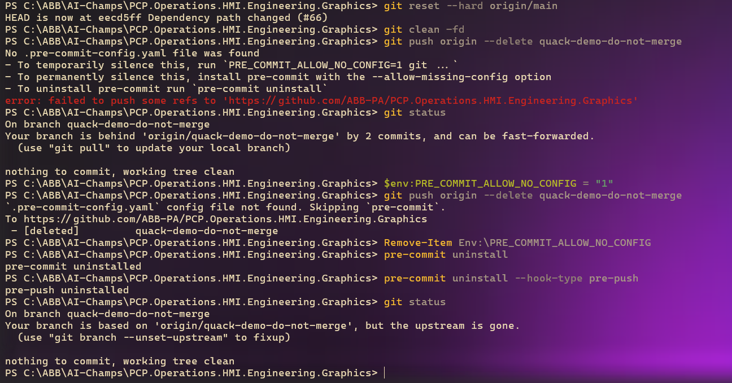
Verified: after git clean -fd removed the untracked .pre-commit-config.yaml, the pre-push hook script itself refused to run (since pre-commit’s installed hook still checks for a config file) and blocked the branch-delete push until PRE_COMMIT_ALLOW_NO_CONFIG=1 was set.
This is a real, reproducible edge case: deleting the config file without uninstalling the git hooks first leaves a hook binary in .git/hooks/ that still enforces a check it can no longer configure. pre-commit uninstall (both hook types) fully restored the repo to an unhooked state.
Case 11 : ‘quack metrics’ reports aggregated local counts only
PS C:\ABB\AI-Champs\PCP.Operations.HMI.Engineering.Graphics> quack metrics
Total runs: 67
Runs by command: agent=6, check=45, watch=16
Blocks: 9
Most common findings: secrets=9
Median duration: 1712 ms
Cache hit rate: 35.6%
Verified: `quack metrics` aggregates local run history across all three commands (`agent`, `check`, `watch`) into counts, durations, and enums only — no file paths, diff content, or code snippets.
Across 67 recorded runs, 9 were blocked, all attributable to the `secrets` finding, with a median duration of 1712 ms and a 35.6% cache hit rate (lower than a fresh-repo session, consistent with a longer-lived working history containing a mix of first-time and repeat reviews).

