**Problem Statement and Motivation**

**Real-time scenario:**

You have joined as a DevOps engineer in XYZ Pvt. Ltd. It is a platform where individuals can create their profile and start blogging on various topics. The application is ready to be hosted on a server.

You are tasked with implementing an Ansible script to deploy this application on a remote Nginx server.

# Step1. Creating inventory / host file

localhost

[node1]

192.168.0.170 # node1 centos

[node2]

192.168.0.171 # node2 kali

# Step2. Write the playbook

Main.yml

---

- name: Deploy application on Nginx server

hosts: node2

become: yes

tasks:

- name: Install Nginx

apt:

name: nginx

state: present

#update_cache: yes

- name: Start and enable Nginx service

systemd:

name: nginx

state: started

enabled: yes

- name: copy the web file into the hosts

copy:

src: ./index.html

dest: /var/www/html/

- name: configure nginx

template:

src: ./nginx_config.j2

dest: /etc/nginx/sites-available/default

- name: test nginx configuration

command: nginx -t

register: nginx_test

- name: display the output of nxgin test

debug:

var: nginx_test

- name: reload nginx

systemd:

name: nginx

state: reloaded

# Step3. Creating J2 (jinja2 template)

nginx_config.j2

server {

listen 80;

server_name node2; # 192.168.0.171

location / {

root /var/www/html;

index index.html index.htm;

}

}

# Step4. Web application sample

**Index.html**

<!DOCTYPE html>

<html>

<head>

<meta charset="UTF-8" />

<title>Ansible Lab</title>

</head>

<body>

<h1> This is the demo of using Ansible to install nginx <br>and depolying the web application.

</h1>

<h2>This is the first project from Simplilearn about CM - Ansible</h2>

</body>

</html>

# Step5. Run playbook / Ansible commands

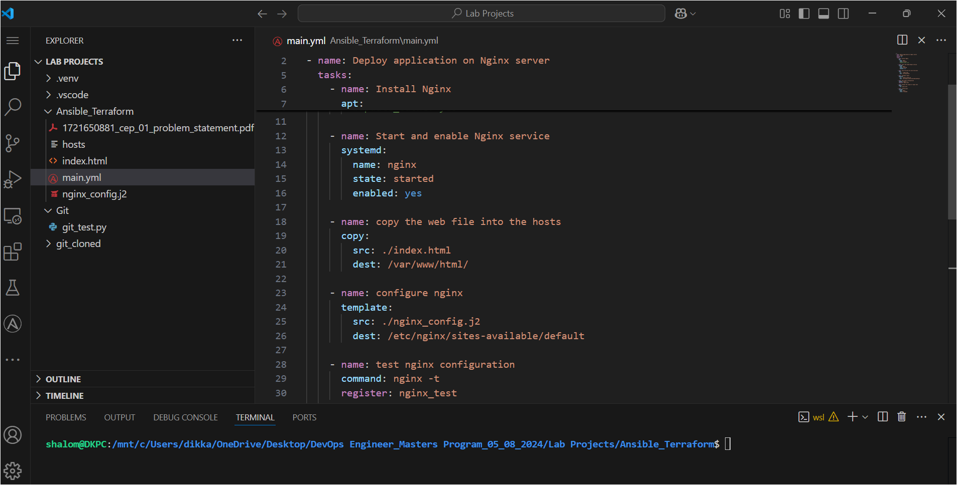 ansible-playbook –i hosts –b –k –K main.yml

