MINISTRY OF EDUCATION AND SCIENCE OF UKRAINE

NATIONAL TECHNICAL UNIVERSITY

"KHARKIV POLYTECHNICAL INSTITUTE"

Department of Computer Engineering and Programming

«Software Means of Information Protection »

*Laboratory work report No 3*

*Topic: «* *Protect software from unauthorized use and copying»*

Student:

Group. KH 919 i.e.

Okechukwu Chukwuemeka Onyekwere-Dike

Verified by:

Lecturer Viktor CHELAK

Kharkiv – 2022

***Purpose of work:***

Development of a program for software installation with security features.

***Individual task:***

Variant 8:

Development of a program for software installation with security features:

1. Keyboard type and subtype.
2. Screen width
3. Set of device’s disk
4. Amount of data about the disk on which the program is installed

***Algorithm of the program:***

*#installer program:*

The program is a program installer of the previous laboratory work. That, asks the user for a destination folder to install the program.

The installer writes there the executable code of the program in its needed DLL files. Also, we collect information about device in which the program is installed. The information are written in HKEY_CURRENT_USER section in form of key.

For that purpose, in click event of the install button we first verify if a path is selected if not we simply show a message box with an error. Then, we begin with the installation process which is rewriting files in debug folder in selected path and automatically create a folder with the name “Lab3” that will contain all needed files. After that, we begin with creating a key for app protection and save it in registry with student’s last name.

*#protected program:*

In the protected program we ask user to input the name of the undressed registry (student's last name) using an input box in load form event. Then, if the name if correct the program generates a key with same parameters it can only change if its path changed, if the generated key is correct the application proceed to authentication form, if not it displays a message box with information collected.

***Screenshots of the program***:

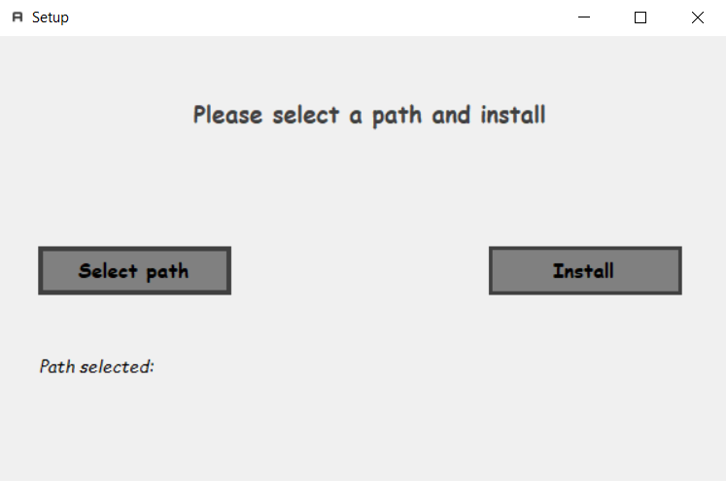

*Figure 1 – Installer program*

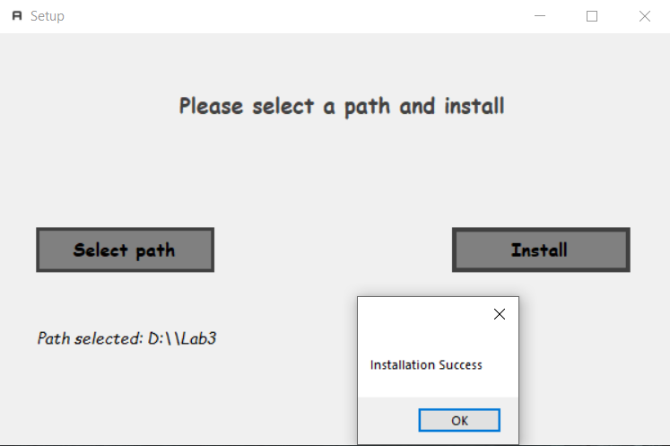

*Figure 2 – Selecting path and install*

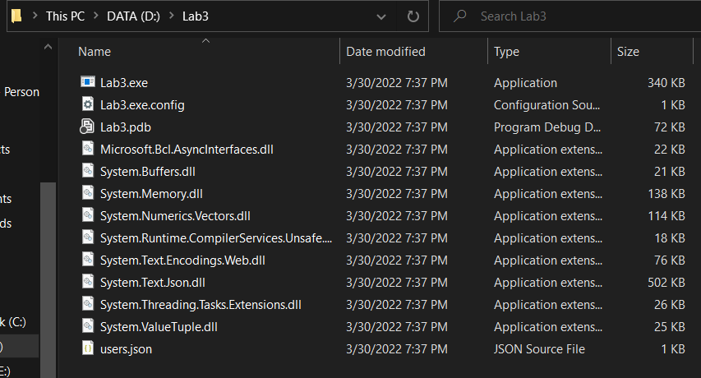

*Figure 3 – Installation directory*

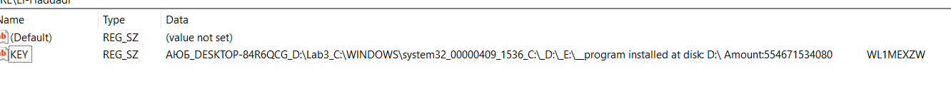

*Figure 4 – Key in Registry editor*

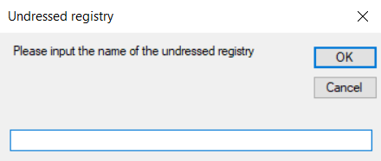

*Figure 5 – Protected app: input box*

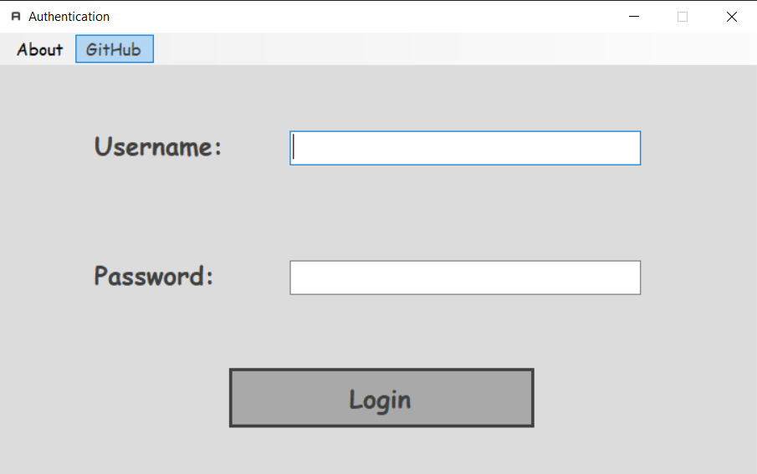

*Figure 6 – Protected program after verification success*

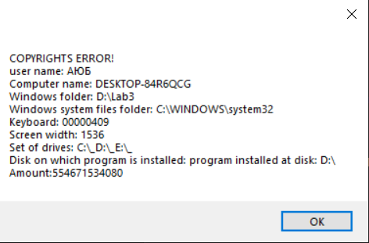

*Figure 7– Verification failure*

**Source Code:**

[*https://github.com/Elh-Ayoub/SMoIP_Labs/tree/main/Lab3*](https://github.com/Elh-Ayoub/SMoIP_Labs/tree/main/Lab3)

**Conclusions:**

For this laboratory work, I have gained principles of developing a program for software installation with security features: Protecting from unauthorized use and copying.