Sequence Alignment with Nextclade, Phylogeny with IQ-TREE, and Visualization in FigTree & Microreact

1. Scope & prerequisites
- You have a FASTA file of sequences.
- You can use a terminal (Linux/macOS/Ubuntu on Windows).
- You have internet access.

Software
Tool | How to get it | Version notes
Nextclade CLI | https://clades.nextstrain.org/
IQ-TREE 2 | conda: mamba install -c bioconda iqtree | iqtree2 binary (invoked as iqtree2)
FigTree | download: https://github.com/rambaut/figtree/releases | Desktop app; use for local tree styling/export
Microreact (web) | https://microreact.org/ | Create projects; upload tree + metadata CSV

2. Nextclade: dataset + alignment + QC

2.1 Run Nextclade on your sequences
- Go to the Nextclade website → choose SARS-CoV-2 (dataset usually selected by default).
- Click “Upload” (or drag-and-drop) your FASTA
- Overall QC: good / mediocre / bad — a quick pass/warn/fail signal.

Screenshot: Example of Nextclade interface

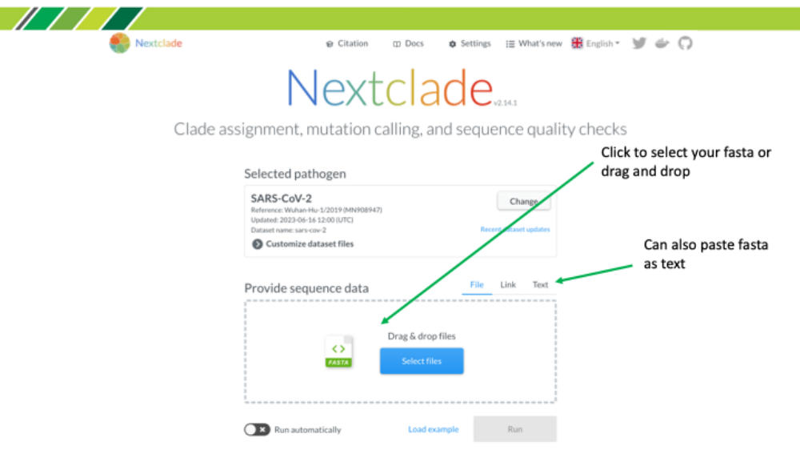
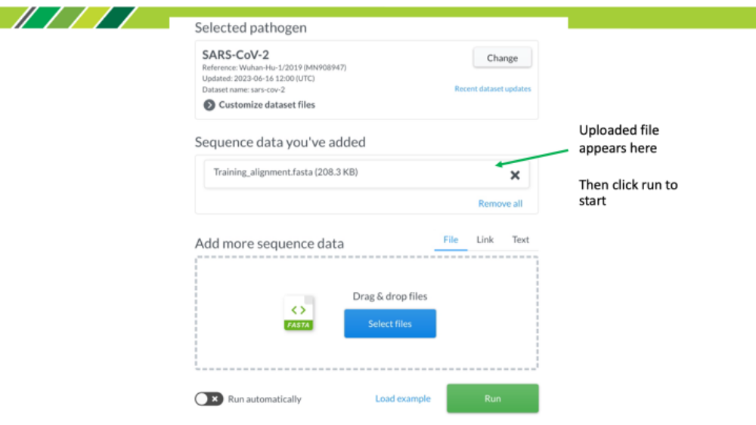
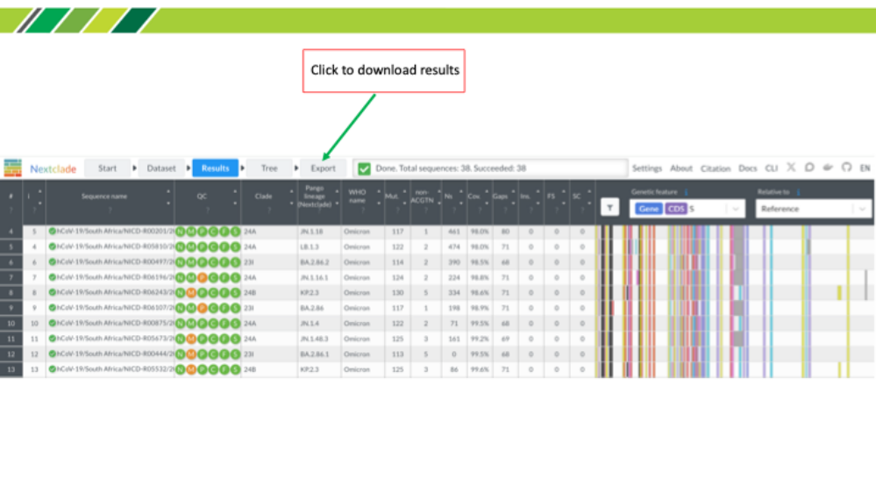

2.2 download files files
- Aligned FASTA: results/nextclade/nextclade.aligned.fasta
- QC & annotations TSV: results/nextclade/nextclade.tsv
- Optional JSON for Auspice: results/nextclade/nextclade.auspice.json
- The aligned FASTA is what we’ll use for tree building (IQ-TREE).
- The TSV has per-sample QC and annotation; keep it for Microreact metadata.
- If Nextclade flags sequences as bad (e.g., too many Ns), remove or fix before tree building.
- Cleanup (recommended): remove low quality sequences; trim leading/trailing regions etc.
- Save aligned sequences in working directory
mkdir phylogeny

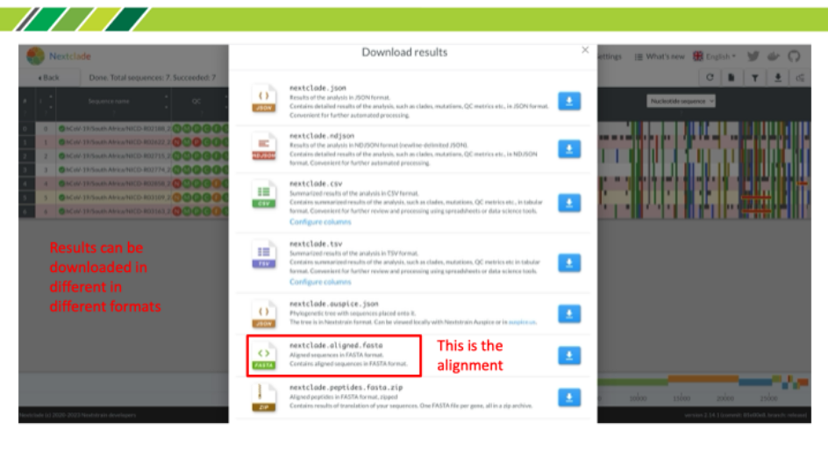

3. IQ-TREE: maximum-likelihood phylogeny (command line)

3.1 Basic IQ-TREE run
Use the aligned FASTA from Nextclade. IQ-TREE 2 will auto-select a nucleotide model (MF) unless you specify one. Common explicit choice: GTR+G.
iqtree2 -s phylogeny/nextclade.aligned.fasta -m MF -alrt 1000
Outputs (in the same folder as the alignment unless -pre is used):
- *.treefile — Newick tree (main file to visualize and upload)
- *.iqtree — run report (model, scores, supports)
- *.log — run log

Example of a command with a specific model chosen:
iqtree2 -s results/nextclade/nextclade.aligned.fasta -m GTR+G -bb 1000 -alrt 1000 -nt AUTO -pre results/phylogeny/run1
Tips:
- -bb 1000 runs ultrafast bootstrap (UFboot); -alrt 1000 adds SH-aLRT supports.
- -nt AUTO uses all available cores (adjust per cluster policy).

4. FigTree: local visualization & export
- Open FigTree and load the Newick tree (*.treefile).
- Root the tree (e.g., midpoint or specific outgroup, if appropriate).
- Display node support (UFboot and/or SH-aLRT).
- Style tips: color by clade or metadata, adjust tip labels, time-scale if relevant.
- Export a PNG/SVG/PDF figure for slides or reports.

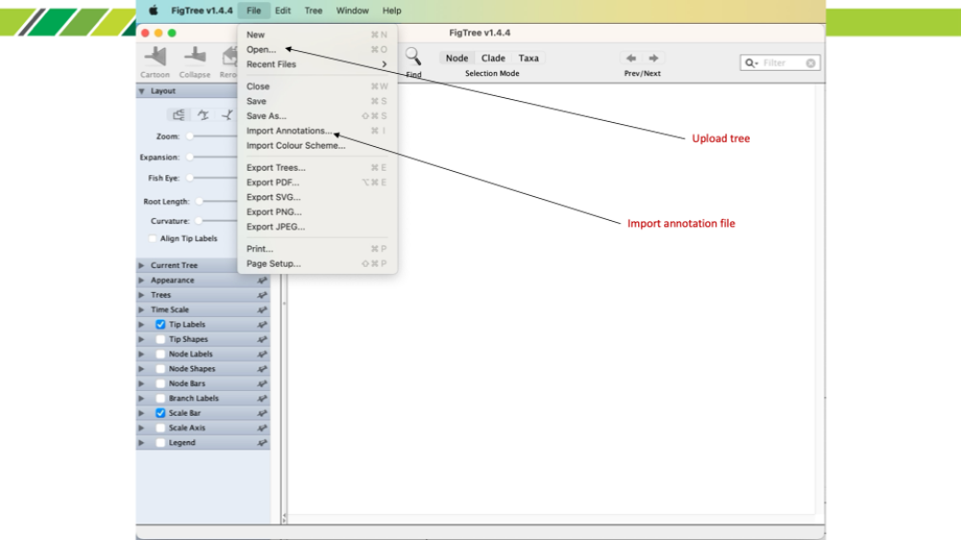

5. Microreact: share an interactive tree + metadata
Microreact lets you host an interactive tree with filters and maps. You’ll need the Newick tree and a metadata CSV.

5.1 Prepare metadata from Nextclade TSV
Create a simple metadata CSV with at least a 'sample' column matching sequence names in the alignment, plus fields you want to visualize (e.g., clade, qc.overallStatus, country, date).
Ensure 'seqName' matches the tip labels in your Newick tree. Rename the column to 'sample' if desired.

5.2 Create a Microreact project
- Go to https://microreact.org/ and sign in.
- Create a new project → upload your Newick tree (*.treefile) and metadata CSV.
- Map the ID column (sample/seqName) to tree tip labels when prompted.
- Customize views: color by clade or QC status; add filters; save and share the project URL.

6. Quality checks & troubleshooting

6.1 Common issues
- Names mismatch: Tip labels in the tree must exactly match metadata IDs (spaces/case matter).
- Low-quality sequences: Remove sequences with failing QC before IQ-TREE.
- Gaps/ambiguous bases: Very gappy alignments can lead to odd trees—consider masking problematic sites if recommended by your dataset.
- Long runtimes: For large datasets, drop bootstrap to 100–500 for drafts, then scale up.

6.2 Reproducibility tips
- Record software versions: nextclade --version; iqtree2 -version.
- Keep commands in a script (e.g., scripts/run.sh) and save environment.yml for conda.
- Store output folders with a run date or git tag.

