# | Test Feature | Expected Results | Actual Results | Status | Comment
Test 1 | LEFT: Top Menu Bar
L 1.1 | Background Colour | e6c36e | e6c462 | Pass Fail | Issue #1
Test 2 | LEFT: Divider Line below Photo Slider
L 2.1 | Line Colour | dcd7d3 | dcd7d3 | Pass Fail
L 2.2 | Line Height | 6px | 5px | Pass Fail | Issue #2
Test 3 | LEFT: Divider Line below Videos
L 3.1 | Line Colour | c8c8c8 | d8d8d8 | Pass Fail | Issue #3
L 3.2 | Line Height | 1px | .85px | Pass Fail | Issue #4
Test 4 | LEFT: “Glimpses of Exhibition” Text
L 4.1 | Font | Droid Serif, Bold | Droid Serif, Bold | Pass Fail
L 4.2 | Font Colour | 333333 | 404040 | Pass Fail | Issue #5
L 4.3 | Font Size | 16px | 1rem = 16px | Pass Fail
Test 5 | LEFT: “Exhibition” Photo Label Text
L 5.1 | Font | Arial, Regular | Arial, Regular | Pass Fail
L 5.2 | Font Colour | 044e8e | 0089ff | Pass Fail | Issue #6
L 5.3 | Font Size | 13px | 13px | Pass Fail
Test 6 | LEFT: “Latest Tweet” Box
L 6.1 | Border-Left Colour | e6c36e | e6c370 | Pass Fail | Issue #7
Test 7 | LEFT: “Tweets” Text
L 7.1 | Font | Arial, Regular | Arial, Regular | Pass Fail
L 7.2 | Font Colour | 333333 | 404040 | Pass Fail | Issue #8
L 7.3 | Font Size | 13px | 13px | Pass Fail
L 7.4 | Line Height | 20px | 19.5px | Pass Fail | Issue #9
Test 8 | LEFT: “Pages” Header Text
L 8.1 | Font | Droid Serif, Bold | Arial, Bold | Pass Fail | Issue #10
L 8.2 | Font Colour | 333333 | 404040 | Pass Fail | Issue #11
L 8.3 | Font Size | 16px | 16px | Pass Fail
Test 9 | LEFT: “Pages” Links Text
L 9.1 | Font | Arial, Regular | Arial, Regular | Pass Fail
L 9.2 | Font Colour | 333333 | 000000 | Pass Fail | Issue #12
L 9.3 | Font Size | 13px | 13px | Pass Fail
L 9.4 | Line Height | 26px | 15px | Pass Fail | Issue #13
Test 10 | CENTER: Top Menu Bar Text
C 10.1 | Font | Arial, Bold | Arial, Bold | Pass Fail
C 10.2 | Font Colour | 333333 | 111111 | Pass Fail | Issue #14
C 10.3 | Font Size | 12px | 11px | Pass Fail | Issue #15
Test 11 | CENTER: Bottom “Disclaimer” Text
C 11.1 | Font | Lorem Ipsum, Regular | Arial, Regular | Pass Fail | Issue #16
C 11.2 | Font Colour | ffffff | ecdeaf | Pass Fail | Issue #17
C 11.3 | Font Size | 12px | 11px | Pass Fail | Issue #18
C 11.4 | Line Height | 16px | 15px | Pass Fail | Issue #19

# | Test Feature | Expected Results | Actual Results | Status | Comment
Test 12 | RIGHT: Top “Contact” Text
R 12.1 | Font | Arial, Bold | Arial, Bold | Pass Fail
R 12.2 | Font Colour | 333333 | 111111 | Pass Fail | Issue #20
R 12.3 | Font Size | 12px | 13px | Pass Fail | Issue #21
Test 13 | RIGHT: “Welcome to rtPanel” Header Text
R 13.1 | Font | Droid Serif, Bold | Arial, Bold | Pass Fail | Issue #22
R 13.2 | Font Colour | b9a071 | c7a84b | Pass Fail | Issue #23
R 13.3 | Font Size | 22px | 24px | Pass Fail | Issue #24
Test 14 | RIGHT: “Welcome to rtPanel” Text
R 14.1 | Font | Arial, Regular | Arial, Regular | Pass Fail
R 14.2 | Font Colour | 333333 | 404040 | Pass Fail | Issue #25
R 14.3 | Font Size | 14px | 13px | Pass Fail | Issue #26
Test 15 | RIGHT: “Welcome to rtPanel” Box Colour
R 15.1 | Background Colour | eeeaeb | ded6d1 | Pass Fail | Issue #27
Test 16 | RIGHT: “Read More” Text
R 16.1 | Font | Arial, Bold | New Times Roman | Pass Fail | Issue #28
R 16.2 | Font Colour | 91794a | 91794a | Pass Fail
R 16.3 | Font Size | 14x | 13px | Pass Fail | Issue #29
Test 17 | RIGHT: “News” Banner
R 17.1 | Background Colour | f4eede | f4eed3 | Pass Fail
Test 18 | RIGHT: “News” Feature Text
R 18.1 | Font | Arial, Bold | Arial, Bold | Pass Fail
R 18.2 | Font Colour | 333333 | 000000 | Pass Fail | Issue #30
R 18.3 | Font Size | 13px | 12px | Pass Fail | Issue #31
Test 19 | RIGHT: “News” Links Text
R 19.1 | Font | Arial, Regular | Arial, Regular | Pass Fail
R 19.2 | Font Colour | 333333 | 000000 | Pass Fail | Issue #32
R 19.3 | Font Size | 14px | 16px | Pass Fail | Issue #33
R 19.4 | Line Height | 24px | 24px | Pass Fail
Test 20 | RIGHT: “More News” Text
R 20.1 | Font | Arial, Regular | Arial, Regular | Pass Fail
R 20.2 | Font Colour | 044e8e | 044e8f | Pass Fail | Issue #34
R 20.3 | Font Size | 13px | 15px | Pass Fail | Issue #35
Test 21 | RIGHT: Date Text
R 21.1 | Font | Arial, Regular | Arial, Regular | Pass Fail
R 21.2 | Font Colour | 333333 | 404040 | Pass Fail | Issue #36
R 21.3 | Font Size | 16px | 16px | Pass Fail
Test 22 | RIGHT: Time Text
R 22.1 | Font | Droid Serif | New Ties Roman | Pass Fail | Issue #37
R 22.2 | Font Colour | 333333 | 333333 | Pass Fail
R 22.3 | Font Size | 60px | 57px | Pass Fail | Issue #38

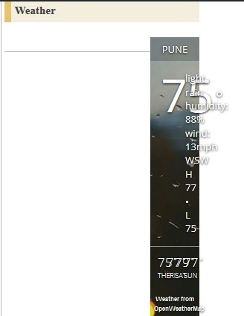  # | Test Feature | Expected Results | Actual Results | Status | Comment
Test 23 | RIGHT: “Terms/Privacy” Text
R 23.1 | Font | Arial, Regular | Arial, Regular | Pass Fail
R 23.2 | Font Colour | 333333 | 000000 | Pass Fail | Issue #39
R 23.3 | Font Size | 12px | 13px | Pass Fail | Issue #40
R 23.4 | Line Height | 20px | 15px | Pass Fail | Issue #42
Test 24 | Bottom “Pages” Panel Position | Lower-left “Pages” panel should be vertically aligned with center and right lower panels. | Page panel position is too low. | Pass Fail | Issue #41  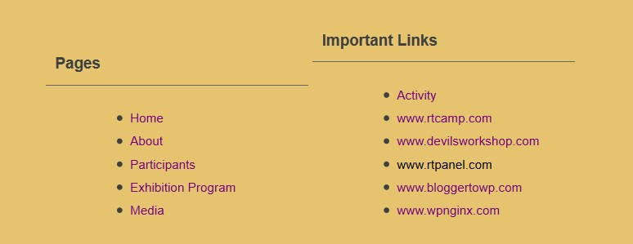
Test 25 | “News” Panel Bullets | Links should have 1 set of >> bullets | Links have double bullets: >> and •  Issue occurs on Firefox and Edge.  Chrome has correct bullets. | Pass Fail | Issue #43  
Test 26 | “Welcome to rtMedia” Header Spacing | Standard, even spacing between words | Extra spacing between words when resize window width | Pass Fail | Issue #44  
Test27 | Links alignment in “Pages” and “Important Links” panels | Links list should be Left-aligned, even with panel Headers | Links are indented | Pass Fail | 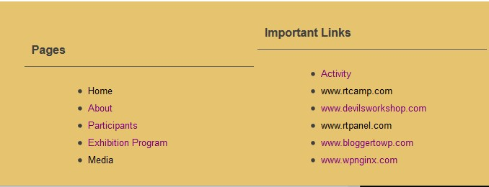  Issue #45
Test 28 | Weather Widget Sizing, Alignment | Width should match width of “Weather” banner. Display should fit properly in box. | Box is too narrow, causing display to wrap, illegible. | Pass Fail | Issue #46 (image rotated)
# | Test Feature | Expected Results | Actual Results | Status | Comment
Test 30 | “News” Links in News panel | Each link should work | Each link opens | Pass Fail
Test 31 | “More News” link in News panel | Link should work | Link is unresponsive | Pass Fail | Issue #47
Test 32 | “Facebook” Links | Links should work | Links open Facebook login page | Pass Fail
Test 33 | Pages Links in bottom panel
33.1 | Home link | Links should open to specified pages | Link opens | Pass Fail
33.2 | About | Links should open to specified pages | Link doesn’t open. Redirects to top menu | Pass Fail | Issue #48
33.3 | Participants link | Links should open to specified pages | Link doesn’t open. Redirects to top menu | Pass Fail | Issue #49
33.4 | Exhibition Program link | Links should open to specified pages | Link doesn’t open. Redirects to top menu | Pass Fail | Issue #50
33.5 | Media link | Links should open to specified pages | Link opens | Pass Fail
Test 34 | “Important Links” in bottom panel should open to specified page
34.1 | Activity link | Link should open | Opens Activity page | Pass Fail
34.2 | RtCamp.com link | Link should open | Opens rtCamp page | Pass Fail
34.3 | Devilsworkshop.com link | Link should open | Unresponsive | Pass Fail | Issue #51
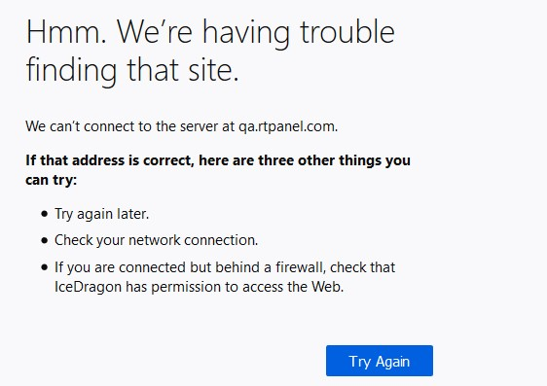  34.4 | RtPanel.com link | Link should open | Server Connect Error | Pass Fail | Issue #52
34.5 | Bloggertowp.com. link | Link should open | Unresponsive | Pass Fail | Issue #53
34.6 | Wpnginx.com link | Link should open | Unresponsive | Pass Fail | Issue #54
Test 35 | Video Links | Videos should work | Videos work | Pass Fail
Test 36 | Pictures Slider | Slider should work | Slider works | Pass Fail
Test 37 | “Home” Link | Link should work | Link works | Pass Fail
Test 38 | Top Menu Bar Links
38.1 | Activity Link | Link should work | Opens Activity | Pass Fail
38.2 | Participants | Link should work | Unresponsive | Pass Fail | Issue #55
38.3 | About Link | Link should work | Unresponsive | Pass Fail | Issue #56
38.4 | Exhibition Program | Link should work | Opens Enterprise | Pass Fail
38.5 | Media | Link should work | Opens Media | Pass Fail
38.6 | Travel Guide | Link should work | Unresponsive | Pass Fail | Issue #57
38.7 | Sponsorship | Link should work | Unresponsive | Pass Fail | Issue #58
38.8 | Guidelines | Link should work | Unresponsive | Pass Fail | Issue #59
38.9 | Visitor Corner | Link should work | Unresponsive | Pass Fail | Issue #60
Test 39 | Terms of Service Link | Link should work | Opens Privacy | Pass Fail | Issue #61
Test 40 | Privacy Link | Link should work | Unresponsive | Pass Fail | Issue #62
Test 39 | Activity Page – Upload Media  1. Add New Post  2. Click Comment on that post.  3. Click Media upload button.  4. Select File > file is displayed  5. Click ‘Post Update’ button.  > File does not post to Activity page | Media should be uploaded and displayed in comments on Activity page. | Media file uploads but does not post to the Activity page. File does post to Media, Photos/Video, All pages. | Pass Fail | Issue #63

