

Notes that match



Cut and match

Cut out the pieces.
Some pieces show one note. Some pieces show more than one note.
Match the pieces that have the same duration.




1 half
8 eighths



4 quarters
1 half



1 whole
1 whole

2 quarters
1 whole

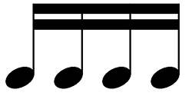

1 quarter + 2 eights
4 sixteenths



1 quarter
4 eighths + 1 half



