

Option D: Can you find the mistakes in this conversation?



Create your own band or orchestra

Read this conversation about Queen and circle the mistakes. Then, rewrite the dialogue with the corrections.

a) Read and circle the mistakes.
Yes, sure!
Do you know Queen?

No, they aren’t. They are Americans.
Are they a French pop rock band?
Are they a French pop rock band?
Are they a French pop rock band?

Yes, they are.
Are they a famous flamenco band?

Are they part of the Spanish culture?
No, they are part of the American culture.

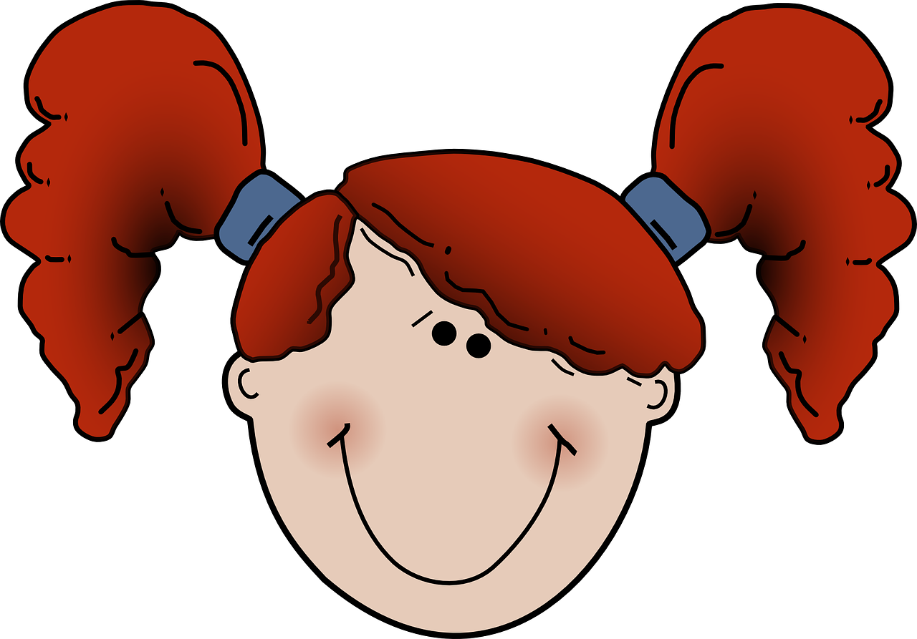
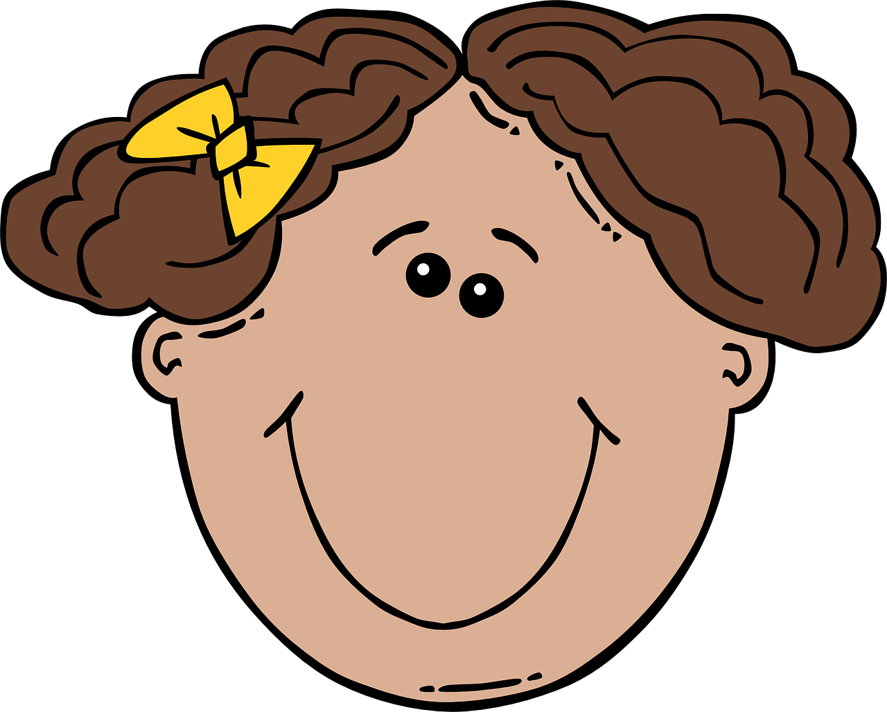

b) Rewrite the dialogues. Yo can add more speech bubbles and dialogues.

Comets
Comets
Asteroids
Asteroids

