

Queen: A legendary band



Queen: A legendary band

Queen was an English rock band formed in 1970. They are considered one of the best rock bands in recent history, with thousands of fans all over the world. They recorded several best-selling albums. They broke up in 1982.
MEMBERS OF THE GROUP
The members of the band are Freddie Mercury, Brian May, John Deacon, and Roger Taylor.
- Freddie Mercury was the leader of the band, singer and songwriter. He formed Queen in 1970 with Brian May and Roger Taylor.
He wrote numerous hits for Queen, such us "Bohemian Rhapsody", "Somebody to Love", "Don't Stop Me Now" and "We Are the Champions”
- Brian May was born in 1947. He was the guitarist of the rock band.

- John Deacon was the bass guitarist and songwriter for the band. He composed several singles for the group including "Another One Bites the Dust" and "I Want to Break Free".

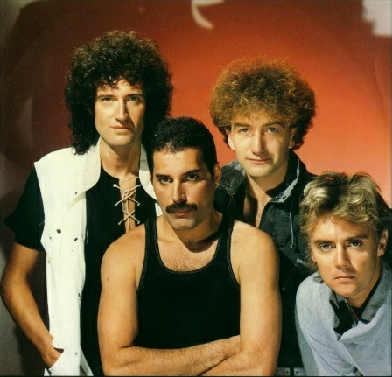
- Roger Taylor was the drummer and songwriter of the legendary band.
Freddy Mercury
Brian May
John Deacon
Roger Taylor



