

Singing about freedom



I want to break free

a) Before watching, discuss with your classmates:
- What does free mean?
- Are boys and girls free to do the same things?

b) Now, watch and listen to the video “I want to break free”.

c) Discuss in pairs:
- What is the man doing in the house?
He is...
- Do usually women do this at home?
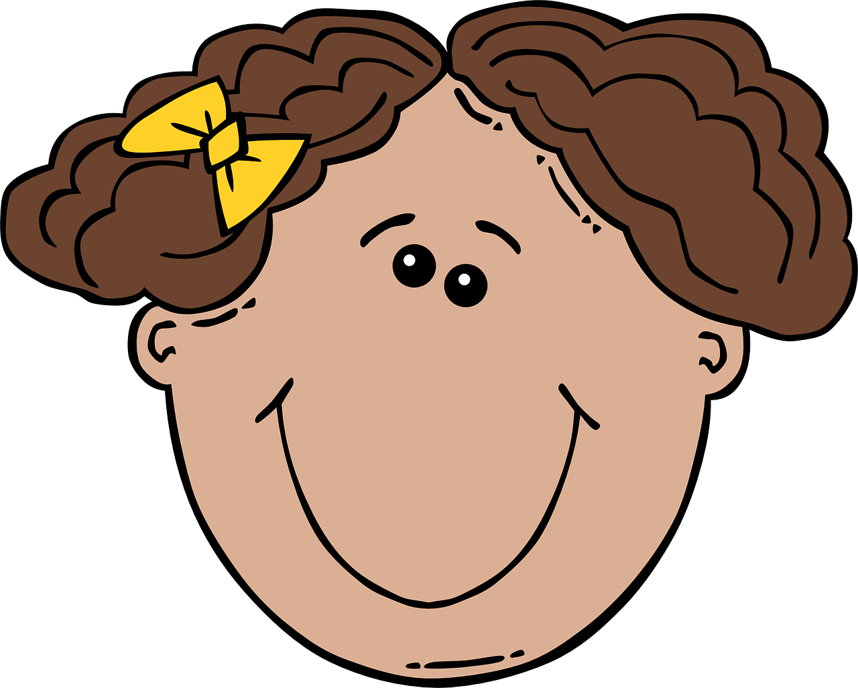
Yes, they do. /No, they don't / Both
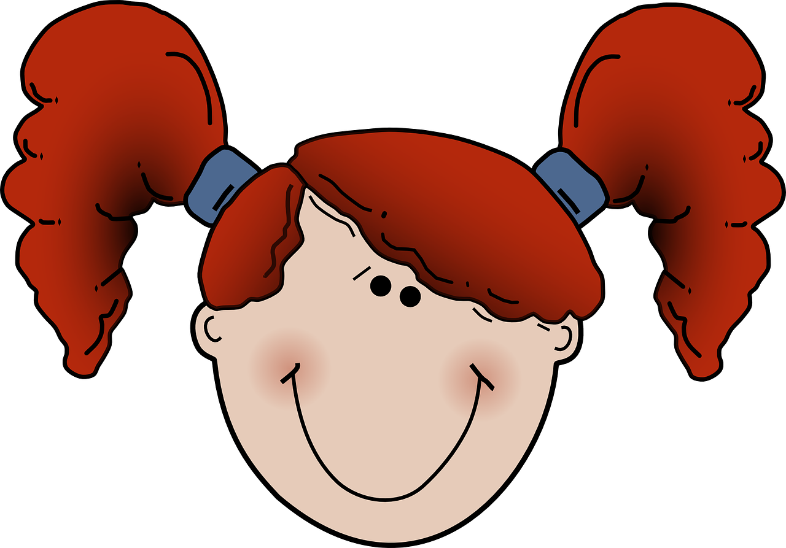
- Can men and women both clean the house?
Yes, they can. / No, they can't.
- Is it fair if only women clean?
No, it isn’t. / Yes, it is.

d) Sing and move.
- Listen to the song again and repeat.
- Sing and do the movements!
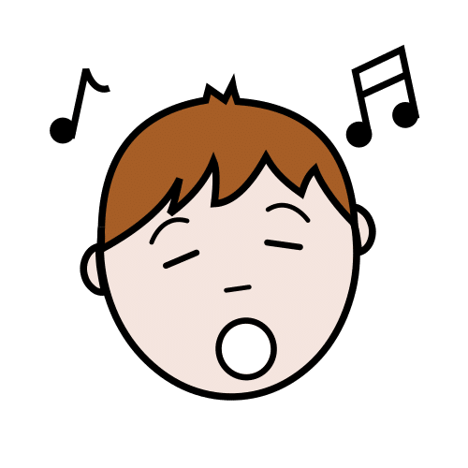
I want to break free!
(Break chains with your arms!)
I want to break free!
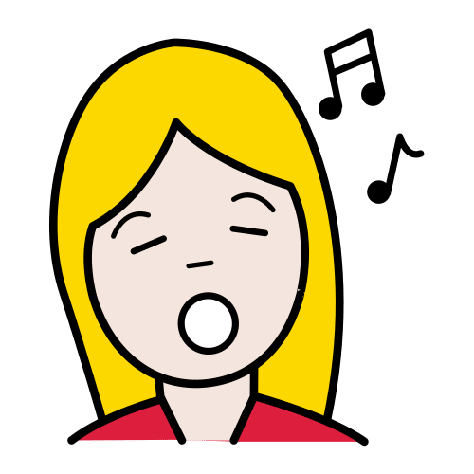
(Open your arms wide!)
I want to break free from your lies...
(Finger to lips!)
You're so self-satisfied, I don't need you!
(Show your strength!)

e) Speak with your classmate. Then draw.
- What do you want to break free from?
We want to break free from...
- Draw your idea.
I want to break free from …………...……………………………………….……….

Comets
Comets
Asteroids
Asteroids

