

Beats, musical figures and bars



Beats, bar and metre
Click!
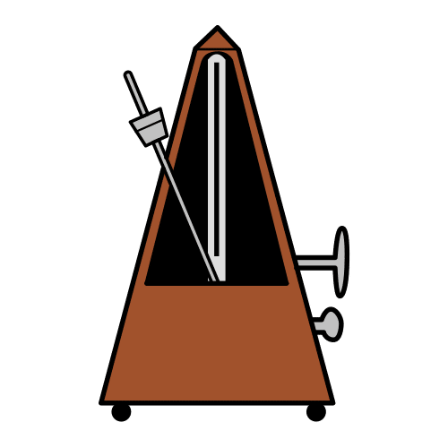
A beat is the regular sound in music.
Click!

Beats go in groups. A group of beats is called bars.
On the stave (musical lines), a bar is between two vertical lines.
Each bar has a number of beats.
Bar


Metre is how we count the beats in each bar. It tells us the rhythm.
2
2
- A duple metre has 2 beats in each bar.
- A triple metre has 3 beats in each bar.

Metre

Musical figures and rests

We use figures, rests and other musical symbols to write sounds and silence (rest) in music.
Different musical figures have different durations.

