BUSINESS LAYER – DIMENSIONAL MODEL
Design Overview
The dimensional model was created from the 3NF business layer to make reporting and data analysis faster and easier. Unlike the 3NF model, which is designed to reduce data duplication, the dimensional model is designed to simplify analytical queries.
The model uses a star schema. In this design, one central fact table stores the sales transactions, while several dimension tables store descriptive information about customers, products, employees, branches, suppliers, payments, geography, and dates.
The central table is FACT_SALES. Each sales transaction is linked to the related dimensions through surrogate keys. This allows users to analyze sales from different perspectives, such as by customer, product, branch, employee, supplier, payment method, location, or time.
The Customer dimension is implemented as a Slowly Changing Dimension Type 2 (SCD Type 2) because customer information, such as email or address, may change over time. Instead of replacing the old information, a new record is created while the previous record is kept. This preserves the history of customer data and allows historical reporting.
The Date dimension is a special case. It is not loaded from the 3NF layer because calendar information does not come from a source system. Instead, it is generated once using a SQL script and reused throughout the data warehouse.
Each dimension table contains a surrogate key, the original source identifier, source triplet columns (SOURCE_DB, SOURCE_TABLE, SOURCE_SYSTEM), and audit columns (INSERT_DT and UPDATE_DT). The Customer dimension also includes the SCD Type 2 fields START_DT, END_DT, and IS_ACTIVE.
Fact Table
The central table in the star schema is FACT_SALES. It stores the measurable values of each sales transaction together with references to all related dimensions.
The fact table contains foreign keys to the following dimensions:
- DIM_DATE
- DIM_CUSTOMER
- DIM_PRODUCT
- DIM_EMPLOYEE
- DIM_BRANCH
- DIM_SUPPLIER
- DIM_PAYMENT
The fact table stores the following measures:
- QUANTITY
- UNIT_PRICE_USD
- TOTAL_PRICE_USD
- TOTAL_PRICE_LOCAL
A calculated metric is also included:
SALES_AMOUNT = QUANTITY × UNIT_PRICE_USD
This metric represents the total sales value of each transaction and can be aggregated to analyze business performance.

Dimension Tables
The dimensional model contains the following dimension tables:
- DIM_DATE – Stores calendar information such as day, month, quarter, and year.
- DIM_CUSTOMER – Stores customer information and maintains historical changes using SCD Type 2.
- DIM_PRODUCT – Stores product details such as name, category, and brand.
- DIM_EMPLOYEE – Stores employee information. The EMPLOYEE_ROLE column identifies whether the employee is a seller or a courier.
- DIM_BRANCH – Stores branch information.
- DIM_SUPPLIER – Stores supplier information.
- DIM_PAYMENT – Stores payment method information.
- DIM_GEOGRAPHY – Stores geographical data such as city, region, country, and continent.

Metrics Description
The FACT_SALES table contains the following business metrics:
Quantity
Represents the number of product units sold in a transaction.
Unit Price (USD)
Represents the selling price of a single product in US dollars.
Total Price (USD)
Represents the total value of the transaction in US dollars.
Total Price (Local)
Represents the total value of the transaction in the local currency.
Sales Amount (Calculated Metric)
This metric is calculated as:
SALES_AMOUNT = QUANTITY × UNIT_PRICE_USD
It represents the total sales value for a transaction and can be aggregated by date, customer, product, employee, supplier, branch, or payment type to support business analysis.

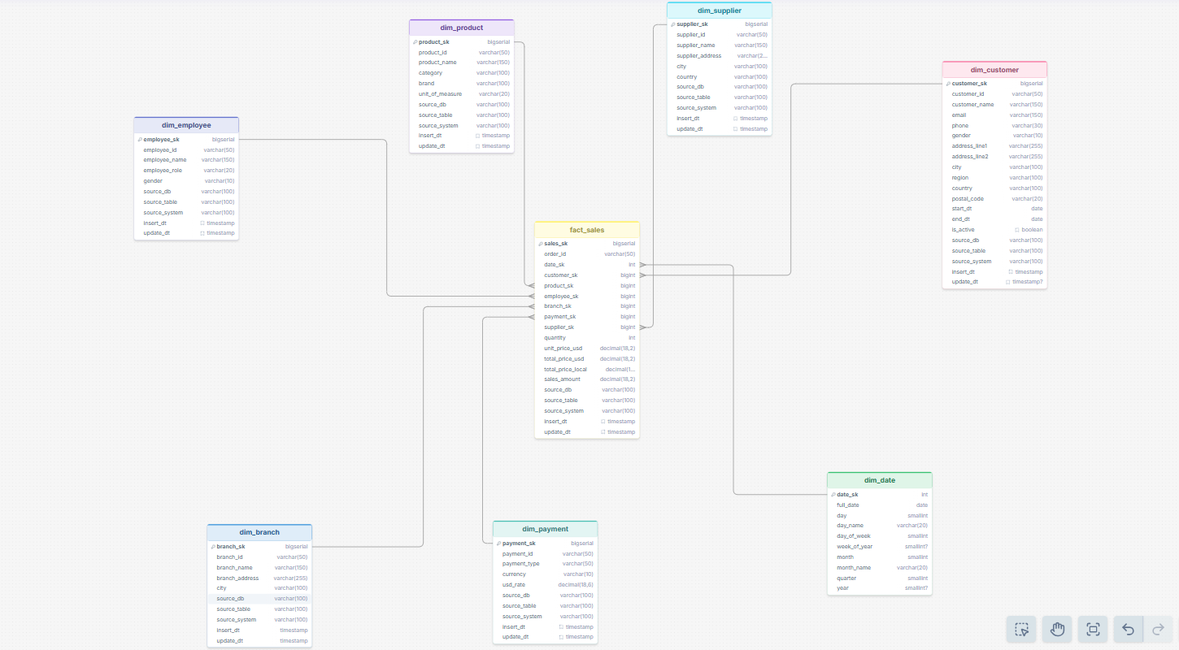

Link https://drawsql.app/teams/muhammad-s/diagrams/task-4

