1 Star Schema

1 Step
- Choosing business process: This 3nf model represents sales process.
A customer purchases a product at a store, served by an employee, and a payment is made for that sale.

2 Step
- Declaring Grain: One row in the fact table represents one sale transaction — a single product sold to a customer, served by an employee, at a specific store, on a specific date, for a specific amount.
It means product sold to customer by employee at store in one some date

3 Step

- Identifying dimension tables
Customer, employee, store, product, date

4 Step

- Identifying Facts:
Product_id
Employee_id
Customer_id
Store_id
Date_id
amount

2 Snowlake schema:
To make snowflake schema from star schema:
- I normalized each dimensions by deleting removing non-key attributes that are not related to primary key.
Only dimdate table is remained is it was in star schema since it does not have columns that are not related to primary key.
- Created normalized tables like address, city , country, economic regions, regions and category that are hierarchically related to each other address cites countries ( regions, economic regions) and products category .
- Finally referenced dimension like employees, customers and stores with address by address_id.
And dimension products with category by category_id

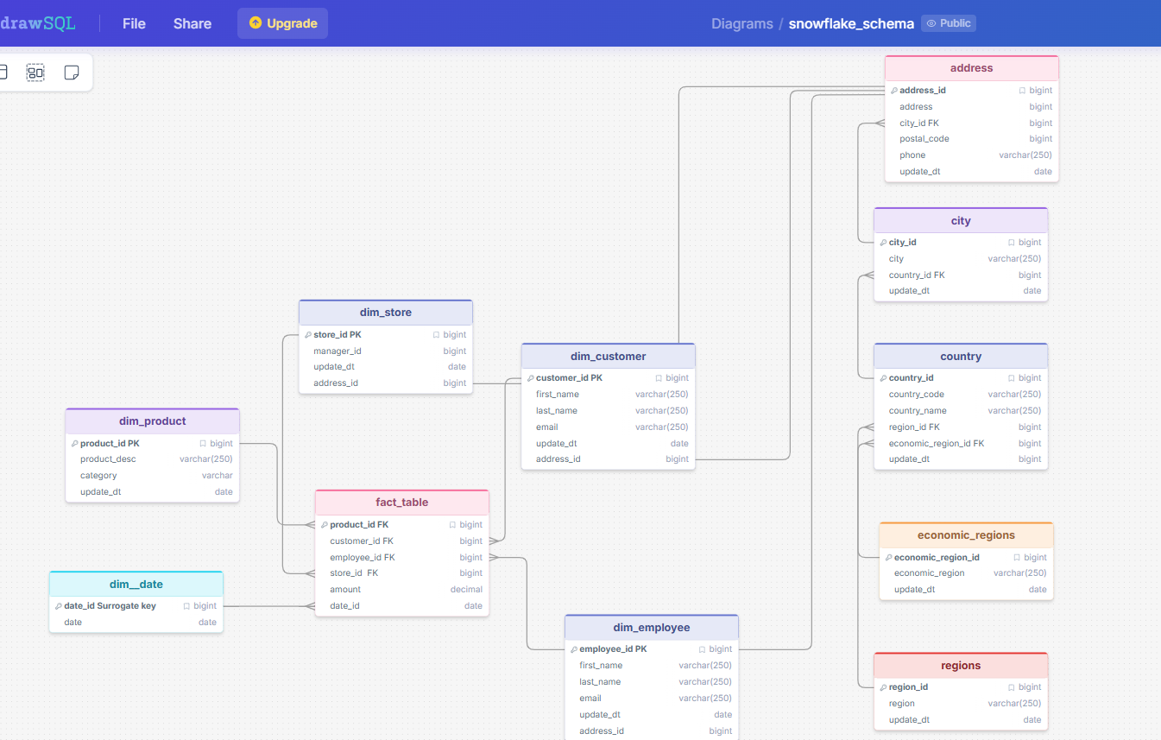

Snowflake schema
Link to snowflake schema: https://drawsql.app/teams/muhammad-s/diagrams/snowflake-schema

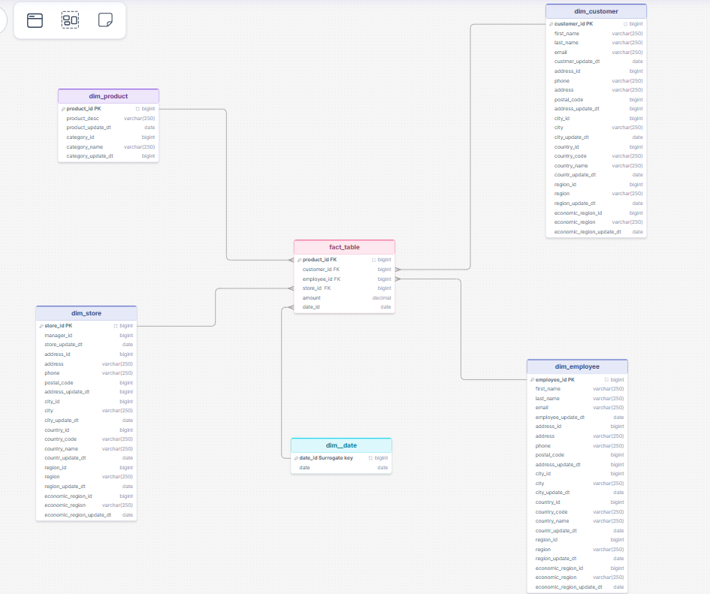

Link to star schema : https://drawsql.app/teams/muhammad-s/diagrams/star

