1 Star Schema

1 Step
- Choosing business process: This 3nf model represents sales process.
A customer purchases a product at a store, served by an employee, and a payment is made for that sale.

2 Step
- Declaring Grain: One row in the fact table represents one sale transaction — a single product sold to a customer, served by an employee, at a specific store, on a specific date, for a specific amount.
It means product sold to customer by employee at store in one some date

3 Step

- Identifying dimension tables
Customer, employee, store, product, date

4 Step

- Identifying Facts:
Product_id
Employee_id
Customer_id
Store_id
Date_id
amount

2 Snowlake schema:
To make snowflake schema from star schema:
- I normalized each dimensions by deleting removing non-key attributes that are not related to primary key.
Only dimdate table is remained is it was in star schema since it does not have columns that are not related to primary key.
- Created normalized tables like address, city , country, economic regions, regions and category that are hierarchically related to each other address cites countries ( regions, economic regions) and products category .
- Finally referenced dimension like employees, customers and stores with address by address_id.
And dimension products with category by category_id

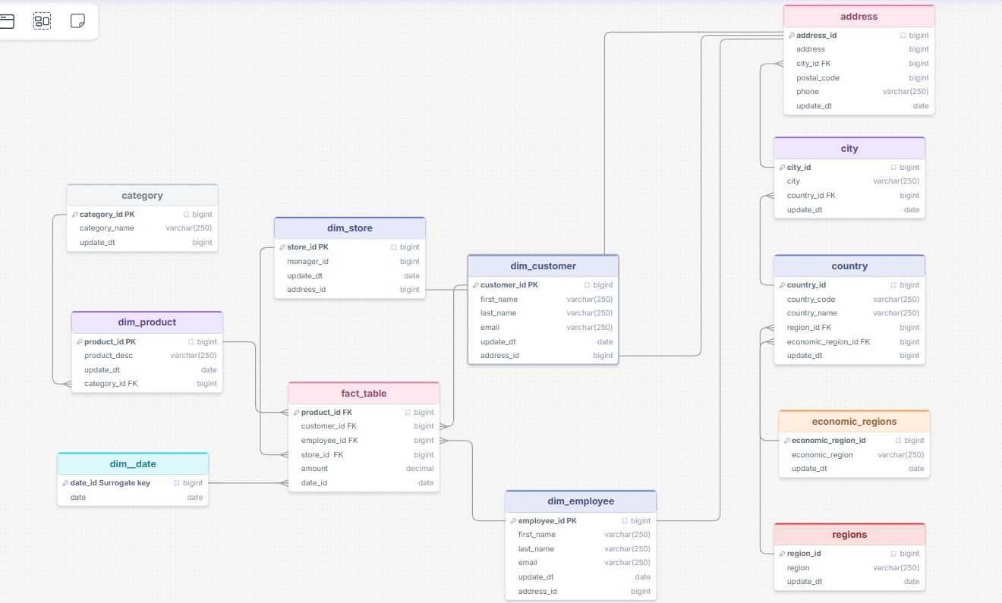

Snowflake schema
Link to snowflake schema: https://drawsql.app/teams/muhammad-s/diagrams/copy-of-star

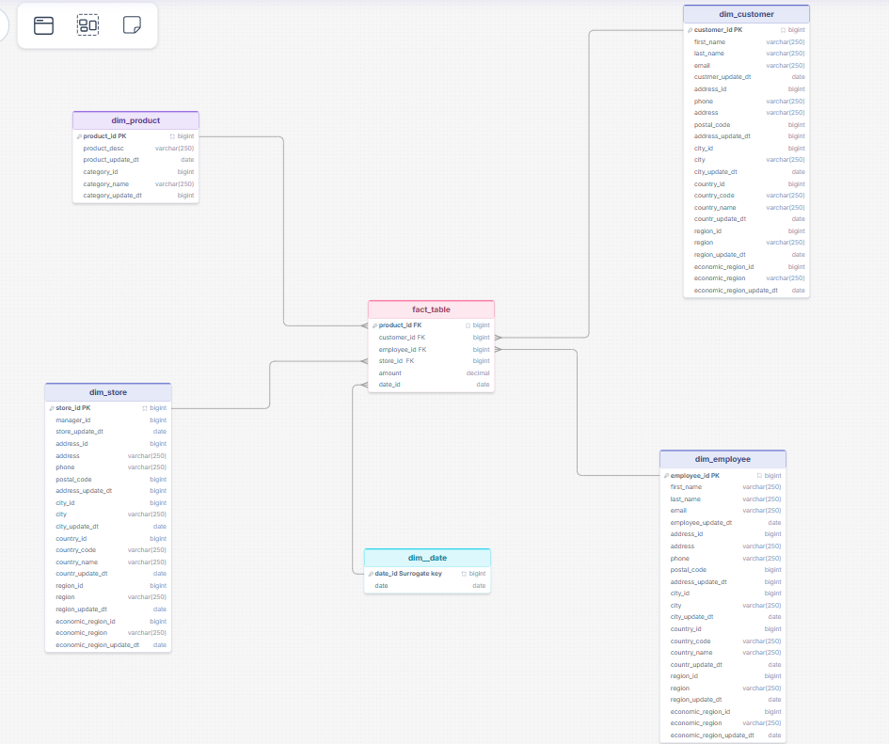

Link to star schema : https://drawsql.app/teams/muhammad-s/diagrams/star

- Determine the grain of the data, which refers to the level of detail or specificity at which the data is captured. Additionally, provide a description explaining why you have selected this particular grain (4 steps).
What is the process?
Grain in source1 dataset is: One product sold, in one order, to one customer, at one branch in one date
Why this level?
Because this is the most detailed level in the data. Going higher (per order or per day) would lose product details like price and quantity.
One row = one product in one order. If a customer buys 3 different items in one visit, there will be 3 rows — all sharing the same OrderID but with different ProductIDs.
Why this level?
Because this is the most detailed level in the data. Going higher (per order or per day) would lose product details like price and quantity.

DIM_CUSTOMER
Column Name | Description | Data Type
CustomerKey | Surrogate key | INT
CustomerID | Source customer ID | VARCHAR
CustomerName | Full name | VARCHAR
DateOfBirth | Birth date | DATE
Gender | Gender | VARCHAR
CustomerEmail | Email address | VARCHAR

DIM_PRODUCT
Column Name | Description | Data Type
ProductKey | Surrogate key | INT
ProductID | Source product ID | VARCHAR
ProductName | Name of product | VARCHAR
Category | Product category | VARCHAR
Brand | Product brand | VARCHAR
MadeIn | Country of manufacture | VARCHAR

DIM_BRANCH
Column Name | Description | Data Type
BranchKey | Surrogate key | INT
BranchID | Source branch ID | VARCHAR
BranchName | Name of the branch | VARCHAR
BranchAddress | Street address | VARCHAR
BranchOpenedYear | Year branch opened | INT
BranchSizeSqm | Floor size in sqm | DECIMAL
ManagerKey | Surrogate key | INT
BranchManagerID | Source manager ID | VARCHAR
BranchManagerName | Full name | VARCHAR
BranchManagerEmail | Email address | VARCHAR
BranchManagerGender | Gender | VARCHAR
BranchManagerBirthDate | Date of birth | DATE

DIM_LOCATION
Column Name | Description | Data Type
CityKey | Surrogate key | INT
CityID | Source city ID | VARCHAR
City | City name | VARCHAR
Country | Country name | VARCHAR
Region | Regional grouping | VARCHAR
Continent | Continent name | VARCHAR
PostalCode | Postal code | VARCHAR

DIM_SELLER
Column Name | Description | Data Type
SellerKey | Surrogate key | INT
SellerID | Source seller ID | VARCHAR
SellerName | Full name | VARCHAR
SellerEmail | Email address | VARCHAR
SellerGender | Gender | VARCHAR
SellerBirthDate | Date of birth | DATE

DIM_SUPPLIER
Column Name | Description | Data Type
SupplierKey | Surrogate key | INT
SupplierID | Source supplier ID | VARCHAR
SupplierName | Supplier company name | VARCHAR
SupplierEmail | Contact email | VARCHAR
SupplierStreetAddress | Street address | VARCHAR
SupplierCity | City of supplier | VARCHAR
SupplierCountry | Country of supplier | VARCHAR
SupplierPrimaryIndustry | Main industry | VARCHAR

DIM_PAYMENT
Column Name | Description | Data Type
PaymentKey | Surrogate key | INT
PaymentID | Source payment ID | VARCHAR
PaymentType | Payment method | VARCHAR
Currency | Currency code | VARCHAR
USDRate | Exchange rate to USD | DECIMAL

FACT_SALES
Column Name | Description | Data Type
SalesKey | Surrogate primary key | INT
OrderID | Source order ID | VARCHAR
DateKey | FK → DIM_DATE | INT
CustomerKey | FK → DIM_CUSTOMER | INT
ProductKey | FK → DIM_PRODUCT | INT
BranchKey | FK → DIM_BRANCH | INT
SellerKey | FK → DIM_SELLER | INT
SupplierKey | FK → DIM_SUPPLIER | INT
PaymentKey | FK → DIM_PAYMENT | INT
OrderStatus | Status of the order | VARCHAR
OrderType | Type of order | VARCHAR
Quantity | Units purchased | INT
UnitPriceInUSD | Price per unit in USD | DECIMAL
TotalAmountUSD | Total in USD | DECIMAL
UnitPriceInLocalCurrency | Price per unit in local currency | DECIMAL
TotalPriceInLocalCurrency | Total in local currency | DECIMAL

