PERFOMANCE WITH UNLLOGED TABLES
I created table labs.test_simple then filled it with numbers from 1 to 1000000 which took around 4 seconds. Here is the screenshot of how much time needed to INSERT this data:
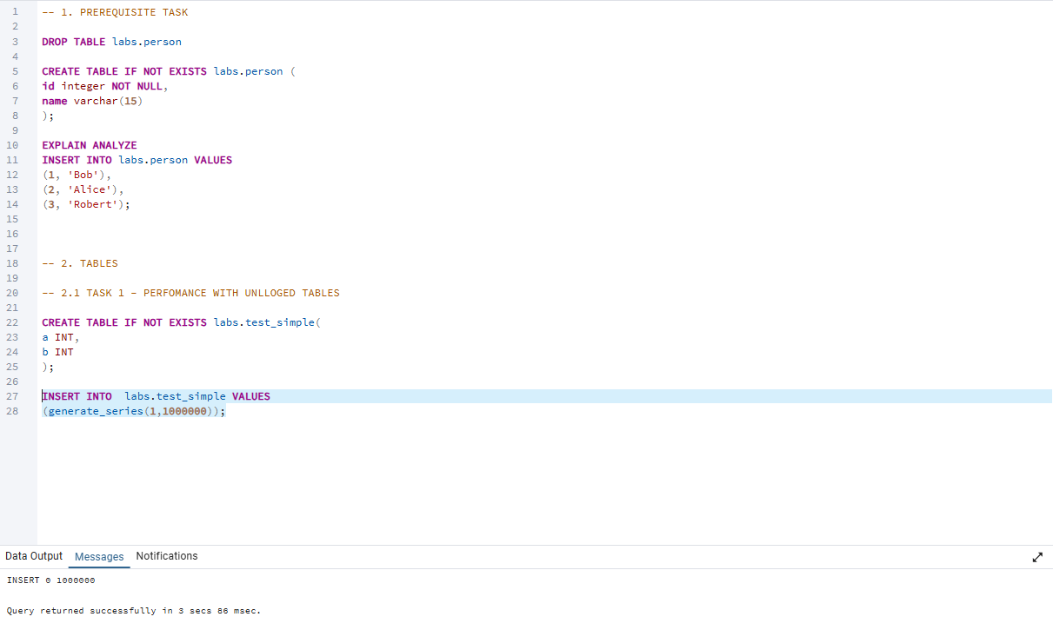
Then inserted numbers from 1 to 5000000 which took around 22 seconds :
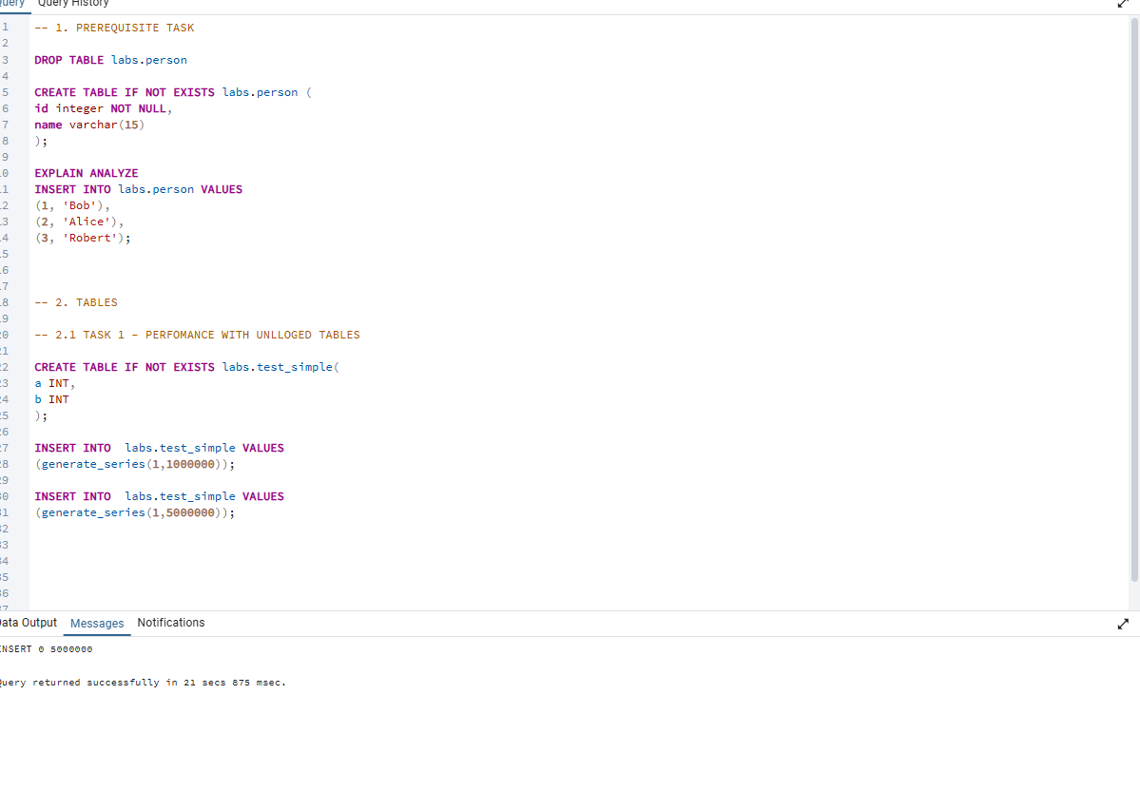

Then created UNLOGGED TABLE and inserted the same numbers first from 1 to 1000000 which took around 1 second:
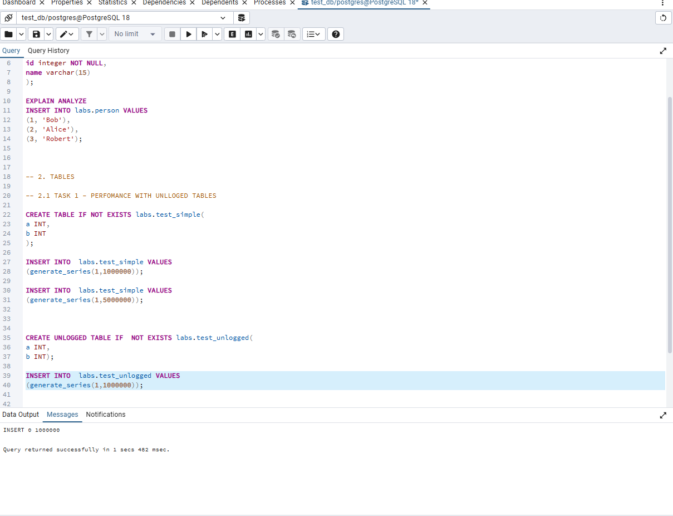

And numbers from 1 to 5000000 which took around 8 seconds:
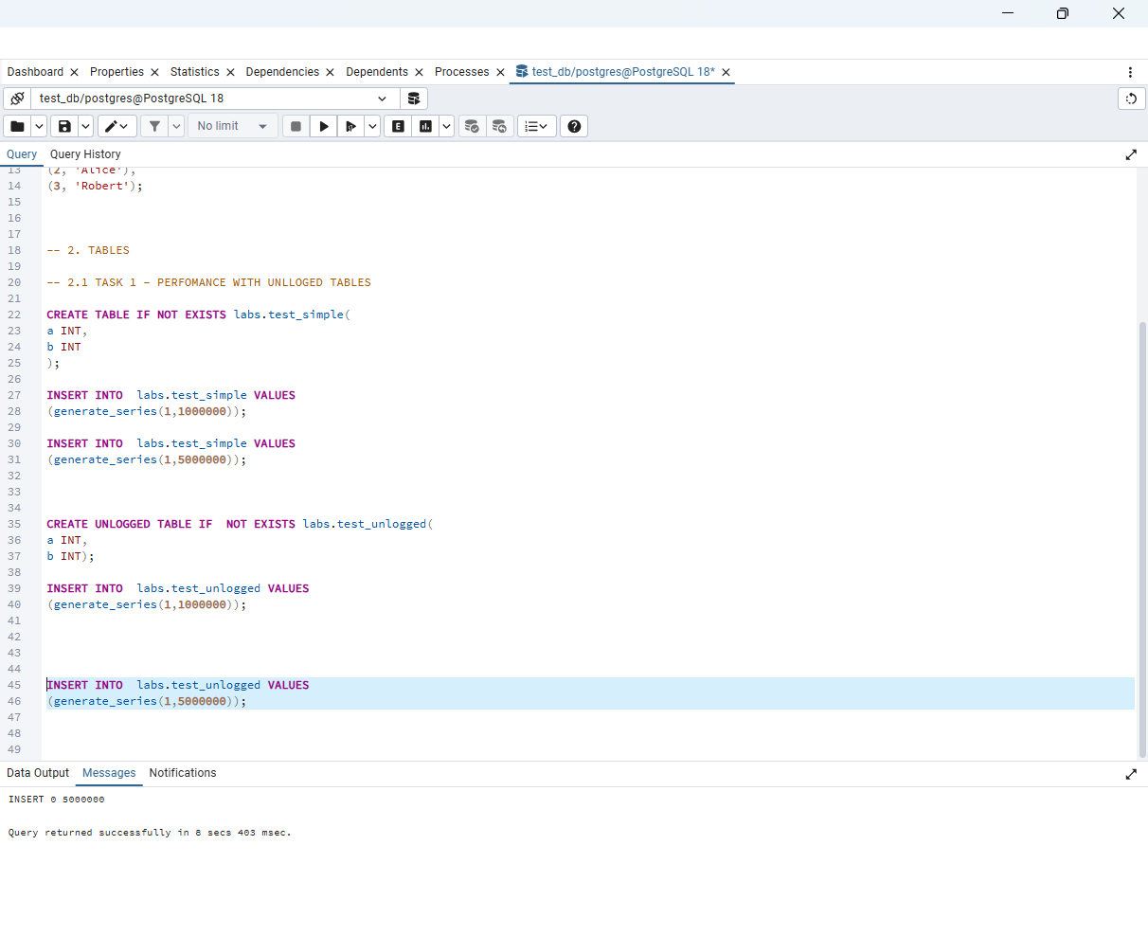
An unlogged table is faster because PostgreSQL does not record changes in the Write-Ahead Log (WAL).
For a normal table, every INSERT, UPDATE, or DELETE is written twice:
- First to the WAL, so PostgreSQL can recover the data if the server crashes.
- Then to the actual table.
For an unlogged table, PostgreSQL skips writing to the WAL and writes only to the table. Because it performs fewer disk write operations, inserts, updates, and deletes are faster.
The trade-off is that if the server crashes, PostgreSQL cannot recover the data in an unlogged table, so its contents are automatically removed.

TASK 2 – UNDERSTANDING INHERITED TABLES
Inheritance: performed select statements for tables:
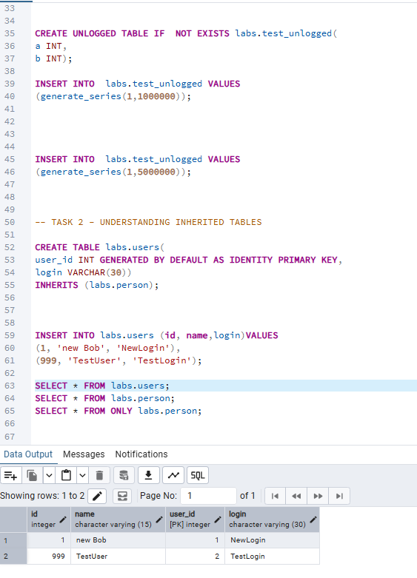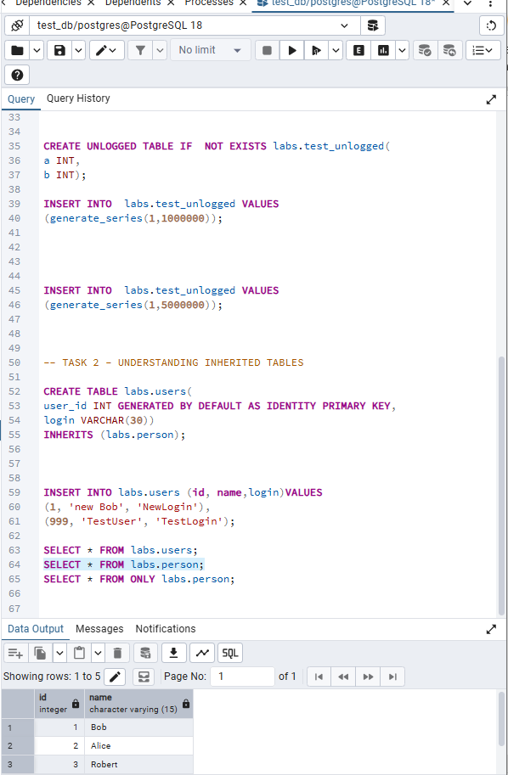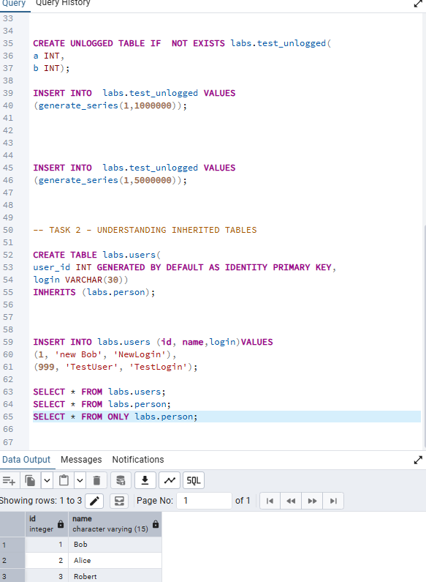
a child table inherits all columns and CHECK constraints from the parent table, and it can have additional columns of its own. However, it does not inherit primary keys, foreign keys, unique constraints, or indexes.
So here child table users inherited columns from person table .
-------------------------------------------------------------------------------------------------------------
when I updated person table and changed name to not Bob' it also affected to the user table since it is inherited from person table
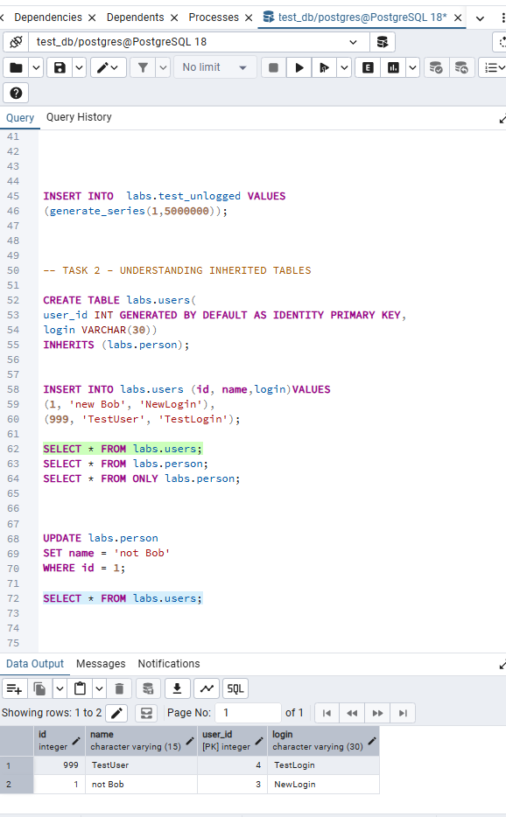

When I updated person table with ONLY statement it did not affected to the users and changed only in person table
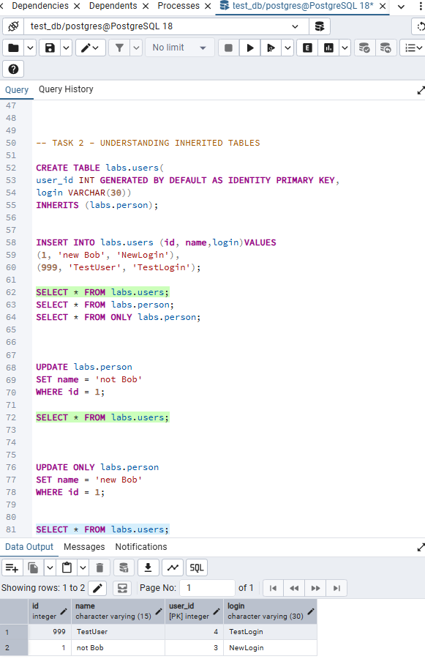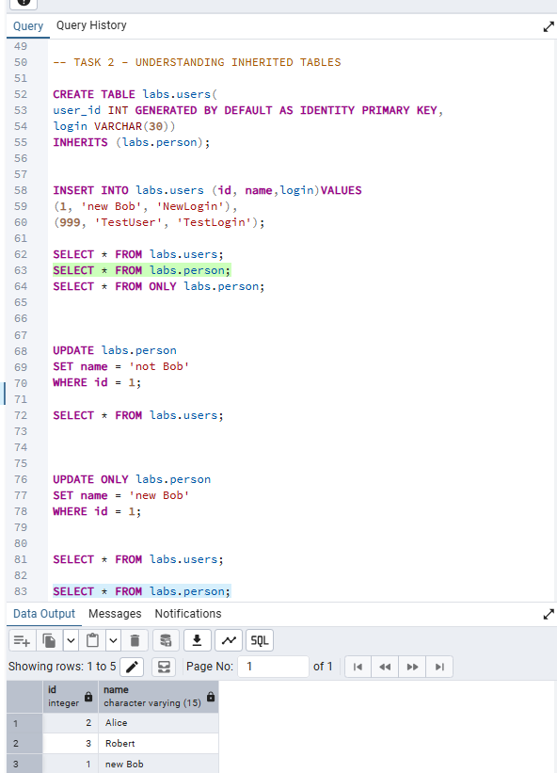
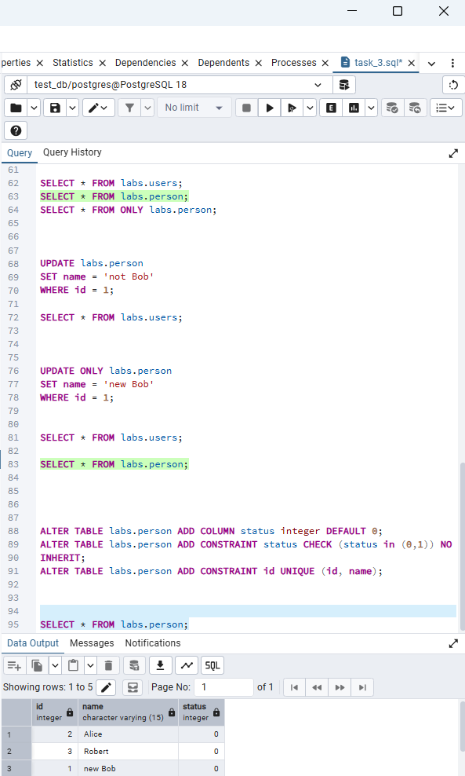
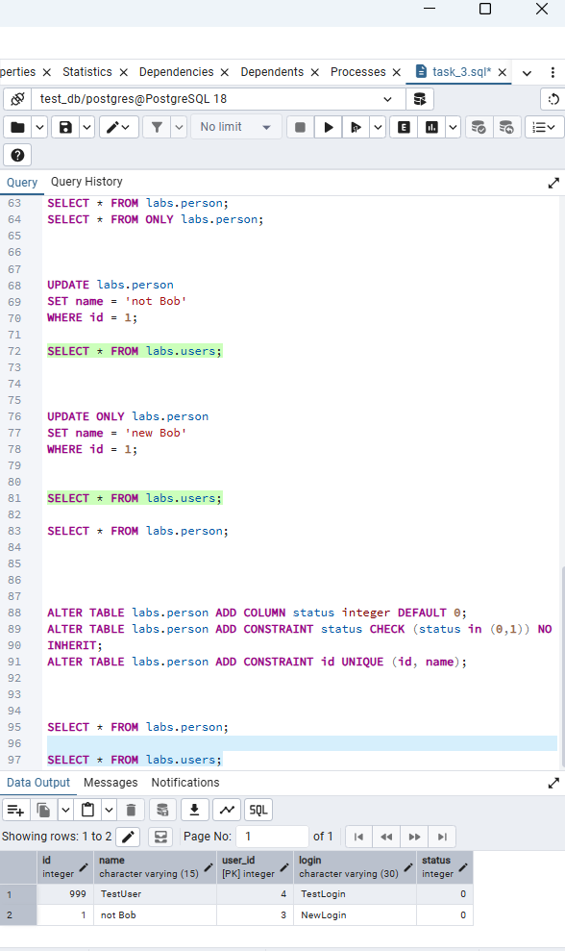
ALTER TABLE labs.person ADD COLUMN status INTEGER DEFAULT 0;
The new status column was automatically added to both the parent table (labs.person) and the inherited child table (labs.users).
ALTER TABLE labs.person ADD CONSTRAINT status_check CHECK (status IN (0,1));
The CHECK constraint was inherited by the child table, so both labs.person and labs.users enforce the same validation rule.
ALTER TABLE labs.person ADD CONSTRAINT id_unique UNIQUE (id, name);
The UNIQUE constraint was applied only to the parent table. It was not inherited by labs.users, because UNIQUE constraints are not inherited in PostgreSQL.

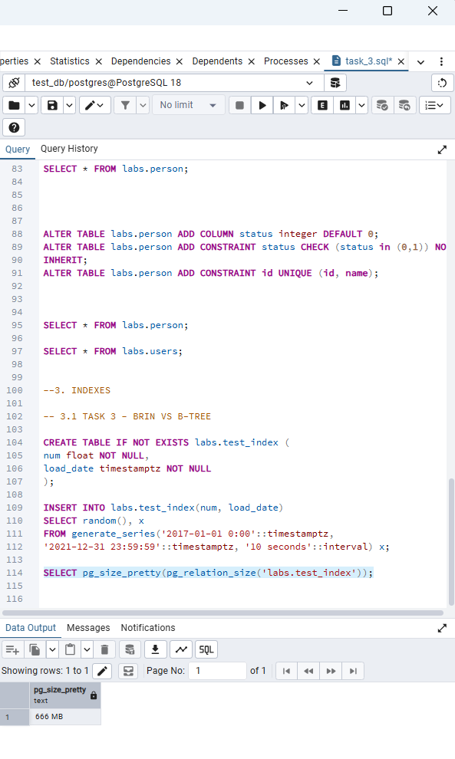
INDEX: The size of table test_index is 666 MB.

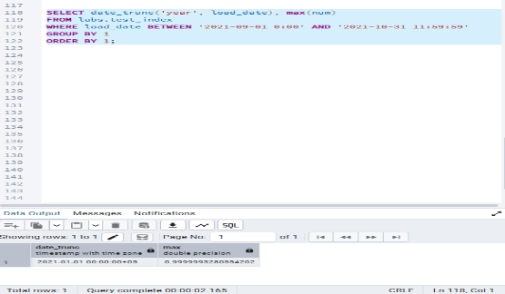
The execution time for this select command is 2 seconds
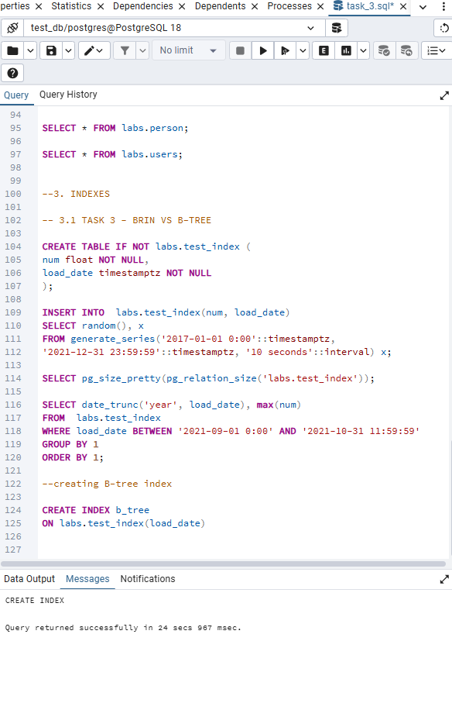
It took around 25 seconds to create B-tree index.

Now with B-tree index it took around 1 seconds. Which means with index data retrieval became faster
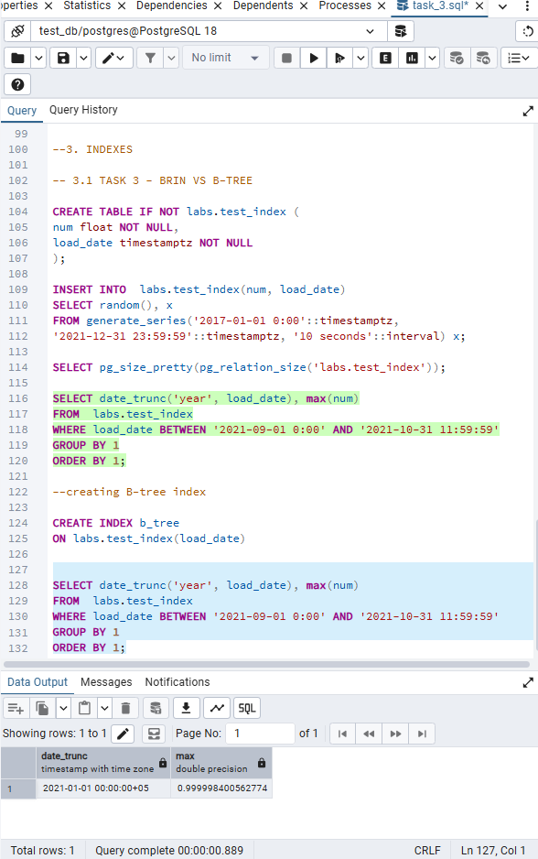
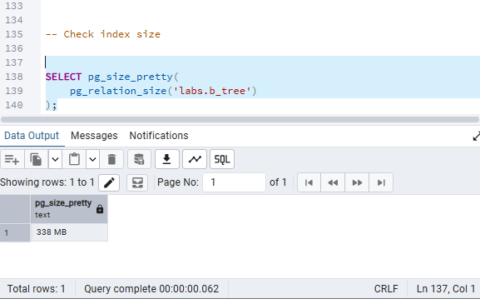
Index size is 338 MB

It took around 2 seconds to create brin index
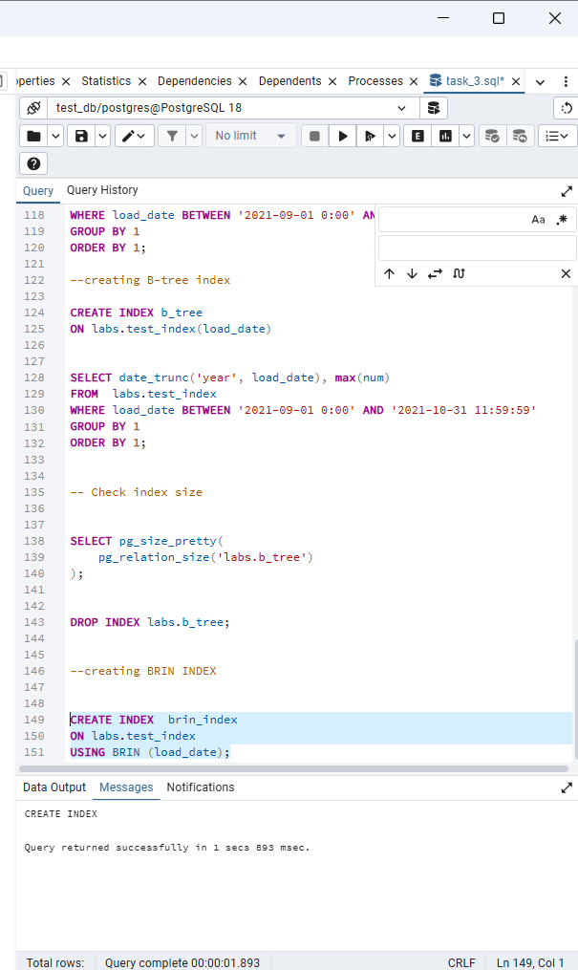
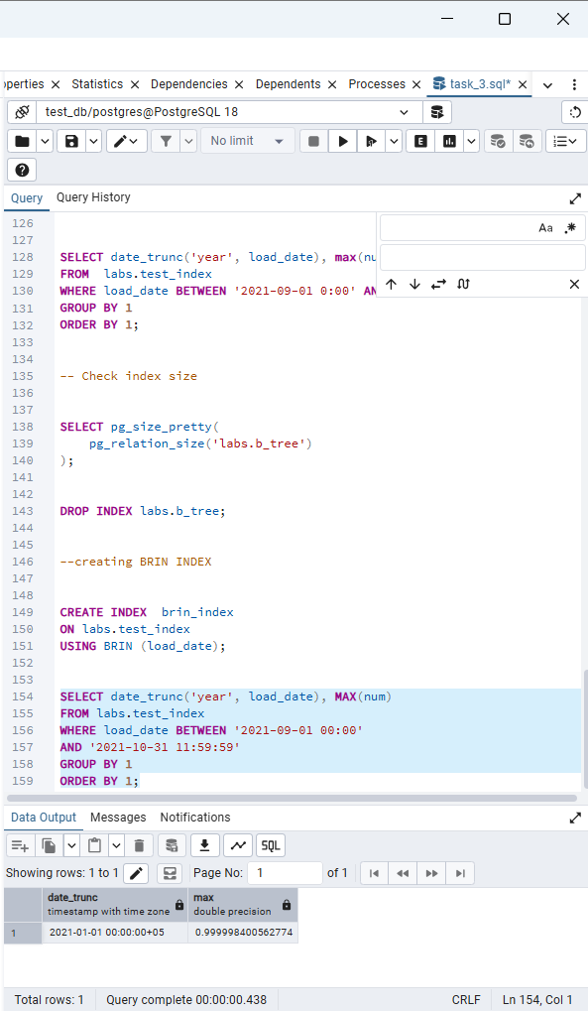
It took around half second to execute this query with brin index, which faster than b-tree index and sequential scan.

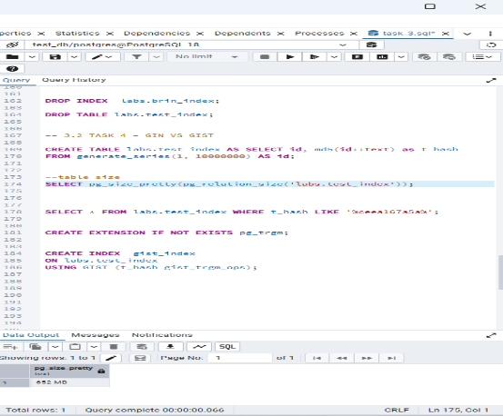
3.2 TASK 4 - GIN VS GIST
Table size id 652 mb
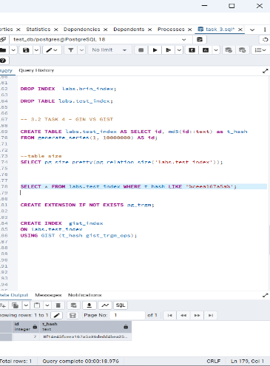
It took 19 seconds to execute this query by sequential scan
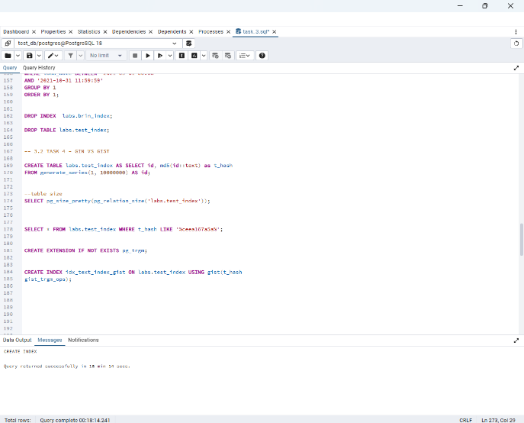
It took 18 minutes to create gist index
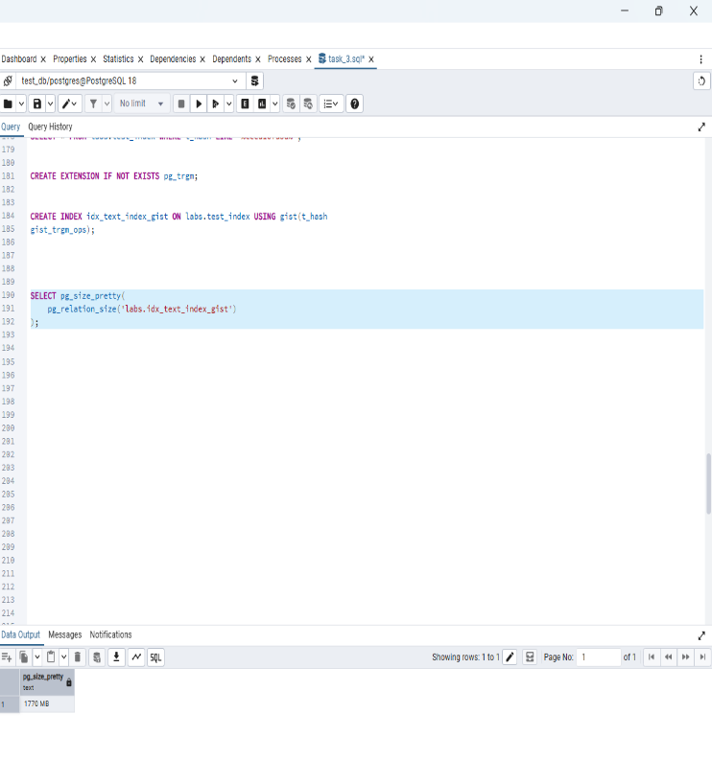
the size of gist index is 1770 MB

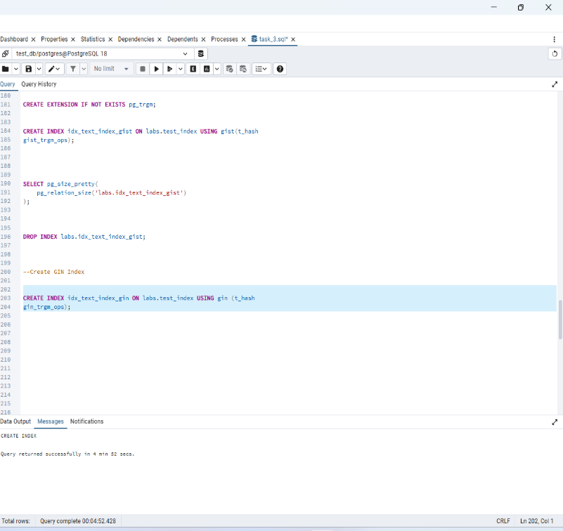
Gin index created in 4 minutes
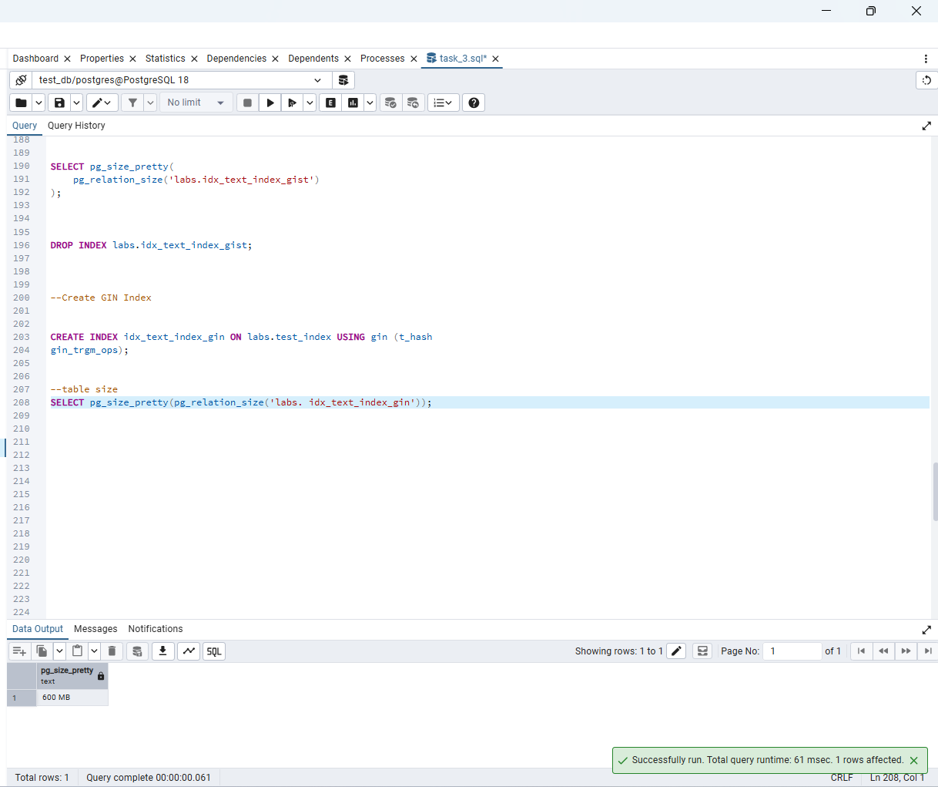
The size of the table is 600 MB

B-tree – A balanced tree index that stores every indexed value in sorted order and is best for equality, range queries, and sorting (=, <, >, BETWEEN, ORDER BY).
BRIN – A Block Range Index that stores only summary information (minimum and maximum values) for groups of table blocks, making it ideal for very large tables with naturally ordered data such as dates or timestamps.
GiST – A Generalized Search Tree index that supports complex data types and similarity searches, making it suitable for geometric, spatial, and fuzzy text searches.
GIN – A Generalized Inverted Index that maps each value to the rows containing it, making it the best choice for full-text search, JSONB, arrays, and text pattern searches.

4. FOREIGN DATA WRAPPERS
4.1 TASK 5 – CSV FILE AS A TABLE
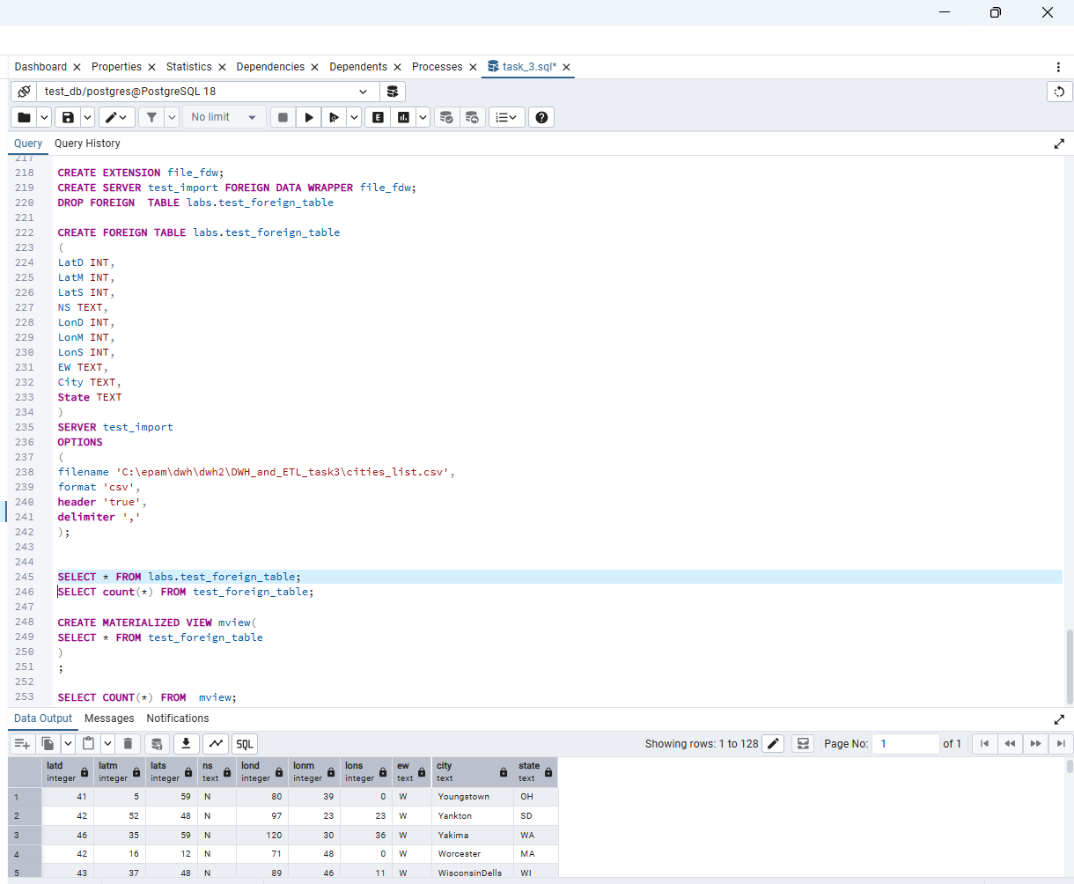

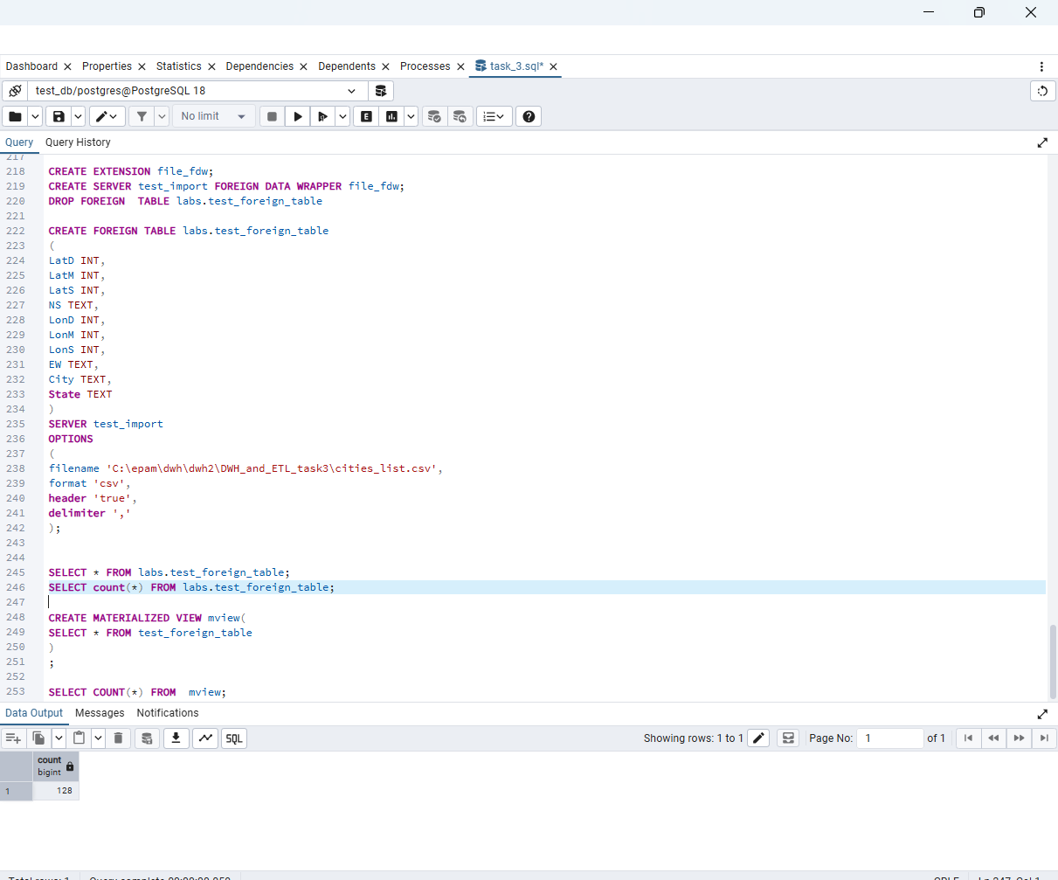

Creating materialized view
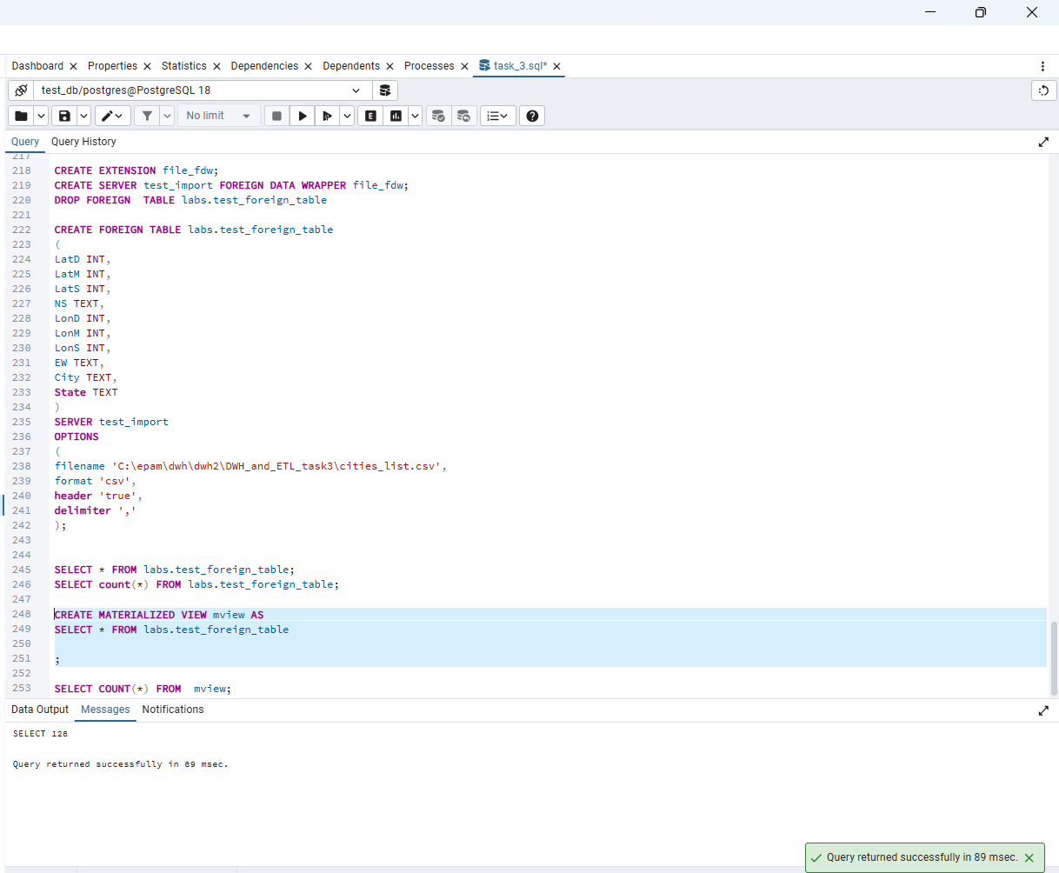

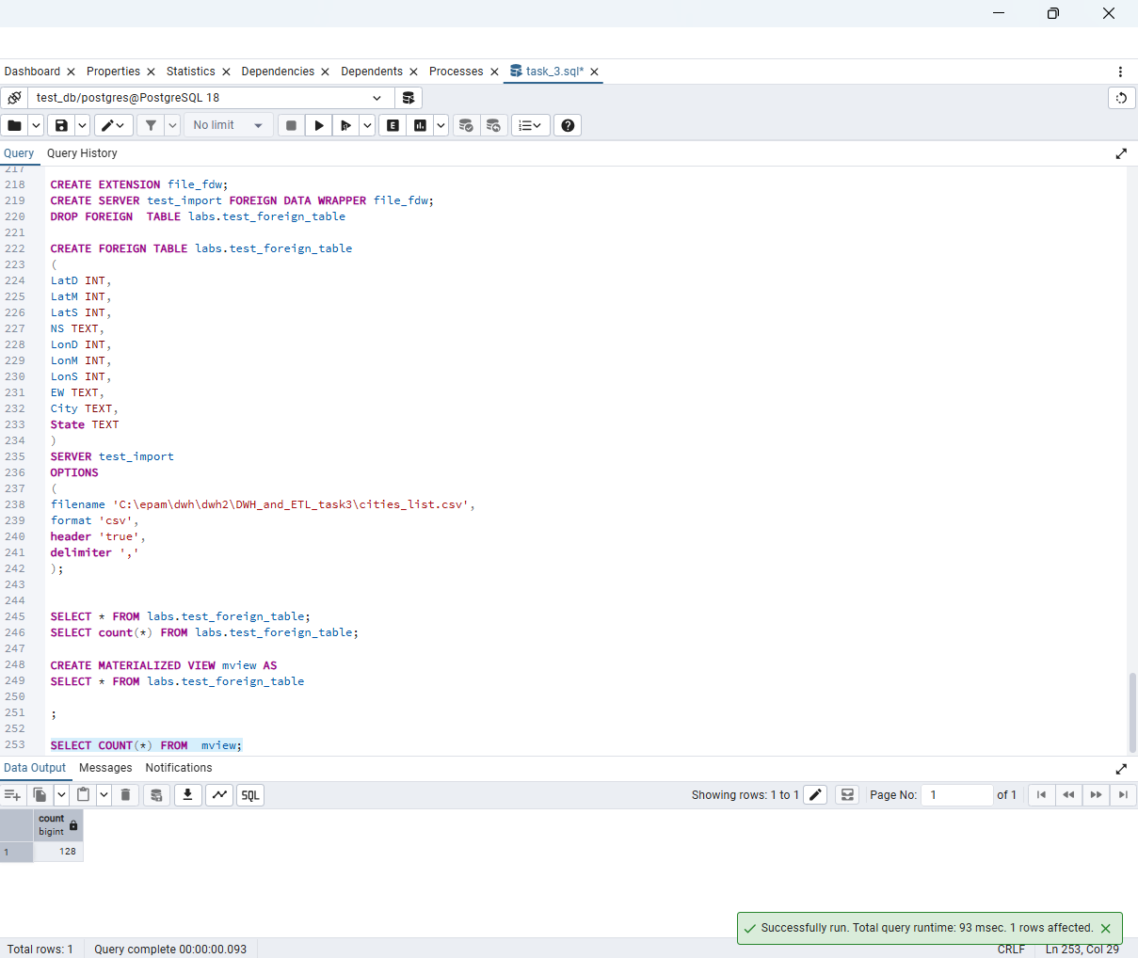

Materialized view is working

