 

**INSTITUTE FOR ADVANCED COMPUTING AND SOFTWARE DEVELOPMENT AKURDI, PUNE**

Documentation On

**“ONLINE BOOK STORE”**

PG-DAC Sep 2021

*Submitted By:*

**Group No: 39**

**Suruchi Patil 219206**

**Diksha Malviya 219059**

**Prashant Karhale Mr.**

**Centre Coordinator Project Guide**

# Table of Contents

1. Introduction 1

Problem Statement 5

Product Scope 5

Aim & Objectives 5

1. Overall Description 6

Product Perspective 7

Benefits of Online Book Store 7

User and Characteristics 8

Operating Environment 9

Design and Implementation Constraints 9

1. Requirements Specification 10

External Interface Requirements 11

3.3 Non-Functional Requirements 11

1. System Diagram 12

Activity Diagram 12

Data Flow Diagram 13

Class Diagram 15

Use Case Diagram 16

ER Diagram 16

1. Table Structure 17

Book_table 18

User_role 18

Roles 18

Category 19

User 19

Cart 19

Cart _Order 20

Order_details 20

1. Conclusion 21

Future Scope 21

1. References 21

**List of Figures**

Figure 1 Admin Activity Diagram 12

Figure 2 User Activity Diagram 13

Figure 4 Level 0 Data Flow Diagram 14

Figure 5 Level 1 Data Flow Diagram 14

Figure 6 Class Diagram 15

Figure 7 Use Case Diagram 16

Figure 8 ER Diagram 17

# Introduction

Online Book Store is a web application that provides the function and features to authenticate and identify the users and provide then with easy, intuitive, personalized and user-customizable web-interface for facilitating access to information and services that are of primary relevance and interests to the users. online Book Store User can purchase the book online instead of going out to a book store. The Purpose of project is to make a full functional online book store system that allows its users to search and purchase a book online based on category, can add the book in shopping cart and place order online.

## Problem Statement

Nowadays, the network plays an import role in people’s life. In the process of the improvement of the people’s living standard, people’s demands of the life’s quality and efficiency is more higher , the traditional bookstore’s inconvenience gradually emerge, and the online bookstore has gradually be used in public. The online bookstore is a revolution of book industry. The traditional bookstores’ operation time, address and space is limited, so the types of books and books to find received a degree of restriction. But the online bookstore broke the management mode of traditional bookstore, as long as you have a computer, you can buy the book anywhere, saving time and effort, shortening the time of book selection link effectively. The online bookstore system based on the principle of provides convenience and service to people and provide facility to users to buy the book online.

## Product Scope

The online bookstore's main Actros are divided into two categories, one is the front user, one is the background user (Admin). Front-end users are mainly customers who will buy books from online bookstore. Front-end users can register, login, search the books, add the book to shopping cart and place orders. The background user (Admin) will be able add, modify or delete the book details, can add the latest books. Also admin will be able to manage category i.e add, update, delete category as per requirement.

## Aims & Objectives

The objective of project is to make a full functional online book store system that allows its users to search and purchase a book online based on category. The online bookstore's main Actros are divided into two categories, one is the front user, one is the background user (Admin). Front-end users are mainly customers who will buy books from online bookstore. Front-end users can register, login, search the books ,add the book to shopping cart And place orders .The background user (Admin) will be able add, modify or delete the book details , can add the latest books. Also admin will be able to manage category i.e add , update ,delete category as per requirement .

Specific goals are: -• To produce a web-based system that allow the admin to add the book and category as per availability of book and able to update delete book .• To ease user by providing different functionalities to it.• User can buy book online based on category.

# Overall Description

## Product Perspective:

**2.1.1 Existing system function:**

Existing System: The Existing System is manual one. For example a client needs to go the book (shop) and he needs to solicit the proprietor from that book shop about the book he needs. It is at times not all that simple to discover our required books. Proprietor needs to control every one of the clients at the same time yet now and again he neglects to oversee and answer every one of the clients. It has all the disadvantages of that a conventional framework postures such has high venture, enlisting representatives, extensive volume stock, abnormal state hazard, tedious procedure, tuff to get consumer loyalty and soon. Also Shop owner need to keep details in manual way in existing system.

* **III. PROPOSED SYSTEM**

The Proposed system provide full functional online book store system that allows its users to search and purchase a book online based on category. The online bookstore's main Actros are divided into two categories, one is the front user, one is the background user (Admin). Front-end users are mainly customers who will buy books from online bookstore. Front-end users can register, login, search the books, add the book to shopping cart And place orders .The background user (Admin) will be able add, modify or delete the book details , can add the latest books. Also admin will be able to manage category i.e add , update ,delete category as per requirement .

## Benefits of Society Management System

Benefits of Online Book Store • This online Book store is fully functional and flexible.• It is very easy to use.• This online Book Store system helps user to purchase the book online from home.• It saves a lot of time.• Eco-friendly: The monitoring of the user order and the overall business becomes easy and includes the least of paper work.• The application acts as an office that is open 24/7.• It increases the efficiency of the system at offering quality services to the customers.• It provides custom features development and support with the application.

## Users and Characteristics:

**Admin Module :**

**1 .Admin Login :**

Admin can login using verified username and password.

**2 .User Management :**

Admin can manage all the details of user , will manage all the user request.

**3 .Book Management :**

Background Administrators can control book information such as adding books, editing book information, and deleting book information.

**4 . Category Management :** Admin can update the category ,delete category or add a new category as per requirements.

**5 .Order Management :**

View orders by order status, view order details, can cancel orders before they are shipped, and can be shipped after buyer payment.

**User Module :**

**1 .User Registration Login :**

Users can register as a member, the user can become a member after login, modify

personal information, modify the password and exit.

**2 .Category display :**

User can view books as per specific category.

**3 .Book display:**

User can Search the books by title or keyword, search for books , able to see the details of book.

**4 . Cart Management:**

User can add the books in the cart which user wants to buy , modify quantity of books , can be able to remove the book from the cart .

**5 .Order Management:**

User can order the book ,review the details of existing order and place the order , cancel the order .

## Operating Environment:

Server Side:

**Processor:** Intel® Xeon® processor 3500 series

**HDD:** Minimum 500GB Disk Space

**RAM:** Minimum 4GB **OS:** Windows 10, Linux 6 **Database:** MySQL

Client Side (minimum requirement):

**Processor:** Intel Dual Core

**HDD:** Minimum 80GB Disk Space

**RAM:** Minimum 2GB

**OS:** Windows 7, Linux

## Design and Implementation Constraints:

• The application will use HTML, JavaScript, jQuery and CSS ,ReactJS as main web technologies.• HTTP protocols are used as communication protocols. • JSON Web Token is used for authentication and authorization providing security.• Several types of validations make this web application a secured one and SQL Injections can also be prevented.• Since Online book Store is a web-based application, internet connection must be established.• The Online Book Store will be used on PCs and will function via internet or intranet in any web browser

# Specific Requirement

## External Interface Requirements:

User Interfaces:

* + All the users will see the same page when they enter in this website. This page asks the users a username and a password.
  + After being authenticated by correct username and password, user will be redirect to their corresponding profile where they can do various activities.
  + The user interface will be simple and consistence, using terminology commonly understood by intended users of the system. The system will have simple interface, consistence with standard interface, to eliminate need for user training of infrequent users.

Hardware Interfaces:

* + No extra hardware interfaces are needed.
  + The system will use the standard hardware and data communication resources.
  + This includes, but not limited to, general network connection at the server/hosting site, network server and •network management tools.

Application Interfaces:

**OS:** Windows 7, Linux

**Web Browser:**

The system is a web-based application; clients need a modern web browser such as Mozilla Firebox, Internet Explorer, Opera, and Chrome. The computer must have an Internet connection in order to be able to access the system.

Communications Interfaces:

* + This system uses communication resources which includes but not limited to, HTTP protocol for communication with the web browser and web server and TCP/IP network protocol with HTTP protocol.
  + This application will communicate with the database that holds all the booking information. Users can contact with server side through HTTP protocol by means of a function that is called HTTP Service. This function allows the application to use the data retrieved by server to fulfil the request fired by the user.

# System Design :

## 1 .Activity Diagram

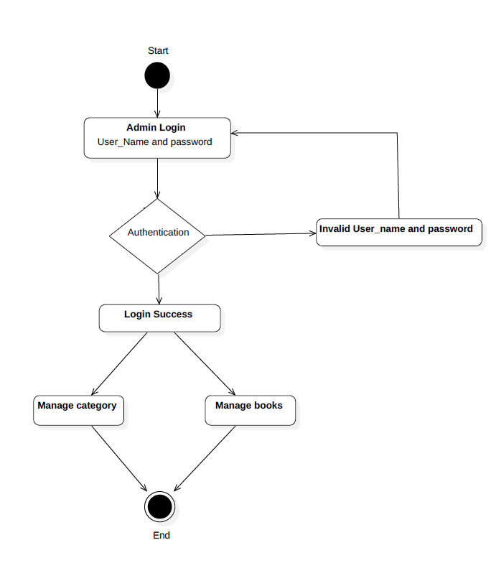

**Figure 1: Admin Activity Diagram**

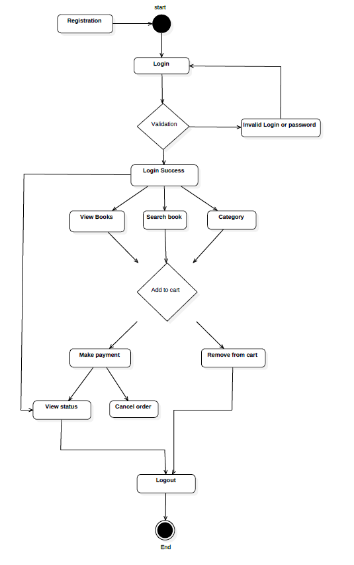

**Figure 2: UserActivity Diagram**

## 2.Data Flow Diagram

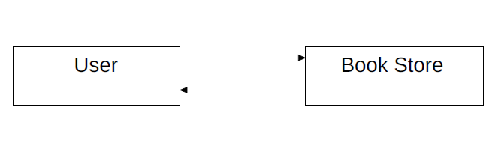

**Figure 3: Level 0 Data Flow Diagram**

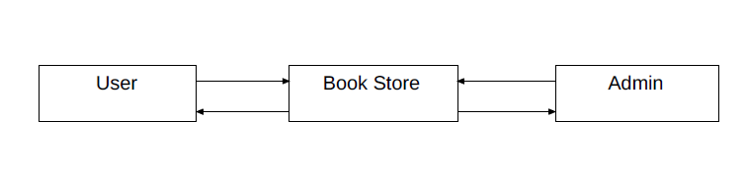

**Figure 4: Level 1 Data Flow Diagram**

## 3 .Class Diagram :

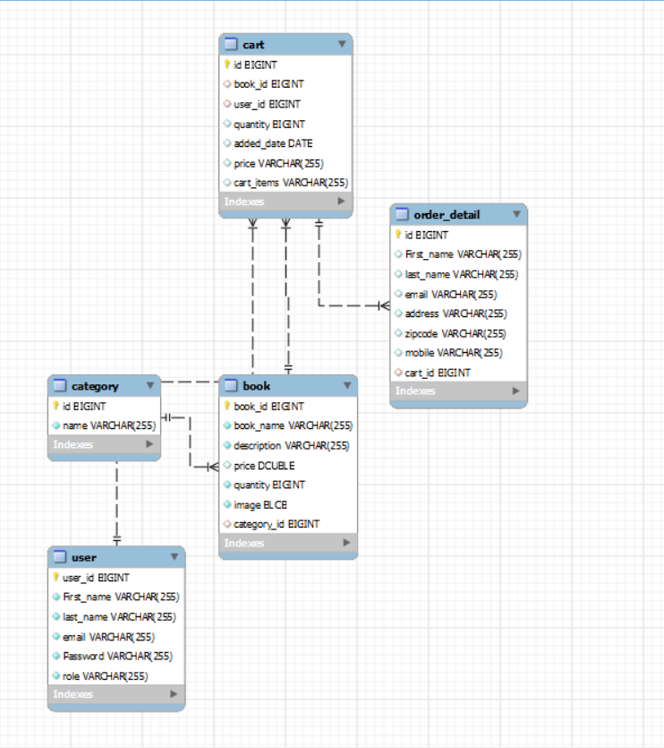

**Figure 5: Class Diagram**

## 4 .Use Case Diagram

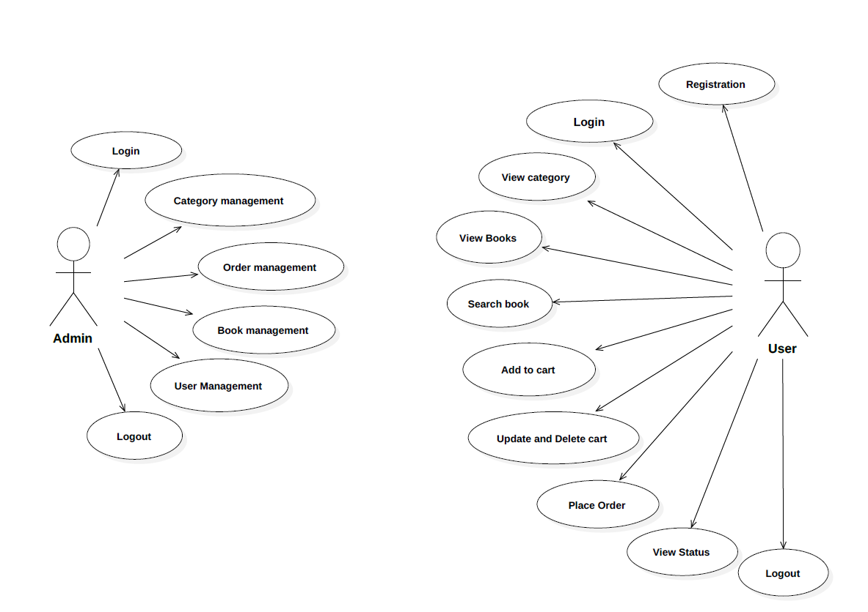

**Figure 6: Use Case Diagram**

## 5 .ERDiagram

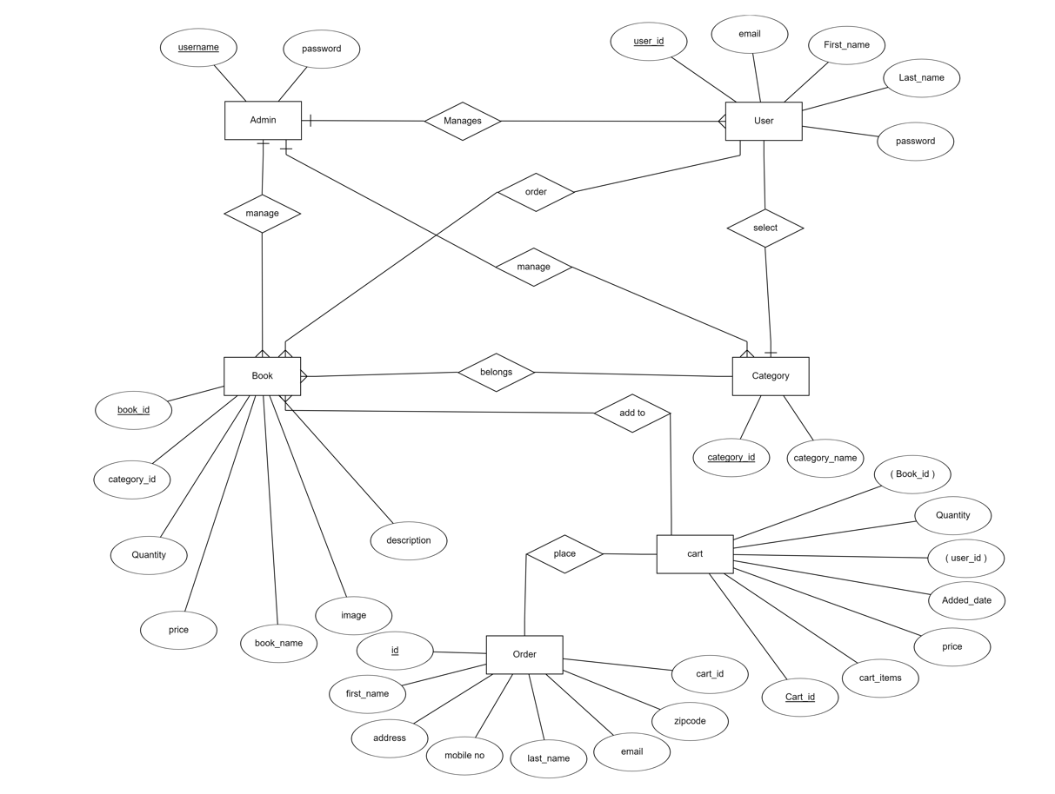

# Table Structure

Book table:

|  |  |  |  |  |  |
| --- | --- | --- | --- | --- | --- |
| **Field** | **Type** | **Null** | **Key** | **Default** | **Extra** |
| Book_id | int | NO | PRI | NULL |  |
| Book_description | Varchar(255) | YES |  | NULL |  |
| image | Blob | YES |  | NULL |  |
| Book_name | Varchar(255) | YES |  | NULL |  |
| Book_price | int | YES |  | NULL |  |
| Book_quantity | Int | YES |  | NULL |  |
| Category_id | int | YES | MUL | NULL |  |

User_Roles :

|  |  |  |  |  |  |
| --- | --- | --- | --- | --- | --- |
| **Field** | **Type** | **Null** | **Key** | **Default** | **Extra** |
| User_id | int | NO | PRI | NULL |  |
| Role_id | Varchar(255) | yes | PRI | NULL |  |

Roles:

|  |  |  |  |  |  |
| --- | --- | --- | --- | --- | --- |
| **Field** | **Type** | **Null** | **Key** | **Default** | **Extra** |
| Role_id | int | NO | PRI | NULL |  |
| Role_name | Varchar(255) | yes |  | NULL |  |

Category table :

|  |  |  |  |  |  |
| --- | --- | --- | --- | --- | --- |
| **Field** | **Type** | **Null** | **Key** | **Default** | **Extra** |
| Category_id | int | NO | PRI | NULL |  |
| Category_name | Varchar(255) | yes |  | NULL |  |

**User table:**

|  |  |  |  |  |  |
| --- | --- | --- | --- | --- | --- |
| **Field** | **Type** | **NULL** | **Key** | **Default** | **Extra** |
| User_id | bigint | NO | PRI | NULL |  |
| Email | Varchar(255) | YES |  | NULL |  |
| First_name | Varchar(255) | YES |  | NULL |  |
| Last_name | Varchar(255) | YES |  | NULL |  |
| Password | Varchar(255) | YES |  | NULL |  |
| role | Varchar(255) | YES | MUL | NULL |  |

Add to Cart :

|  |  |  |  |  |  |
| --- | --- | --- | --- | --- | --- |
| **Field** | **Type** | **Null** | **Key** | **Default** | **Extra** |
| Cart_id | int | NO | pri | NULL |  |
| User_id | BIGINT | NO | MUL | NULL |  |
| Book_id | BIGINT | NO | MUL | NULL |  |
| quantity | int | YES |  | NULL |  |

Order :

|  |  |  |  |  |  |
| --- | --- | --- | --- | --- | --- |
| **Field** | **Type** | **Null** | **Key** | **Default** | **Extra** |
| id | int | NO | pri | NULL |  |
| address | Varchar | NO |  | NULL |  |
| Email | Varchar | NO |  | NULL |  |
| Mobile no | Varchar | YES |  | NULL |  |
| Payment_type | Varchar | NO |  | NULL |  |
| Customer_id | Varchar | NO |  | NULL |  |
| zipcode | int | NO |  | NULL |  |
| Cart_id | int | No | MUL | NULL |  |
| Order_date | Date | NO |  | NULL |  |

Order_Details_cart :

|  |  |  |  |  |  |
| --- | --- | --- | --- | --- | --- |
| **Field** | **Type** | **Null** | **Key** | **Default** | **Extra** |
| Order_id | int | NO | MUL | NULL |  |
| Cart_Id | int | yes | PRI | NULL |  |

# Conclusion :

This project aid in automating the existing manual system. This is a paperless work. It can be monitored and guarded remotely also provide accurate information . Online Book Store the customer can purchase books online. It is mainly different from the traditional physical bookstores, to overcome a series of physical bookstores limited variety, fixed location, limited space and narrow sales channels and other issues, for people to purchase the book has brought convenience. Online bookstore system not only can easily find the information and purchase books, and the operating conditions are simple, user-friendly, to a large extent to solve real-life problems in the purchase of books,

# Future Scope

As for other future developments, the following can be done:

User can buy some subscription plan for accessing some advanced functionality like reading books online. if user don’t want to purchase the book but want to read the book in online mode so user need to pay some amount and they will be part of premium subscribers and after paying the specific amount they will easily access and read the book online.

# 7.0 References

1 .https://spring.io/projects/spring-data-jpa

2 .<https://www.bezkoder.com/spring-boot-jwt-authentication/>

3 .https://docs.spring.io/spring-framework/docs/current/reference/html/