In this assignment, we compared the generic version of Quick Sort with one pivot element to the dual pivot Quick Sort.

Quicksort (sometimes called partition-exchange sort) is an efficient sorting algorithm. When implemented well, it can be about two or three times faster than its main competitors, merge sort and heapsort.

The time complexity of Quick Sort is as below:

Average Case: O (n log n)

Worst Case: O (n2)

Quick Sort is an in place sorting algorithm and requires very few extra variables to complete the sorting process. It is a divide and conquer algorithm and sorts the sub arrays recursively to achieve the sorted array in the end. At each recursion step the array is split into smaller sub arrays where each of them undergo the same process. We stop the division into sub arrays when the end index of the sub array becomes equal to or less than the starting index of the sub array.

The execution times for our quick sort implementation in java is as below:

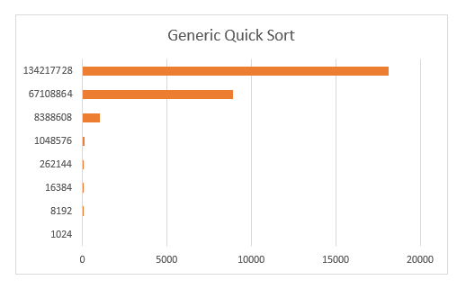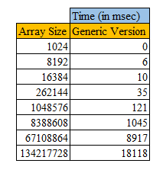

Few variations Quick Sort with multiple pivots have been proposed by researchers. We implemented the dual pivot Quick Sort algorithm. In the dual pivot Quick Sort – the array is divided into 3 sub parts and recursively sorted just like in generic quick sort with one pivot element.

We choose two pivots elements and place them to end of the array – starting and ending position. We recursively increment the starting index ensuring that the elements on the left of the index are smaller than the element on the index position. On the right end of the array we do opposite of this. We decrement the ending index of the array provided the elements to the right of the index position are greater than the element we are comparing to. We keep the unsorted subarray in between these two indexes which grows smaller with each recursion step and in the end we are left with sorted array.

We compared the execution time of generic quick sort with the dual pivot quick sort. Our findings are as below:

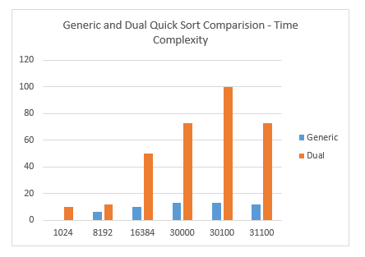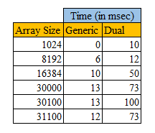

Beyond 32000 array size – the dual pivot program gave stack overflow error. However the generic version of quick sort worked fine for larger arrays.