Link :- https://www.hackerearth.com/problem/algorithm/digit-sum-4/

Name :- A.Digit Sum

(HACKEREARTH)

Code :-
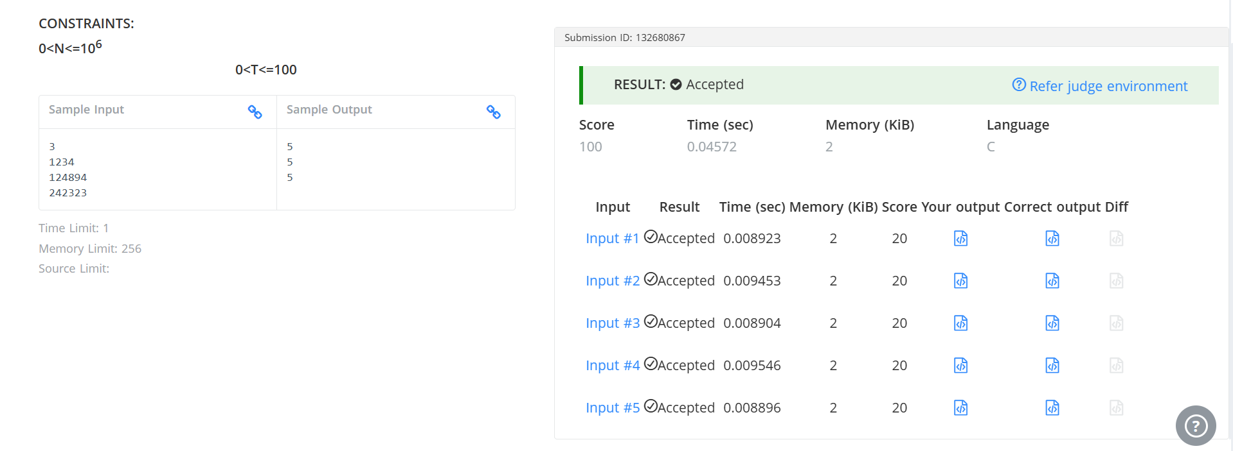

#include <stdio.h>

int main() {
int t, n;
scanf("%d", &t);

for (int i = 0; i < t; i++) {
scanf("%d", &n);

int last = n % 10;

while (n >= 10) {
n = n / 10;
}

int first = n;

printf("%d\n", first + last);
}

return 0;
}

