Link :- https://www.hackerrank.com/challenges/printing-pattern-2/problem
Name :- Printing Pattern Using Loops

(HACKERRANK)

Code :-

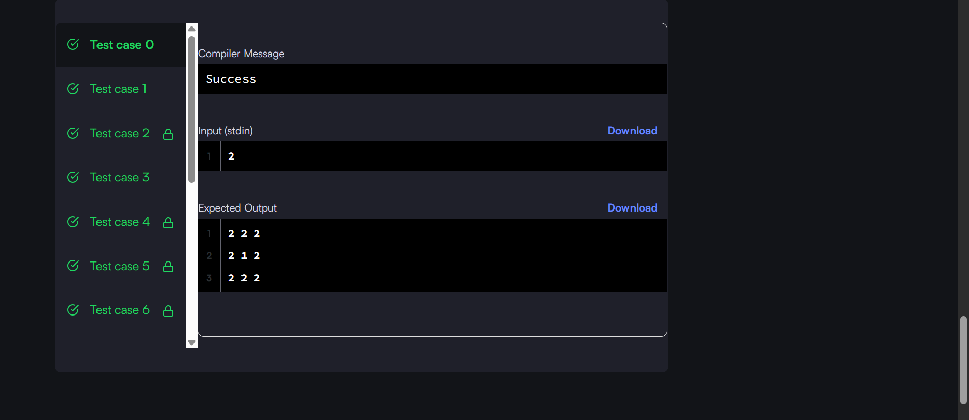

#include <stdio.h>

int main() {
int n;
scanf("%d", &n);

int size = 2 * n - 1;

for (int i = 0; i < size; i++) {
for (int j = 0; j < size; j++) {

int a = i;
int b = j;
int c = size - 1 - i;
int d = size - 1 - j;

int min = a;

if (b < min) min = b;
if (c < min) min = c;
if (d < min) min = d;

printf("%d ", n - min);
}
printf("\n");
}

return 0;
}

