**EXECUTION PLANS**

1ST EXECUTION PLAN

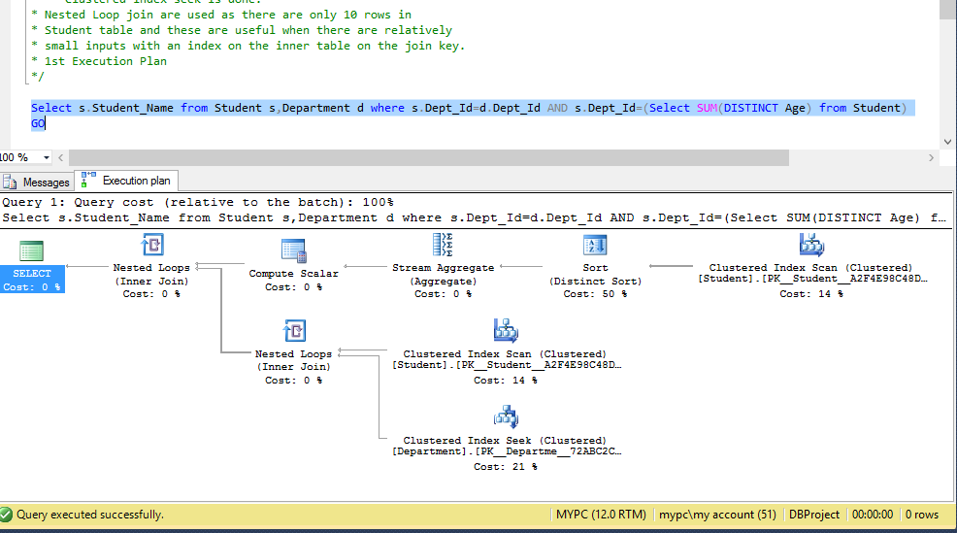

2ND EXECUTION PLAN

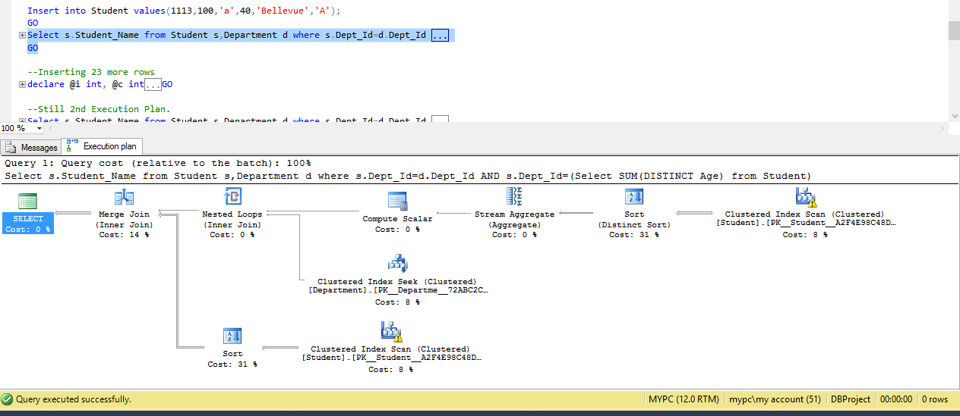

3rd EXECUTION PLAN

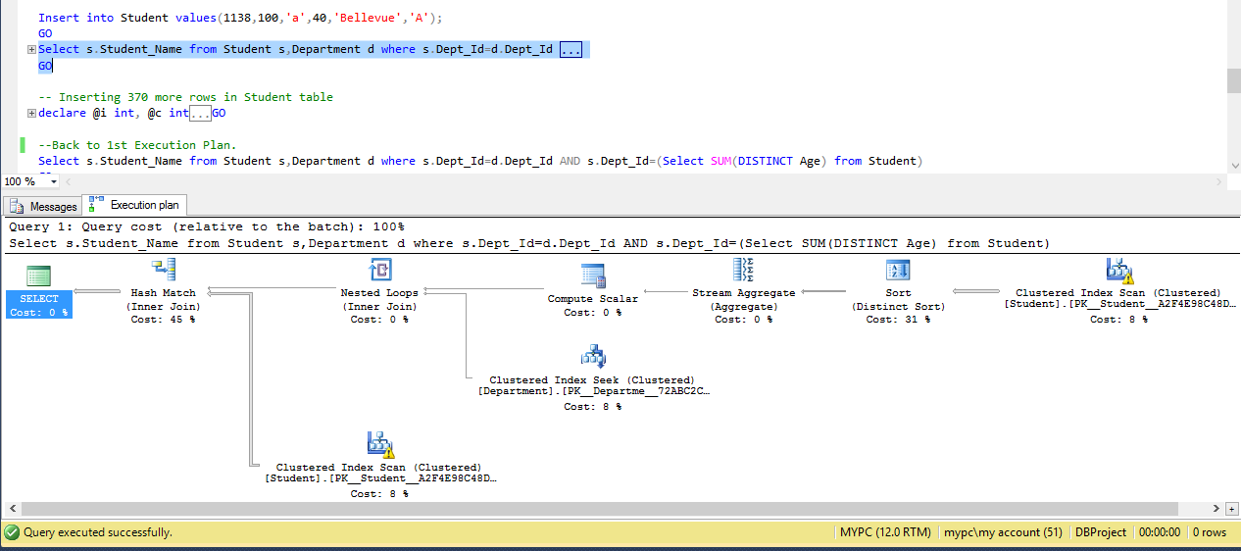

4TH EXECUTION PLAN

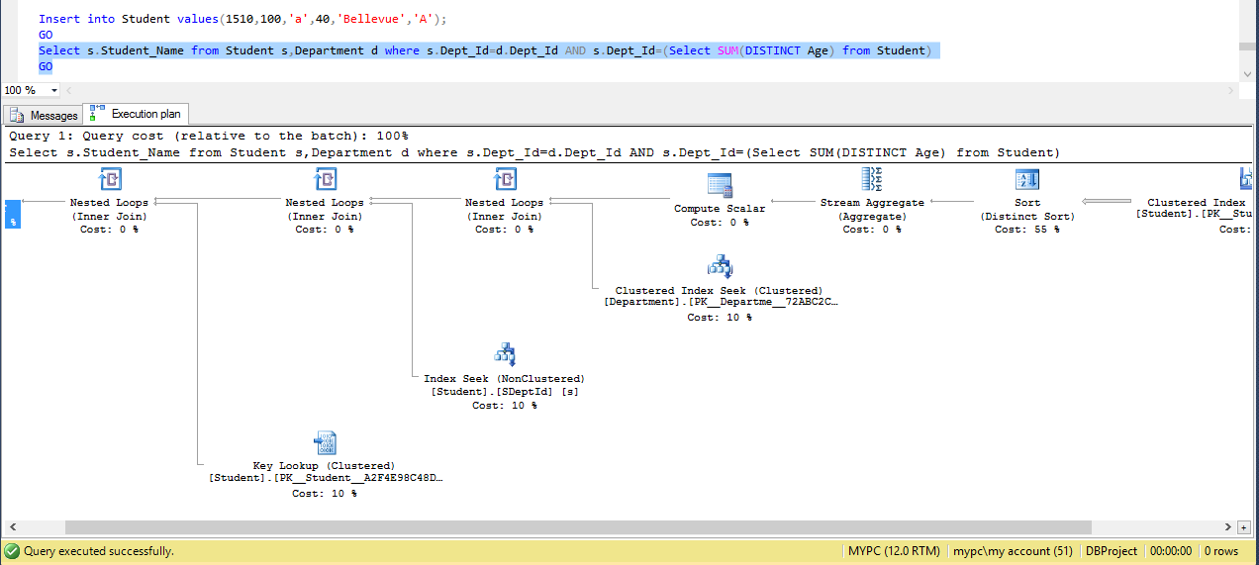

5TH EXECUTION PLAN

