**EXECUTION PLANS**

1. EXECUTION PLAN 1:

* For Query 1, Q1:

Statistics:

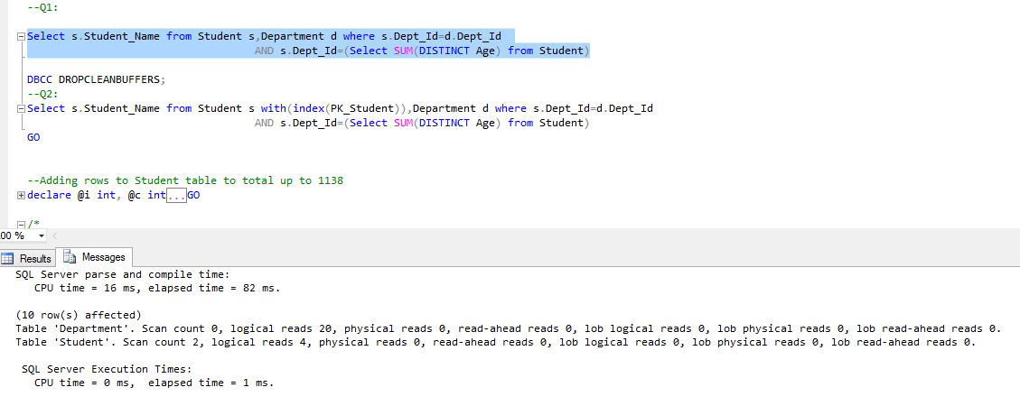

Execution Plan:

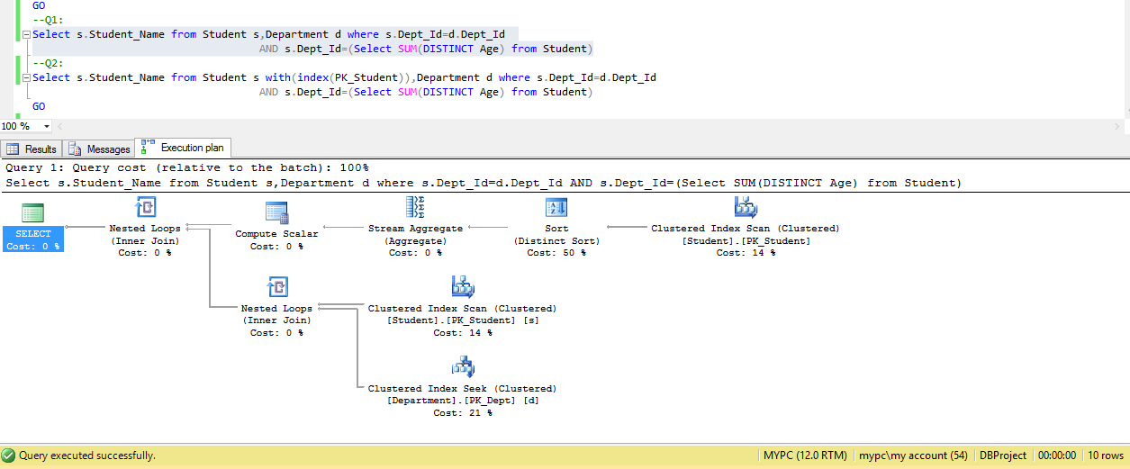

* For Query 2, Q2:

Statistics:

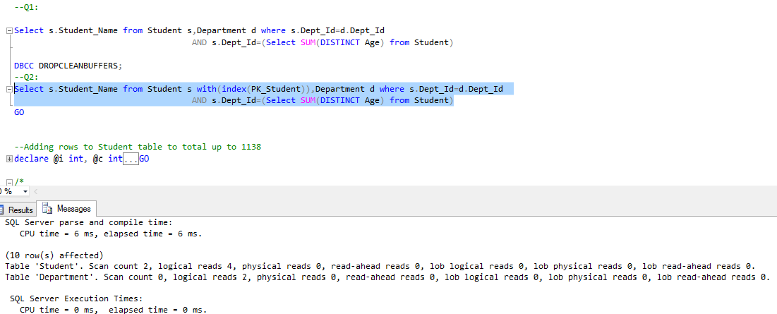

Execution Plan:

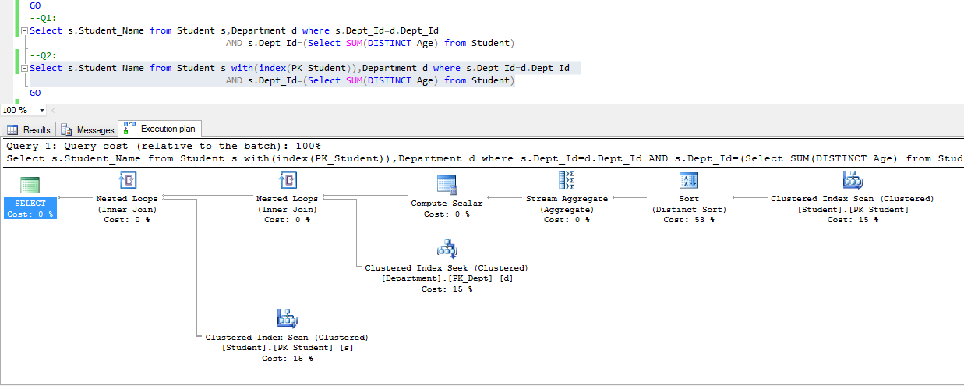

* Relative Cost of Q1 and Q2:

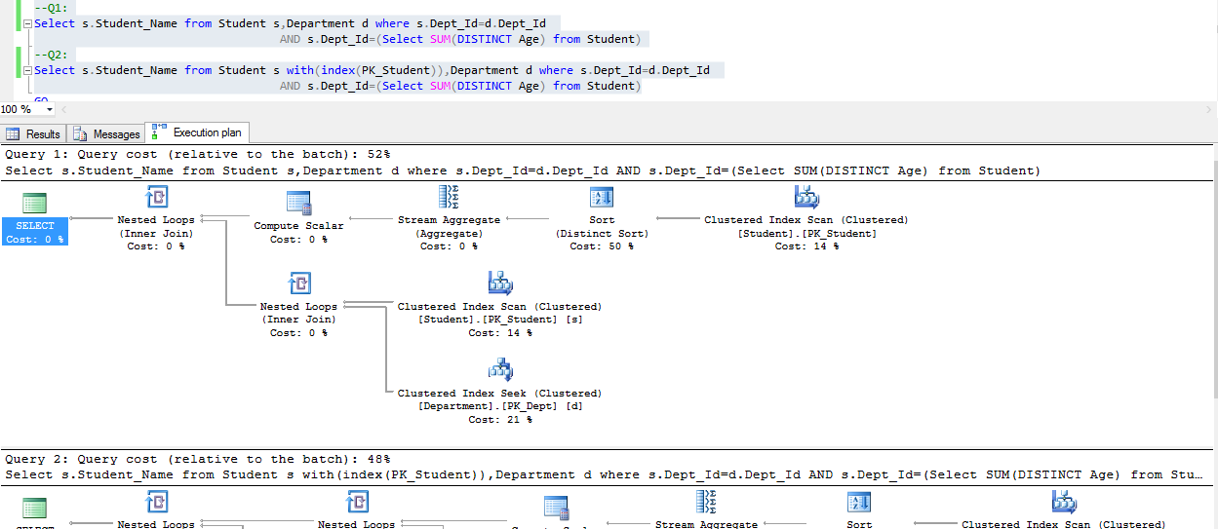

1. **EXECUTION PLAN 2**

* For Query, Q1:

Statistics

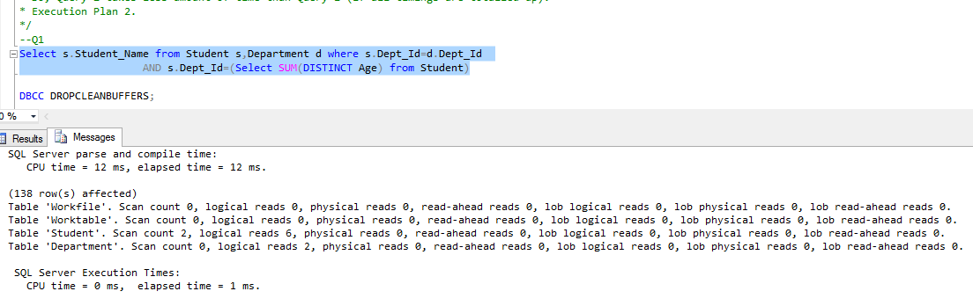

Execution Plan

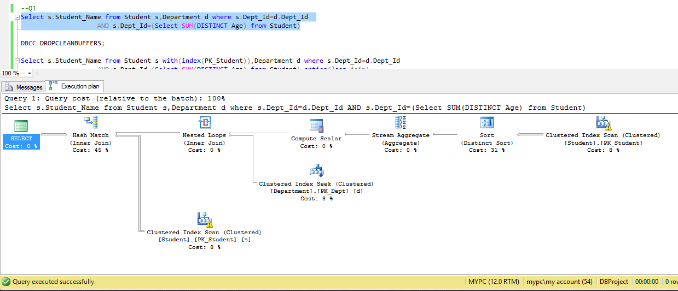

* For Query,Q2

Statistics

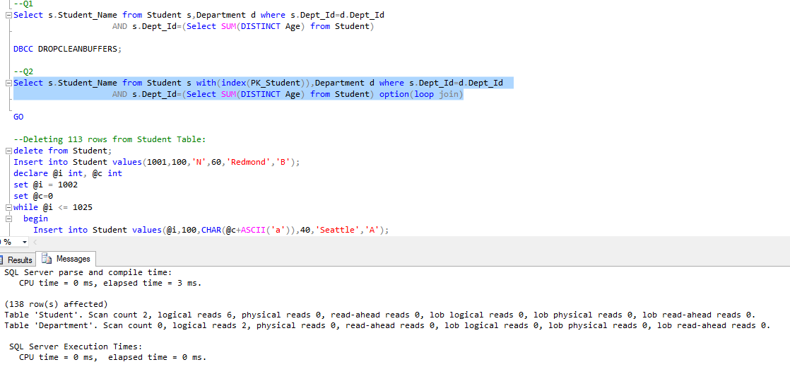

Execution Plan

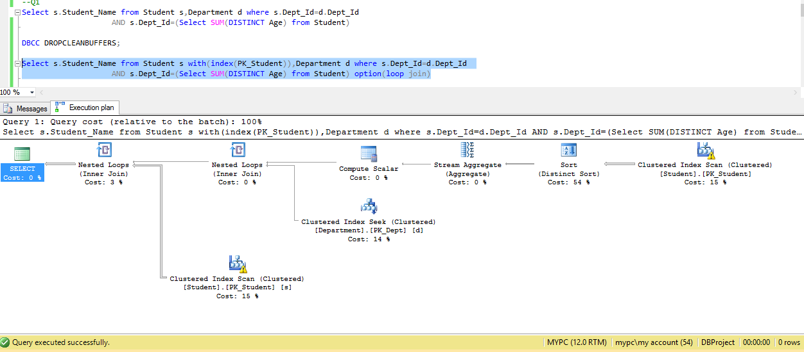

* Relative Cost of Q1 and Q2:

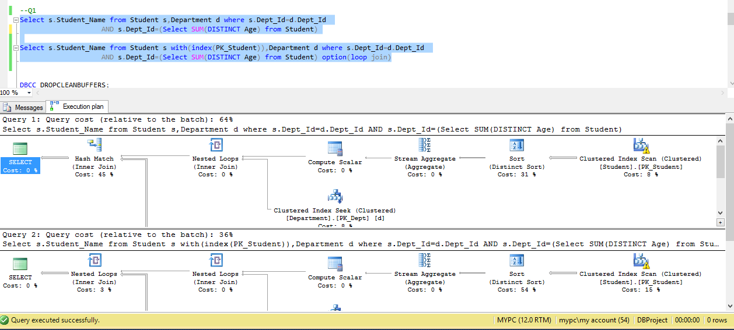

1. **EXECUTION PLAN 3**

* For Query, Q1:

Statistics

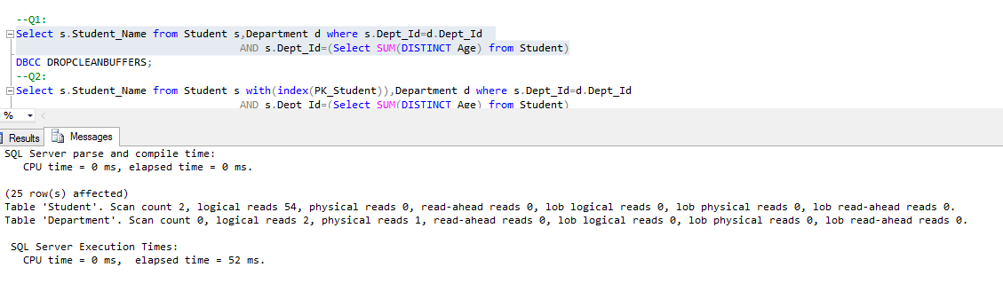

Execution Plan

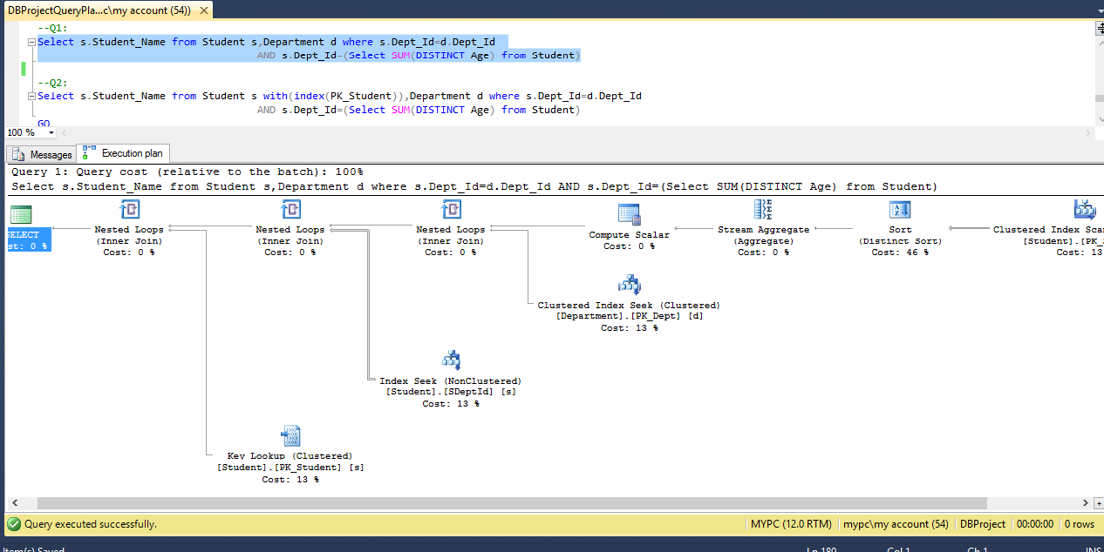

* For Query,Q2

Statistics

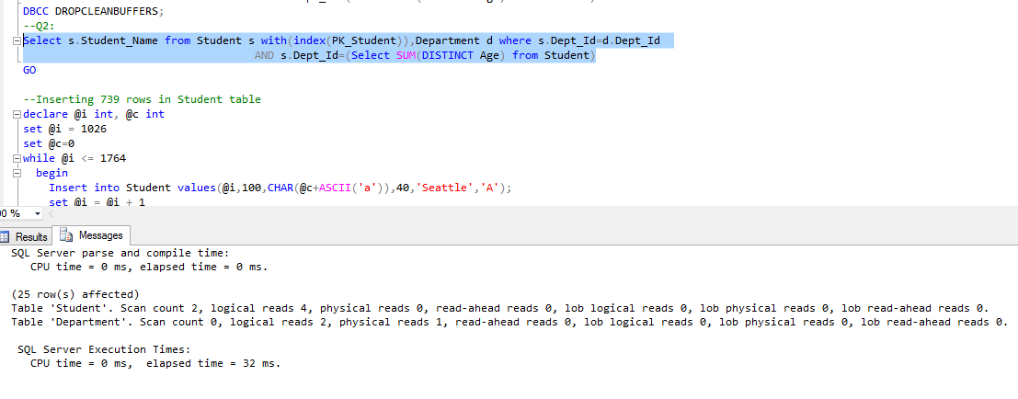

Execution Plan

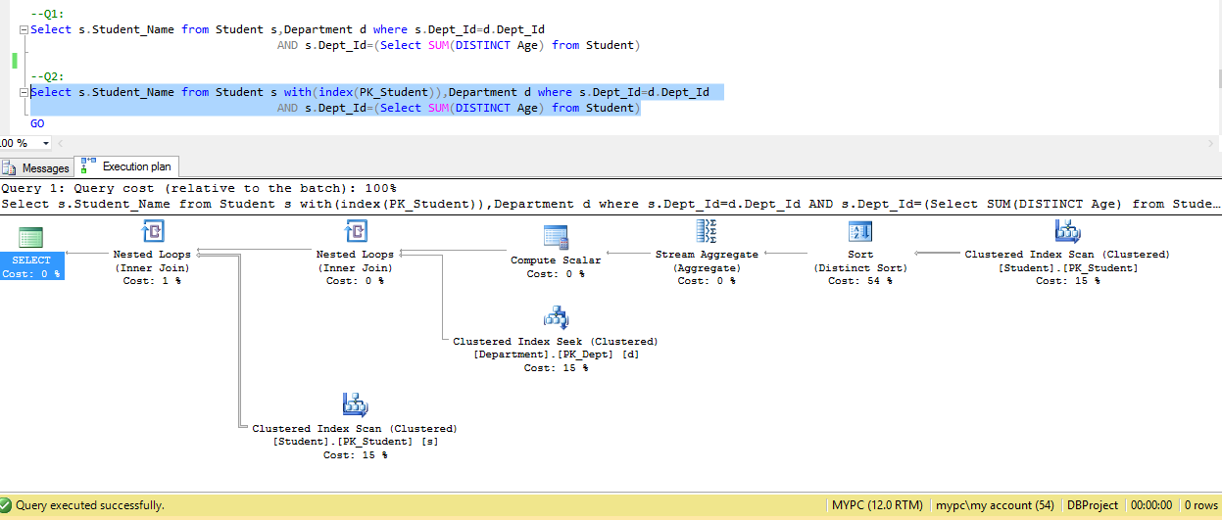

* Relative Cost of Q1 and Q2:

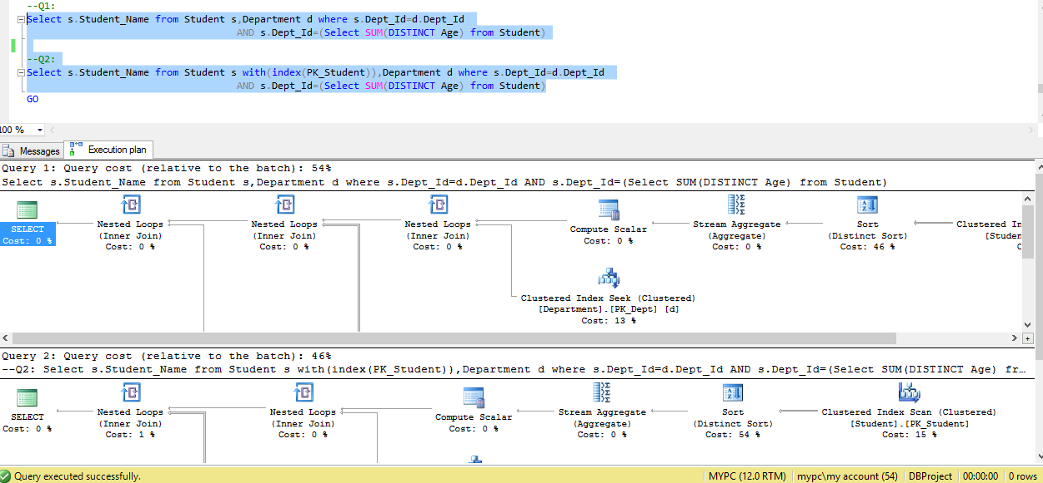

1. **EXECUTION PLAN 4**

* For Query, Q1:

Statistics

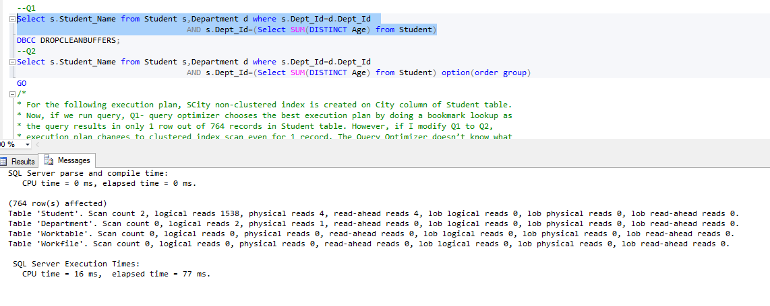

Execution Plan

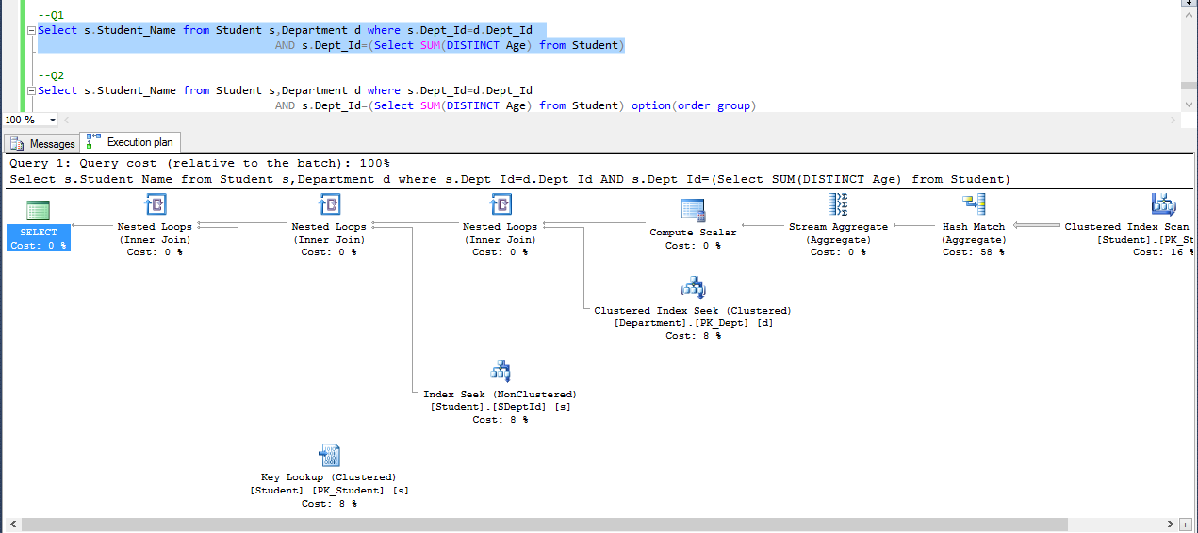

* For Query, Q2:

Statistics

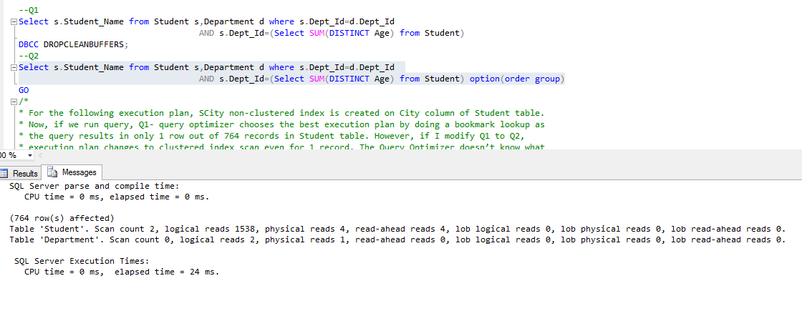

Execution Plan

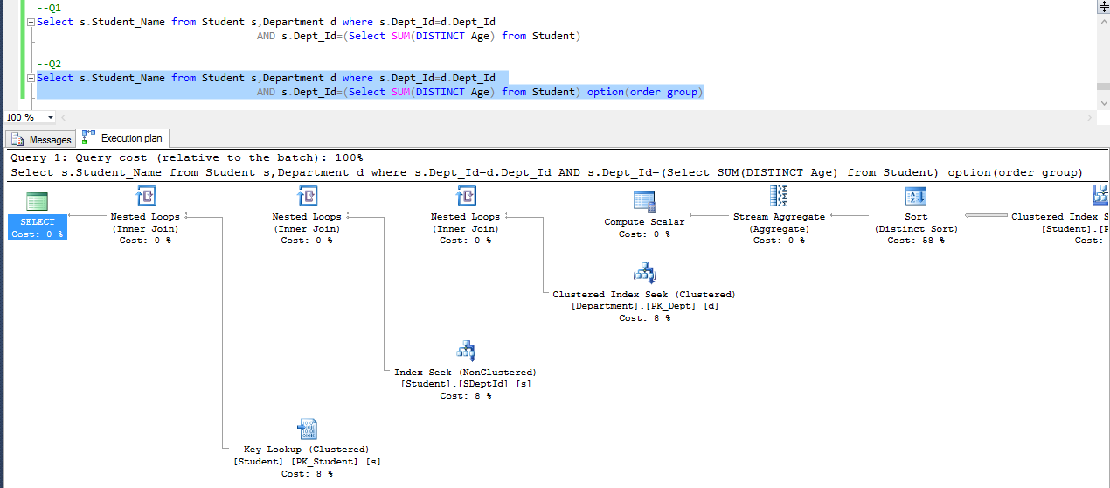

* Relative Cost of Q1 and Q2:

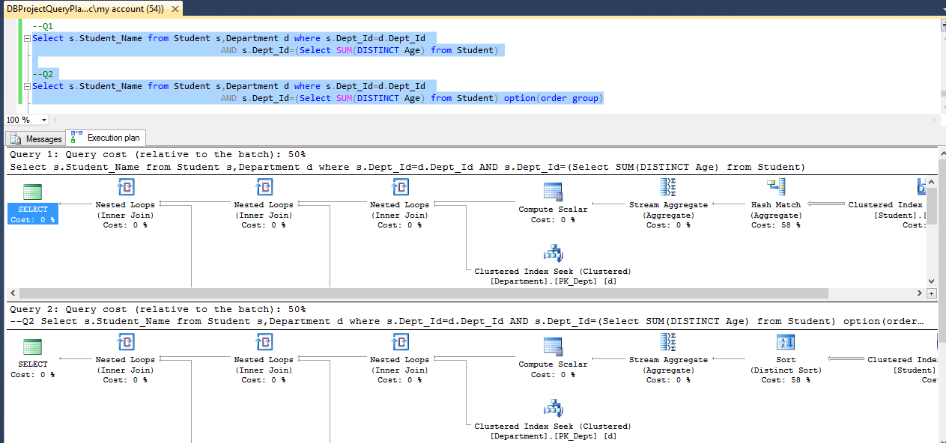

1. **EXECUTION PLAN 5**

* For Query, Q1:

Statistics

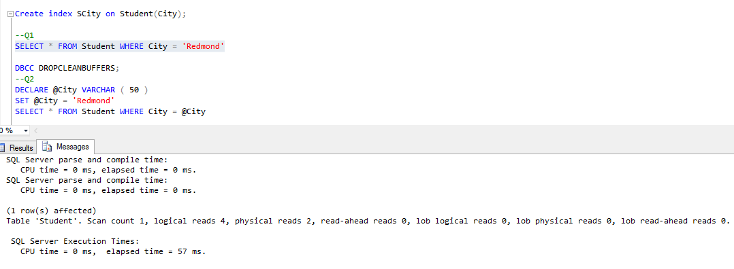

Execution Plan

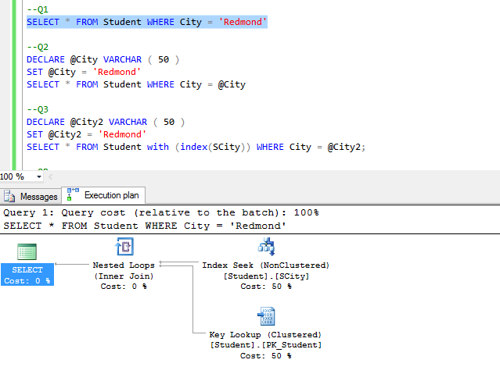

* For Query, Q2:

Statistics:

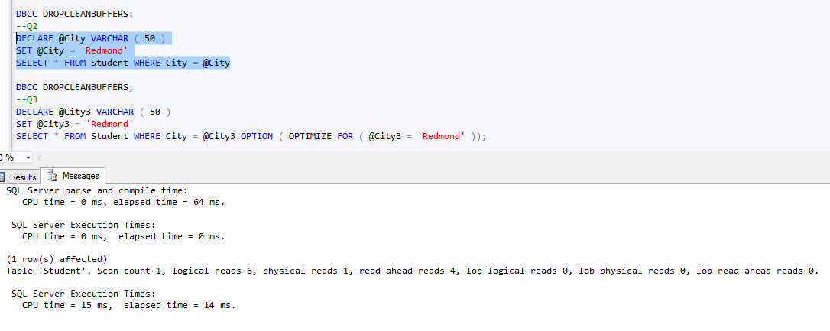

Execution Plan

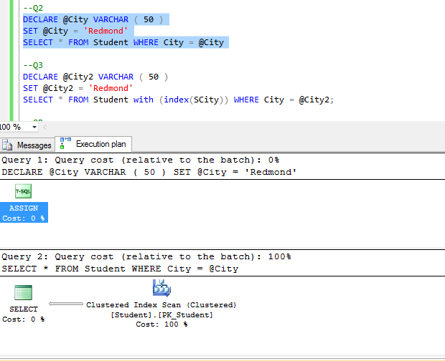

* For Query, Q3:

Statistics

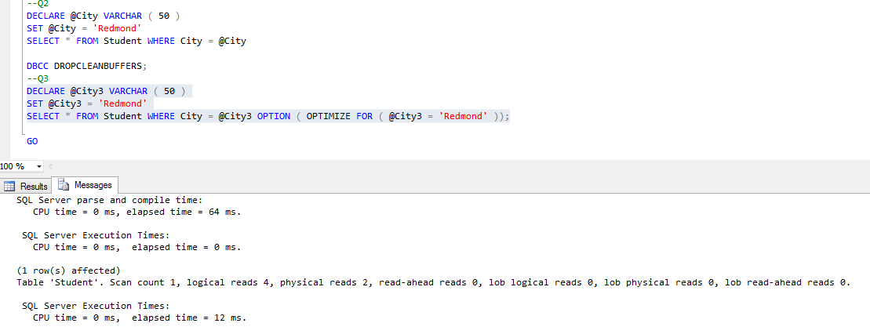

Execution Plan

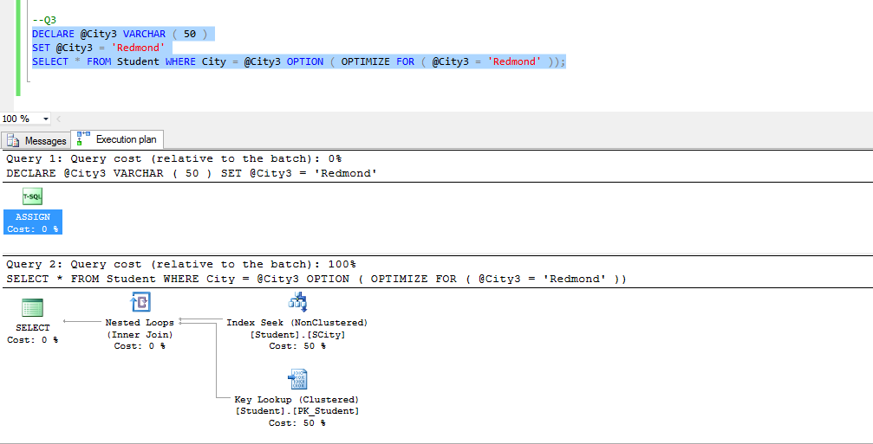

1. Execution Plan 6

For Query 1:

Estimation with Actual Execution Plan for Query Q1:

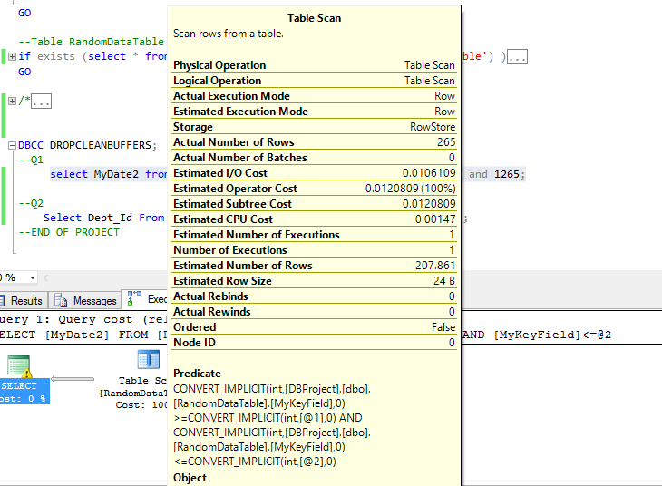

Statistics:

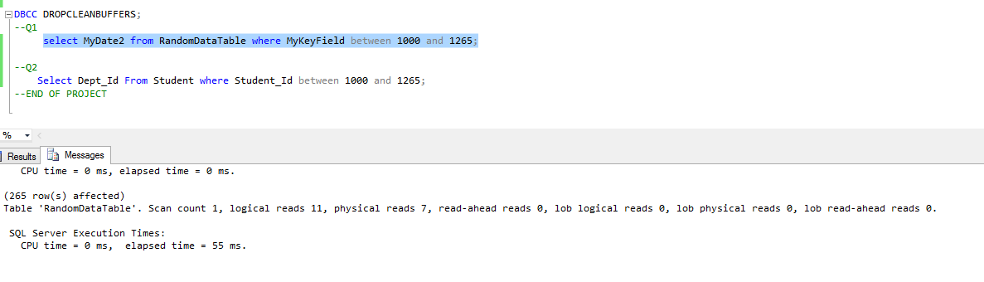

For Query 2,

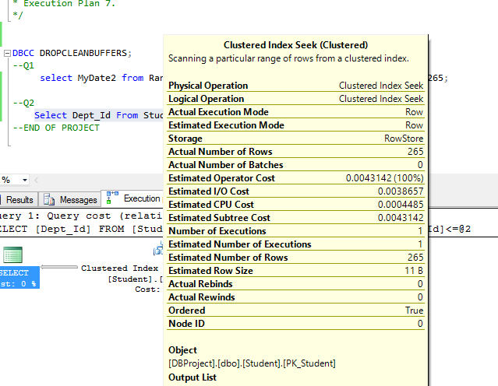

Statistics:

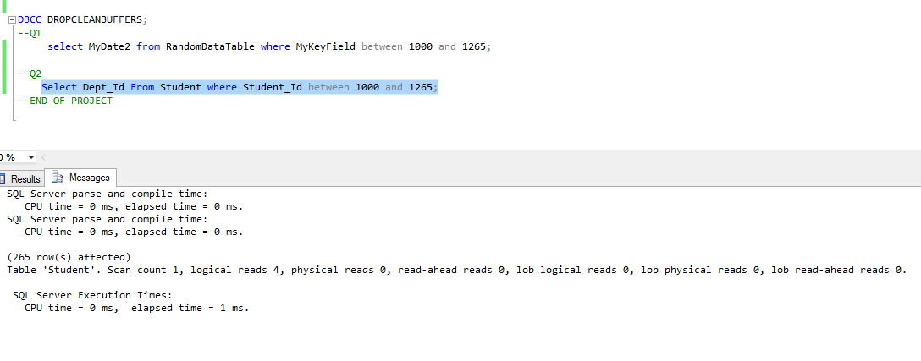

1. Execution Plan 7

Estimation with Actual Execution Plan for Query Q1:

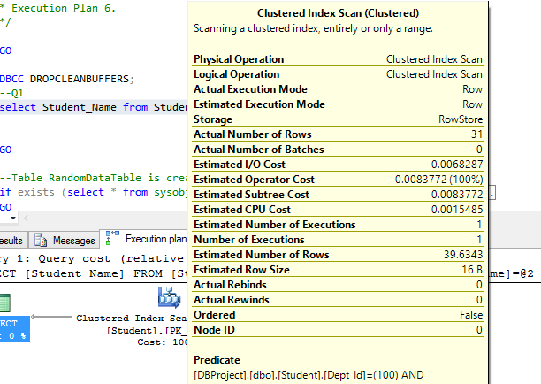

Time and I/O estimation:

