**RESULTS**

TimeInMins NumberOfTrees PercentageAccuracy high medium low

1 0.160000 10 38.190 50.458 27.859 30.612

2 0.270710 20 39.420 53.972 25.872 31.385

3 0.569000 50 40.860 62.235 25.021 25.748

4 1.065885 100 42.690 68.591 24.255 23.730

5 2.124385 200 43.730 74.470 22.720 20.529

6 3.145339 300 44.160 75.953 22.128 20.390

7 4.155372 400 45.330 78.230 24.936 18.789

8 5.155309 500 45.530 78.972 24.766 18.580

9 6.089084 600 45.180 78.178 24.766 18.511

10 7.137334 700 44.636 78.549 25.170 17.382

11 8.048808 800 44.780 78.443 24.766 16.910

12 9.023772 900 45.270 79.873 24.170 17.049

13 10.082752 1000 45.400 80.244 24.000 17.119

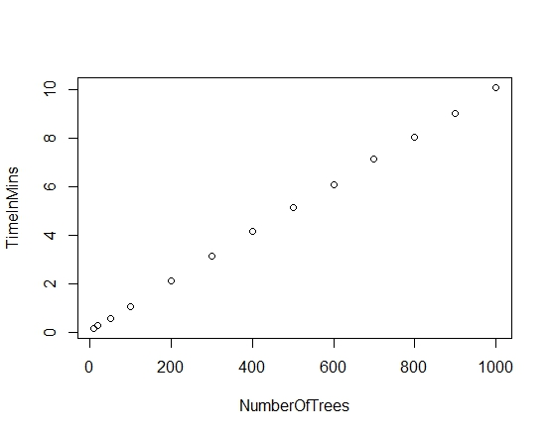

PLOT 1:

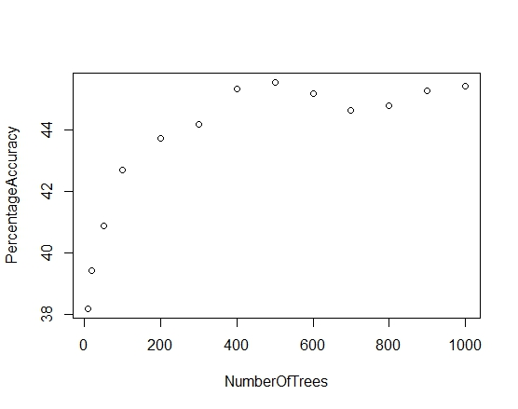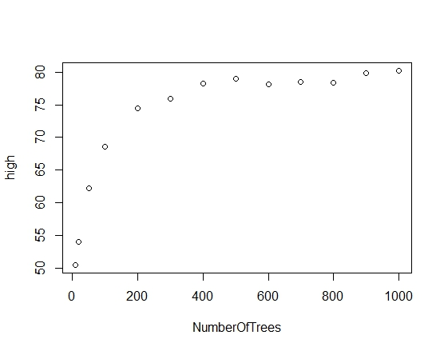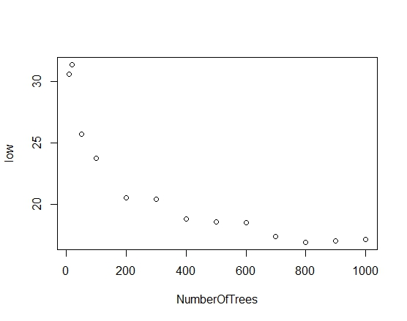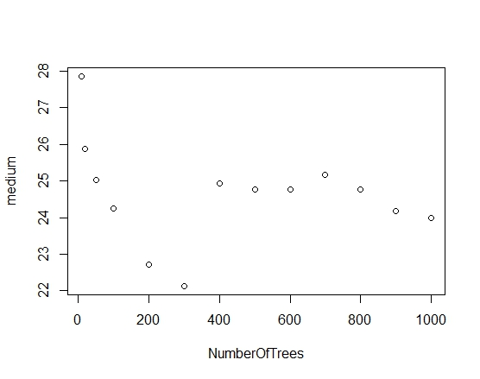

PLOT 3:

PLOT 2:

From Plot 3,4 and 5; we can conclude that for “high cost” records, the accuracy is increasing with number of trees, for “low” it decreases and for “medium” it is decreasing till 300 trees and then accuracy is around 25% till 1000 tress. This explains class imbalance problem.

PLOT 4:

PLOT 5: