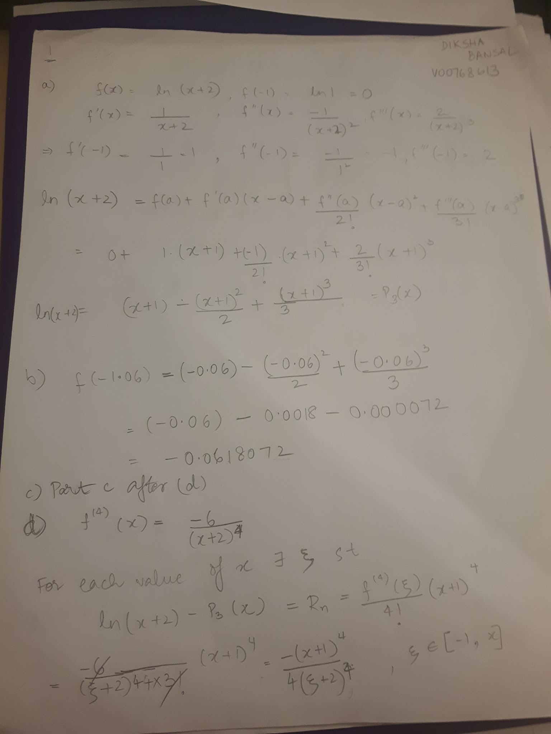

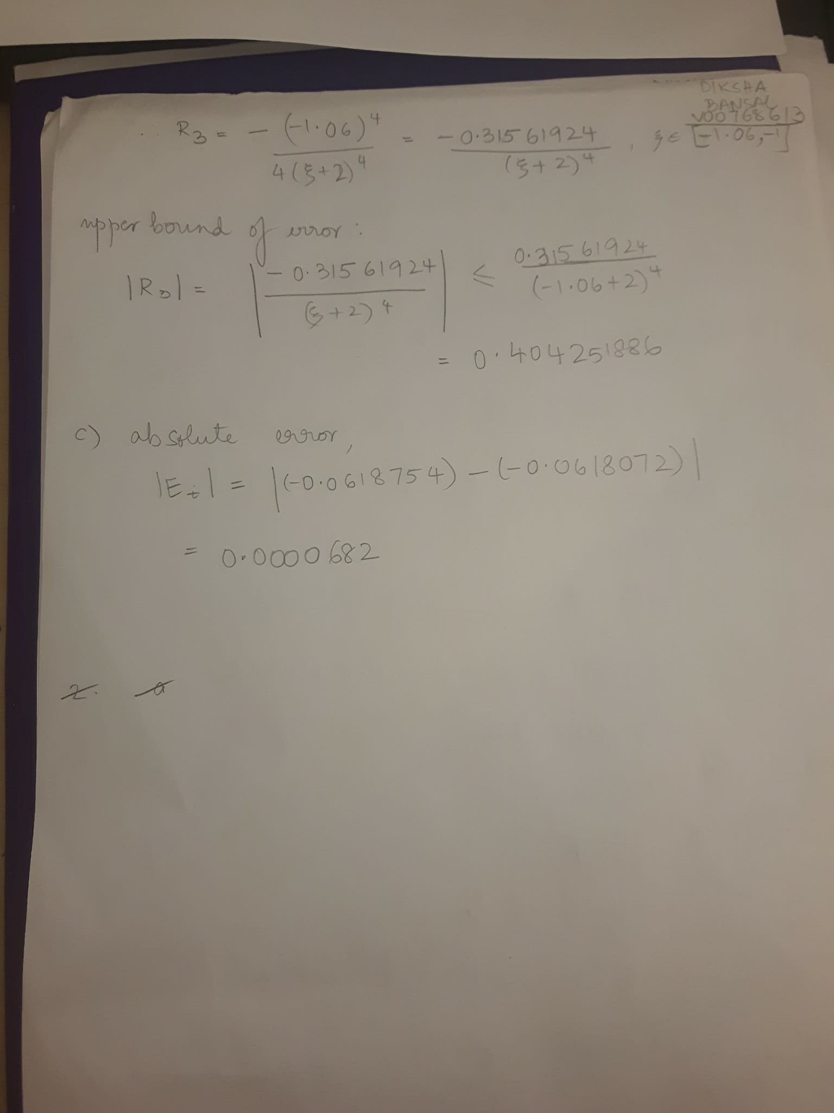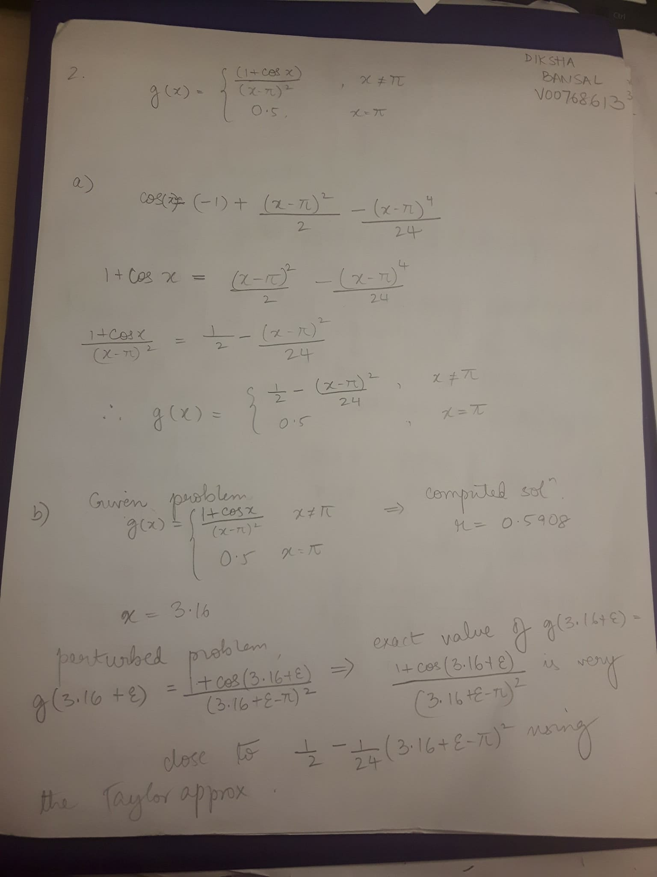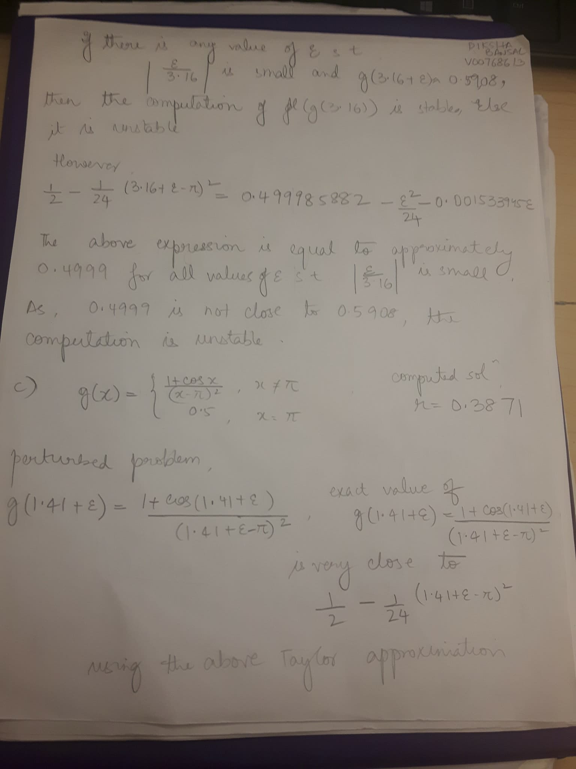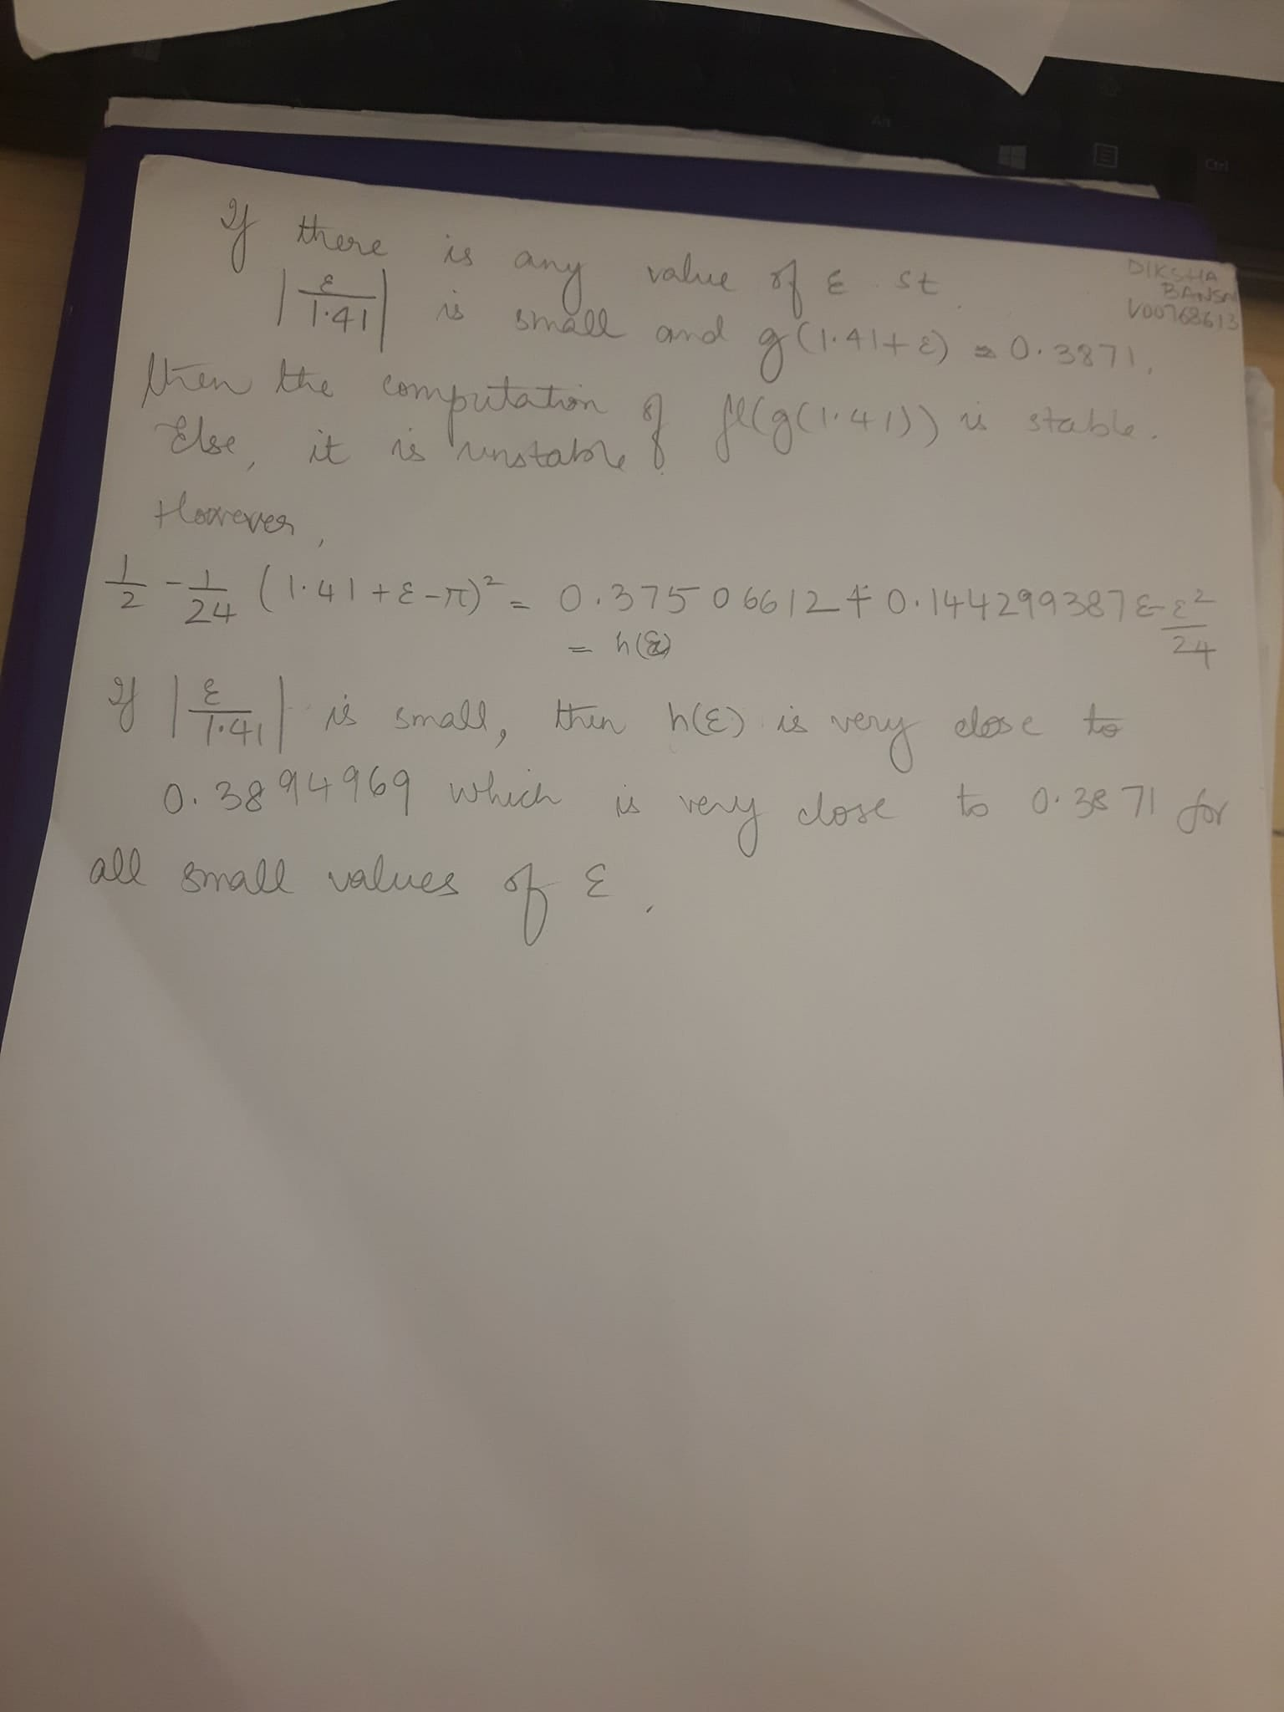

3.

a) function root = Bisect(xl, xu, eps, imax, f)

i = 1;

f = f(xl);

fprintf('iteration approximation \n')

while(i <= imax)

xr = (xl+xu)/2;

fprintf('%6.0f %18.8f \n', i, xr)

fr = f(xr);

if(fr == 0 || ((xu-xl)/(xu+xl)) < eps)

root = xr;

exit;

end

i = i+1;

if(fl\*fr < 0)

xu = xr;

else

xl = xr;

fl = fr;

end

end

fprintf('failed to converge in %g iterations \n ', imax);

b)

function [vol] = height(h)

vol = (pi\*h\*h\*(12.3-h))/3 - 45;

end

root = Bisect(0, 4.1, 1e-4, 20, 'height')

c) function [vel] = fall(m)

vel = (9.81\*m/13.5)\*(1-e ^(-135/m);

end

root = bitset(1,100,10^(-4),20,'fall')