# CSC 349A ASSIGNMENT 5

1. a)

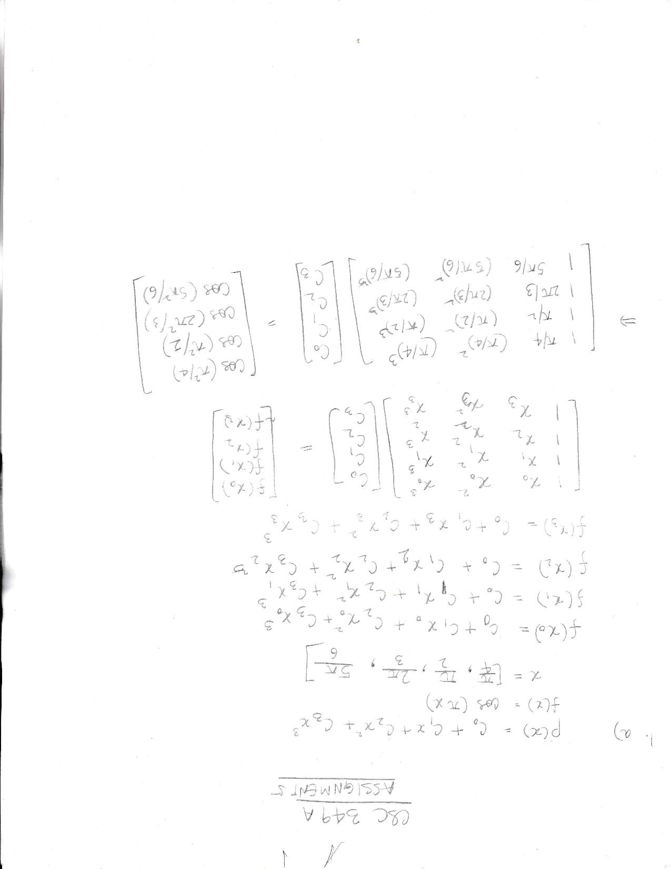

b)   
>> a_1 = pi/4  
a_1 =  
 0.7854

>> a_2 = a_1^2

a_2 =

0.6169

>> a_3 = a_1^3

a_3 =

0.4845

>> b_1 = pi/2

b_1 =

1.5708

>> b_2 = b_1^2

b_2 =

2.4674

>> b_3 = b_1^3

b_3 =

3.8758

>> c_1 = 2*pi/3

c_1 =

2.0944

>> c_2 = c_1^2

c_2 =

4.3865

>> c_3 = c_1^3

c_3 =

9.1870

>> d_1 = 5*pi/6

d_1 =

2.6180

>> d_2 = d_1^2

d_2 =

6.8539

>> d_3 = d_1^3  
d_3 =  
 17.9434

>> A = [1 a_1 a_2 a_3; 1 b_1 b_2 b_3; 1 c_1 c_2 c_3; 1 d_1 d_2 d_3]

A =

1.0000 0.7854 0.6169 0.4845

1.0000 1.5708 2.4674 3.8758

1.0000 2.0944 4.3865 9.1870

1.0000 2.6180 6.8539 17.9434

>> B = [cos(a_2); cos(b_2); cos(c_2); cos(d_2)]

B =

0.8157

-0.7812

-0.3202

0.8415

>> A\B

ans =

6.4957

-10.4697

4.5287

-0.5174

c) fplot(@(x) cos(pi*x), [pi/4 5*pi/6], ‘b’)

>> hold on

>> fplot(@(x) 6.4957 - 10.4697.*(x) + 4.5287.*(x.^2) - 0.5174.*(x.^3), [pi/4 5*pi/6], 'r')

>> hold off

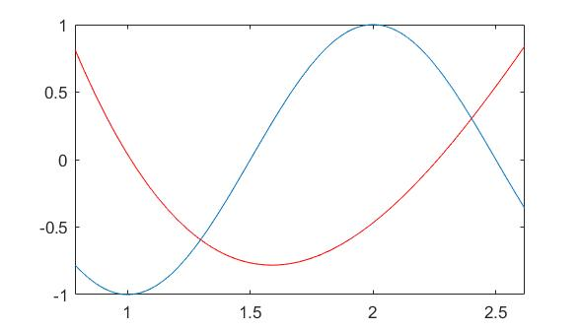

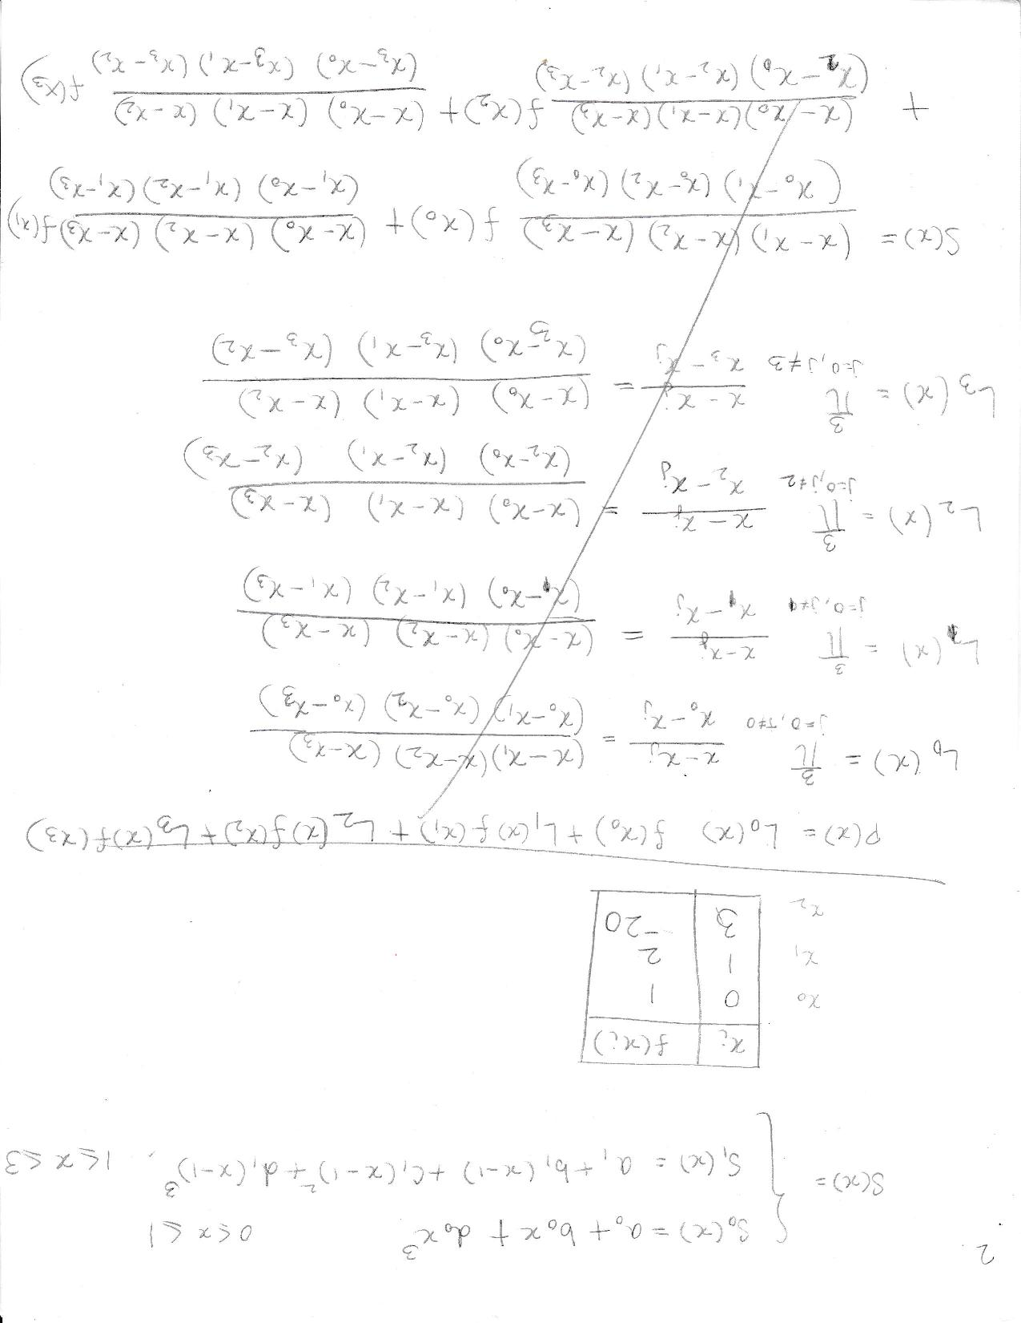

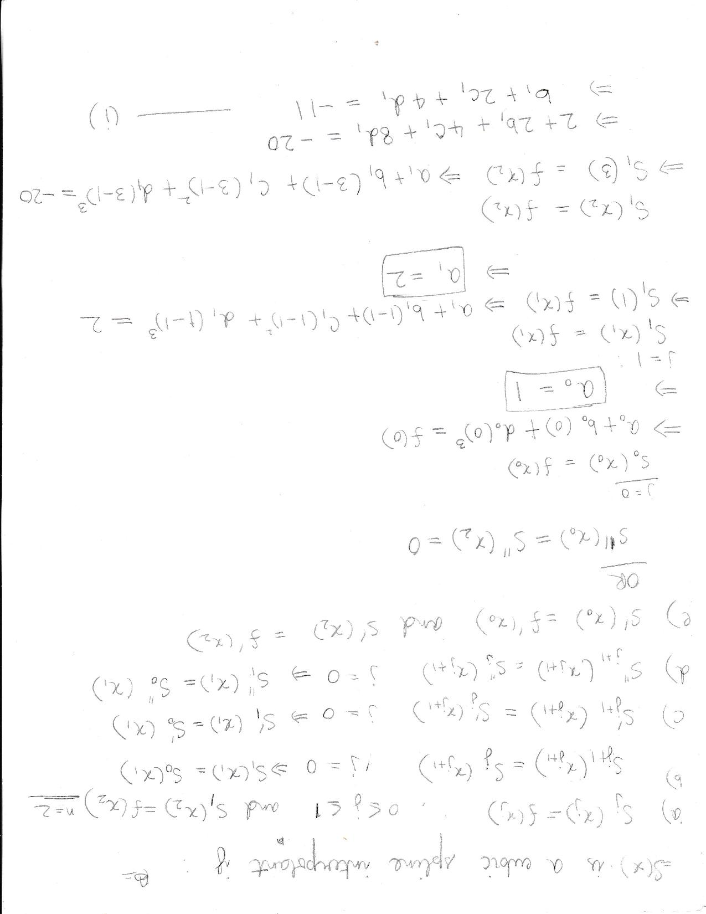

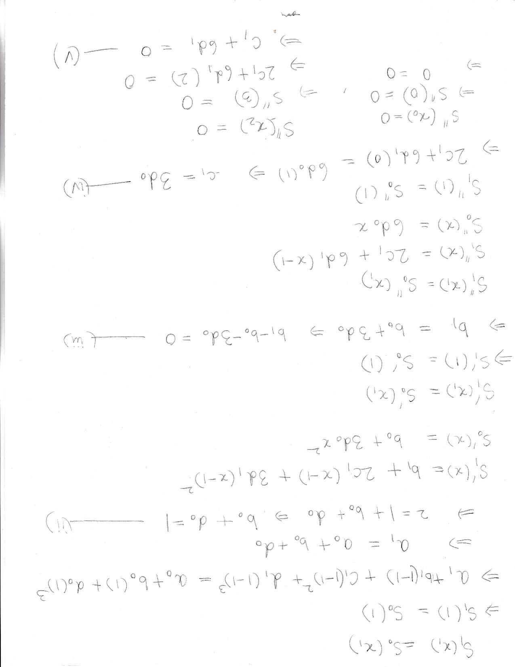

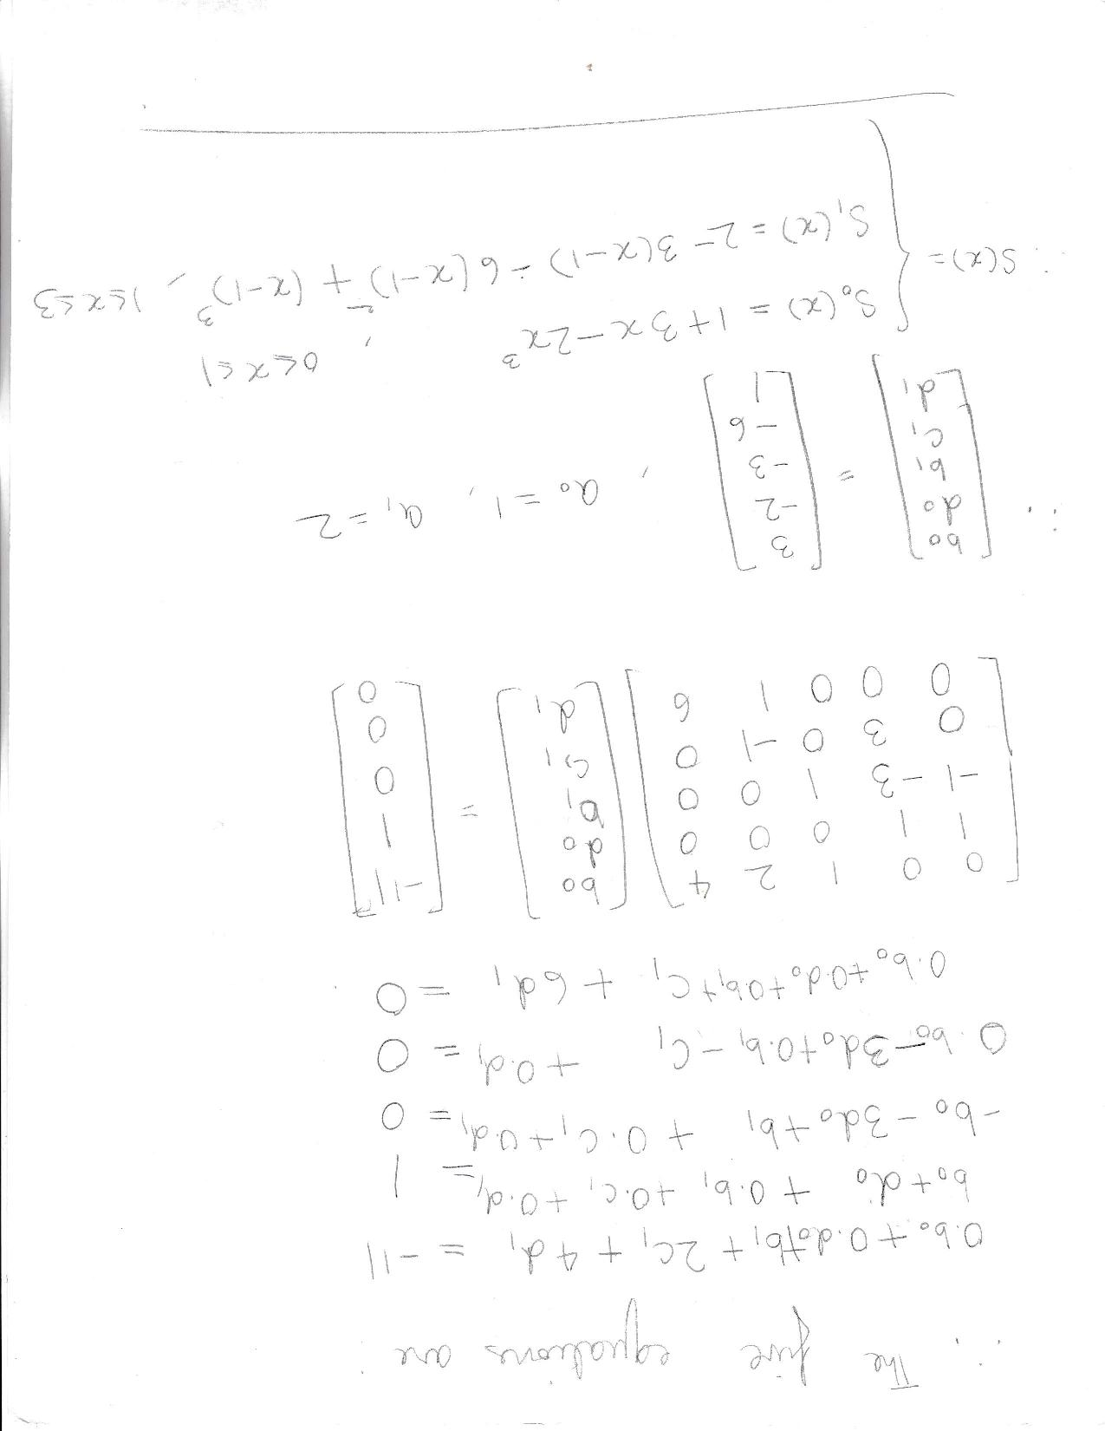

>> C = [0 0 1 2 4; 1 1 0 0 0; -1 -3 1 0 0; 0 3 0 -1 0; 0 0 0 1 6]

C =

0 0 1 2 4

1 1 0 0 0

-1 -3 1 0 0

0 3 0 -1 0

0 0 0 1 6

>> D = [-11; 1; 0; 0; 0]

D =

-11

1

0

0

0

>> C\D

ans =

3

-2

-3

-6

1

1. a) >> X = [1 2 5 6 7 8 10 13 17]

X =

1 2 5 6 7 8 10 13 17

>> Y= [1 3 3.7 3.9 4.2 5.7 6.6 7.1 6.7 4.5 -0.67]

Y =

1.0000 3.0000 3.7000 3.9000 4.2000 5.7000 6.6000 7.1000 6.7000 4.5000 -0.6700

>> pp = spline(X, Y)

pp =

struct with fields:

form: 'pp'

breaks: [1 2 5 6 7 8 10 13 17]

coefs: [8×4 double]

pieces: 8

order: 4

dim: 1

>> format short

>> [b,c] = unmkpp(pp)

b =

1 2 5 6 7 8 10 13 17

c =

0.0468 -0.3468 1.0000 3.0000

0.0266 -0.2064 0.4468 3.7000

0.3419 0.0326 -0.0745 3.9000

-0.5745 1.0582 1.0163 4.2000

0.1563 -0.6654 1.4091 5.7000

0.0239 -0.1965 0.5472 6.6000

-0.0026 -0.0529 0.0485 7.1000

0.0057 -0.0759 -0.3381 6.7000

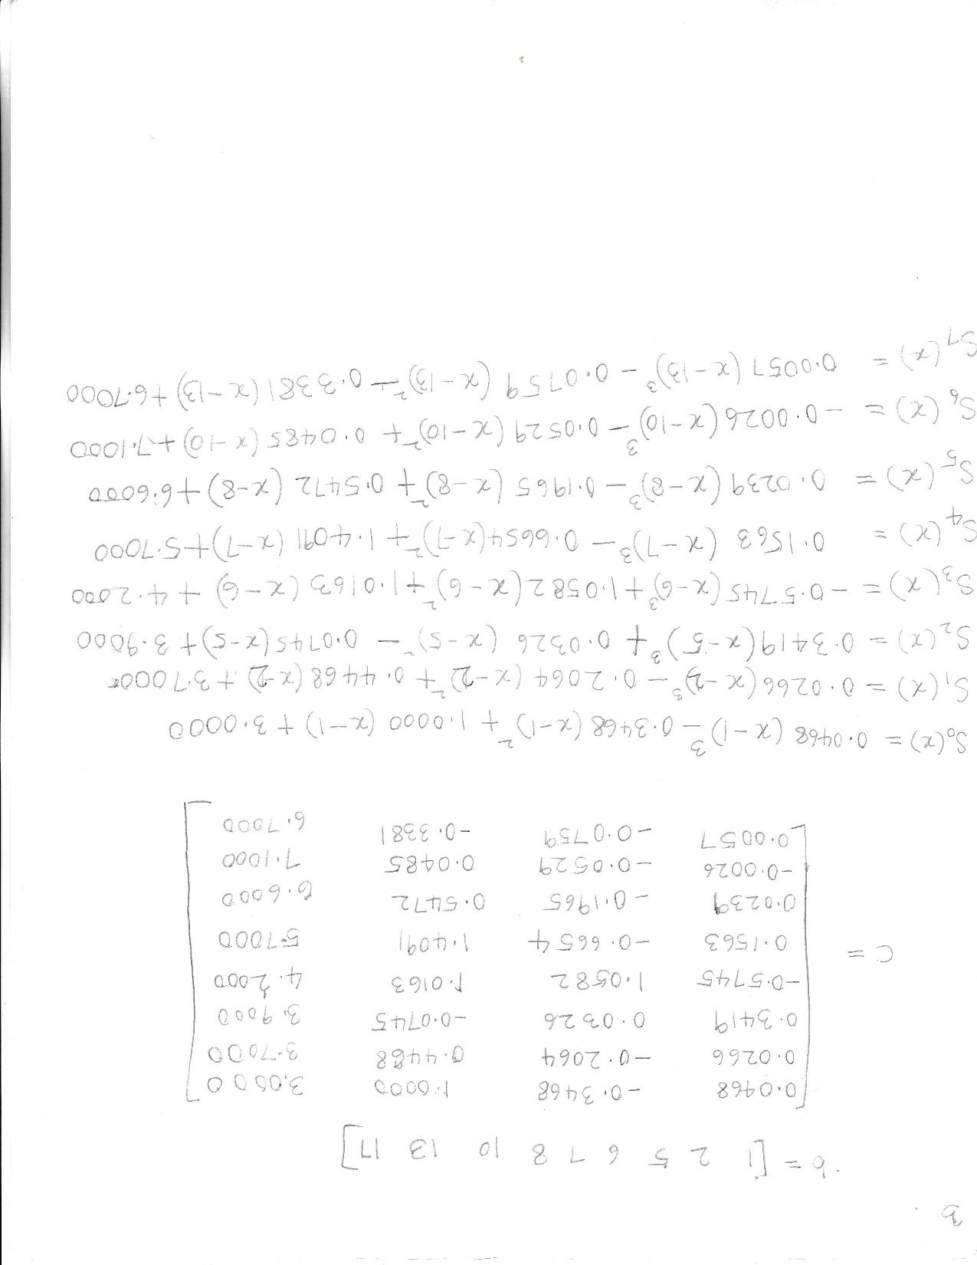

b) X1 = linspace(1,2,50);

>> Y1 = 0.0468*(X1-1).^3-0.3468*(X1-1).^2+1.0000*(X1-1)+3.0000;

>> plot(X1,Y1,'-')

>> hold on

>> X2 = linspace(2,5,50);

>> Y2 = 0.0266*(X2-2).^3-0.2064*(X2-2).^2+0.4468*(X2-2)+3.7000;

>> plot(X2,Y2,':')

>> hold on

>> X3 = linspace(5,6,50);

>> Y3 = 0.3419*(X3-5).^3+0.0326*(X3-5).^2-0.0745*(X3-5)+3.9000;

>> plot(X3,Y3,'-')

>> hold on

>> X4 = linspace(6,7,50);

>> Y4 = -0.5745*(X4-6).^3+1.0582*(X4-6).^2+1.0163*(X4-6)+4.2000;

>> plot(X4,Y4,':')

>> hold on

>> X5 = linspace(7,8,50);

>> Y5 = 0.1563*(X5-7).^3-0.6654*(X5-7).^2+1.4091*(X5-7)+5.7000;

>> plot(X5,Y5,'-')

>> hold on

>> X6 = linspace(8,10,50);

>> Y6 = 0.0239*(X6-8).^3-0.1965*(X6-8).^2+0.5472*(X6-8)+6.6000;

>> plot(X6,Y6,':')

>> hold on

>> X7 = linspace(10,13,50);

>> Y7 = -0.0026*(X7-10).^3-0.0529*(X7-10).^2+0.0485*(X7-10)+7.1000;

>> plot(X7,Y7,'-')

>> hold on

>> X8 = linspace(13,17,50);

>> Y8 = 0.0057*(X8-13).^3-0.0759*(X8-13).^2-0.3381*(X8-13)+6.7000;

>> plot(X8,Y8,':')

>>

