Q6.

i)

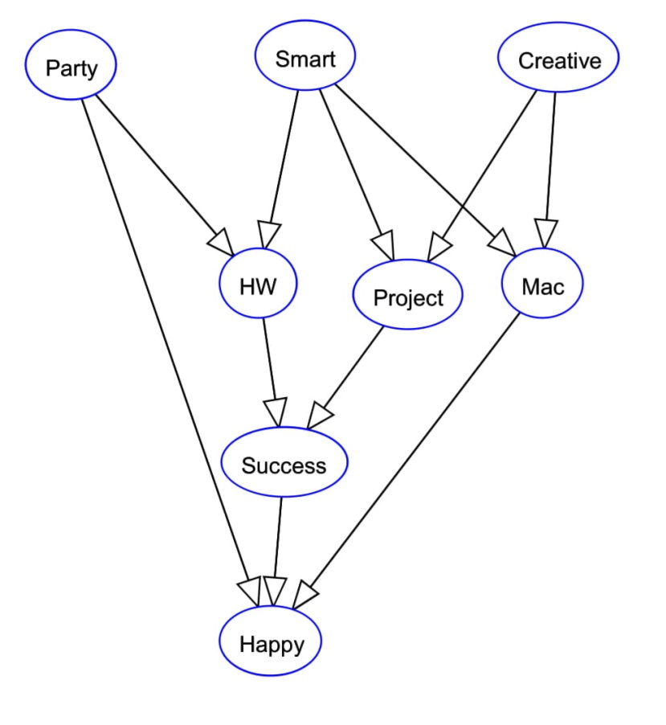

ii)

For part ii, please look at “student.xlsx” file. Note that each sheets in the Excel file represent each 1 pivot table.

iii)

P (**h**appy = T | **p**arty = T, **s**mart = T, **c**reative = F) = 0.6922

P (h | p, s, c)

= alpha*Σhw,mac,proj,succ (P(c)P(s)P(p)P(proj|s,c)P(mac|s,c)P(hw|p,s)P(succ|hw,proj)P(h|p,s,c))

= alpha*()

P (-h | p, s, c)

= alpha*Σhw,mac,proj,succ (P(c)P(s)P(p)P(proj|s,c)P(mac|s,c)P(hw|p,s)P(succ|hw,proj)P(-h|p,s,c))

= alpha*()

alpha=1/( P (h | p, s, c) + P (-h | p, s, c) )

iv) P (Happy = T| Smart = T, Creative = T) = 0.58156

v) P (Happy = T| Party = F, HW = T, Project = T) = 0.31725

vi) P (Happy = T| Mac = T) = 0.56663

vii) P (Party = T | Smart = T) = 0.6022

viii) P (Party = T| Smart = T, Happy = T) = 0.79272