

PYTHON
PROGRAMMING

Practical file

DEPARTMENT OF COMPUTER SCIENCE & IT BHADERWAH CAMPUS


PYTHON PROGRAMMING

SUBMITTED BY: SUBMITED TO:
DIKSHA RANI Dr. Ashok Sharma

Department of computer science & it bhaderwah campus

Bachelor of Computer Applications

CERTIFICATE
This is to certify that DIKSHA RANIstudent of BCA 7th SEMISTERbearing university ROLL NO. 713040005 has completed the required number of practical of Python Programming under the guidance of course C0-ordinate Ms. Jahanvi Kotwal from the Department of Computer Science and IT. Bhaderwah Campus University of Jammu.

Signature of Incharge:

acknowledgement

I would like to ecpress my gratude to all those who gove me the possibility to complete this practical file. I want to thank dept.of computer science & it for providing me all the tools and resources for the completion of my practical file.

I have further more to thank our concerned teacher ms. Jahanvi kotwal encouraged me to move ahead and complete my work in time. I would also like to thank our lab incharge ,whose simulating suggrstions and encouragement helped me all the time during my work.

Thank you.
DIKSHA RANI

INDEX
S.NO | NAME OF THE PYTHON PROGRAM
1. | Wap to find sum of digits of number.
2. | Wap to demonstrate String concatenation.
3. | Wap to find reverse of a number.
4. | Wap to calculate Simple interest.
5. | Wap to prompt a user to enter a day of the week .If the entered day of the week is between 1 to 7 then display the respective name of the day.
6. | Wap to display inverted half pyramid using “*”.
7. | Wap using while loop to print factorial of a number.
8. | Wap to check whether the entered number is Armstrong number or not.
9. | Wap to demonstrate the use of list slicing.
10. | Wap to demonstrate the use of inbuilt functions.
11. | Wap to print Fibonacci series upto 8.
12. | Wap to count words/lines in a file.
13. | Wap to create a class Student and print the details of a student.
14. | Wap to show how encapsulation works using private variables.
15. | Wap to implement abstraction using ABC(Abstract Base Case).

1.WAP TO FIND SUM OF DIGITS OF NUMBERS
p=int(input("Enter the number:"))
sum=0
for digit in str(p):
sum=sum+int(digit)
print("Sum of Digits:",sum)
OUTPUT:-
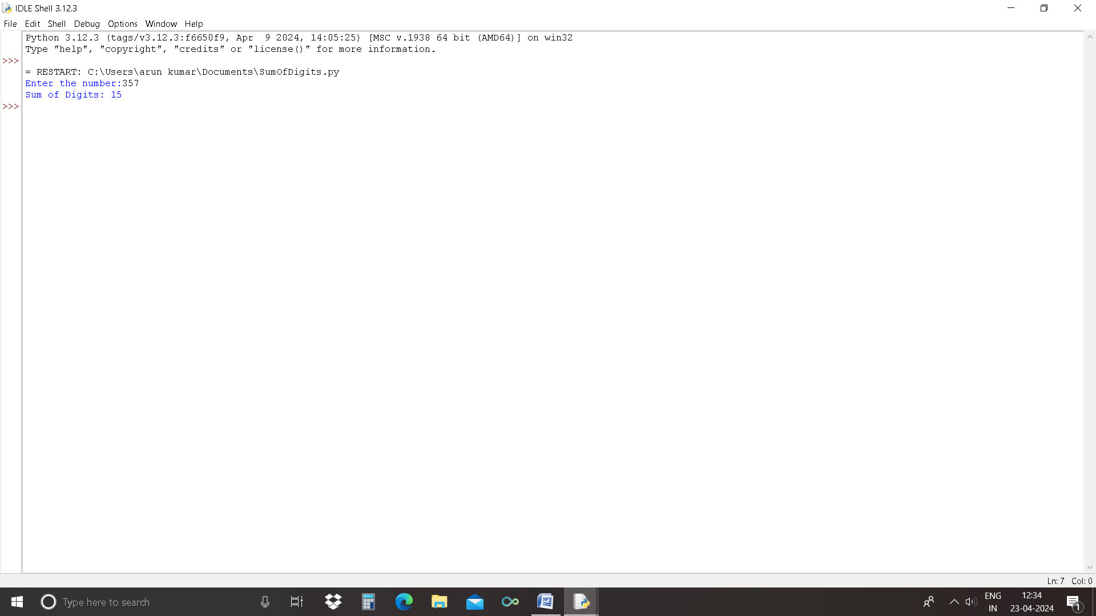

2.WAP TO DEMONSTRATE STRING CONCATENATION
var1="Hello,"
var2="I'm Diksha"
var3=var1+var2
print(var3)
OUTPUT:-
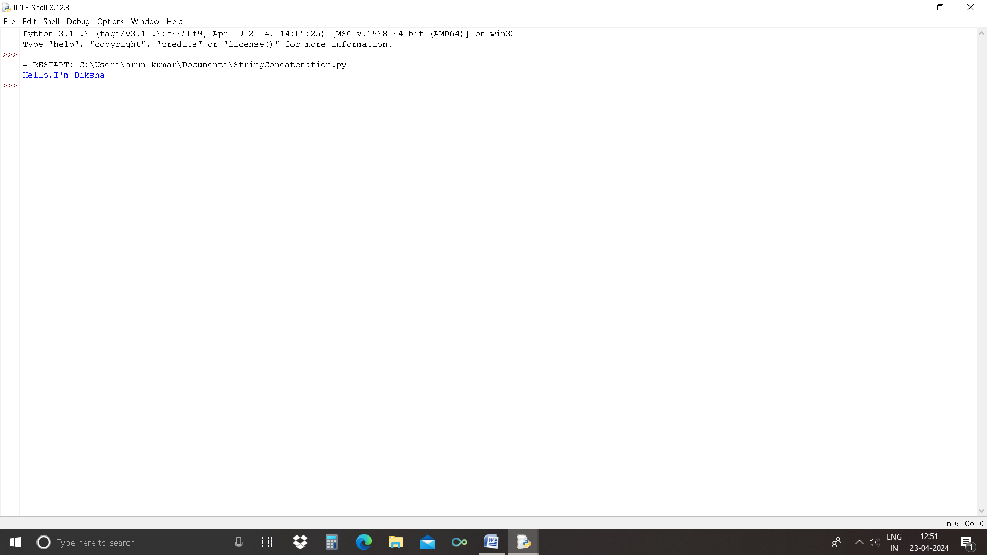

3.WAP TO FIND REVERSE OF A NUMBER
x=9876
rev=0
while(x>0):
a=x%10
rev=rev*10+a
x=x//10
print(“The Reverse of x is: ”rev)
OUTPUT:-
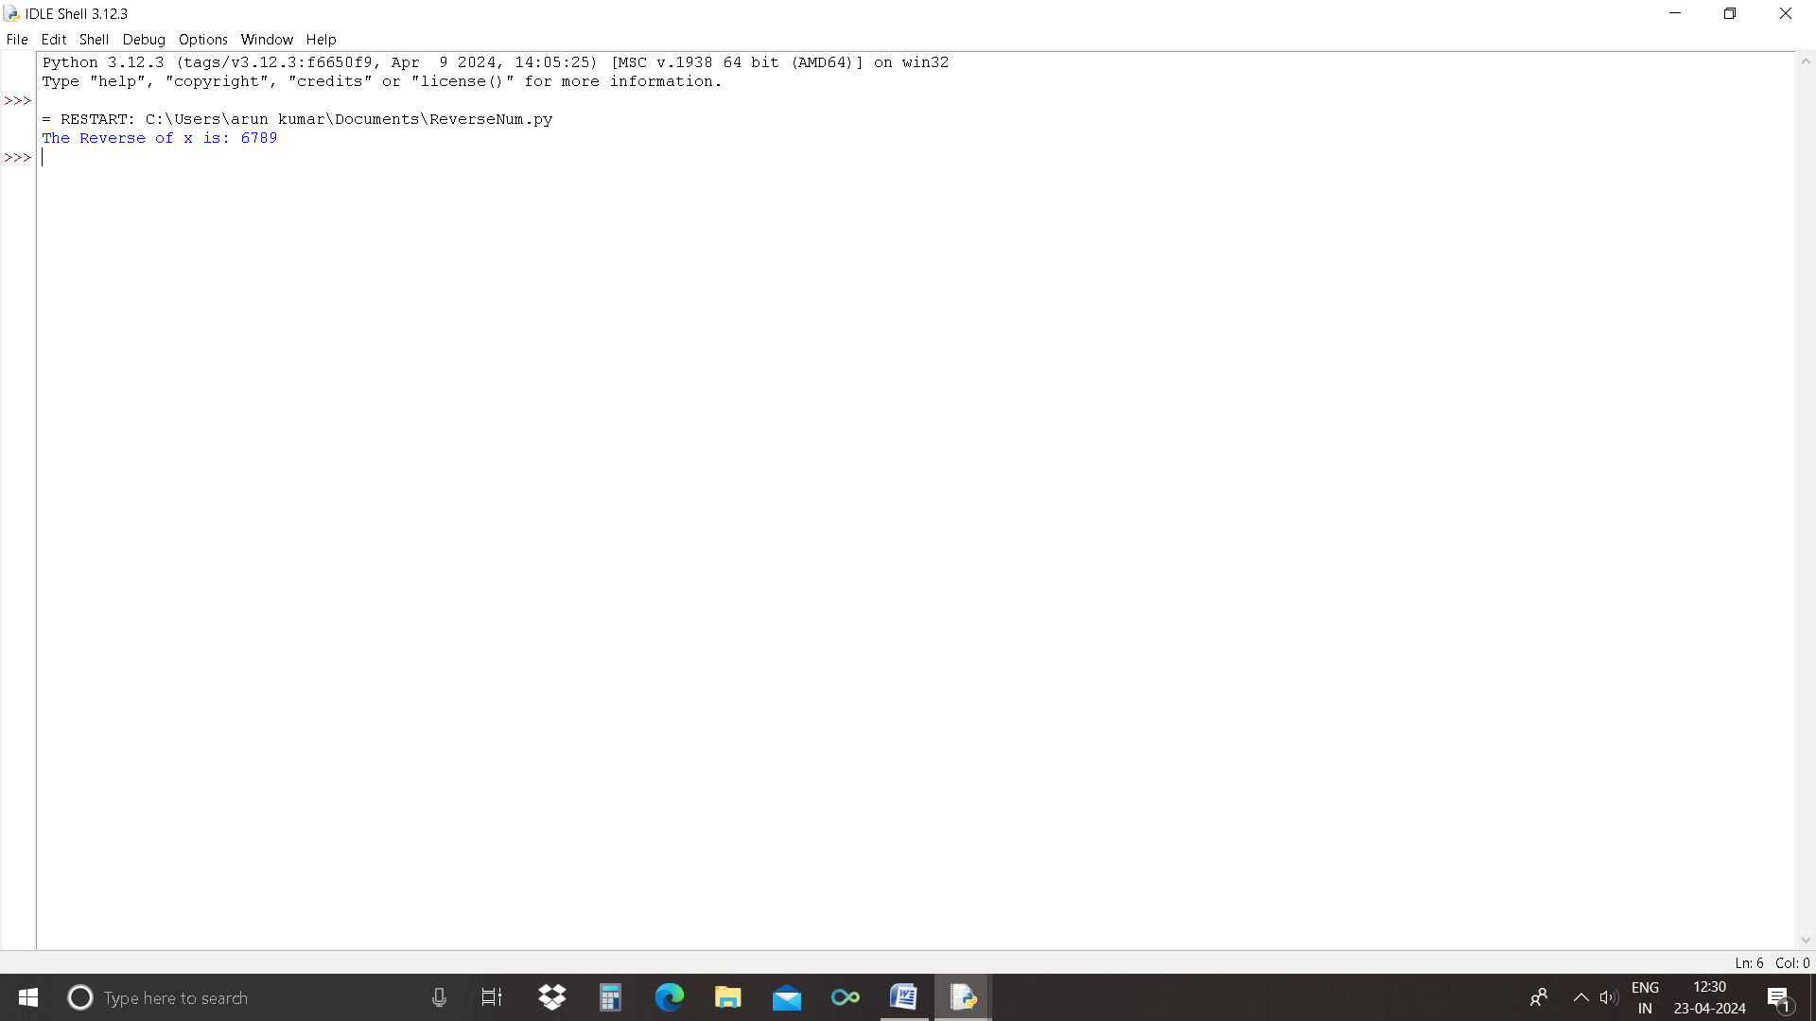

4.WAP TO CALCULATE SIMPLE INTEREST
P=300
R=1
T=4
Simple_interest=(P*R*T)/100
print("The Simple Interest is:",Simple_interest)

OUTPUT:-
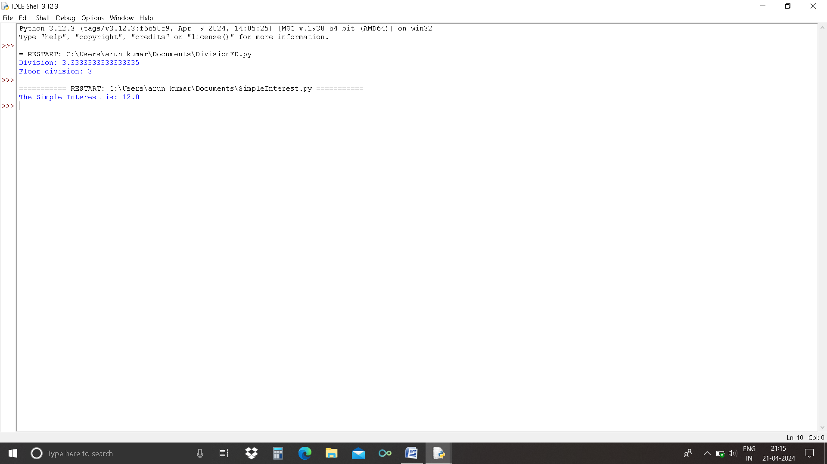

5.WAP TO PROMPT A USER TO ENTER A DAY OF THE WEEK
day=int(input("Enter a number from 1 to 7: "))
if day==1:
print("is Sunday",day)
elif day==2:
print("is Monday",day)
elif day==3:
print("is Tuesday",day)
elif day==4:
print("is Wednesday",day)
elif day==5:
print("is Thursday",day)
elif day==6:
print("is Friday",day)
elif day==7:
print("is Saturday",day)
else:
print("Wrong input!")
OUTPUT:-
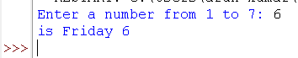

6.wap to display inverted half pyramid using “*”
rows = int(input("Enter the number of rows: "))
for i in range(rows, 0, -1):
for j in range(i):
print("* ", end="")
print()

OUTPUT:-
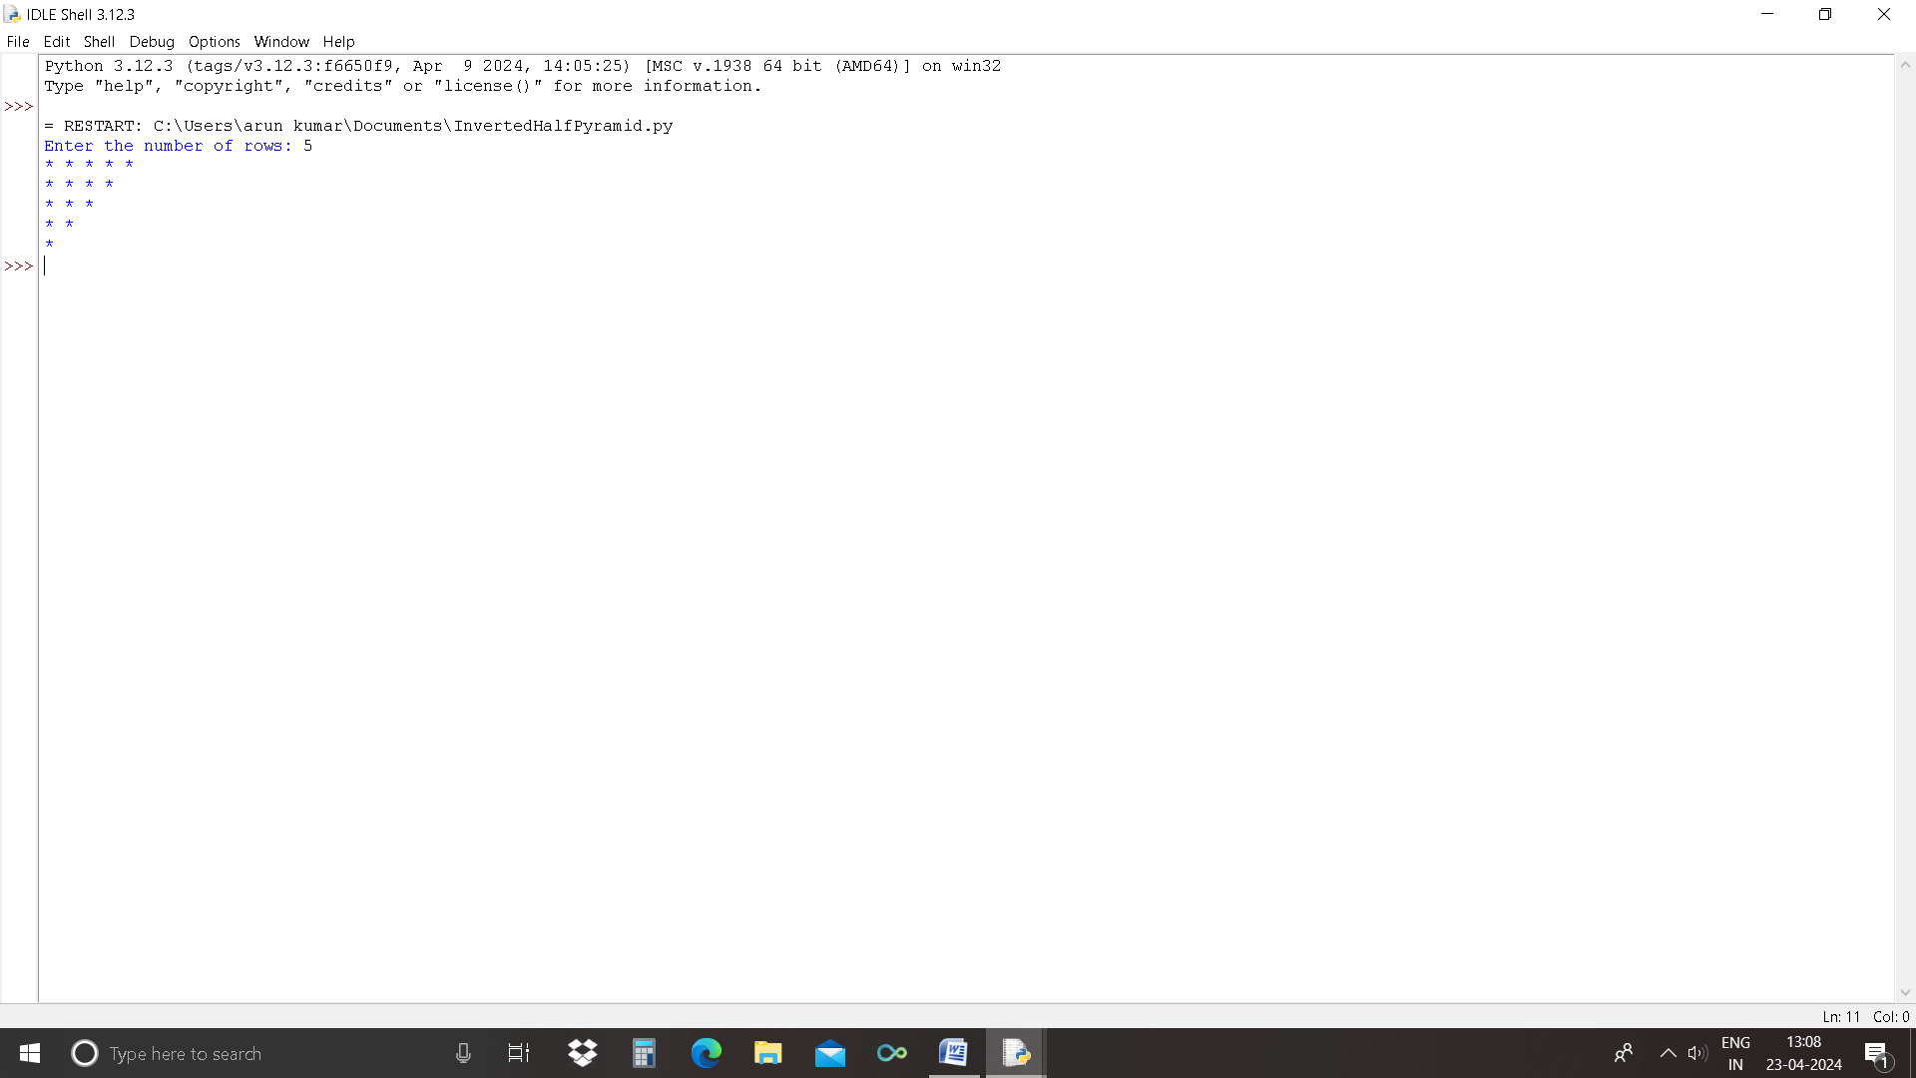

7.WAP USING WHILE LOOP TO PRINT FACTORIAL OF A NUMBER
n=int(input("Enter any number:"))
f=1
while n>=1:
f*=n
n-=1
print("Factorial is: ",f)

OUTPUT:-
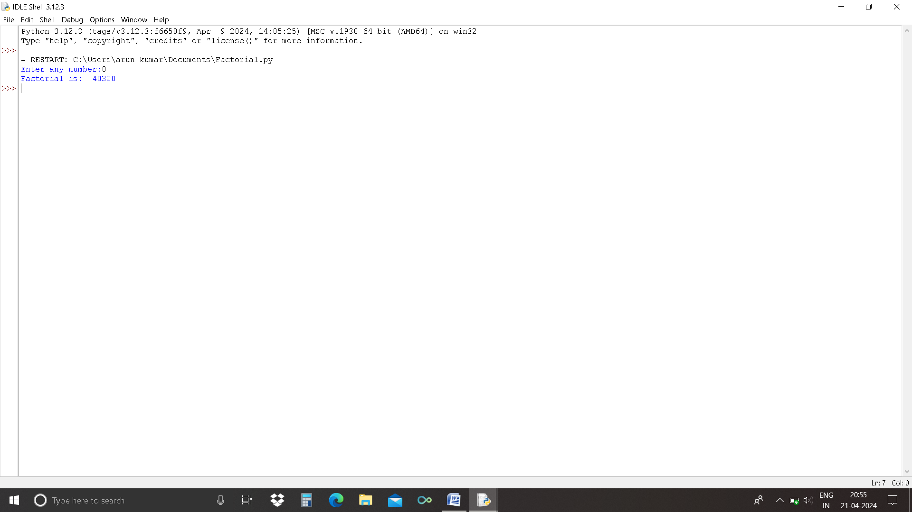

8.WAP TO CHECK WHETHER THE NUMBER ENTERED IS ARMSTRONG OR NOT
num = int(input("Enter a number: "))
sum = 0
temp = num
while temp > 0:
digit = temp % 10
sum += digit ** 3
temp //= 10

if num == sum:
print(num,"is an Armstrong number")
else:
print(num,"is not an Armstrong number")

OUTPUT:-
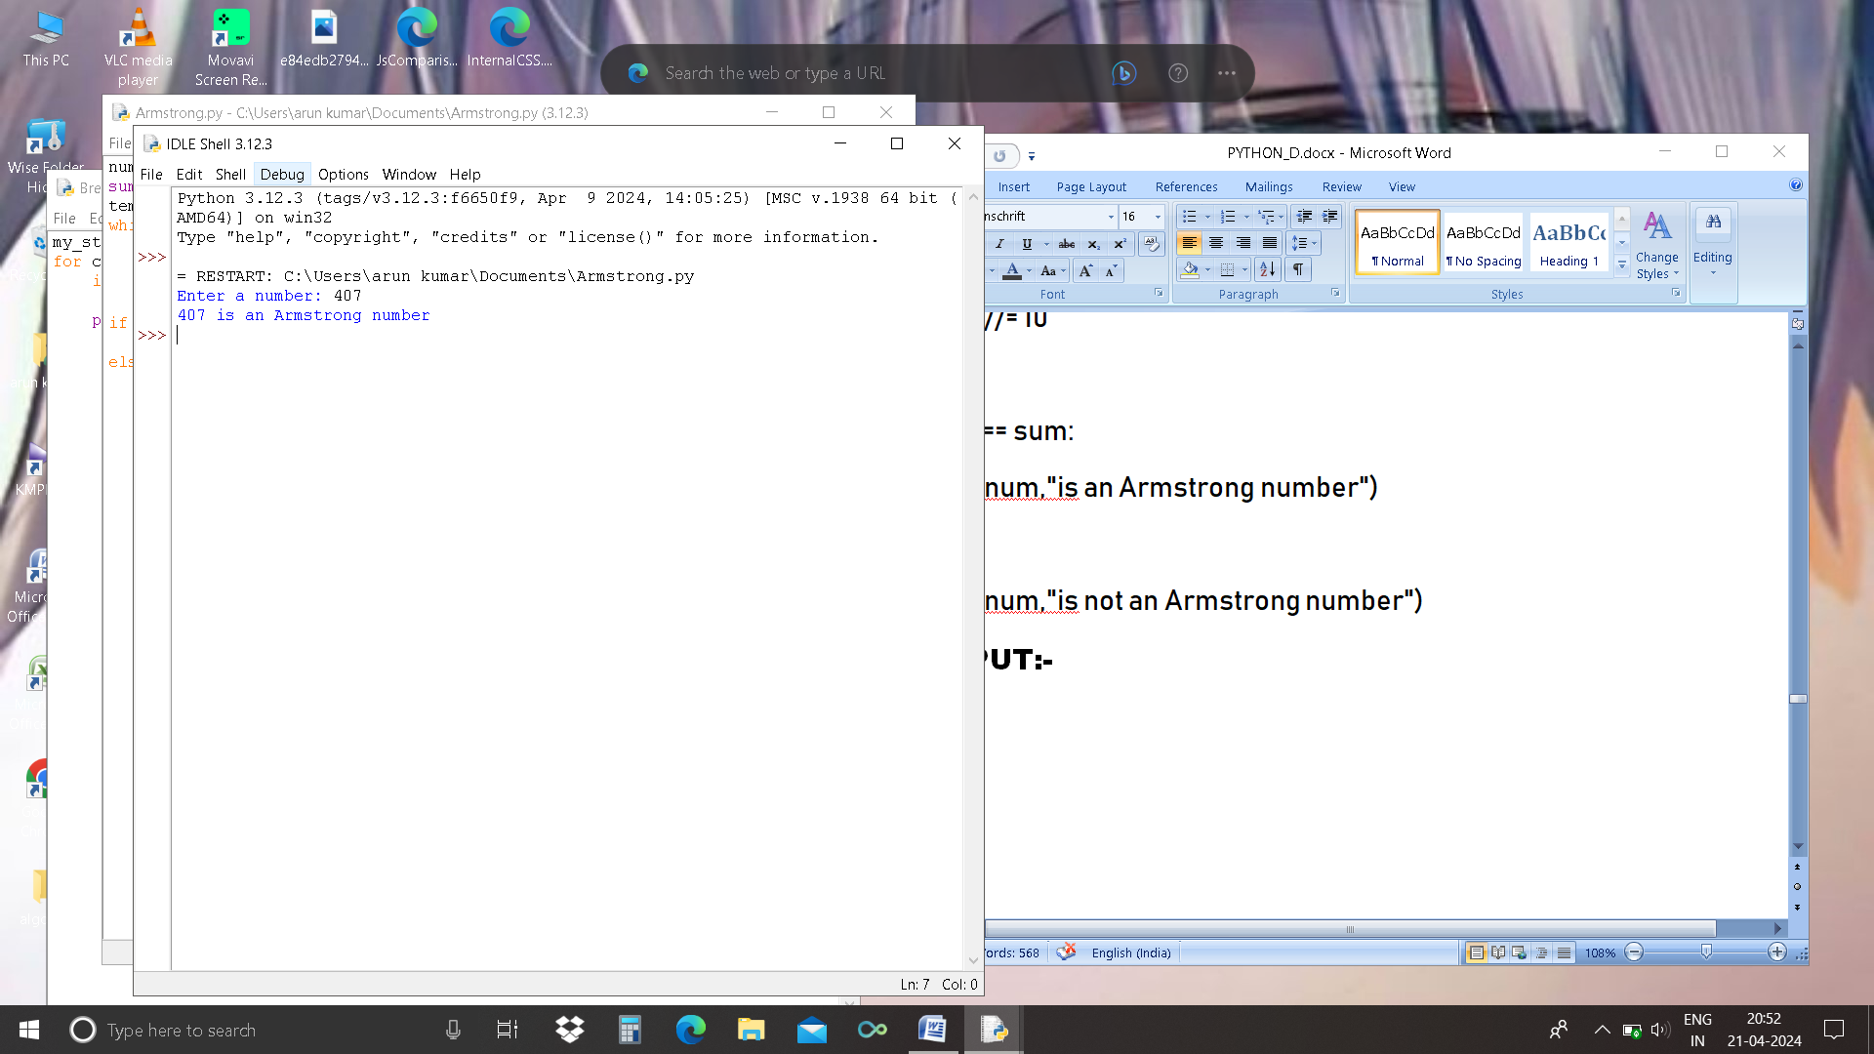

9.WAP TO DEMONSTRATE THE USE OF LIST SLICING
List = [1, 2, 3, 4, 5, 6, 7, 8, 9]
print("Original List:\n", List)

print("\nSliced Lists: ")

print(List[3:9:2])

print(List[::2])

print(List[::])

OUTPUT:-
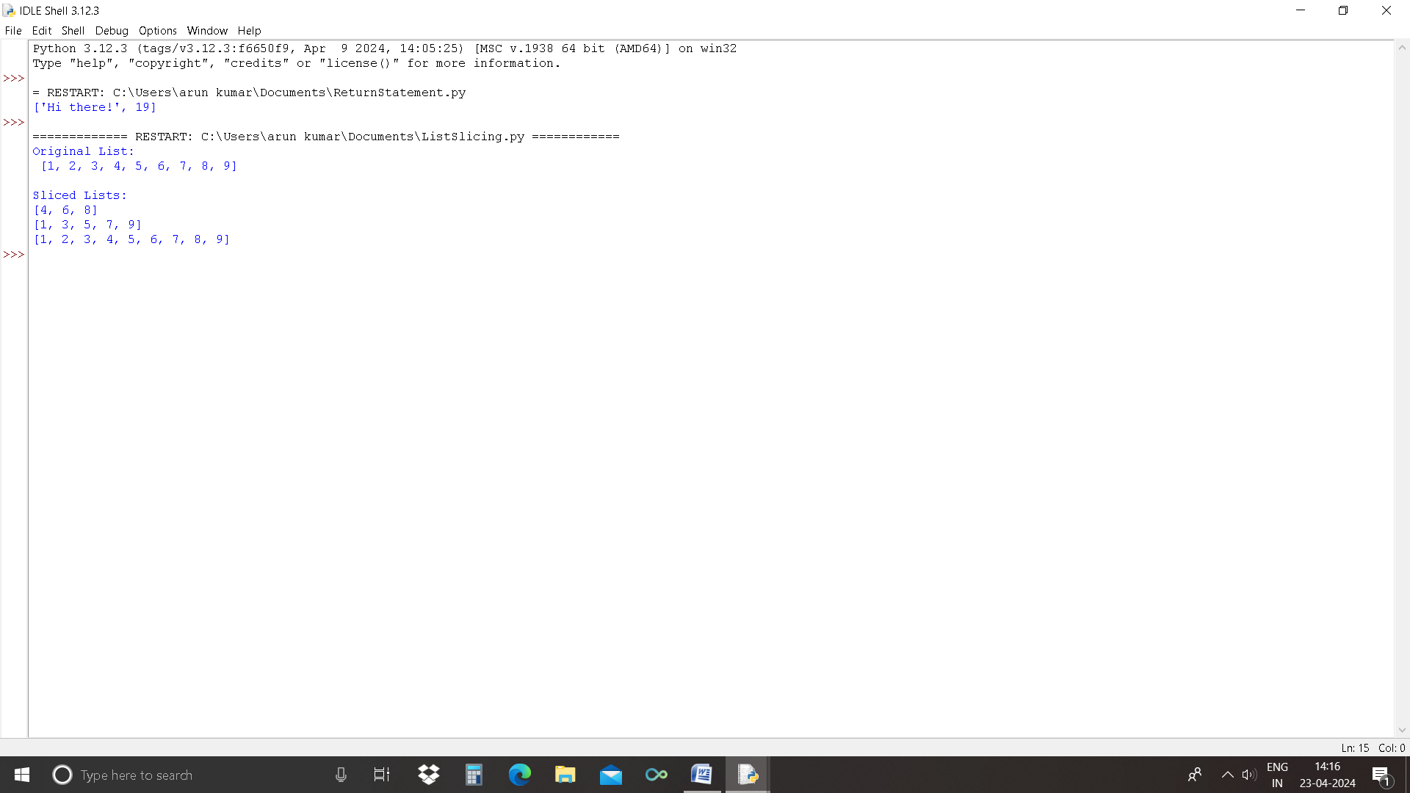

10.WAP TO DEMONSTRATE THE USE OF INBUILT FUNCTIONS
num=[5,2,8,1,9,3,6]
length=len(num)
print("Length og the list:",length)
maximum=max(num)
print("Maximun value in the list:",maximum)
minimum=min(num)
print("Minimum value in the list:",minimum)
total=sum(num)
print("Sum of all elements in the list is:",total)
import random
print("The original list is:" + str(num))
random.shuffle(num)
print("The shuffled list is :" + str(num))

OUTPUT:-
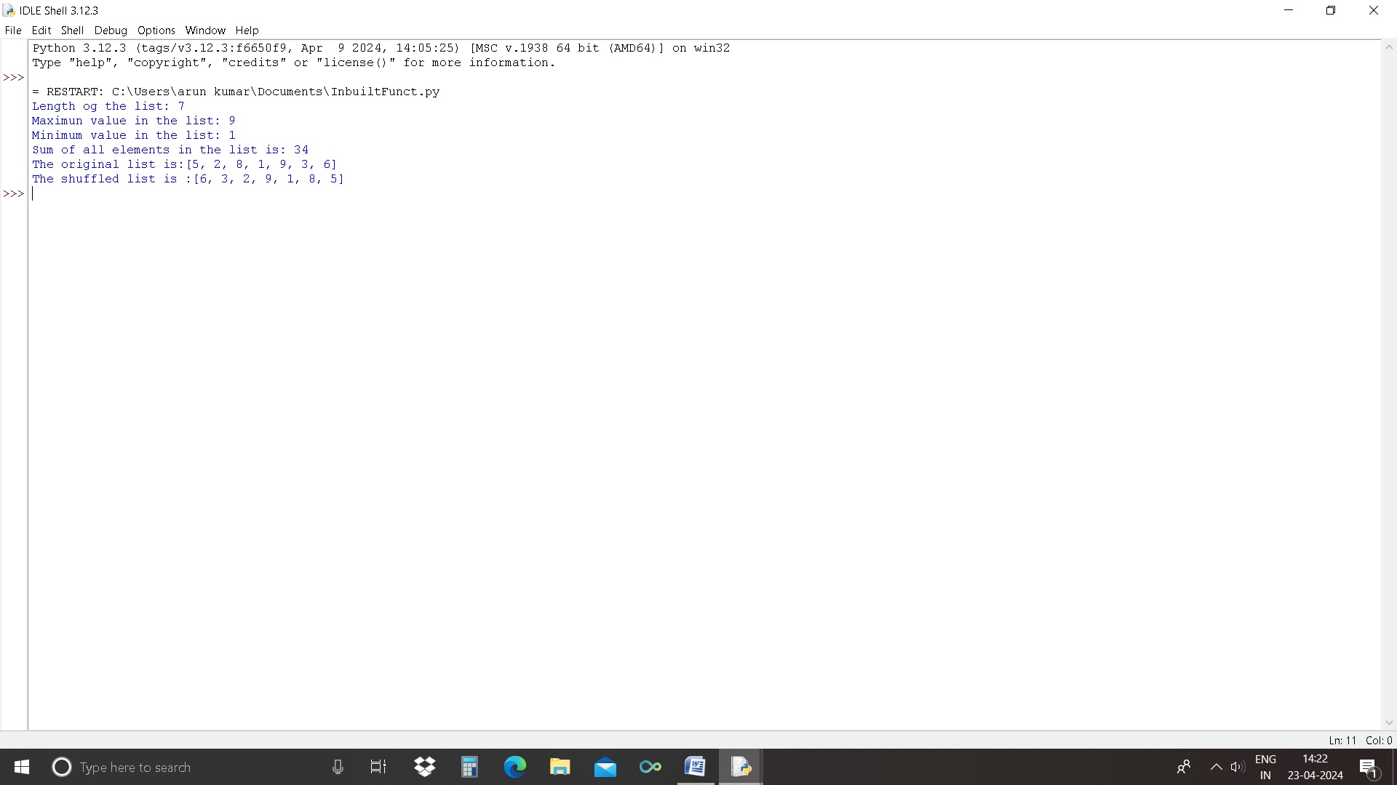

11.WAP TO PRINT FIBONACCI SERIES UPTO 8(FIRST_NUM=0)
n = 8
a = 0
b = 1
sum=0
count=1
print("Fibonacci Series:",end="")
while(count<=n):
print(sum,end=" ")
count+=1
a=b
b=sum
sum=a+b

OUTPUT:-
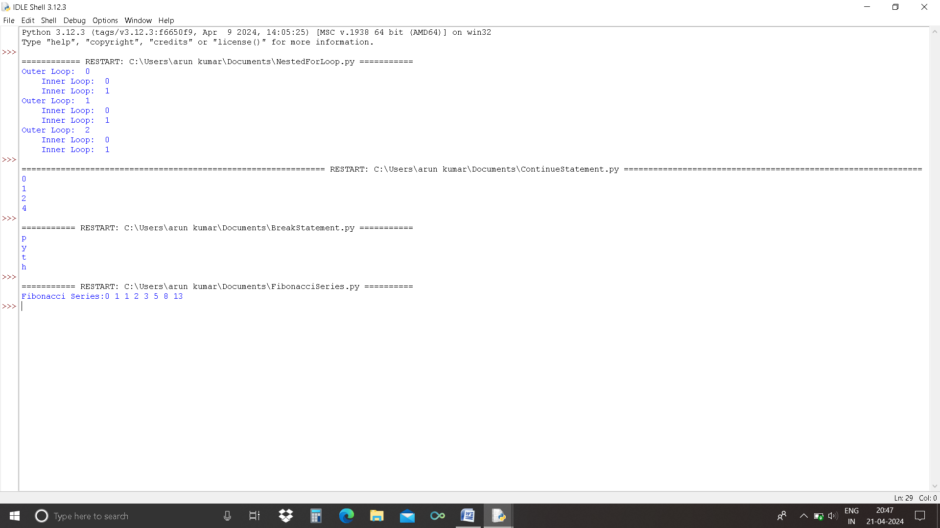

12.Wap to count words/lines in a file.
def count_words_lines(file_path):
"""
Counts the number of lines and words in the given file.
:param file_path: Path to the file
:return: tuple (line_count, word_count)
"""
try:
with open(file_path, 'r', encoding='utf-8') as file:
line_count = 0
word_count = 0

for line in file:
line_count += 1

words = line. Split()
word_count += len(words)

return line_count, word_count
except FileNotFoundError:
print(f"Error: File '{file_path}' not found.")
return None, None
except PermissionError:
print(f"Error: Permission denied to read '{file_path}'.")
return None, None
except Exception as e:
print(f"An unexpected error occurred: {e}")
return None, None
if __name__ == "__main__":

file_path = input("Enter the file path: ").Strip()

lines, words = count_words_lines(file_path)

if lines Is not None:
print(f"Total Lines: {lines}")
print(f"Total Words: {words}")

output:-
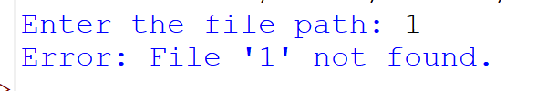

13. Wap to create a class Student and print the details of a student.

class Student:
def getStudentDetails(self):
self.rollno=input("Enter Roll Number : ")
self.name = input("Enter Name : ")
self.physics =int(input("Enter Physics Marks : "))
self.chemistry = int(input("Enter Chemistry Marks : "))
self.maths = int(input("Enter Math Marks : "))

def printResult(self):
self.percentage = (int)( (self.physics + self.chemistry + self.maths) / 300 * 100 );
print(self.rollno,self.name, self.percentage)

S1=Student()
S1.getStudentDetails()

print("Result : ")
S1.printResult()

S1.physics += 9

print("result after adding grace marks...")
S1.printResult()

OUTPUT:-
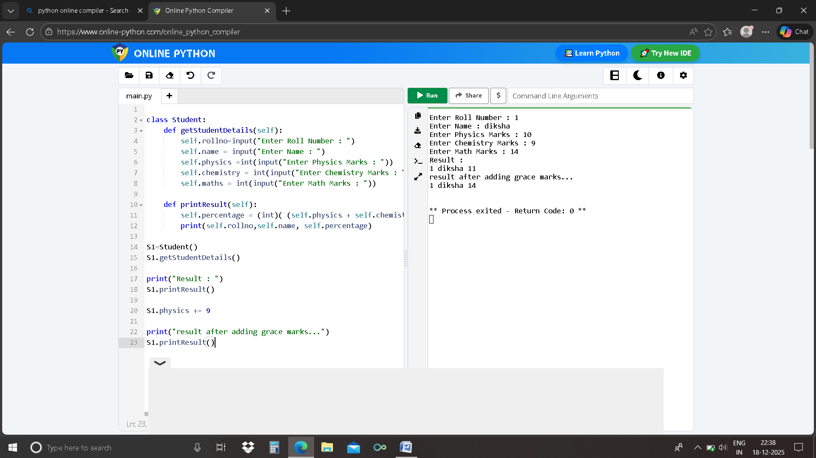

14. Wap to show how encapsulation works using private variables.

class Employee:
def __Init(self, name, salary):
self.name = name
Self_Salary = None
self.set_salary(salary)
def get_salary(self):
returnSelf_ Salary
def set_salary(self, salary):
if not isinstance(salary, (int, float)):
raise ValueError("Salary must be a number.")
if salary < 0:
raise ValueError("Salary cannot be negative.")
Self.salary = salary
def display_info(self):
print(f"Name: {self.name}")
print(f"Salary: ₹{self_salary}")
try:
emp = Employee("John Doe", 50000)
print("Public attribute (name):", emp.name)
print("Private attribute (salary) via getter:", emp. Get_salary())

emp. Set_salary(60000)
print("Updated salary via getter:", emp.Get_salary())
emp. Display_info()
except Exception as e:
print("Error:", e)

Output:-

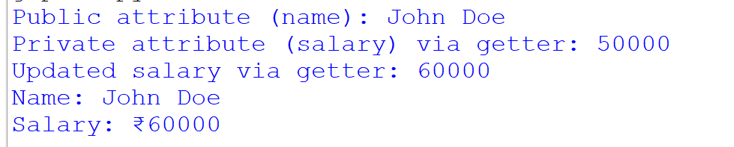

15.Wap to implement abstraction using ABC(Abstract Base Case).

from ABC import ABC, abstractmethod
class Shape(ABC):
"""
Abstract base class representing a geometric shape.
All shapes must implement the area() and perimeter() methods.
"""
@abstractmethod
def area(self):
"""Calculate and return the area of the shape."""
pass
@abstractmethod
def perimeter(self):
"""Calculate and return the perimeter of the shape."""
pass
class Circle(Shape):
def __ Init__(self, radius):
if radius <= 0:
raise ValueError("Radius must be positive.")
self. Radius = radius
def area(self):
from math import pi
return pi * self.radius ** 2
def perimeter(self):
from math import pi
return 2 * pi * self.radius
class Rectangle(Shape):
def __ Init__(self, length, width):
if length <= 0 or width <= 0:

raise ValueError("Length and width must be positive.")
self.length = length
self. Width= width
def area(self):
return self.length * self.width

def perimeter(self):
return 2 * (self.length + self.width)
if __name__ == "__main__":
try:
print("Choose shape: 1. Circle 2. Rectangle")
choice = input("Enter choice (1/2): "). Strip()

if choice == "1":
radius = float(input("Enter radius: "))
shape = Circle(radius)
Elif choice == "2":
length = float(input("Enter length: "))
width = float(input("Enter width: "))
shape = Rectangle(length, width)
else:
raise ValueError("Invalid choice.")

print(f"Area: {shape. Area():.2f}")
print(f"Perimeter: {shape.perimeter():.2f}")

except ValueError as e:
print(f"Error: {e}")
except Exception as e:
print(f"Unexpected error: {e}")

OUTPUT:-

