Assignment 1

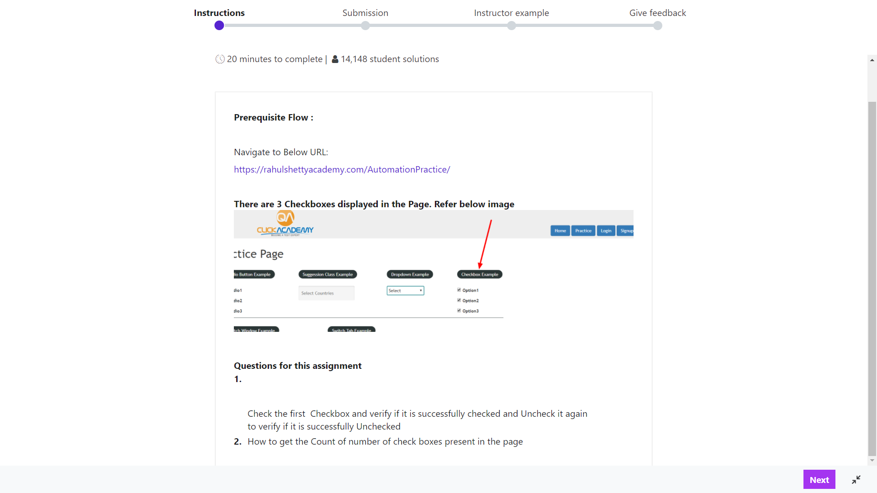

Assignment 2

<https://www.cleartrip.com/>

1. Select any adult, children from dropdown
2. Then select/click on depart on… select today’s date
3. Then click on More options link…enter class of travel and preferred airline
4. Click search….then will get error message grab and display error message

Assignment 3

<http://www.itgeared.com/demo/1506-ajax-loading.html>

1. Click on Click to load get data via ajax!
2. Text will be displayed in red…print that text
3. Use explicit wait to display text

Assignment 4:

1. Hit url <https://the-internet.herokuapp.com/dynamic_loading>
2. Click on multiple windows->click here->Text will be displayed on child window grab that text, print it…switch back to parent window….and print “opening a new window” i.e. text displayed on parent window.

Assignment 5:

1. <https://the-internet.herokuapp.com/dynamic_loading>
2. Click nested frames->print “middle” text

Assignment 6:

<https://www.rahulshettyacademy.com/AutomationPractice/>

1. Select any one checkbox and grab text e.g. option2 is checked
2. So from Dropdown it should select option2(dropdown option should be same as checkbox selected)
3. Enter text seseled from checkbox into textbox…click alert
4. Then popup should display that text into alert

Assignment 7:

<https://www.rahulshettyacademy.com/AutomationPractice/>

1. Print no of rows and no of columns present in “web table example”
2. Print 2nd row data

Assignment 8: