Basic selenium Questions:
- Difference between get and navigate method in selenium?
Ans: get() is used to navigate particular URL(website) and wait till page load. And when we try to interact with element before it completely loads complete webpage it will throw an error
navigate() is used to navigate to particular URL and does not wait to page load. This will hit url and will continue execution of next steps.(then what is use of creating navigate method- there are some methods present like back, forward/refresh same is not achieved using get())

- Quit() vs close()
close – It closes the the browser window on which the focus is set(suppose there are 3 browsers open and focus is on 2nd then 2nd browser will b closed)
quit – all the browsers r closed
dispose method which in turn closes all the browser windows and ends the WebDriver session gracefully.

- Impicit vs explicit wait
Implicit waits - are used to provide a default waiting time between each consecutive test step/command across the entire test script
Explicit - we declared implicit Wait of 10 secs but an element takes more than that, say 20 seconds and sometimes may appears on 5 secs, so in this scenario, Explicit wait is declared

- Different ways to handle frames in application using web driver methods
Ans: driver.swichTo().frame(index/name(or id)/frame webelement);
Three ways by index/name(or id)/frame webelement

- How to handle 3rd child window?
Ans: Set<string> s = driver.getWindowHandles(); //ref of all opened browsers
Iterator it = s.iterator(); //iterate through each browser
It.next(); //0th index //0th
It.next(); //1st index //1st
String thirdId = It.next(); //2nd index //2nd
Driver.switchTo.window(thirdId); //now switch to 3rd window
driver.getWindowHandle(); //is to get reference object(informally handle) for the current browser window. (which is rarely useful )
vs
driver.getWindowHandles(); //is to get reference objects for the all opened browser windows

- Handle https certifications:

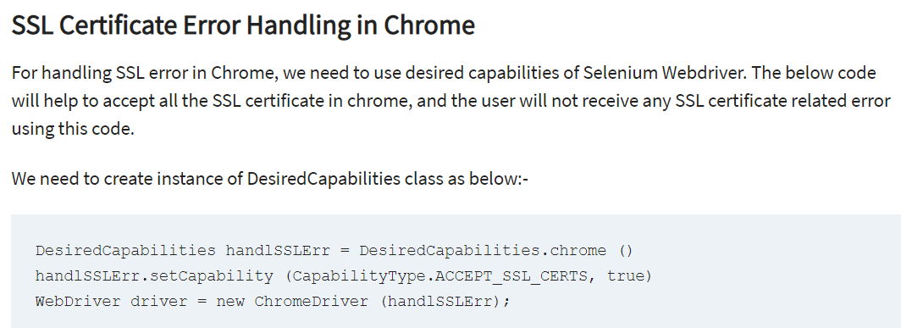
- Types of locators in web driver
Xpath/cssSelector/id/name/className/linkText/partialText/tagName

- Syntax for xpath and css if id and tag are given
Xpath = //tagName[@id=’value’]
Css = tagName[id=’value’]

- Xpath and css to use regular expression (using contains)
We use regular expression xpath when id changes evry time when we refresh page e.g. id= username111, userName222…(here userName is common )

//tagName[contains(@id,’userName’)]

tagName[id*=’userName’]

- Absolute vs relative xpath
Absolute xpath = starts from html/body to actual element
Relative xpath = This is more like starting simply by referencing the element you want and go from the particular location.

- https://www.youtube.com/watch?v=5tuiK5WS86s

- https://www.youtube.com/watch?v=co4PO7t5aX4&list=PLFh6J1ZHhqNjC-ODipd9CVZWtX4uq7P3I

TestNG:
- What is TestNG
- Adv and disadv of testNG, features
- Annotations, @listener, @factory, @DataProvider, @BeforeTest vs @BeforeMethod
- Importance of testing.xml file
- Pass parameter via .xml file to testcase.java
- List some common testNG assertions
- soft assert vs hard assert
- Set priority to test case and if priority is not set what should be order of execution of test cases(what if -ve priority is set)
- What is parameterized testing
- How to create data driven framework i.e. @DataProvider
- Run group of test cases using testNG
- Run test cases In parallel
- Include/exclude particular test case/group from execution
- Disable test case in testNG
- Skip @test method
- Dependencies in testNG
- Different ways to generate reports for testNG results (listeners/reporters)
How to write regular expression In testng.xml file to search @Test methods containing “smoke” keyword (<methods>
<exclude name=".*mobile.*"/>
</methods>)
- Use of invocationCount, enabled, priority, dependsOnMethod, dependsOnGroups, timeout, expectedExceptions, single threaded
- timeOut in testNG
- Q 18) What is the need to create a testng.xml file?
Answer: When we test a project using Selenium Webdriver, it has a lot of classes on it. We cannot choose these classes one by one and put them for automation. Hence we need to create a suite so that all the classes run in a single test suite.
We can achieve this by creating a testing.xml file
- TestNG xml structure
- How to run failed test cases
- How to ignore packages and classes

Cucumber:
- What is cucumber, adv, disadv, features
- Use of scenarioOutline and eg
- What is dataTable
- Annotations(given, and, then, when,but) in cucumber
- Keywords(feature, and, when, then, given, but, scenario, back ground) and use in cucumber
- What is gherkin lang
- What is scenario in cucumber
- What is stepDefination in cucumber, use of glue property
- Files needed in cucumber framework and their use
- Hooks in cucumber(like testNG annotation @before and @after)
- What is dry run
- How BDD framework works, aim of BDD framework, BDD VS TDD
- Why to use cucumber with selenium
- Jbehave vs cucumber
- Files required to execute cucumber test case
- s/w require to run cucumber web test case
- TestRunner class in cucumber

1. What is deferred state?
2. Test cases around time cases
3. Test cases around ecommerce websites from cart perspective.
4. Post method using get method

