**REQUIREMENTS OF FACE RECOGNITION SYSTEM**

**(with GUI)**

**Hardware:**

* Pansonic IP cam BL-C131/C111
* Logitech C170 Webcam

**Python 3.6.x**

**Libraries:**

* opencv-contrib-python
* Numpy
* scipy
* sk-learn
* Tensorflow==1.5
* Requests
* Autocrop
* Imutils
* Tkinter
* PIL

**Files:**

1. Facenet model file in path (*model.pb*)
2. Haar-Cascade file (*haarcascade_frontalface_alt*)
3. Embedding file (*Extracted_Dict_Infogen.pickle*)
4. User name list (*EachIndividual_Infogen.pickle*)
5. Face recognition python file using IP cam (*mainip.py*)
6. Face recognition python file using USB/Integratated cam (*mainusb.py*)

**Execution:**

Run following files

* Using **IP camera**: *python mainip.py model18.pb*

OR

* Using **USB/Integrated** **camera**: *python mainusb.py model18.pb*

**Graphical User Interface:**

1. Before Face Recognition

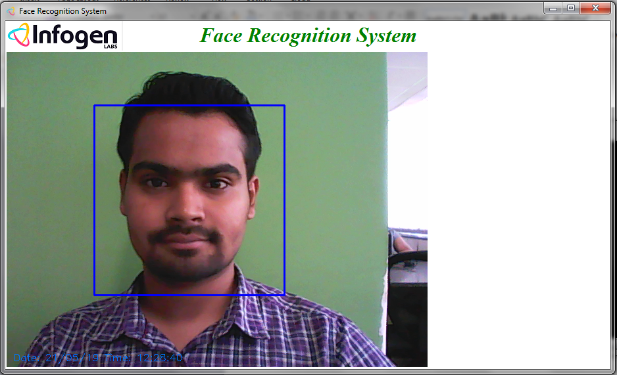

1. After getting Recognized

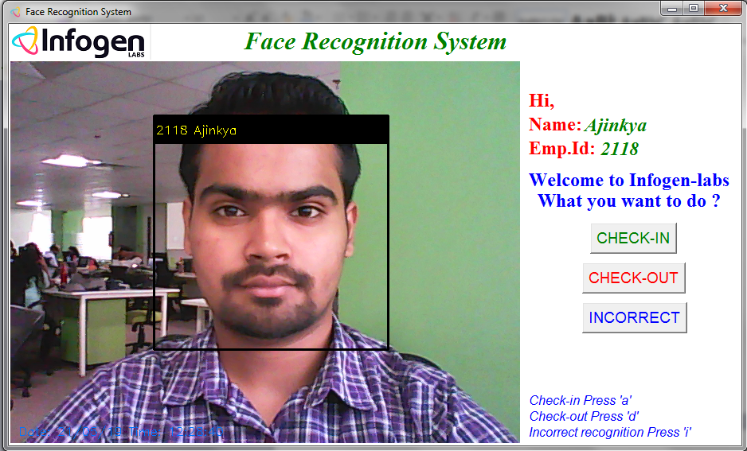

1. On Pressing CHECK-IN button

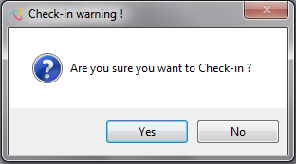

1. After pressing Yes

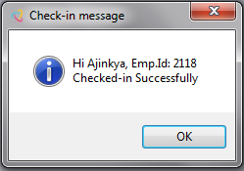

1. On pressing CHECK-OUT

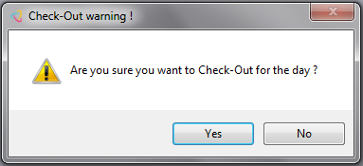

1. After pressing Yes

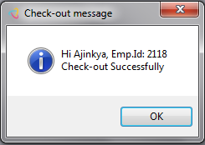

1. On Pressing INCORRECT

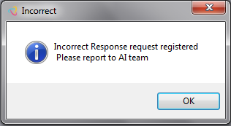

1. Demo video([FR_GUI](https://infogenlabspvtltd-my.sharepoint.com/personal/ajinkya_pathak_infogen-labs_com/Documents/Microsoft%20Teams%20Chat%20Files/FR_GUI.mp4))