**Ola services:**

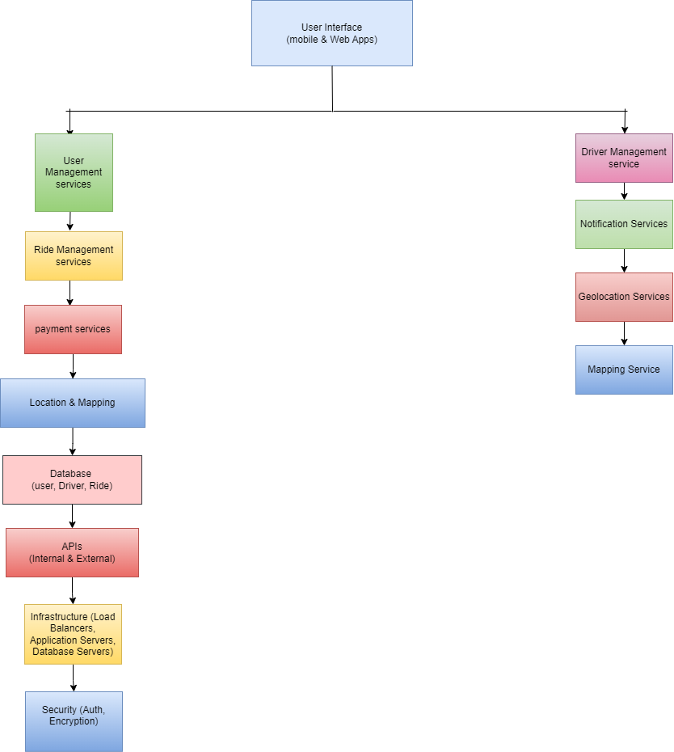

**Swiggy-like Food Delivery Service :**



Implement a custom dynamic array class that supports basic operations like insertion, deletion, resizing, and clearing.

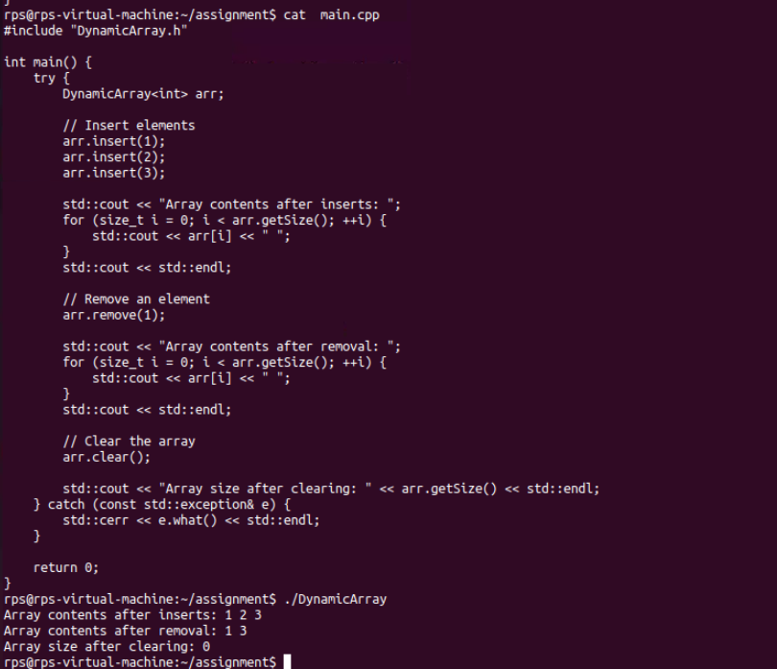

Create a template-based stack class supporting push, pop, and peek operations. Implement it for different data types like int, float, and std::string.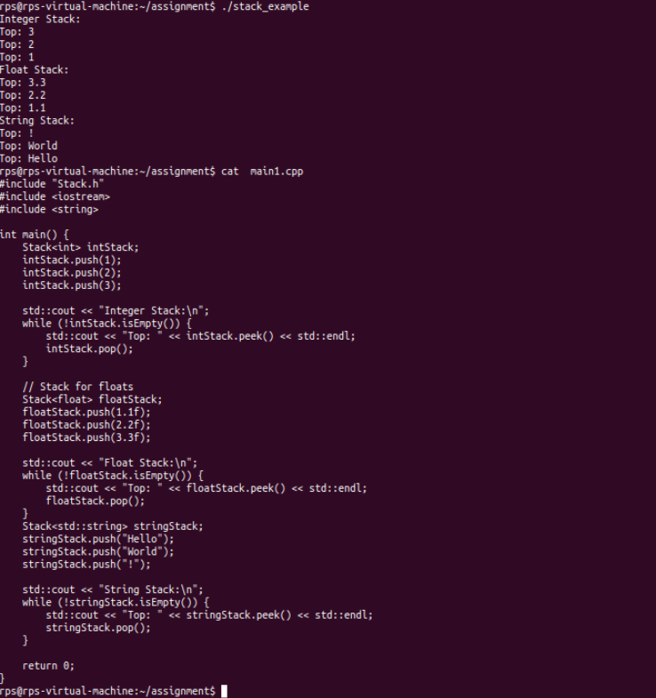

Write a program that reads from a file and handles various exceptions such as file not found, read errors, and unexpected data formats.

