Notes

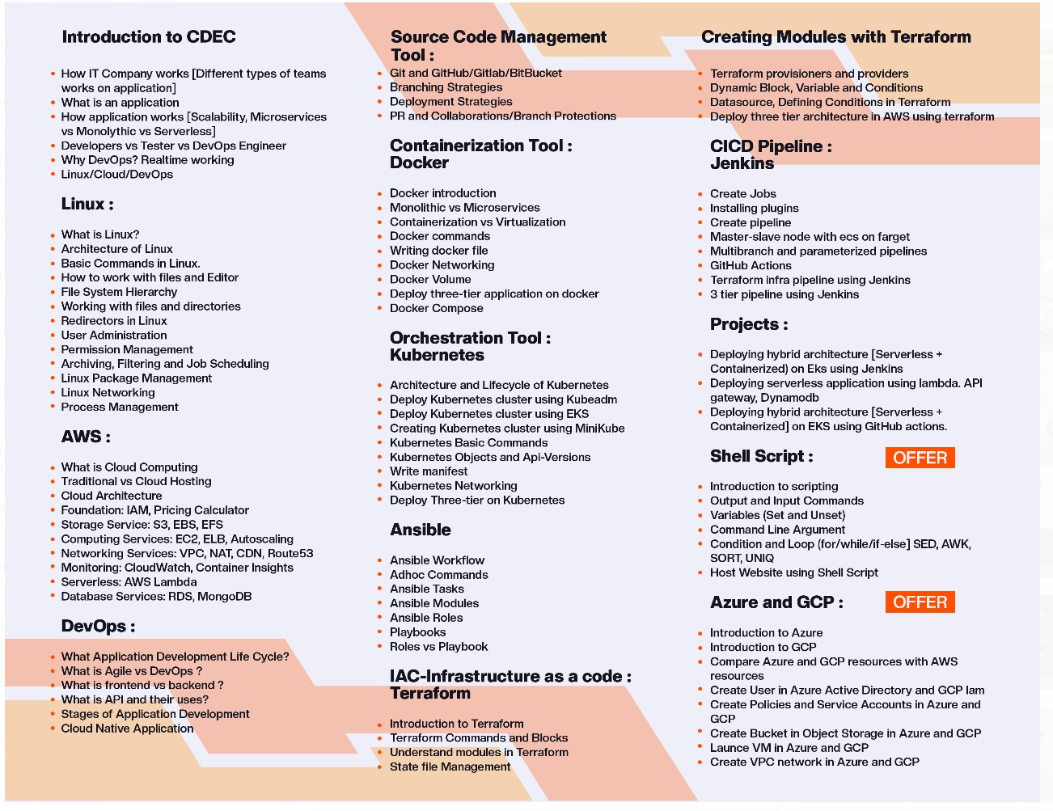

- what is linux?
Linux is a open source operating system that used in many devices like smartphones, computers, and supercomputers.

- Linux distributers
Linux distro is a version of the open source Linux operating system that is packaged with other components, such as an installation programs, management tools and additional software such as the KVM hypervisor.

- Linux vs Windows
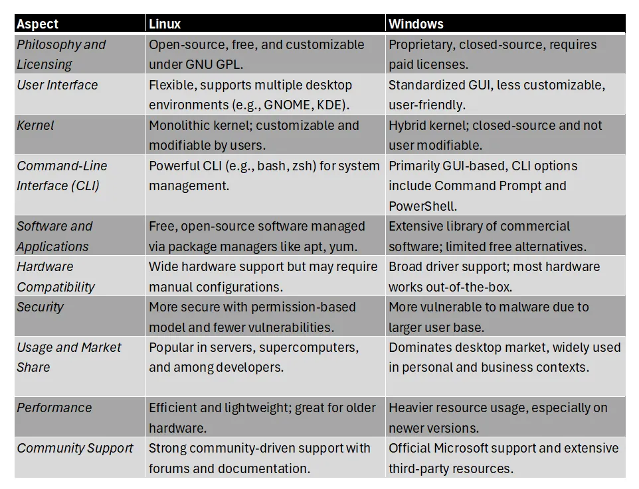
- Linux advantages and disadvantages

Advantages
- Open Source and Free: Linux is free to use, distribute, and modify, fostering a community-driven approach to software development.
- Security: Linux is generally considered a more secure operating system than Windows, with a smaller attack surface and robust security features.
- Lightweight and Resource Efficient: Linux distributions can run efficiently on older or lower-powered hardware, making them suitable for a wide range of devices.
- Customization and Flexibility: Linux offers extensive customization options, allowing users to tailor their operating system to their specific needs.
- Stability and Reliability: Linux is known for its stability and reliability, minimizing system crashes and downtime.
- Wide Range of Distributions: The open-source nature of Linux has led to a variety of distributions, each with its own unique features and user interface.
- Strong Community Support: Linux benefits from a large and active community of users and developers who provide support and resources.

Disadvantages:
- Steeper Learning Curve: The command-line interface and the need to learn how to manage the system can be intimidating for beginners.
- Software Compatibility: Some software and applications may not be readily available for Linux, especially those specifically designed for Windows or macOS.
- Hardware Compatibility: Some hardware devices may not have readily available Linux drivers, which can limit compatibility.
- Desktop Experience: While Linux offers many excellent desktop environments, some users may find the user interface less intuitive than Windows or macOS.
- Gaming: While Linux gaming has improved significantly, the availability and performance of games may still be limited compared to Windows.

- Architecture of linux
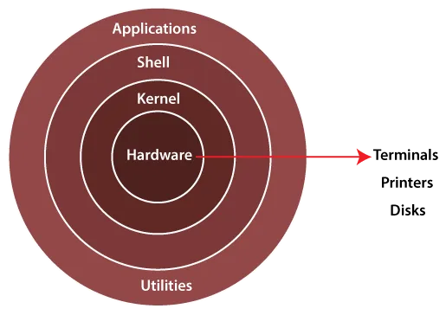
- Hardware: Computer hardware refers to the physical parts of a computer, like the brain (CPU), memory (RAM), and storage (hard drive). These components work together to make the operating system and programs run.
- Kernel: The Linux kernel is like a manager for the computer. It takes care of important tasks like managing the CPU, memory, and devices.
- Shell: The shell is like a translator between you and the computer. It’s the part of the operating system that lets you give commands and interact with it.
- Application: Applications are programs that you use on your computer. They have a user-friendly interface and rely on the kernel to work properly.

- File system hierarchy

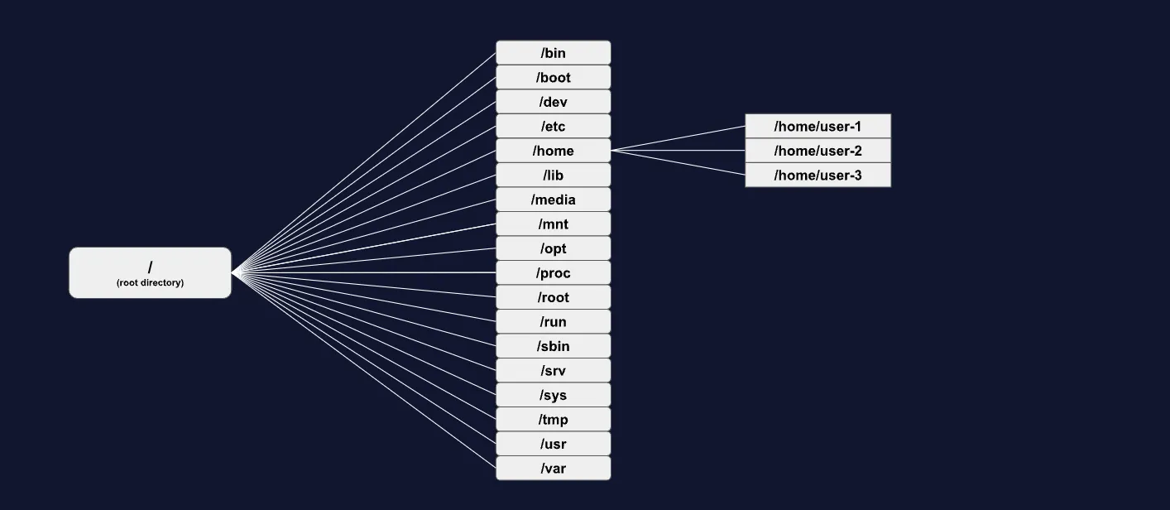

/bin common binary executables used by all users
/boot files associated with boot loader
/dev attached devices (usb, cdrom, mouse, keyboard)
/etc configuration files
/home personal directories for each user account
/lib shared system libraries
/media directory for mounting removable devices (floppy drive, cdrom)
/mnt directory for mounting file-systems (nfs, smb)
/opt optional vendor add-on software
/proc virtual file-system for system processes/resources information
/root home directory for root/administrator account
/run storage for runtime information
/sbin binary executables used by administrator
/srv data for server services
/sys virtual file-system for hardware/driver information
/tmp temporary files purged on reboot
/usr utilities and read-only user data/programs
/var variable and log files

- Linux syntax

Syntax = Command + Option + Arguments

- What is linux type we used?
- Ubuntu

- What are the basic commands in linux?
- ls : List files and directories.
cd : Change the current directory.
mkdir : Create a new directory.
touch : Create a new file.
cp : Copy files or directories.
mv : Move or rename files or directories.
rm : Remove files or directories.
pwd : Print the current working directory.
cd~ : use for home directory

- What is the use of execute permissions for directories?
- Can access (enter) the directory cd command

- Find the different type of file type in linux and describe it?
- Type Symbol File Type Description
- Regular file Text, images, binaries, etc.
d Directory Folder
l Symbolic link Shortcut to another file
c Character device Serial device (keyboard, terminal)
b Block device Disk devices (hard drives, USBs)
p Named pipe (FIFO) Used for process communication
s Socket Used for IPC or networking

Zip and unzip folder and files

1. What is file compression
- File compression reduces the size of file by encoding their data more efficiently
This is especially useful for backup, storage, and file transfer.

#Creating a tar archive
tar cvf archive_name.tar file_*.txt

#Compressing a single file
gzip filename.txt

#Decompressing a single file
gunzip filename.txt.gz

#Compressing the tar archive with gzip
tar -czvf archive_name.tar.gz file_*.txt

#Drecompressing a tar.gz archive
tar xzvf archive_name.tar.gz

#Decompressing a tar.bz2 archive
tar xjvf archive_name.tar.bz2

#compressing a multiple files
zip archive_name.zip file_*.txt

#Decompressing a zip archive
unzip archive_name.zip

AWS CLI configure

1. aws ec2 describe-instances \
--query "Reservations[*].Instances[*].[
InstanceId,
State.Name,
PublicIpAddress,
Tags[?Key=='Name'] | [0].Value
]" \
--output table

2. aws ec2 start-instances --instance-ids i-0b6350dcd3b3e7a2d

3. ssh -i test12.pem ubuntu@3.87.222.102

Understanding `ls -l` Output
d rwxr-xr-x 2 root root 6 Jun 27 22:20 srv

| Part | Description |
|--------------------------|------------------------------------------- |
| `d` | File type (directory) |
| `rwxr-xr-x` | Permissions (user, group, others) |
| `2` | Link count |
| `root` | Owner of file |
| `root` | Group owner |
| `6` | Size (bytes) |
| `Jun 27 22:20` | Date/time of creation |
| `srv` | File/Directory name |

Types of Linux Files
1. **User-defined files:**
- Normal file (-)
- Directory (d)
- Link file (l)
2. **System-defined files:**
- Block device (b)
- Character device (c)
- Socket (s)
- Pipe (p)

Linux File Permissions Basics
- `r` = read (4)
- `w` = write (2)
- `x` = execute (1)

| User Type | Permissions Eg. |
|--------------------------|--------------------------|
| Owner (u) | rwx |
| Group (g) | r-x |
| Others (o) | --x |

Directory vs File Permissions

| Permission | Directory | File |
|-----------------|--------------------------------------------|------------------------------------------- |
| Read (r) | List contents (`ls`) | Read file (`cat`, `vim`) |
| Write (w) | Create, delete files (`touch`, `rm`) | Modify file (`vim`, `rm`) |
| Execute(x) | Access directory (`cd`) | Execute file (scripts, commands) |

Changing Permissions — `chmod` Command
| Command | Purpose |
|-----------------------------------|------------------------------------------- |
| `chmod u-r file` | Remove read permission for user |
| `chmod u-rx file` | Remove read & execute for user |
| `chmod g+rwx file` | Add rwx for group |
| `chmod o=rw file` | Set others to read & write only |

Numeric Permission Representation
- `r=4`, `w=2`, `x=1`
- Examples:
- `chmod 777 file` → rwxrwxrwx
- `chmod 732 file` → rwx-wx-w-
- `chmod 651 file` → rw-r-x—x

Default File and Directory Permissions

| User Type | File Permissions | Directory Permissions |
|-----------------|--------------------------|-----------------------------------|
| Root user | 644 (rw-r--r--) | 755 (rwxr-xr-x) |
| Local user | 664 (rw-rw-r--) | 775 (rwxrwxr-x) |

Types of Links in Linux
1. Hard Link
- Link to actual data, same inode number
- Only for files, not directories
- Link works even if original file is deleted
- Command: `ln original_file hard_link_name`

2. Soft Link (Symbolic Link)
- Points to filename, different inode number
- Works for files and directories
- Link breaks if original is deleted
- Command: `ln -s original_file soft_link_name`

Link Count
- Default for files: 1
- Default for directories: 2
- Link count increases for files when hard linked
- Link count increases for directories as subdirectories are added

Changing Ownership

| Command | Purpose |
|------------------------------------------- |-----------------------------------|
| `chown username file` | Change owner |
| `chgrp groupname file` | Change group |
| `chown username:groupname file` | Change user and group |

Archiving in Linux
- Purpose: Backup & transfer files as bundles
- Tool: `tar` (Tape Archive)

Basic commands:
- Create Archive: `tar -cvf archive.tar files`
- List Archive: `tar -tvf archive.tar`
- Extract Archive: `tar -xvf archive.tar`
- Extract to Location: `tar -xvf archive.tar -C /path`

Compression Tools

| Tool | Compress Command | Decompress Command | File Extension |
|-----------------|-----------------------------------|-----------------------------------|--------------------|
| gzip | `gzip file` | `gunzip file.gz` | `.gz` |
| bzip2 | `bzip2 file` | `bunzip2 file.bz2` | `.bz2` |
| xz | `xz file` | `unxz file.xz` | `.xz` |

Archiving & Compressing in One Step
| Tool & Command | Extract Command |
|---------------------------------------------------------|-------------------------------------------------------------------|
| `tar -czvf archive.tar.gz /etc` (gzip) |`tar -xzvf archive.tar.gz -C /destination/` |
| `tar -cjvf archive.tar.bz2 /etc` (bzip2) | `tar -xjvf archive.tar.bz2 -C /destination/` |
| `tar -cJvf archive.tar.xz /etc` (xz) | `tar -xJvf archive.tar.xz -C /destination/` |

Checking File Size
- Command: `du -sh filename`
- Shows human-readable size summary

28. Which file is responsible for the boot loader configuration in Linux?
a) /etc/boot.conf
b) /boot/grub/grub.cfg
c) /boot/loader.conf
d) /etc/grub.cfg

33. Which command is used to check network connectivity in Linux?
a) netstat
b) ping
c) trace
d) route

36. Which file contains system-wide environment variables?
a) /etc/environment
b) /etc/profile
c) /etc/bashrc
d) All of the above

Interview Questions

- what is tree and which tree command?
In this “tree”command use to display the file and directories in the tree format.

- What is the purpose of root directory
It is a top level directory of the file system hierarchy

- Difference between bin and sbin
sbin – this binaries accessible for root/superuser.
Bin – this binaries accessible for all user.

- What is the purpose of etc directory
it holds various configuration file it is essential for proper functioning of the system and its installed applications

- what is external mounting
the process of making a file system (like a USB drive or a network share) accessible within the system's file system hierarchy

- What is the use of I and i
in vim editor use I and i for insert the text , if you use I the text enter from start, and you use i then the text start from current cursor

- how do u create user
log-in in virtual machine and switch in root user using sudo su – then use adduser <username> and useradd <username> .

- What is the purpose of shadow file
stores encrypted user passwords

- how to delete user
userdel <username>
username -r <username>
username -f <username>

- how to change user passwords in linux
sudo passwd <username>

- how to check how many user login in the terminal
users, w, who, users | wc

- how to lock and unlock the user
passwd -l <username>
passwd -u <username>

- what is the purpose of skel directory in linux
when we create new user then the file and directory is in the etc skel directory are copied in the new user home directory

- how to set expiration for user like passwords, account, and all
chage -l <username>
to change expiration date – chage -E 2025-04-14 <username>
like that we can set all expiration of the user

- what is group in linux
the collection of user and shared common permission and access rights

- how to create group in linux
groupadd <grpname> - create grp
usermod -aG <grpname> <username> - add in grp
groupmod -n <new_grpname> <old_grpname> - rename grpname
gpasswd –delete <username> <grpname> - is use to remove user from grp
groupdel <grpname> - to delete grp

- what is primary and supplementary groups in linux
primary groups – it is default grp for user’s file and directories, 1 per user, located in etc/passwd, default grp for file creation
supplementary grp – it is manually created grp , this grps are located in etc/grp, it assign 15 per user “limit” , allow inheritance of grp permission.

- How to change group passwords
gpasswd <groupname>

- what is the default permission for file and directory
chmod 777 for file and directory

- how many files in linux
linux supports 7 different file types, there are regular,directory,link, block, character, socket and named pipe

- how many link in linux
there are 2 type of link in linux, hardlink and softlink

- difference between hardlink and softlink
hardlink – hard link taken same inode number, hardlink only for files not for directory, it is faster, if original file deleted the hardlink also worked
softlink – softlink taken different inode number, soft link used for directory, it is slower, if original file remove then the link not working

- what is inode number
it is index inode number is a unique number which is assigned to all the files in linux

- what is the purpose of archive file in linux
bundle up a multiple file into a single manageable unit

- what is the tool use for archive the file
the main tool for archive the file is tar command

- how many tools is use to compress a file
there are several tool for compression gzip, bzip2, xz and zip as well as tar utility.

- What is the command for archive and compress a file in linux
tar -czvf <archive_filename.tar.gz> <filename> - use proper extension as per your flags

- what is task scheduling
the process of operating system manages and executing the operation on specific time

- what is at and crontab command in linux
‘at’ use for scheduling one time task
‘crontab’ user for scheduling periodically executing task

- which field in crontab
there are five fields in this minute, hour, day_of_month, months, day_of_week

- list all the cronjobs
crontab -l

- what is the use of sort command-line
this command use to arranging the records in particular order
sort <filename>

- what is the use of unique command-line
is use to avoid for duplication
uniq <filename>

- what is the use of wc command-line
is use to count the no. of lines, words, and bytes “wc”

- what is the use of grep command-line
is use to search specific text such as words, phrases and patterns

- how do we view running process on linux terminal
using “top” command

- what is foreground and background processes
foreground processes run directly in the terminal and require user interaction or completion before another command can be entered. Background processes, on the other hand, run independently of the terminal, allowing the user to continue working while the process executes

- what is the name of background processes
bg

- how to terminate processes
kill -9 (1234 - pid)

- what is shell
the Linux command line interpreter

- how to see own ip address
ifconfig

- how to check network connectivity
ping <url>

- s
- s
- s
- s
- s

