Task - 1

1. Create a directory named devops in your home directory.
mkdir devops

2. Inside devops, create two subdirectories: projects and scripts.
cd devops
mkdir scripts
mkdir projects

3. Navigate to the projects directory and create an empty file named project1.txt.
cd projects
touch project1.txt

4. Write the text “Linux is powerful” into project1.txt.
vim project1.txt
cat project1.txt

5. Copy project1.txt to the scripts directory.
Cd .. ---------- exit to the projects directory
/devops$ cp ./projects/project1.txt ./scripts

6. Rename the copied file in scripts to linux_notes.txt.
cd scripts
mv project1.txt linux_notes.txt

7. Move the linux_notes.txt file back to the projects directory.
Cd ..
mv ./scripts/linux_notes.txt ./projects

8. Delete the original project1.txt file.
rm project1.txt

9. Create a hidden file named .config in the devops directory.
touch .config

10. List all files and directories (including hidden ones) in the devops directory.
ls -a
.. .config projects scripts

11. Display the contents of linux_notes.txt using a command.
cat linux_notes.txt

12. Append the line “Shell scripting is fun” to linux_notes.txt.
echo “Shell scripting is fun” > linux_notes.txt – use to replace old text to new
echo “Shell scripting is fun” >> linux_notes.txt – add new text means append

13. Create a new empty file named temp.log and then remove it.
touch temp.log
rm temp.log

14. Change the name of the scripts directory to automation.
mv scripts automation

Task – 2

1. Open a new file called notes.txt using the vi or nano editor.
vim notes.txt

2. Insert the text “This is my first note” into the file.
Press I and then insert
This is my first note

3. Save and exit the editor.
Press esc then :wq!

4. Open the notes.txt file again and append a new line: “Learning Linux editors”.
Vim notes.txt
I
Learning Linux editors
echo “Learning Linux editors” >> notes.txt – add new text means append

5. Delete the second line in the file.
Vim notes.txt
I
Learning Linux editors

6. Copy the first line and paste it below the second line.
Vim notes.txt
I
This is my first note
Learning Linux editors
This is my first note

7. Undo the last change you made.
Vim notes.txt
I
This is my first note
Learning Linux editors
This is my first note
press esc and type u then you can see output

8. Search for the word “Linux” inside the file.
Vim notes.txt
I
This is my first note
Learning Linux editors
This is my first note
press esc and type :g/Linux

9. Replace the word “note” with “document” throughout the file.
Vim notes.txt
I
This is my first note
Learning Linux editors
This is my first note
press esc and type :g/note/s//document/g

10. Enable line numbers while editing the file.
press esc and type :set number
for set permanent number - cd ~ ; echo set number > .vimrc
for remove permanent number – rm ~/.vimrc

11. Create a new file named tasklist.txt and write at least 3 bullet points.
- This is my first document
- Learning Linux editor
- This is my first document
echo -e "• This is my first document\n• Learning Linux editor\n• This is my first document" > tasklist.txt

12. Save the file without exiting the editor.
:w!

13. Move the third line above the first line.
Press 3G then press dd then press 1G then press pp

14. Use visual mode (in vim) to select and delete multiple lines.
Press esc then go to the line which you want to delete it from that select multiple line then press d.

15. Open multiple files (file1.txt, file2.txt) in a single vim session.
vim file1.txt file2.txt
insert I to edit 1st file then save it :w! After that :n press and start editing in 2nd file then save it :wq!

16. Split the screen in vim to view two files side by side.
vim file1.txt file2.txt after that use :split command both screen showing same text or same file then u can use :n command to enter 2nd file and if u want to edit file 1 then press I and want to edit 2nd file then hold ctrl key and press ww if u want to exit both files then use :wqa! Command.

17. Create and save a file in read-only mode using the editor.
vim file1.txt && chmod 444 file1.txt
to check it use ls -l file1.txt and u will see
-r--r--r-- 1 diksha diksha 99 Apr 17 18:55 file1.txt

18. Enable syntax highlighting in vim for a .sh file.
Vim file.sh then :syntax on and :syntax off and one more for always want syntax highlights use ~/.vimrc command

19. Record and play back a macro to insert the same text in multiple lines.
vim file1.txt Press esc then type qa – to start recording then press I type hello world! Then press esc then type q – to stop recording now u want to see then type @a or @@.

20. Exit the editor without saving changes
:q!

Task -3

1. How do you create a new user in Linux?
In /:
Sudo useradd user1
sudo adduser user1

2. What is the purpose of the /etc/passwd file?
root:x:0:0:root:/root:/bin/bash
daemon:x:1:1:daemon:/usr/sbin:/usr/sbin/nologin
bin:x:2:2:bin:/bin:/usr/sbin/nologin
sys:x:3:3:sys:/dev:/usr/sbin/nologin
sync:x:4:65534:sync:/bin:/bin/sync
games:x:5:60:games:/usr/games:/usr/sbin/nologin
man:x:6:12:man:/var/cache/man:/usr/sbin/nologin
lp:x:7:7:lp:/var/spool/lpd:/usr/sbin/nologin
mail:x:8:8:mail:/var/mail:/usr/sbin/nologin
news:x:9:9:news:/var/spool/news:/usr/sbin/nologin
uucp:x:10:10:uucp:/var/spool/uucp:/usr/sbin/nologin
proxy:x:13:13:proxy:/bin:/usr/sbin/nologin
www-data:x:33:33:www-data:/var/www:/usr/sbin/nologin
backup:x:34:34:backup:/var/backups:/usr/sbin/nologin
list:x:38:38:Mailing List Manager:/var/list:/usr/sbin/nologin
irc:x:39:39:ircd:/run/ircd:/usr/sbin/nologin
_apt:x:42:65534::/nonexistent:/usr/sbin/nologin
nobody:x:65534:65534:nobody:/nonexistent:/usr/sbin/nologin
systemd-network:x:998:998:systemd Network Management:/:/usr/sbin/nologin
systemd-timesync:x:996:996:systemd Time Synchronization:/:/usr/sbin/nologin
dhcpcd:x:100:65534:DHCP Client Daemon,,,:/usr/lib/dhcpcd:/bin/false
messagebus:x:101:101::/nonexistent:/usr/sbin/nologin
syslog:x:102:102::/nonexistent:/usr/sbin/nologin
systemd-resolve:x:991:991:systemd Resolver:/:/usr/sbin/nologin
uuidd:x:103:103::/run/uuidd:/usr/sbin/nologin
usbmux:x:104:46:usbmux daemon,,,:/var/lib/usbmux:/usr/sbin/nologin
tss:x:105:105:TPM software stack,,,:/var/lib/tpm:/bin/false
systemd-oom:x:990:990:systemd Userspace OOM Killer:/:/usr/sbin/nologin
kernoops:x:106:65534:Kernel Oops Tracking Daemon,,,:/:/usr/sbin/nologin
whoopsie:x:107:109::/nonexistent:/bin/false
dnsmasq:x:999:65534:dnsmasq:/var/lib/misc:/usr/sbin/nologin
avahi:x:108:111:Avahi mDNS daemon,,,:/run/avahi-daemon:/usr/sbin/nologin
tcpdump:x:109:112::/nonexistent:/usr/sbin/nologin
sssd:x:110:113:SSSD system user,,,:/var/lib/sss:/usr/sbin/nologin
speech-dispatcher:x:111:29:Speech Dispatcher,,,:/run/speech-dispatcher:/bin/false
cups-pk-helper:x:112:114:user for cups-pk-helper service,,,:/nonexistent:/usr/sbin/nologin
fwupd-refresh:x:989:989:Firmware update daemon:/var/lib/fwupd:/usr/sbin/nologin
saned:x:113:116::/var/lib/saned:/usr/sbin/nologin
geoclue:x:114:117::/var/lib/geoclue:/usr/sbin/nologin
cups-browsed:x:115:114::/nonexistent:/usr/sbin/nologin
hplip:x:116:7:HPLIP system user,,,:/run/hplip:/bin/false
gnome-remote-desktop:x:988:988:GNOME Remote Desktop:/var/lib/gnome-remote- desktop:/usr/sbin/nologin
polkitd:x:987:987:User for polkitd:/:/usr/sbin/nologin
rtkit:x:117:119:RealtimeKit,,,:/proc:/usr/sbin/nologin
colord:x:118:120:colord colour management daemon,,,:/var/lib/colord:/usr/sbin/nologin
gnome-initial-setup:x:119:65534::/run/gnome-initial-setup/:/bin/false
gdm:x:120:121:Gnome Display Manager:/var/lib/gdm3:/bin/false
nm-openvpn:x:121:122:NetworkManager OpenVPN,,,:/var/lib/openvpn/chroot:/usr/sbin/nologin
diksha:x:1000:1000:diksha:/home/diksha:/bin/bash

it contain username password unique id group id home directory and shell. There are 3 type of user local, root and system

3. What does the /etc/shadow file contain?
sudo cat /etc/shadow
stores actual passwords in hashed format, along with additional information related to these passwords

4. How do you set or change a user password?
Sudo passwd user1

5. How do you delete a user from the system?
sudo userdel user1
sudo rm -r /home/user2

6. How do you modify an existing user’s properties?
sudo usermod -c "detail" user1 - this command use for comments
sudo usermod -u 1234 user2 - this command use for change UID
sudo usermod -g 1000 user2 – this command use for change GID
sudo usermod -l user1 user2 – this command use for change user name
id user2 – used to check all commands are modified or not
sudo usermod -d /new-home/user1 -m user1 – this command use to change home directory
eval echo ~user1 - to we can use this command

7. What command is used to lock and unlock user account sudo apt remove gparted mounts?
sudo usermod -L user1 -use for lock the user
sudo passwd -S user1 – to check lock or not
sudo passwd -u user1 – use to unlock
sudo apt remove gparted

8. How do you force a user to change their password on next login?
sudo passwd --expire user1

9. How do you check when a user account will expire?
sudo chage -l user1

10. How do you create a user with a specific home directory?
sudo useradd -m -d /new-home/user1 user1
getent passwd user1 – to check

11. What is the use of the /etc/skel directory?
ls -l /etc/skel
directory in Linux holds files and directories that are copied to a new user's home directory when they are created

12. How do you change the default shell for a user?
sudo su user1
grep `whoami` /etc/passwd - to check current shell
cat /etc/shells – to where we can login
exit – use to exit a shell
sudo usermod --shell /bin/bash user1 – command for change the shell

13. How do you create a group in Linux?
Sudo groupadd demo – used to create grp
sudo getent group demo -used to verify grp is created or not

14. How do you add or remove a user from a group?
sudo usermod -a -G demo customuser – use to add
cat /etc/group – to verify - groups customuser
sudo usermod -G customuser,sudo customuser – use to remove

15. How can you view group membership of a user?
id customuser – use from id
uid=1002(customuser) gid=1003(customuser) groups=1003(customuser),1004(demo) - output

16. What is the difference between primary group and supplementary groups?

Key Differences:
Feature | Primary Group | Supplementary Groups
Purpose | Default group for user's files/directories | Additional groups for shared access/permissions
Number | One per user | Up to 15 per user
Definition | Specified in /etc/passwd | Specified in /etc/group
Access | Default group for file creation | Allows inheritance of group permissions

17. How do you change a user’s UID or a group’s GID?
sudo usermod -u new_uid username – to change UID
sudo groupmod -g new_gid groupname – to change GID

18. How do you find all users on the system?
getent passwd - 1st commands
cat /etc/passwd - 2nd commands
awk -F':' '{ print $1}' /etc/passwd - 3rd commands

19. How do you find inactive or locked users?
Checking Recent Login Activity – last -n 100
sudo passwd -S user_name – to check status of user
sudo lastlog – user activity

20. How do you set user account expiration?
sudo chage -l username – use to check expire

21. How do you set password policies (like minimum/maximum age)?
sudo chage -M 90 username – set maximum age
sudo chage -m 8 username – to set minimum age

22. How can you prevent a user from logging in without deleting their account?
Locking the Account :- Using passwd command - sudo passwd -l <username>
Using usermod command - sudo usermod -L <username>
Changing the Login Shell to /bin/nologin - sudo usermod -s /bin/nologin <username>
Editing /etc/passwd directly - You can also edit the /etc/passwd file and change the user's login shell directly. Find the line corresponding to the user and replace the login shell with /bin/nologin

23. How do you switch to another user account from the command line?
Sudo su <username> - for switch account
exit – for exit the account

24. What is the difference between su and sudo?
su (Switch User):
Switches to a different user's account and environment.
Requires the password of the user you're switching to (defaulting to root if no user specified).
Starts a new shell with the target user's environment, including their home directory and environment variables.
Can be used to switch to different users besides root.
Example: su - (switch to root with login shell) or su <username> (switch to a different user).

sudo (Superuser DO):
Executes a single command with the privileges of another user (usually root) without switching to that user.
Requires your current user's password (if configured correctly).
Your current shell and environment remain unchanged.
Allows for more granular control over which users can execute which commands with elevated privileges.
Example: sudo <command> (execute the command as root).

25. How do you give a user sudo access?
sudo usermod -aG sudo <username>

26. How can you restrict a user to only execute certain commands with sudo?
You can define which commands a user is allowed to run. For example :- username ALL=(ALL) NOPASSWD: /bin/systemctl restart apache2, /usr/bin/apt update
username: the user you want to restrict
ALL=(ALL): allows the command to be run as any user (usually root)
NOPASSWD:: optional, allows running without password
List of allowed commands, comma-separated

27. How do you create a user without a home directory?
sudo useradd -M username
-M: Instructs the system to skip creating the home directory.

28. How do you find users who are currently logged in?
who or users – this command we can use to check

29. How do you track the login history of a user?
lastlog -u username => using this command

30. What logs help in auditing user login activity?
sudo cat /var/log/auth.log

Task – 4

1. How do you give read, write, and execute permissions to the owner of a file but only read permissions to the group and others?
chmod 744 NarX.txt
for check – ls -l

2. What command will you use to change the owner of a file to user john and the group to devs?
First you have to create a grp and user for this question then use command-line
chown john:devs NarX.txt

3. How can you find all files in /home that have 777 permissions?
find /home -type f -perm 777 -print

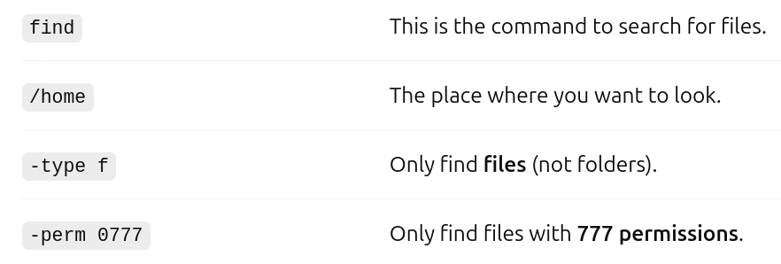

4. What is the difference between chmod 755 and chmod 775?
chmod 755:
Owner: Read, write, and execute (rwx)
Group: Read and execute (rx)
Others: Read and execute (rx)
chmod 775:
Owner: Read, write, and execute (rwx)
Group: Read, write, and execute (rwx)
Others: Read and execute (rx)

5. How do you remove write permissions for the group from a file named report.txt?
Chmod 646 report.txt

6. How do you check the current permissions of all files in a directory?
Ls -l

7. What permission is required to delete a file from a directory?
Write - To make changes in the directory and execute - To enter/access the directory

8. If a file has permission -rwxr--r--, who can execute the file?
Only the owner can execute the file

9. How can you recursively change all .sh files in a directory to be executable by everyone?
find /path/to/directory -type f -name "*.sh" -exec chmod a+x {} \;

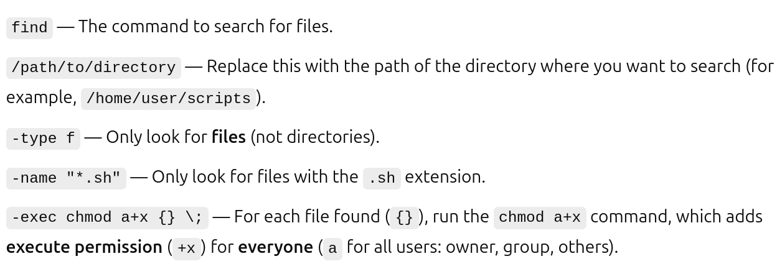
10. What’s the significance of the +x permission on a directory?
+x permissions on any and all parent directories to cd or access a file in a directory.

11. How can you make a script readable and writable only by the owner?
Permissions of 600 give the owner full read and write access to the file

12. How do you give full permissions to everyone on a directory named public?
chmod 777 foldername

13. What command do you use to set the set uid bit on a binary file?
chmod u+s filename

14. How do you prevent a user from deleting a file even if they have write access to the directory?
sudo chattr +i filename and for remove use -i

15. How can you allow a user to read and write a file, but not execute it?
chmod u=rw filename

Task – 5

1. Create a hard link for a file named file1.txt and name the link file1_hard.
ln file1.txt file1_hard

2. Create a soft link for the same file1.txt and name it file1_soft.
ln -s file1.txt file1_soft

3. How can you verify whether a file is a hard link or a soft link?
use the ls -i command to view the inode number. Files that are hard-linked together share the same inode number

4. If the original file file1.txt is deleted, what happens to:
• file1_hard?
Showing file content as using cat file1_hard
• file1_soft?
But in this showing “cat: file1_soft: No such file or directory”

5. How do you find the number of hard links associated with a file?

6. Can you create a hard link for a directory? Why or why not?
there are some limitations to what hard links can do. For starters, they can only be created for regular files (not directories or special files). Also, a hard link cannot span multiple filesystems. They only work when the new hard link exists on the same filesystem as the original.

7. How can you find all symbolic links in a given directory?
find . -type l -xtype d

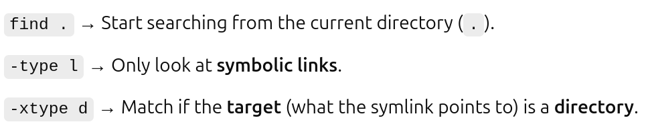
8. Modify the content of a file using a soft link. What happens to the original file?
Original file also modified

9. If you change the permissions of a file via a hard link, what happens to the original file?
If you change the permissions of a file via a hard link, the original file is affected too

10. Create a soft link using a relative path instead of an absolute path.

11. What happens when you move the original file that a soft link points to? Test it.
Soft links can be linked across different file systems, although if the original file is deleted or moved, the soft linked file will not work correctly (called hanging link).

12. Can a hard link exist across different filesystems? Why or why not?
No, a hard link cannot exist across different file systems. Hard links work by associating a filename with an inode, which is a unique identifier for the file within a specific file system. Since inodes are unique to a file system, a hard link cannot point to a file on a different file system because the inode would be different

13. Create multiple hard links to a file and then delete the original file. What remains?
the link will still show the content of the file

14. How do you remove a symbolic link without deleting the original file?
Use either the unlink or rm commands

15. Use ls -li to list inode numbers. Explain the difference in inode numbers for:
• original file - The original file has its own inode number.
• hard link - Same inode as the original because a hard link is just another name pointing to the same inode.
• soft link - Different inode because a symbolic link is a separate file that contains a path to the original file.

Task – 6

1. Schedule a cron job to run a script every day at 5:30 AM.
Crontab -e
30 5 * * *

2. Run a job every 15 minutes.
15 * * * *

3. Schedule a job to execute only on Mondays at 1:00 PM.
0 13 * * 1

4. Run a script every 6 hours.
0 */6 * * 1

5. Set up a job to run every weekday (Monday to Friday) at 9:00 AM.
0 9 * * 1-5

6. Create a cron job that runs at 12:00 midnight on the first day of every month.
0 0 1 * *

7. Schedule a job to run every 10 minutes, only between 9 AM and 6 PM.
*/10 9-18 * * *

8. Run a task every Sunday at 3:00 AM.
0 3 * * 0

9. Set up a cron job that runs every 30 seconds. (Is this possible with cron?)
No, it's not possible to directly set up a cron job to run every 30 seconds.

10. Create a cron job that runs every minute during working hours (9 AM to 5 PM) from Monday to Friday.
* 9-17 * * 1-5

11. Run a script at 6:45 PM every day except Saturday.
45 18 * * 0-5

12. Schedule a job to run every 2 hours, but only on the 15th of each month.
0 0/2 15 * *

13. Run a cron job at 7:00 AM and 7:00 PM daily.
0 7,19 * * *

14. Set up a cron job that runs every 5th minute of every hour.
5 * * * *

15. Schedule a job to run at 11:59 PM on the last day of each month.
59 23 28 * * [ "$(date +\%d -d tomorrow)" == "01" ] && your-command-here
59 23 30 * *
59 23 31 * *

16. Set a cron job to delete files older than 7 days every Sunday at 2:00 AM.
0 2 * * 0 find /path/to/directory -type f -mtime +7 -exec rm {} \;

17. Run a job every minute, but only on Sundays.
* * * * 0

18. Schedule a cron job to run a backup script every 4 hours on weekends.
0 0/4 * * 6,0

19. Set up a job to run a script every day at 9:00 AM and log the output to a file.
0 9 * * * /home/user/backup.sh >> /var/log/backup.log 2>&1

20. Run a job on the 1st and 15th of every month at noon.
0 12 1,15 * *

Task – 7

1. Display the first 15 lines of a file named sample.txt.
vim sample.txt – write some 20 lines in this text file then
head -n 15 sample.txt

2. Show only the lines that contain the word “Failed” from auth.log.
cat /var/log/auth.log | grep failed
grep “failed” /var/log/auth.log

3. Replace all occurrences of “localhost” with “127.0.0.1” in a file using a single command.
sed -i 's/localhost/127.0.0.1/g' sample.txt

4. Print lines 10 to 20 of a file using sed.
sed -n '10,20p' sample.txt

5. Extract the usernames (first column) from /etc/passwd.
cat /etc/passwd | awk -F: '{print $1}'

6. Sort a list of names in names.txt and remove duplicates.
sort sample.txt | uniq

7. Display the number of unique IP addresses from an access.log file.
awk '{print $1}' var/log/auth.log | sort | uniq | wc -l => there is no file or directory

8. Show the last 50 lines of a file named output.log.
tail -n 50 var/log/auth.log – there is no file or directory

9. Count how many times the word “error” appears in logfile.txt.
grep -oi "error" logfile.txt | wc -l

10. Redirect the output of ps aux to a file called processes.txt.
ps aux > processes.txt

11. Append the current date to a file named backup.log.
sudo date >> backup.log
cat backup.log

12. From a CSV file, print the 2nd and 4th columns only.
awk -F',' '{print $2, $4}' filename.csv

13. Find all lines that start with the letter “A” in data.txt.
grep "^A" data.txt

14. Display only lines where the 3rd column value is greater than 500.
awk -F',' '$3 > 500' filename.csv

15. Delete all empty lines from a file called config.txt.
sed -i '/^$/d' config.txt

16. Continuously monitor a log file and display only new lines that contain “CRITICAL”.

17. Count the number of lines, words, and characters in report.txt.
wc -l employees.txt

18. Show only the duplicate lines in a sorted file.
sort employees.txt | uniq -d

19. Redirect both stdout and stderr of a command to the same file.
command > output.log 2>&1
ls /nonexistentdir > output.log 2>&1

20. Print the total of the last column in a space-separated file.
awk -F',' '{sum += $NF} END {print sum}' filename

21 . I want to get output on line 15th to line 24th
sed -n '15,24p' sample.txt
awk 'NR>=15 && NR<=24' file.txt

22. compress a file of size more then 1gb and run in background
tar -czvf new_swap swap.img
ctrl + z
bg
jobs

23. common ports
Port 22 (SSH): Used for Secure Shell (SSH), which enables secure remote access to the server. This is essential for administrators to manage their systems from afar.
Port 80 (HTTP): Handles standard web traffic for websites. It’s open for any website operating over the non-secure HTTP protocol.
Port 443 (HTTPS): The secure version of HTTP, this port is used by SSL/TLS to encrypt web traffic, protecting data exchanged between a website and its users.
Port 21 (FTP): Used for File Transfer Protocol (FTP) connections, enabling file transfers between computers on a network.
Port 25 (SMTP): Simple Mail Transfer Protocol (SMTP) is responsible for sending emails.
Port 3306 (MySQL): Used by MySQL databases, this port is commonly open for applications that need to communicate with MySQL.

