**Sales Data Analysis Report**

**Excel Project**

**By: Dikshant Sharma**

**(INT 217: Introduction to Data Management)**

**Registration No. 11918272**

**5th Semester Final term Project**

**Lovely Professional University**

**Product Sales Data Analysis**

**Purpose:**

**The Main purpose for is project, is to analysis the data of product based on several categories using Excel. Analysis of data helps in improving business model to increase sales as well as profit. By analysing data this data, we get to know in which sectors we can improve, and which sectors are not giving enough profit. The competition among different companies is very high and they are fighting in market to increase their sales, Data analysis plays a major role in this. In this sales data the profit and sales depend on several factors like, location, city, Shipping mode, Categories etc. Some factors increase the profit positively but there are some factors that are affecting sales negatively that company needs to focus on.**

**Why Excel:**

**Excel is a one of the best tools for data analysis purpose. Excel provide graphical support for data analysis, and it has many inbuilt functions that helps in doing tasks very easily. Excel has many graphs for visualization of tabular data so one can easily understand. It has many features to perform operation on entire data very easily.**

**Dataset Source:**

[**https://data.world/codefordc/retail**](https://data.world/codefordc/retail)

**Dataset:**

There are 13 Categories and 9994 Rows in dataset

Categories:

Ship mode, Segment, Country, City, State, Postal Code, Region, Category, Subcategory, Sales, Quantity, Discount, Profit

Objectives:

* Objective 1: What are the total sales according to each state and which states gives the highest profits?
* Objective 2: Sales according to the mode of the shipping, which shipping mode gives maximum sales.
* Objective 3: Profit according to the mode of the shipping, which shipping mode gives maximum profit respective to sales.
* Objective 4: What are the best-selling products which gives the maximum profit and sales?
* Objective 5: Sales and profit in each city of every state and In which cities profit is affecting negatively.

Objective 1: What are the total sales according to each state and which states gives the highest profits?

For this the sum of the sales is grouped by State

**Pivot Table**

**Pivot Chart:**

Map Chart

This is a map chart that shows data distribution on map. The darkest Part is the highest sales, and the lightest part has lowest sales.

Major cities like Texas, California, New York, Washington gives the highest sales as their size is bigger and they are metropolitan cities, their population is higher as compared to other cities.

Objective 2: Sales according to the mode of the shipping, which shipping mode gives maximum sales.

Data is Grouped by mode of shipping and segment and their sum of profit is calculated using pivot table

Pivot Table:

**Pivot Chart:**

**Bar Chart**

**Outcome**:

Consumers in the Standard Class of shipping has maximum Sales of $ 247102.963

Overall Standard class of shipping has better sales than others.

Most of the sales comes form Consumer Category regardless of Mode of shipping.

Home office gives least sales

Objective 3: Profit according to the mode of the shipping, which shipping mode gives maximum profit respective to sales.

Pivot table:

Pivot Chart:

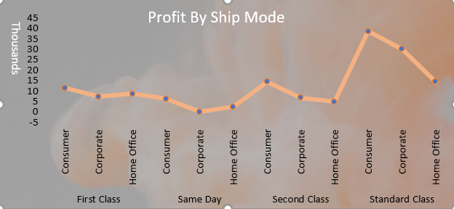

**Conclusion**:

Consumers in standard shipping mode gives maximum profit of 39 thousand dollars

But in first class and Same day mode of shipping the profit in home office is higher than

corporate even after having lower sales in same shipping mode.

Overall Same day mode of shipping gives the least profit.

The is statistics for the whole united states we can go even further into states in cities

To get better insights of every state

Objective 4: What are the best-selling products which gives the maximum profit and sales?

Pivot Table

The Category columns and the subcategory columns are grouped by sum of sales and profit using pivot table

As we can see that sales is not directly proportional to profit. Even after good sales some products like bookcases, Tables, supplies etc. are giving negative profit

**Pivot Charts**

**Conclusion:**

There are three categories Furniture, Office supply, Technology and they further have their

Subcategories

In Furniture:

Chairs are giving best profit of around 35000 USD.

Bookcase and Tables are giving loss of around 4900 and 9800 USD respectively.

In Office Supply:

Fasteners and Papers are giving maximum profit of around 17000 and 15100 USD.

Only Supplies is giving negative profit.

In Technology:

In this segment profit is maximum

Profit in Copiers, Phones, Accessories is giving profit of around 24000, 23800, 20200 USD respectively.

Objective 5: Sales and profit in each city of every state and in which cities profit is affecting negatively.

Pivot Table:

States and cities are grouped by sum of sales and profit using pivot table.

**Pivot Chart**

**Conclusion:**

This is city profit statistics for state Alabama and there are 49 other states we can easily see them using filters.

Sales of each city is indicated by blue bar and the profit is orange block.

Mobile city is having highest sales and profit of 6150 and 2000 respectively.

There are some cities like Florence, Hoover and Montgomery etc which are having good sales 1997, 525, 3722 USD but profit is still not that good like 248.65, 18.175, 834 USD respectively

Sales to profit ratio of city Tuscaloosa is good 175.7 USD of sales and 51.01 USD profit