HR ANALYTICS

Employee Data Analysis Using SQL

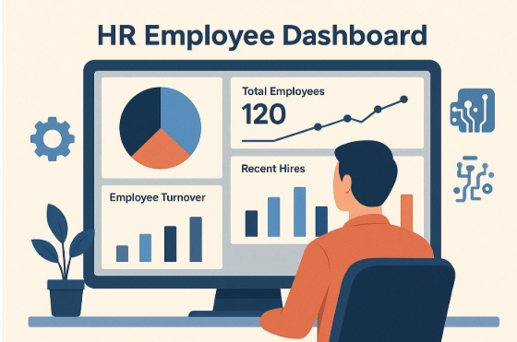

Prepared by: Diksha Pagare
Project Type: Data Analytics Project
Tools Used: MySQL, MySQL Workbench
Database: HR Analytics DB

1. Introduction
Human Resource (HR) Analytics is the process of collecting, organizing and analyzing employee-related data to understand workforce patterns and support better business decisions.
Every organization maintains information about its employees, including their departments, salaries, attendance, performance, promotions and employment status. Analyzing this information helps organizations understand their workforce and identify areas that require improvement.
This project, HR Analytics: Employee Data Analysis Using SQL, focuses on analyzing employee data using Structured Query Language (SQL). The project uses MySQL to store, manage and analyze HR-related information.
The database consists of four tables: Employees, Department, Attendance and Performance. Different SQL queries are used to examine employee distribution, salary patterns, performance ratings, attendance, employee attrition and other important HR metrics.
The main purpose of this project is to convert raw employee data into meaningful insights that can help an organization understand its workforce and make informed decisions.

2. Problem Statement
Organizations generate large amounts of employee-related data, but understanding this data and identifying useful patterns can be challenging.
Without proper analysis, organizations may find it difficult to monitor employee attendance, understand employee attrition, evaluate performance, compare salaries across departments and identify workforce trends.
Therefore, this project aims to use SQL to analyze HR data systematically and answer important business questions related to employee management.

3. Project Objectives
The main objectives of this project are:
- To analyze the total number of employees and active employees.
- To calculate the employee attrition rate.
- To analyze salary distribution across departments and designations.
- To identify top-performing employees.
- To examine employee attendance and leave utilization.
- To analyze gender diversity and age distribution.
- To understand employee tenure and monthly hiring trends.
- To examine employee performance ratings.
- To identify employees eligible for promotion based on the available criteria.
- To analyze department-wise employee distribution and attrition.
- To generate meaningful insights from HR data using SQL.

4. Tools and Technologies Used
MySQL: Used as the database management system to store and manage HR data.
MySQL Workbench: Used to write, execute and manage SQL queries and perform data analysis.
SQL (Structured Query Language): Used to retrieve, filter, group, sort and analyze employee information.
Microsoft Excel / CSV: Used to store and review exported analysis results.

5. Dataset Description
The project uses an HR dataset containing employee, department, attendance, and performance information. The database consists of four tables.

5.1 Employees Table
Contains employee details such as employee ID, name, gender, age, department ID, designation, salary, hire date, city, and employment status.

5.2 Departments Table
Contains department information, including department ID and department name.

5.3 Attendance Table
Contains attendance records, including attendance ID, employee ID, attendance date, and attendance status.

5.4 Performance Table
Contains employee performance information, including review ID, employee ID, review year, performance rating, and bonus.
The tables use employee IDs and department IDs to connect related information for analysis.

6. Data Cleaning
No separate data-cleaning process was performed as part of this project. The downloaded HR dataset was imported into MySQL and used for SQL-based analysis.
The project focused on writing SQL queries to analyze employee details, department information, attendance records, and performance data.

7. SQL Analysis and Queries
SQL was used to analyze the HR dataset and answer important business questions related to employee information, salary, performance, attendance, and workforce trends.
A total of 25 HR-related business questions were explored using SQL queries.

7.1 Employee Analysis
- Total number of employees
- Number of active employees
- Employee attrition rate
- Average employee salary

7.2 Salary Analysis
- Salary by department
- Salary by designation
- Highest-paying department
- Highest-paying job role

7.3 Performance Analysis
- Average performance rating
- Top-performing employees
- Bonus distribution
- Performance rating distribution
- Promotion eligibility list

7.4 Department and Diversity Analysis
- Department-wise employee count
- Gender diversity ratio
- Age distribution
- Employees by city
- Department-wise attrition

7.5 Attendance and Workforce Analysis
- Average employee tenure
- New hires by month
- Employee attendance rate
- Leave utilization
- Absenteeism rate
- Employee growth trend
- Workforce dashboard metrics
These queries helped organize the HR data and identify useful workforce insights.

8. Key Findings and Insights
The SQL analysis provided useful insights into employee strength, attrition, salaries, attendance, performance, and workforce trends.

8.1 Employee Workforce
- The dataset contains 10,000 employees.
- Out of these, 7,018 employees are active.
- The employee attrition rate is 29.82%.
- The average employee tenure is 6.81 years.

8.2 Salary Analysis
- The overall average employee salary is 136,301.88.
- Operations has the highest average department salary at 138,354.26.
- Procurement Executive has the highest average salary by designation at 147,337.32.
- Note: The currency unit was not specified in the original dataset; therefore, salary values are presented without a currency symbol.

8.3 Gender Diversity
- Female employees account for 50.15% of the workforce.
- Male employees account for 49.85% of the workforce.
- The results show a nearly balanced gender distribution.

8.4 Attendance Analysis
- The employee attendance rate is 69.16%.
- The absenteeism rate is 10.09%.
- The leave utilization query returned 1,069 leave days.

8.5 Performance Analysis
- The average performance rating is 2.99.
- The analysis identified 10 top-performing employees with a rating of 5.00.
- The promotion eligibility query returned 1,000 employees.

8.6 Department-wise Attrition
- Information Technology has the highest department attrition rate at 32.63%.
- Sales has the lowest department attrition rate at 26.78%.

8.7 Employee Growth
- Employee hiring records cover the years 2015 to 2024.
- Annual hiring totals ranged from 952 employees in 2017 to 1,046 employees in 2022.
Overall, the analysis demonstrates how SQL can be used to examine workforce patterns and support HR-related decision-making.

9. Conclusion
The HR Analytics SQL project provided an opportunity to explore and analyze employee data using MySQL and MySQL Workbench.
The project involved working with four tables: Employees, Departments, Attendance, and Performance. A total of 25 HR-related business questions were explored using SQL queries.
Through this analysis, important insights were obtained about employee strength, attrition, salary distribution, gender diversity, attendance, performance ratings, and workforce trends.
This project helped develop practical skills in SQL, including data retrieval, filtering, aggregation, grouping, sorting, and joining tables.
Overall, the project demonstrates how SQL can be used to transform HR data into meaningful information that can support better workforce analysis and HR decision-making.

