**SYSC 5709 – Summer 2020 – Course Project**

**Game Simulation: Snakes and ladders**

To provide a feeling of competency, autonomy and to relieve stress, we propose a game as the best time killing application. The main idea is to reciprocate a board game into an online game application for easy access. Simplicity and efficiency is the main agenda about building this game that we can obtain using the C programming language.

Game will be played based on below rules:

1. Snakes and ladders game is a grid of 10 x10 squares. The entire grid is numbered from 1 to 100.
2. It is a multi-player game. 2 players are required.
3. Each player takes turns to roll a six-sided dice. The player moves as many squares forward as number on the dice. A player gets a consecutive turn if player gets a six.
4. Each player starts at 1. Each player needs to roll 1 or a 6 to start playing the game.
5. If a player’s counter lands at bottom of ladder, the player moves to top of ladder.
6. If a player’s counter lands on a snake, then player must slide down the snake.
7. Player whose counter reaches number 100 first is the winner.

This project provides following options to user:

1. Start new game
2. Load existing game
3. Save game
4. Exit game

**File and Folder Structure Organization**

**1.bin:** This folder has executable and data file for the game 'Snakes and Ladders'.

1. snakesladders.exe

**2.doc:** It contains all the documents for the project.

1. html: The html folder generated by Doxigen for our project.
2. latex: The latex folder generated by Doxigen for our project.
3. user_manual.doc
4. developer_guide.doc

**3.external_files:** This folder contains dat files used in the project to save data to the file and read data from the file.

1. snakeladders.dat
2. players.dat

**4.obj:** This folder has all the object files generated using make file.

1. snakeladders.o

**5.include:** It contains all the header files included in the project.

1. snakeladders.h

**6.lib:** This folder contains library files used in the project.

In our project, we are not using any library file.

**7.src:** It has following .c file:

1. snakesladders.c

**8.test:** It has file used to test the project along with the file generated after testing:

1. test.c
2. test.txt

**Flow diagram:**

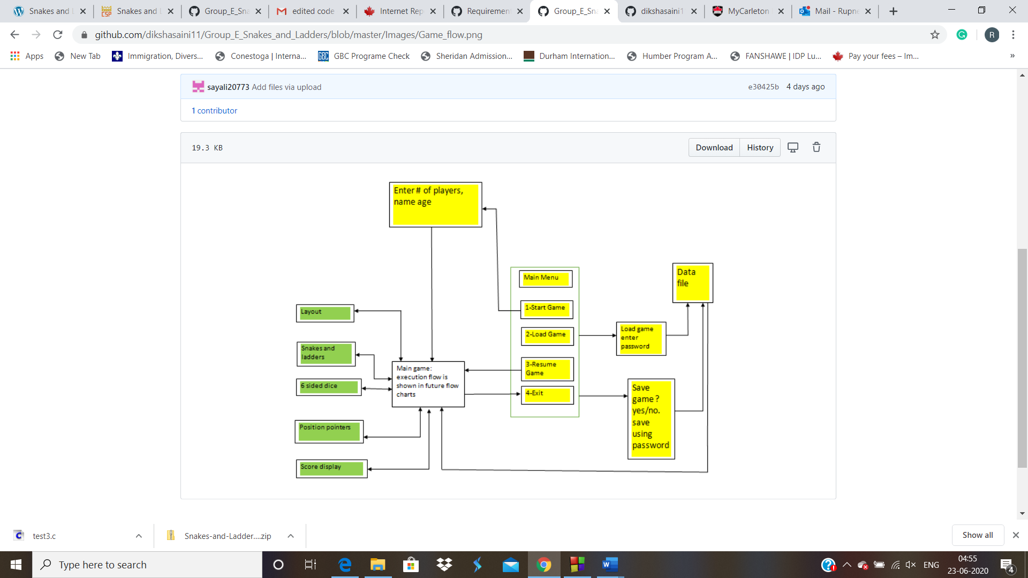

**GitHub Link:** <https://github.com/dikshasaini11/Group_E_Snakes_and_Ladders>