

**Software Development with C**

**Snakes and Ladders Game: User guide**

**SUBMITTED TO:**

**Prof. Cristina Ruiz**

Diksha Saini (101112561) Github userid: dikshasaini11

Rupneet Kaur Gill (101133228) Github userid: Rupneetkaurgill

Sayali Dhokar (101134253) Github userid: sayali20773

Vidushi Gupta (100985580) Github userid: Vidushi187

**SUBMITTED BY:**

**Installing Cygwin, GCC**

**Windows – Installation**

1) Visit **http://www.cygwin.com/.**

2) Look for the section "Installing Cygwin" and select the appropriate version (32 bit or 64 bit) for your PC.

3) Download the setup file chosen. Based on the OS version we will get a file named setup-x86_64.exe (64-bit installation) or setup-x86.exe (32-bit installation).

4) Fig 1: Cygwin page.

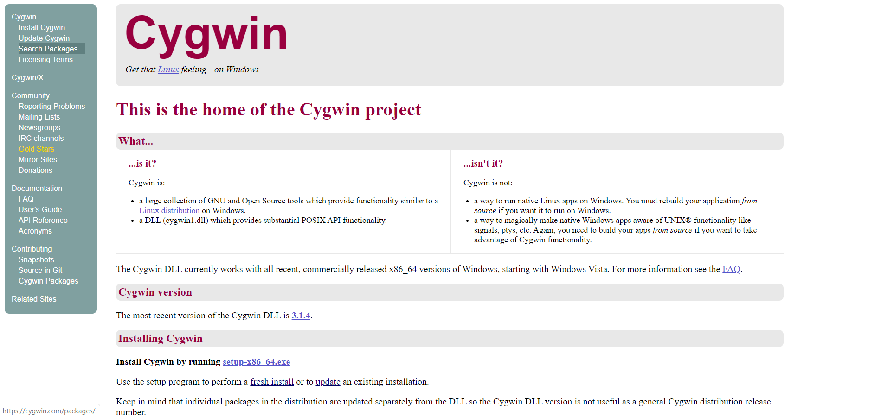

5) Execute setup-x86_64.exe (64-bit installation) or setup-x86.exe (32-bit installation) and click on “Next >”. We will see the following welcome screen.

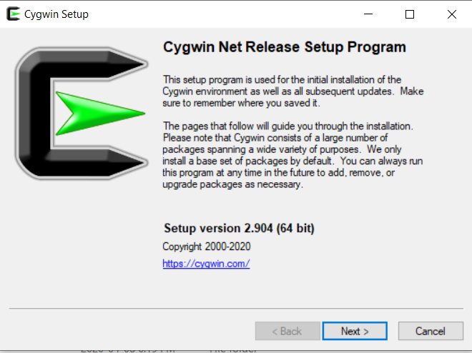

Fig 2: Cygwin Setup Program.

6) Select option to setup from internet and click next.

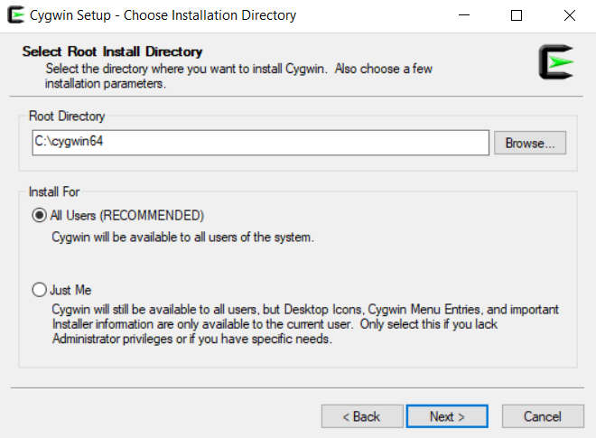

Fig 3: Choose Installation.

7) Choose path to download.

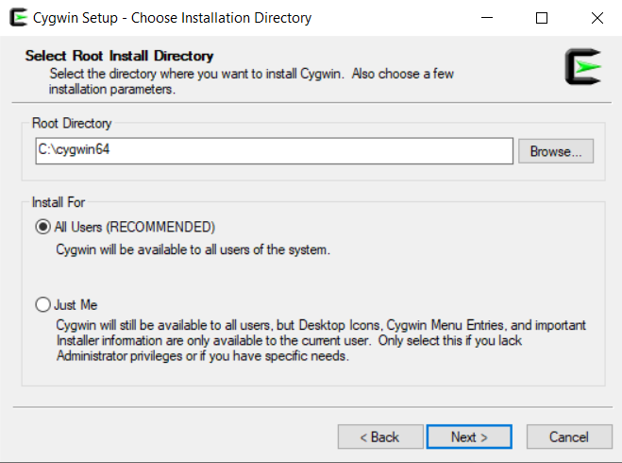

Fig 4: Installation path.

8) Select the option “Use System Proxy Setting” and click on Next.

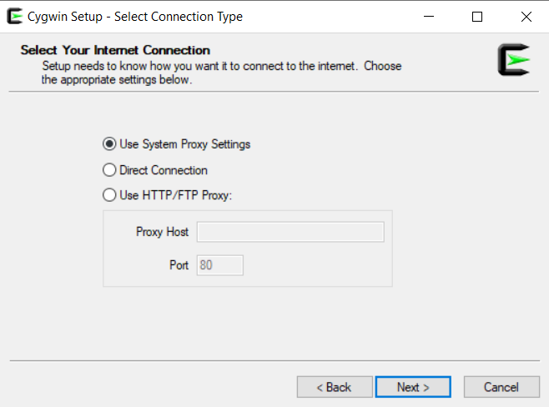

Fig 5: Select Internet connection.

9) Choose download site.

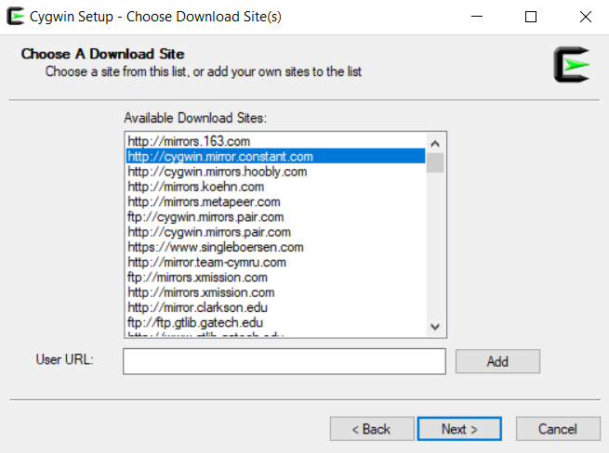

Fig 6: Choose download site.

10) Cygwin will start the installation process.The above window will appear.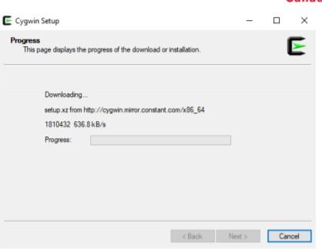

11) Whenwegetthefollowingwindow,ifweclickon“All”,wewillseealltheexistingpackages. Donotchooseanything;simplyclickNext leaving everythingas default.

This will install the default tools and libraries.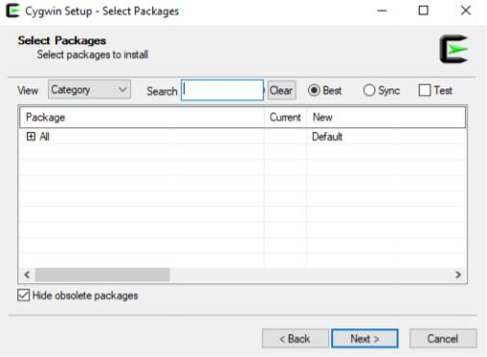

Fig 8: Select packages.

12) The following window will appear. Click on “Next>”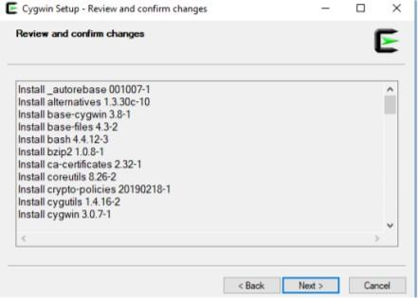

Fig 9: Review and confirm.

13) The progress window below will appear.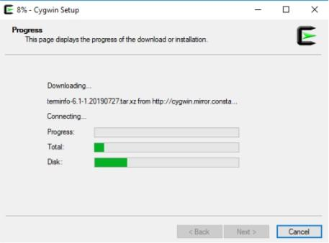

Fig 10: Setup progress.

14) Once the installation finishes, select the option “Create icon on Desktop” to easily access the Cygwin terminal. Click on“Finish”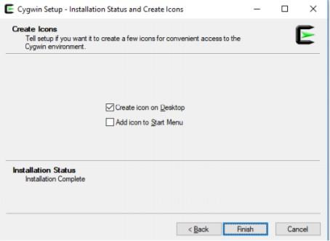

Fig 11 Setup Finish.

15) Once the installation finishes, if we open the cygwin64 folder, it should have the following content.

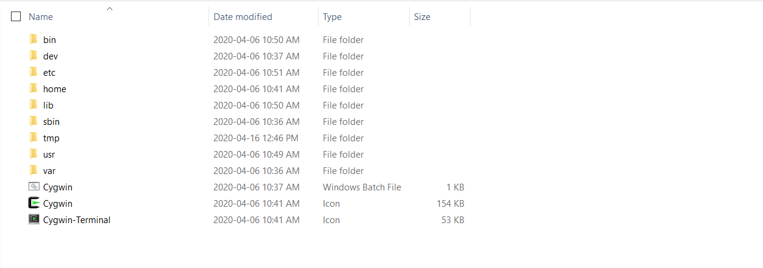

Fig 12: C:\cygwin64

16) Openthewindowsterminal(CommandPrompt;type“cmd”onyourWindowssearch).Type cdc:\cygwin64

For the 64-bit installation, type: Setup-x86_64.exe-q-Pchere-Pwget-Pgcc-g++-Pmake-Pdiffutils-Plibmpfr-devel-Plibgmp- devel-Plibmpc-devel-Pgit(For32-bitinstallation,replacebysetup-x86.exe)

It will install all the necessary libraries and the last version of gcc/g++ compiler.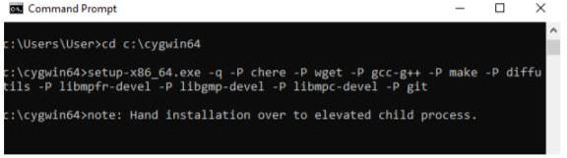

Fig 13: Command prompt.

17) A Progress window will popup while all the required packages along with their dependencies are downloaded and installed, as in the following screen capture.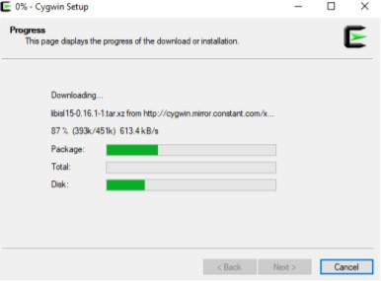

Fig 14: Setup

The installation process will take several minutes.Once the installation process finishes, the window will disappear automatically, and we can close the Command Prompt.

18) Cygwin on your desktop, in administrator mode (right-click) on the desktop icon and select the action“Run as administrator”; we can also use c:\cygwin64 and run the script “cygwin.bat” in Administrator mode).

The skeleton files will be created.

19) Type the following command on the terminal and press “Enter” (in this case, we show an example for user “User” running Cygwin on theDesktop):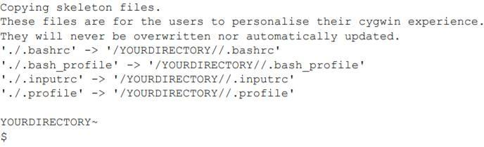

wget rawgit.com/transcode-open/apt-cyg/master/apt-cyg

20) Type the following command and press “Enter” install apt-cyg/bin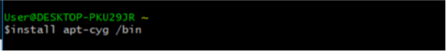

"apt-cyg" is a command in Cygwin like the"sudoapt-get" command in Linux. It is used to install packages, update them, list them, etc.

21) Type the following command and press “Enter” chere-i-tmintty-sbash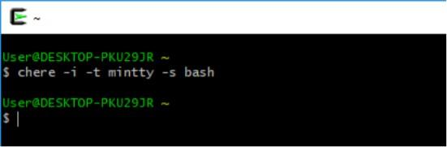

This will allow us to open a Cygwin bash terminal from any folder in your Windows File Explorer or other applications.

22) Type the following command on Cygwin terminal and press “Enter”. apt-cyg installlibboost-devel

This installs the Boost Library. A progress message will show the installation.

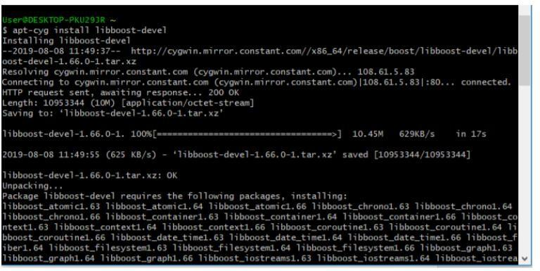

Fig 15: Installing

23). Go to C:\cygwin64\lib\gcc\x86_64-pc-cygwin\9.3.0\include to check various libraries or include any library you want for your project in this folder.

**Downloading Game**

1) Install Git (User can use Git bash or any other software of choice to clone the project).

2) Create a new folder for the project. Right Click inside the folder and open a gitbash here. Right Click +” Git Bashhere”.

3) Type the following command in the git terminal:

Git clone https://github.com/ dikshasaini11/Group_E_Snakes_and_Ladders

OR

Go to the link <https://github.com/dikshasaini11/Group_E_Snakes_and_Ladders> and clickon Clone or Download and download the zip folder of the software.

**Running snakes and ladders game application:**

1) Compiling the project.

a) Open the downloaded folder, open ..\.

b) Copy path.

c) Open Cygwin64 Terminal, type cd (path) and enter.

d) Type “make” and enter.

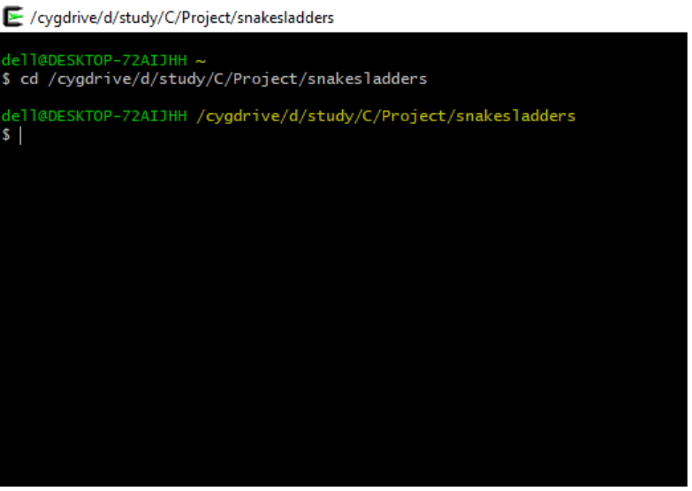

Fig1:Copy make file folder path.

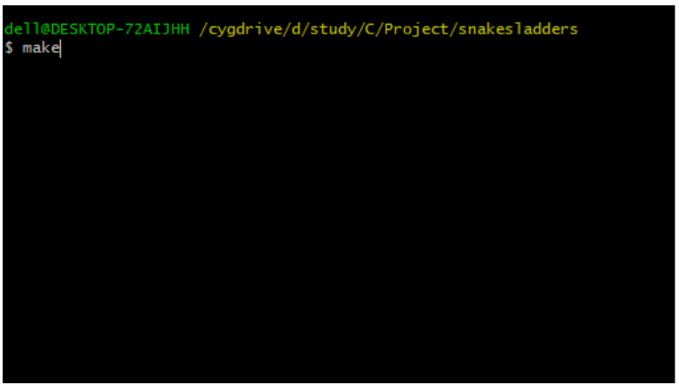

Fig2: Type make and enter.

After this command, object files will be created. We can either run application or testcases.

If you type bin/./test, you will see test case result in file test result in folder ..\employee_payroll\test

2) After you type bin/./snakes_and_ladders, you will see First screen with Game name

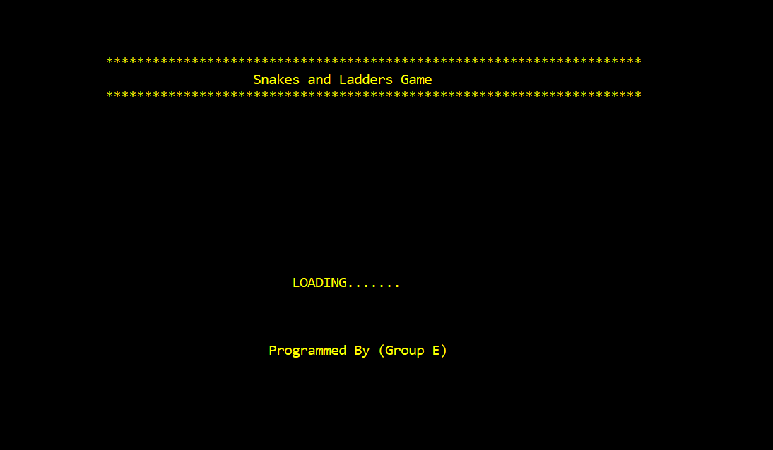

Fig 3: First Screen

3) The screen moves to main menu after few seconds, you can see the following options on it.

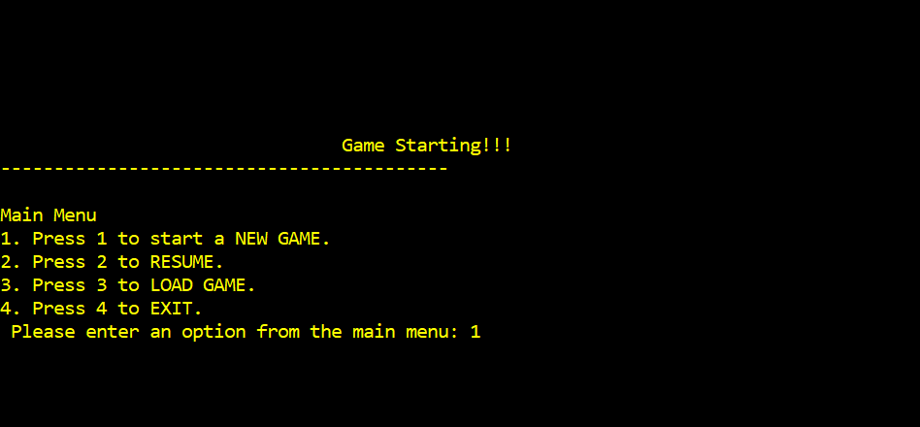

Fig 4: Main Menu

* If user opt for 1. New Game, the following screen will appear.

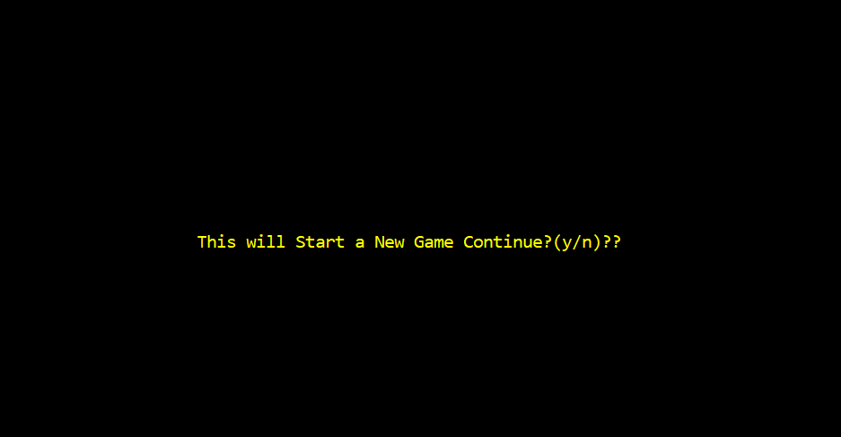

Fig 5: New Game

* If user opts for option yes by typing y, the page asks the user to enter player details.

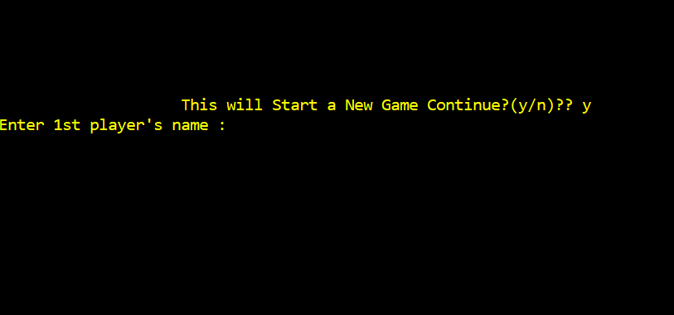

Fig 6

And then player 2 details after pressing enter. (Fig 7,8: Player details)

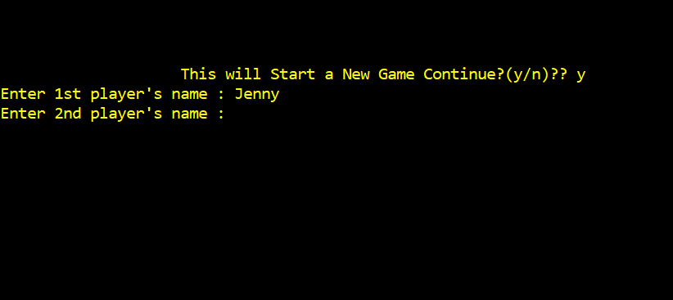

Fig 7

* After player details, press enter to start playing.

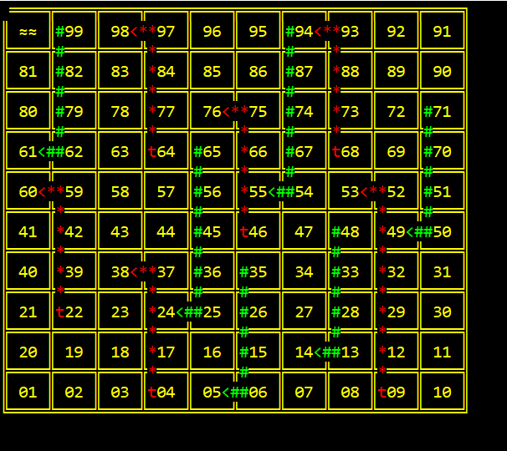

Fig 8: Game layout

* If user opt for 3. Load Game:

Firstly, game should be saved before load. steps are as follows:

step 1: while playing a game, choose a option to quit the game. press ‘q’. the following screen will appear.

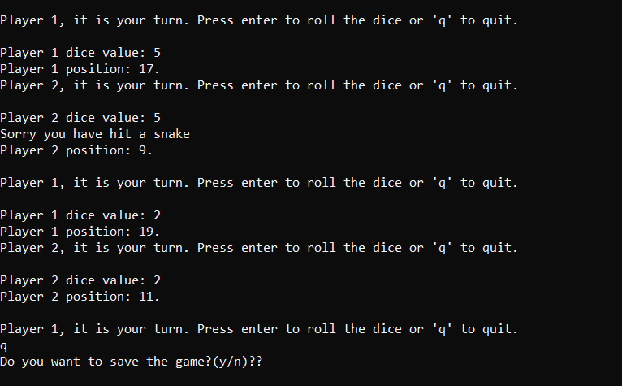

Fig 9: Save game

step2: when ‘y’ is pressed to save game there comes the following screen to get authentication for game and password. so, the password must be more than 6 letters that includes atleast one capital letter, small letter and digit.If user selects ‘n’, he can directly quit the game.

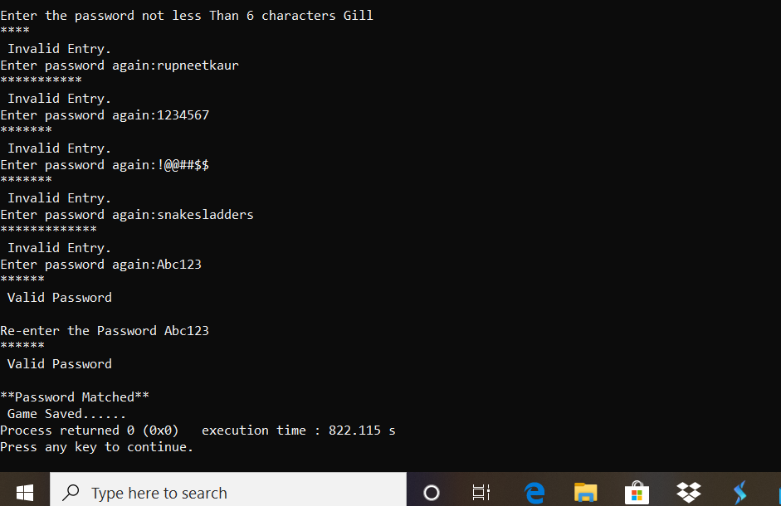

Fig10: game saved

* If user opt for 4 ‘Exit’, the following screen will appear.

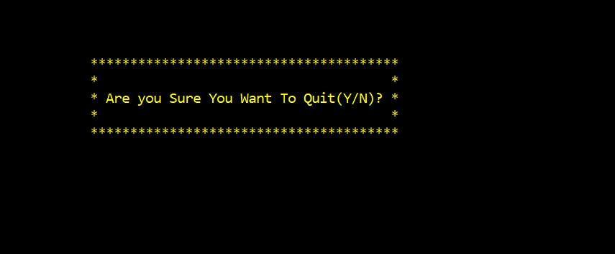

If user selects ‘y’, he will exit the game, if selects ‘n’ goes to main screen.