Fundamentals of Computer Programming
Assignment 1 — Solutions & Source Code (26CSU189)

Module 1

Question 1: Read from STDIN, Write to STDOUT
Problem: Read an integer N and a string S from standard input, then output twice the integer and the string.
Source Code:
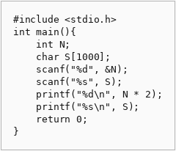

Question 2: Solve Me First
Problem: Implement a function that returns the sum of two integers.
Source Code:
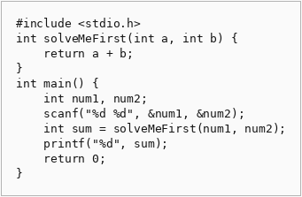

Question 3: 2235 — Add Two Integers
Problem: Write a function that returns the sum of two integers.
Source Code:
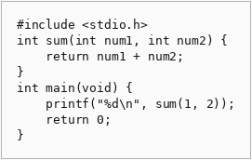

Question 4: 2651 — Calculate Delayed Arrival Time
Problem: Given arrival time and delayed time, compute the actual arrival time modulo 24.
Source Code:
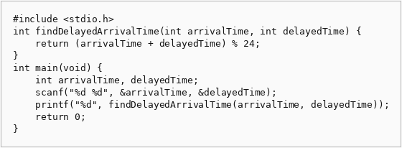

Question 5: 2739 — Total Distance Traveled
Problem: Calculate total distance traveled given main tank and additional tank fuel.
Source Code:
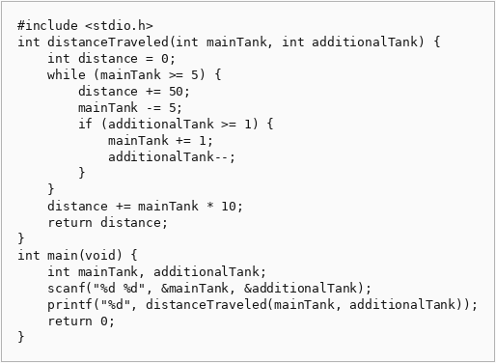

Module 2

Question 1: Conditional Statements in C
Problem: Print the English word for numbers 1-9, or "Greater than 9" otherwise.
Source Code:
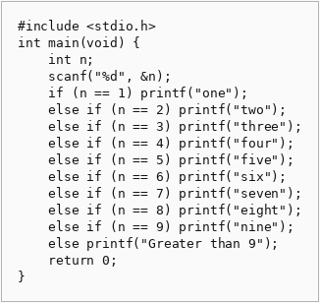

Question 2: 2413 — Smallest Even Multiple
Problem: Return the smallest even multiple of n.
Source Code:
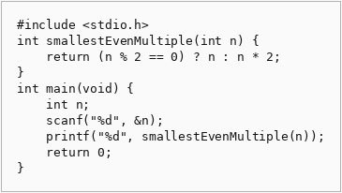

Question 3: Grading Students
Problem: Round grades according to the given rules if the grade is 38 or above.
Source Code:
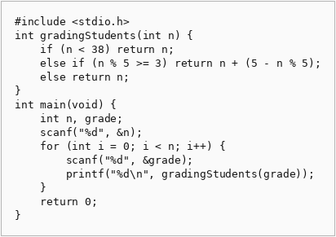

Question 4: Roy and Profile Picture
Problem: Check if a photo meets dimension requirements and output appropriate message.
Source Code:
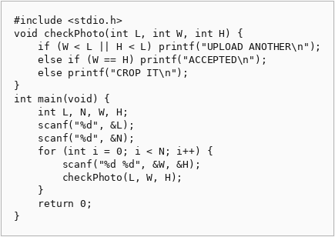

Question 5: FizzBuzz
Problem: Print numbers from 1 to 100 with Fizz, Buzz, and FizzBuzz rules.
Source Code:
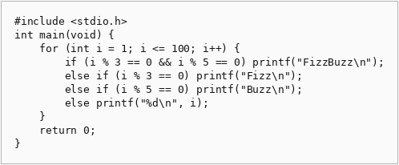

Module 3

Question 1: For Loop in C
Problem: For a given range, print the English representation for numbers 1-9 and even/odd for larger numbers.
Source Code:
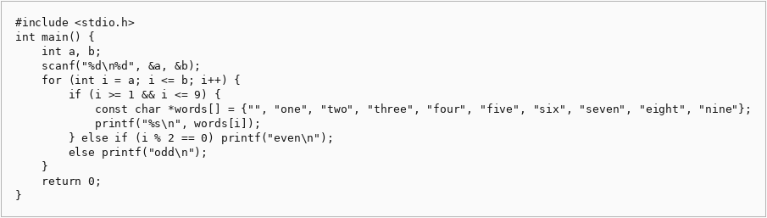

Question 2: 1342 — Number of Steps to Reduce a Number to Zero
Problem: Count the steps to reduce a number to zero by subtracting 1 or dividing by 2.
Source Code:
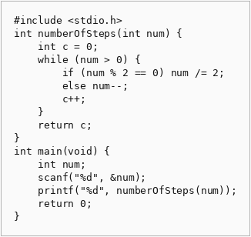

Question 3: 2169 — Count Operations to Obtain Zero
Problem: Count operations to make one of the numbers zero by subtraction.
Source Code:
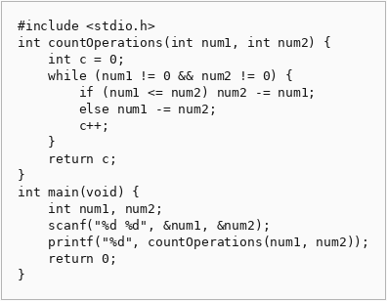

Question 4: 1523 — Count Odd Numbers in an Interval Range
Problem: Count odd numbers between low and high inclusive.
Source Code:
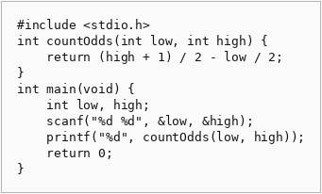

Question 5: 2652 — Sum Multiples
Problem: Sum of all multiples of 3, 5, or 7 up to n.
Source Code:
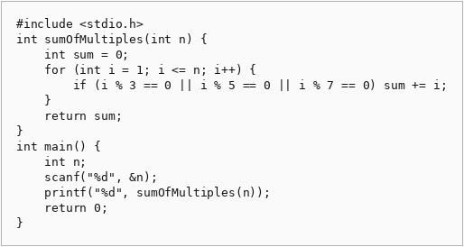

Question 6: Number Line Jumps
Problem: Determine if two kangaroos land on the same position at the same time.
Source Code:
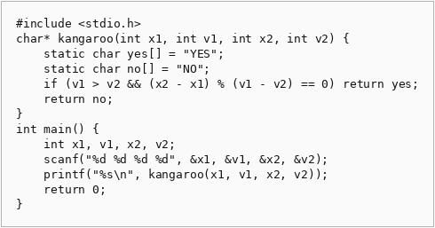

Module 4

Question 1: Digit Sum
Problem: For multiple test cases, print the sum of the first and last digits of N.
Source Code:
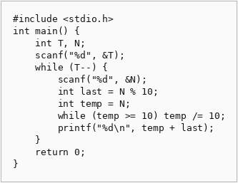

Question 2: Find Digits
Problem: Count how many digits of n divide n evenly (excluding zero).
Source Code:
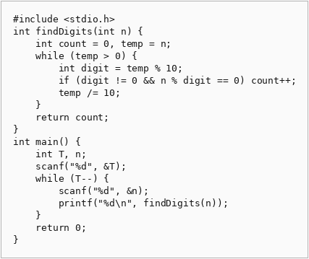

Question 3: 1281 — Subtract the Product and Sum of Digits
Problem: Return the product of digits minus the sum of digits.
Source Code:
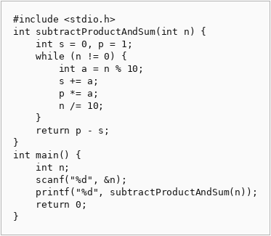

Question 4: 2520 — Count the Digits That Divide a Number
Problem: Count digits of num that divide num evenly.
Source Code:
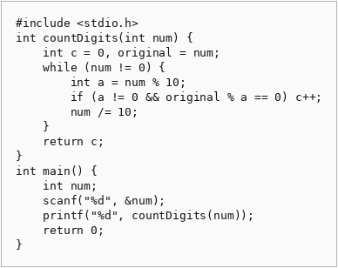

Question 5: 9 — Palindrome Number
Problem: Check if an integer is a palindrome.
Source Code:
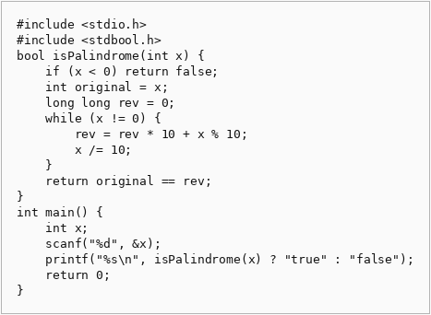

Question 6: 7 — Reverse Integer
Problem: Reverse the digits of an integer, returning 0 on overflow.
Source Code:
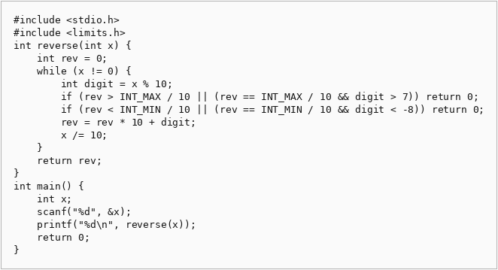

Module 5

Question 1: 231 — Power of Two
Problem: Determine if n is a power of two.
Source Code:
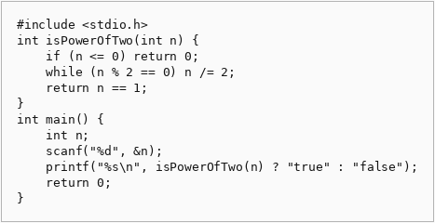

Question 2: 326 — Power of Three
Problem: Determine if n is a power of three.
Source Code:
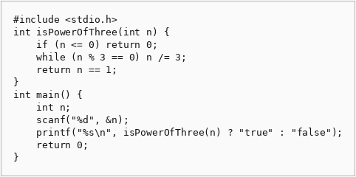

Question 3: Factorial!
Problem: Compute the factorial of n (handling large numbers by digit array).
Source Code:
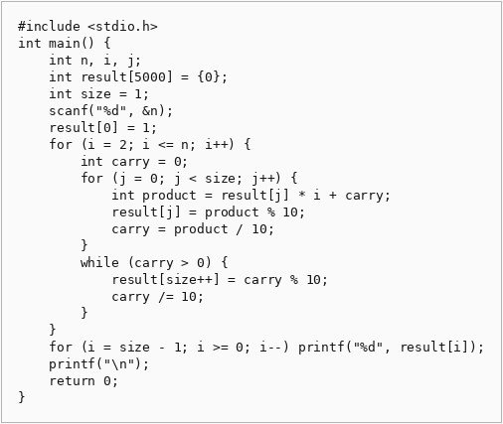

Question 4: Count Divisors
Problem: Count numbers between l and r that are divisible by k.
Source Code:
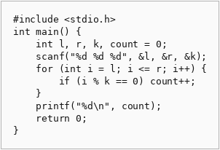

Question 5: Prime Numbers
Problem: Check if a number is prime (print 1 if yes, 0 if no).
Source Code:
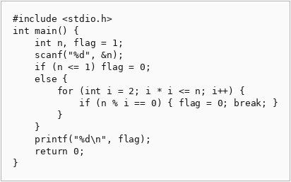

Question 6: 507 — Perfect Number
Problem: Check if a number is perfect (sum of proper divisors equals the number).
Source Code:
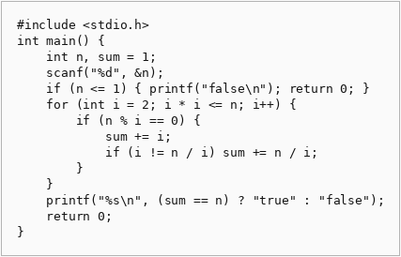

Module 6

Question 1: Staircase
Problem: Print a right-aligned staircase of height n using # characters.
Source Code:
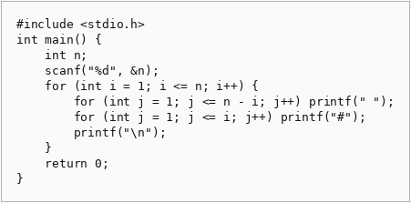

Question 2: Printing Pattern Using Loops
Problem: Print a pattern of decreasing numbers based on the minimum distance to edges.
Source Code:
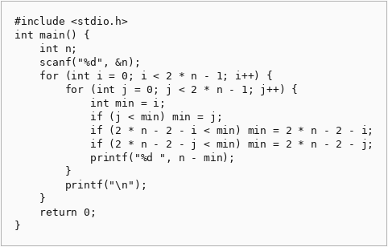

Module 7

Question 1: Square of Asterisks
Problem: Print an n by n square of asterisks with no spaces between them.
Source Code:
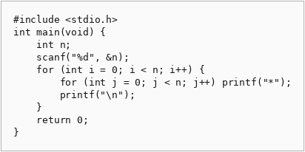

Question 2: Left-Aligned Triangle
Problem: Print a left-aligned triangle with row i containing i asterisks.
Source Code:
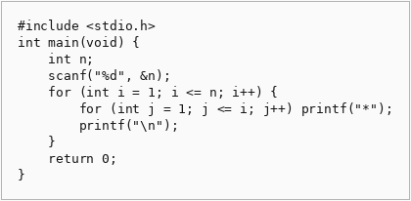

Question 3: Inverted Left-Aligned Triangle
Problem: Print a left-aligned inverted triangle starting with n asterisks.
Source Code:
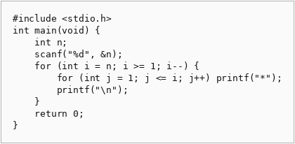

Question 4: Number Triangle
Problem: On row i, print integers from 1 to i separated by spaces.
Source Code:
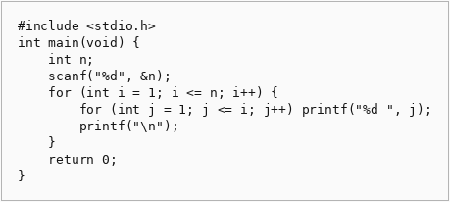

Question 5: Repeated Number Triangle
Problem: On row i, print the number i exactly i times.
Source Code:
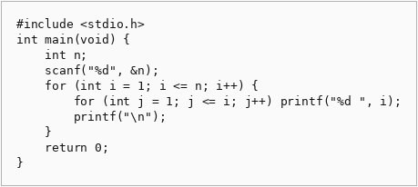

Question 6: Consecutive Numbers Triangle
Problem: Print consecutive positive integers across triangular rows.
Source Code:
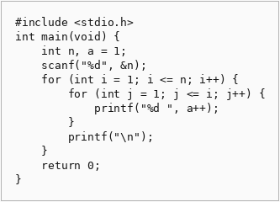

Question 7: Right-Aligned Triangle
Problem: Print a right-aligned triangle using leading spaces.
Source Code:
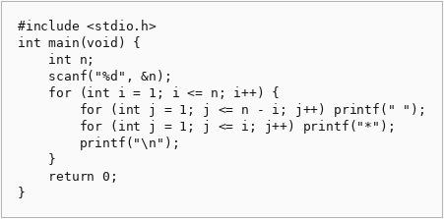

Question 8: Centered Pyramid
Problem: Print a centered pyramid with 2*i-1 asterisks on row i.
Source Code:
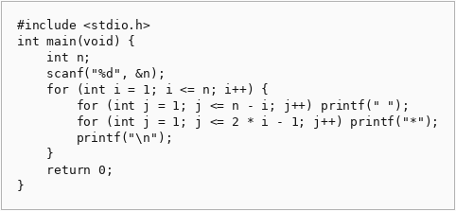

Question 9: Inverted Centered Pyramid
Problem: Print an inverted centered pyramid.
Source Code:
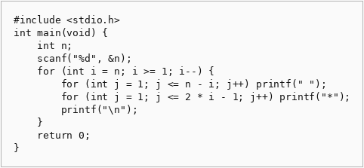

Question 10: Hollow Square
Problem: Print an n-by-n hollow square of asterisks.
Source Code:
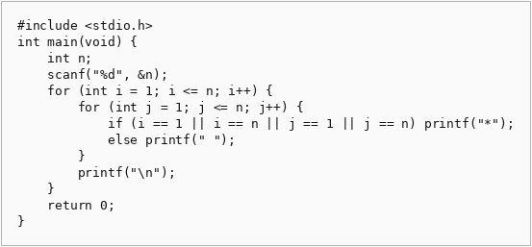

Question 11: Hollow Left Triangle
Problem: Print the outline of a left-aligned right-angled triangle.
Source Code:
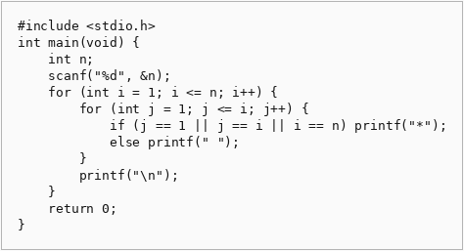

Question 12: Multiplication Grid
Problem: Print an n-by-n multiplication table.
Source Code:
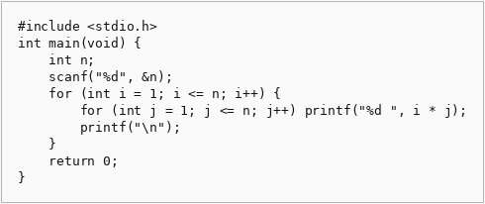

Question 13: Checkerboard
Problem: Print an n-by-n checkerboard starting with X in the top-left.
Source Code:
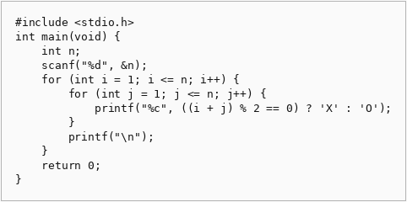

Question 14: Floyd's Triangle
Problem: Print Floyd's triangle with n rows of consecutive integers.
Source Code:
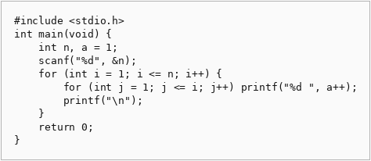

Question 15: Butterfly Pattern
Problem: Print a butterfly pattern of asterisks for odd n.
Source Code:
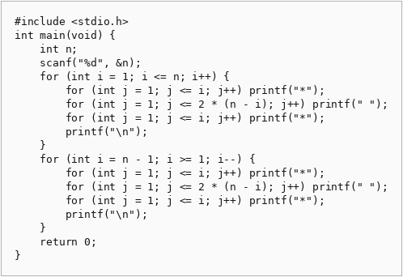

Question 16: Centered Diamond
Problem: Print a centered diamond pattern.
Source Code:
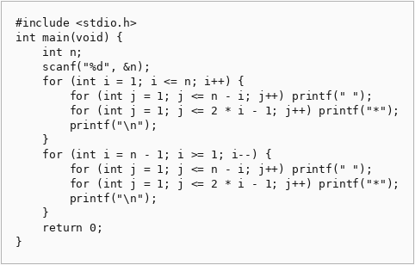

Conclusion
All programs have been implemented according to the problem statements. The solutions demonstrate proper use of control structures, functions, loops, and modular programming practices in C. The source code is provided via the screenshots above.
This completes Assignment 1 for Fundamentals of Computer Programming.

