**Assignment-02**

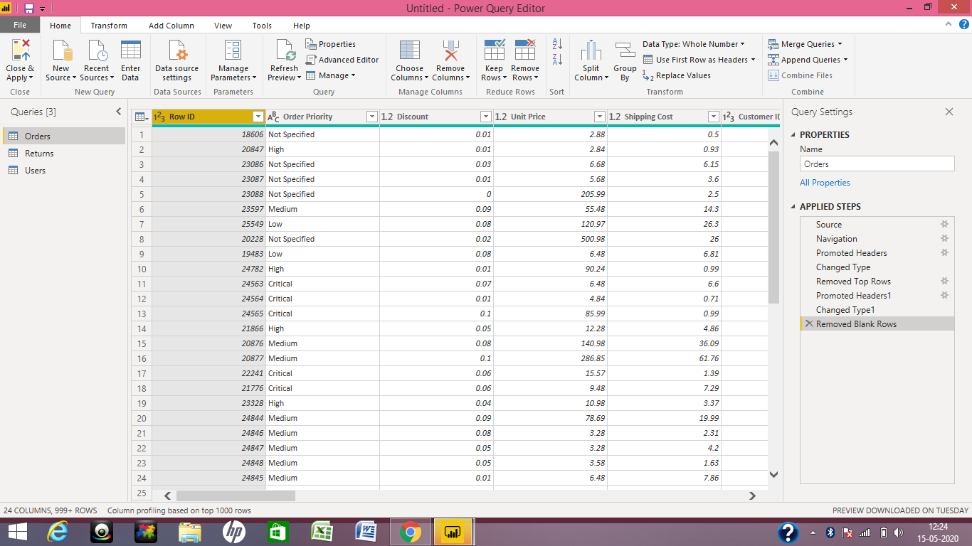

**Removed Blank Rows and Updated column header**

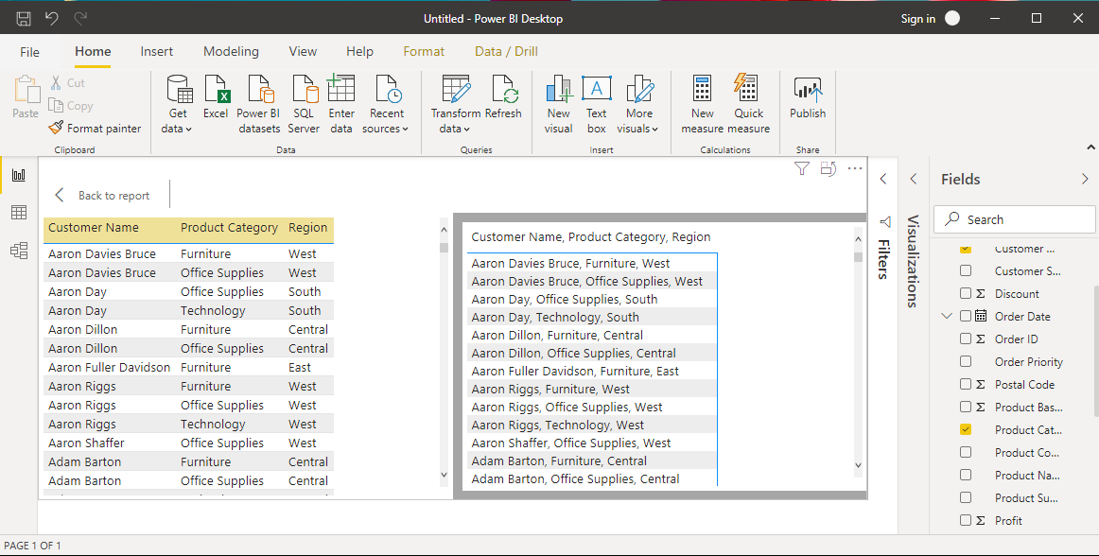

**Text Table**

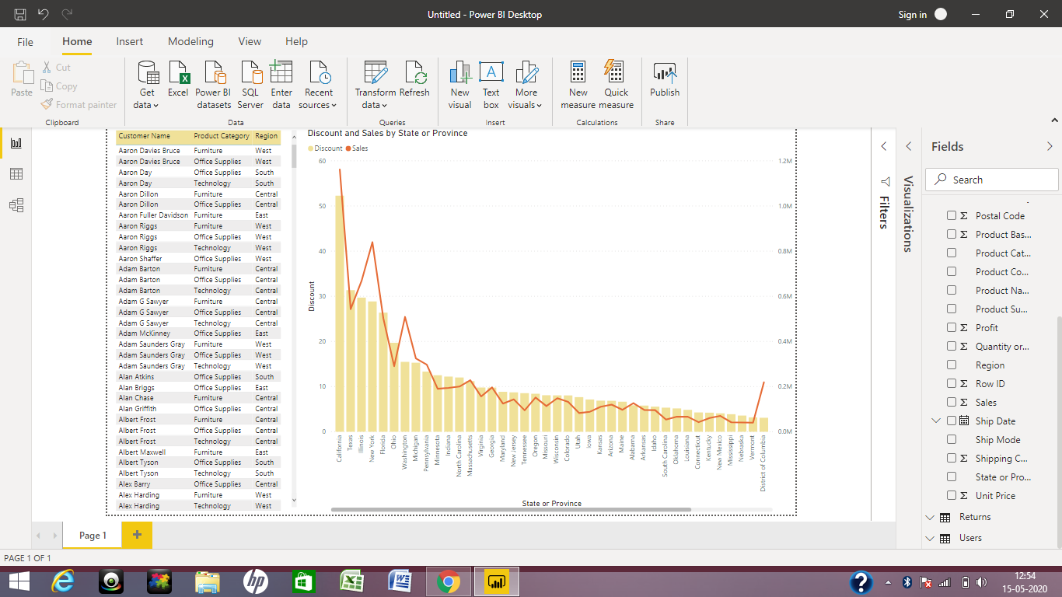

**Line and Clustered Column Chart**

**Which state has the highest sales in terms Technology?**

**ANS:** New York

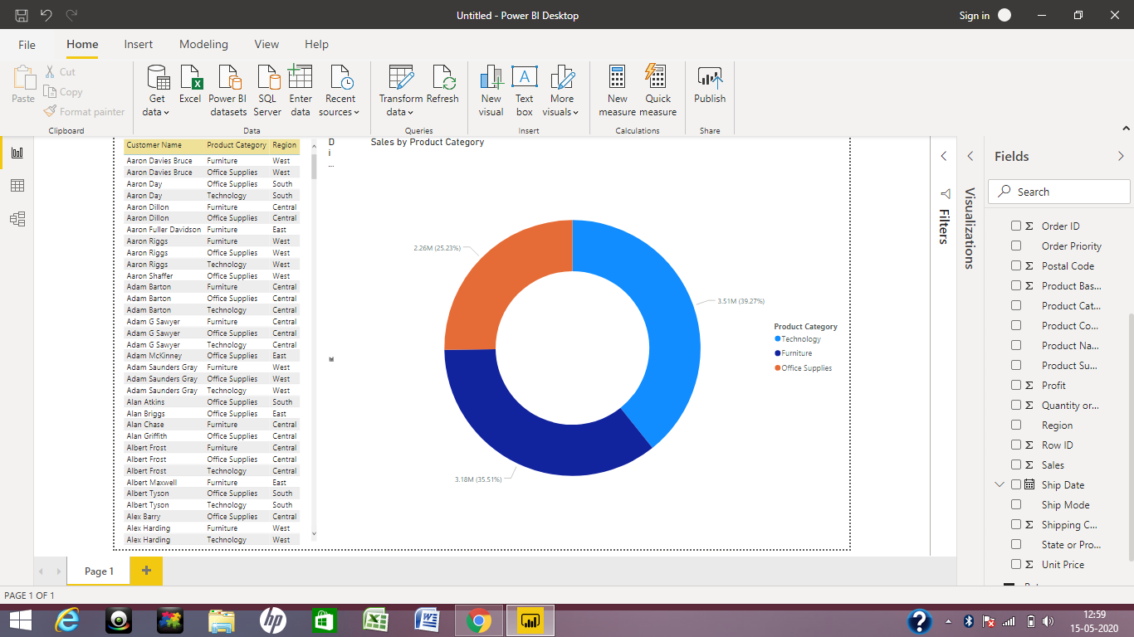

**Donut Chart**

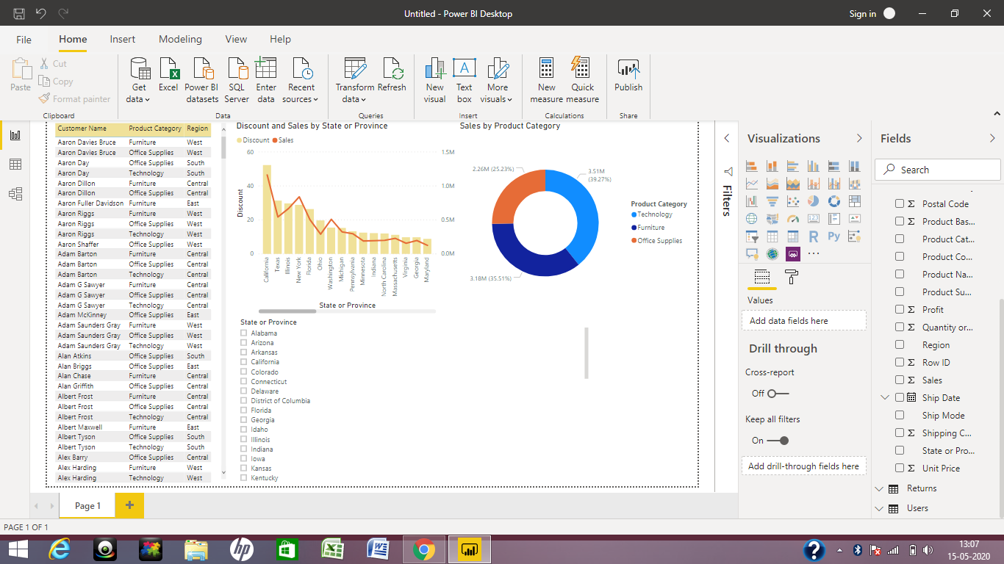

**Use of Slicer**