**Assignment-03**

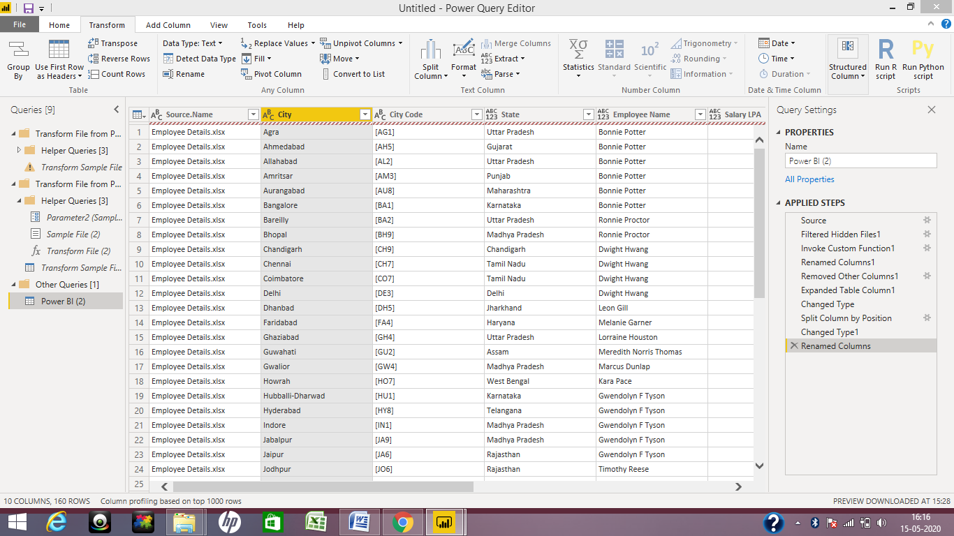

**Split the column**

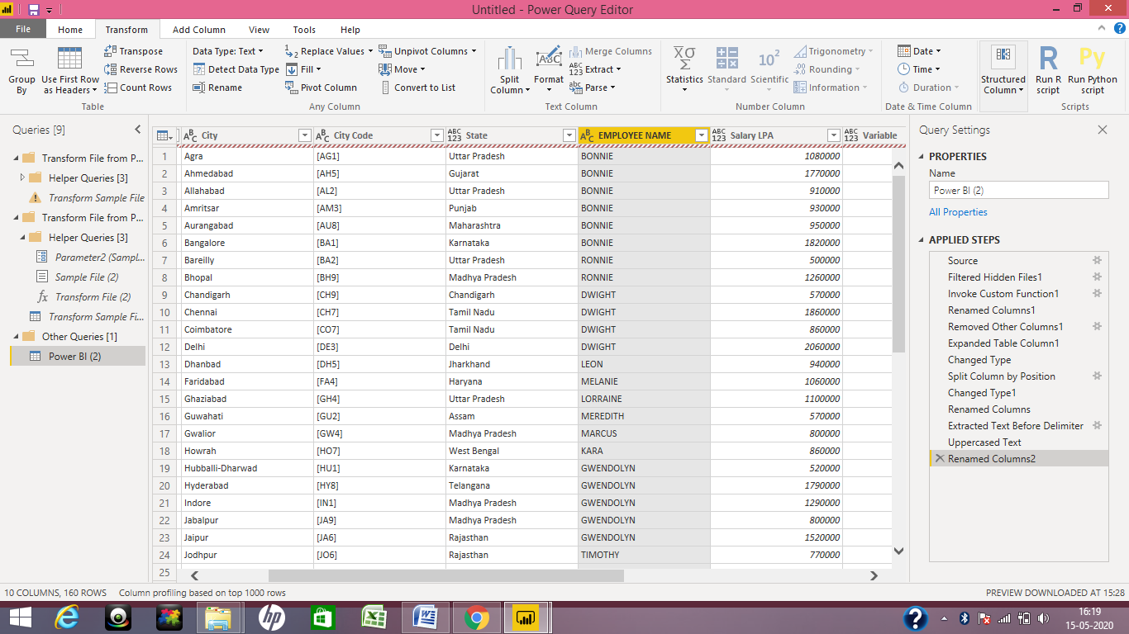

**Extracted first name from EMPLOYEE NAME**

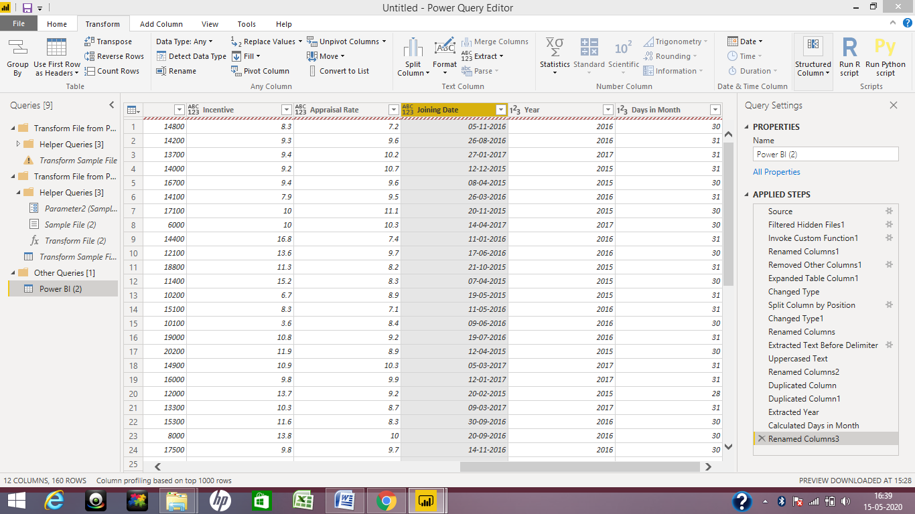

**Extracted the year and no. of days for that month**

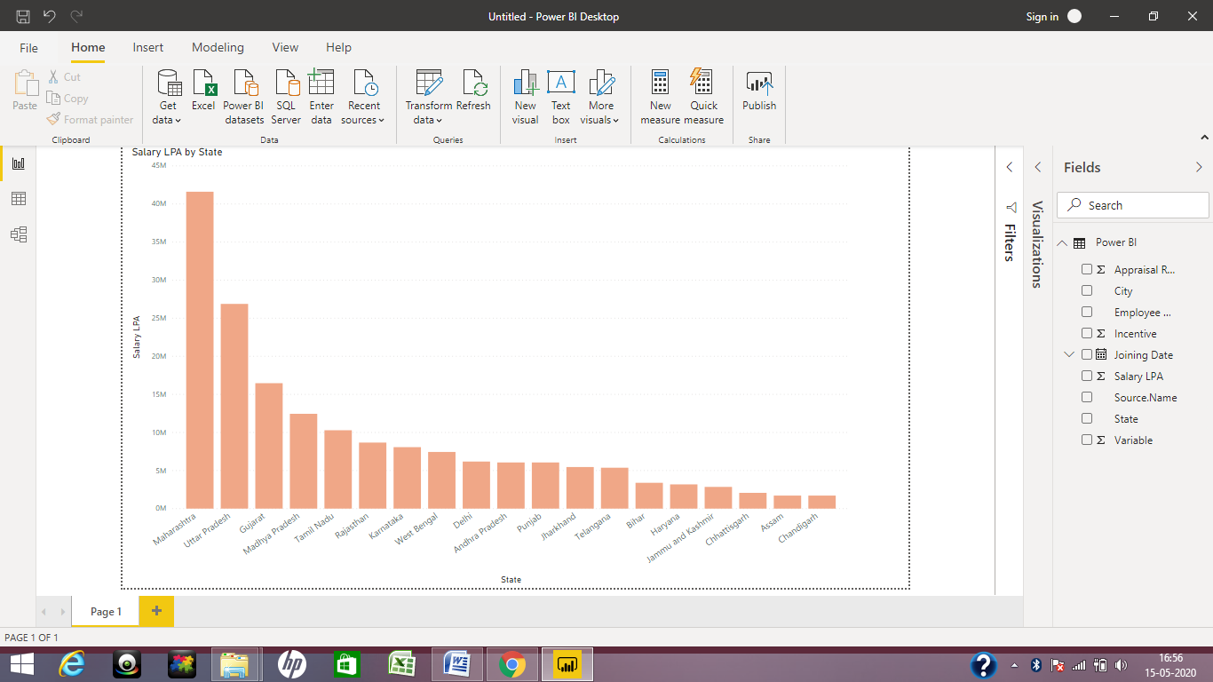

**Salary paid to each state**

**ANS: Assam** and **Chandigarh** have the lowest payout values.