

**Networks and Communications**

**Digital Assignment-2**

**Name -Diksha Singhania Reg no.-17BCE0032**

**Software-GNS3**

**Topic: Multicast Tunnelling**

**About Gns3?**

Graphical Network Simulator-3 (shortened to GNS3) is network software emulator first released in 2008. It allows the combination of virtual and real devices, used to simulate complex networks. It uses Dynamips emulation software to simulate Cisco IOS.

GNS3 is used by many large companies including Exxon, Walmart, AT&T and NASA, and is also popular for preparation of network professional certification exams.

**What is multicast tunnelling**

In many network scenarios you want to configure your network to use GRE tunnels to send Protocol Independent Multicast (PIM) and multicast traffic between routers. Typically, this occurs when the multicast source and receiver are separated by an IP cloud which is not configured for IP multicast routing. In such network scenarios, configuring a tunnel across an IP cloud with PIM enabled transports multicast packets toward the receiver. This document describes the configuration.

**Installation:**

1. Browse to [https://gns3.com](https://gns3.com/) and click the **Free Download** link
2. If you have not already registered on the GNS3 site, you will be prompted to create an account.
3. Click the **Download** button to download the GNS3-all-in-one package
4. double-click the **GNS3-2.1.11-all-in-one-regular.exe**
5. click next until extraction finishes and installation is finished.

**Components used**

## Cisco 3640(ios image:- c3640-jk9s-mz.124-16.bin)

**Diagram(topology):**

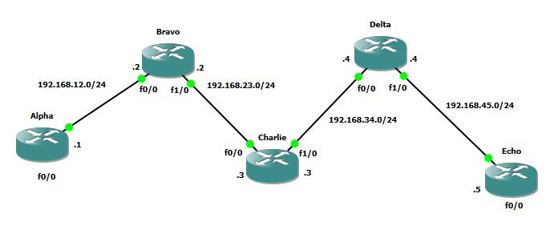

**Aims of the above:**

* All IP addresses have been configured.
* Configuring OSPF on all routers to achieve full connectivity.
* We have configured dense-mode Multicast on all routers EXCEPT router Charlie.
* Configured router Echo to join the following multicast group:224.1.1.1
* A ping has been started from router Alpha to the multicast group address 224.1.1.1 to generate traffic.
* Making sure router Echo can receive the multicast stream without configuring multicast on router Charlie.

**Code:**

**Router1(Alpha)**

1. Alpha#ena
2. Alpha#conf t
3. Alpha(config)#int f0/0
4. Alpha(config-if)#no shut
5. Alpha(config-if)#ip address 192.168.12.1 255.255.255.0
6. Alpha(config-if)#do wr
7. Alpha(config-if)#router ospf 1
8. Alpha(config-router)#network 0.0.0.0 255.255.255.255 area 0
9. Alpha(config-router)#^Z
10. Alpha#conf t
11. Alpha(config)#ip multicast-routing
12. Alpha(config)#int f0/0
13. Alpha(config-if)#ip pim dense-mode
14. Alpha(config-if)#int f1/0
15. Alpha(config-if)#ip pim dense-mode
16. Alpha(config-if)#^Z
17. Alpha#ping 224.1.1.1 repeat 5
18. Alpha#ping 224.1.1.1 repeat 999

**Router2(Bravo)**

1. Bravo#ena
2. Bravo#conf t
3. Bravo(config)#int f0/0
4. Bravo(config-if)#no shut
5. Bravo(config-if)#ip address 192.168.12.2 255.255.255.0
6. Bravo(config-if)#int f1/0
7. Bravo(config-if)#no shut
8. Bravo(config-if)#ip address 192.168.23.2 255.255.255.0
9. Bravo(config-if)#int f1/0
10. Bravo(config-if)#no shut
11. Bravo(config-if)#do wr
12. Bravo(config-if)#ena
13. Bravo(config)#router ospf 1
14. Bravo(config-router)#network 0.0.0.0 255.255.255.255 area 0
15. Bravo(config-router)#^Z
16. Bravo#conf t
17. Bravo(config)#ip multicast-routing
18. Bravo(config)#int f0/0
19. Bravo(config-if)#ip pim dense-mode
20. Bravo(config-if)#int f1/0
21. Bravo(config-if)#ip pim dense-mode
22. Bravo(config-if)#^Z
23. Bravo#show ip int brief
24. Bravo#conf t
25. Bravo(config)#interface tunnel 0
26. Bravo#conf t
27. Bravo(config-if)#tunnel source fastEthernet 1/0
28. Bravo(config-if)#tunnel destination 192.168.34.4
29. Bravo(config-if)#ip pim dense-mode
30. Bravo(config-if)#router ospf 1
31. Bravo(config-router)#passive-interface tunnel 0
32. Bravo(config-router)#^Z
33. Bravo#show ip int brief
34. Bravo#conf t
35. Bravo(config)#interface tunnel0
36. Bravo(config-if)#^Z
37. Bravo#ping 192.168.24.4
38. Bravo#

**Router3(Charlie)**

1. Charlie#ena
2. Charlie#conf t
3. Charlie(config)#int f0/0
4. Charlie(config-if)#no shut
5. Charlie(config-if)#ip address 192.168.23.3 255.255.255.0
6. Charlie(config-if)#int f1/0
7. Charlie(config-if)#no shut
8. Charlie(config-if)#ip address 192.168.34.3 255.255.255.0
9. Charlie(config-if)#do wr
10. Charlie(config-if)#router ospf 1
11. Charlie(config-router)#network 0.0.0.0 255.255.255.255 area 0
12. Charlie(config-router)#^Z
13. Charlie#conf t
14. Enter configuration commands, one per line. End with CNTL/Z.
15. Charlie(config)#ip multicast-routing
16. Charlie(config)#int f0/0
17. Charlie(config-if)#ip pim dense-mode
18. Charlie(config-if)#int f1/0
19. Charlie(config-if)#ip pim dense-mode
20. Charlie(config-if)#int f0/0
21. Charlie(config-if)#no ip pim dense-mode
22. Charlie(config-if)#no ip pim dense-mode
23. Charlie(config-if)#int f1/0
24. Charlie(config-if)#no ip pim dense-mode
25. Charlie(config-if)#^Z
26. Charlie#

**Router4(Delta)**

1. Delta#ena
2. Delta#conf t
3. Enter configuration commands, one per line. End with CNTL/Z.
4. Delta(config)#int f0/0
5. Delta(config-if)#no shut
6. Delta(config-if)#ip address 192.168.34.4 255.255.255.0
7. Delta(config-if)#int f1/0
8. Delta(config-if)#no shut
9. Delta(config-if)#ip address 192.168.45.4 255.255.255.0
10. Delta(config-if)#do wr
11. Delta(config-if)#router ospf 1
12. Delta(config-router)#network 0.0.0.0 255.255.255.255 area 0
13. Delta(config-router)#
14. Delta(config-router)#
15. Delta(config-router)#^Z
16. Delta#
17. Delta#conf t
18. Delta(config)#ip multicast-routing
19. Delta(config)#int f0/0
20. Delta(config-if)#ip pim dense-mode
21. Delta(config-if)#int f1/0
22. Delta(config-if)#ip pim dense-mode
23. Delta(config-if)#interface tunnel 0
24. Delta(config-if)#tunnel source fastEthernet 0/0
25. Delta(config-if)#tunnel destination 192.168.23.2
26. Delta(config-if)#ip pim dense-mode
27. Delta(config-if)#^Z
28. Delta#conf t
29. Delta(config)#interface tunnel 0
30. Delta(config-if)#ip address 192.168.24.2 255.255.255.0
31. Delta(config-if)#router ospf 1
32. Delta(config-router)#passive-interface tunnel 0
33. Delta(config-router)#
34. Delta(config-router)#^Z
35. Delta#conf t
36. Delta#ping 192.168.24.2
37. Delta#conf t
38. Delta(config)#interface tunnel 0
39. Delta(config-if)#ip address 192.168.24.4 255.255.255.0
40. Delta(config-if)#
41. Delta(config-if)#^Z
42. Delta#ping 192.168.24.2
43. Delta#debug ip mpacket
44. *Mar 1 01:06:33.247: IP(0): s=192.168.12.1 (Tunnel0) d=224.1.1.1 id=542, ttl=252, prot=1, len=100(100), not RPF interface
45. Delta#no de all
46. All possible debugging has been turned off
47. Delta#
48. *Mar 1 01:06:37.243: IP(0): s=192.168.12.1 (Tunnel0) d=224.1.1.1 id=544, ttl=252, prot=1, len=100(100), not RPF interface
49. Delta#show ip route
50. Delta#conf t
51. Delta(config)#ip mroute 0.0.0.0 0.0.0.0 tunnel 0
52. Delta(config)#^Z
53. Delta#debug ip mp
54. Delta#no de all
55. Delta#

**Router5(Echo**)

1. Echo#ena
2. Echo#conf t
3. Echo(config)#int f0/0
4. Echo(config-if)#no shut
5. Echo(config-if)#
6. Echo(config-if)#ip address 192.168.45.5 255.255.255.0
7. Echo(config-if)#do wr
8. Echo(config-if)#router ospf 1
9. Echo(config-router)#network 0.0.0.0 255.255.255.255 area 0
10. Echo(config-router)#
11. Echo(config-router)#
12. Echo(config-router)#^Z
13. Echo#conf t
14. Echo(config)#ip multicast-routing
15. Echo(config-if)#ip pim dense-mode
16. Echo(config-if)#
17. Echo(config-if)#int f0/0
18. Echo(config-if)#ip igmp join-group 224.1.1.1
19. Echo(config-if)#

**Screenshots:**

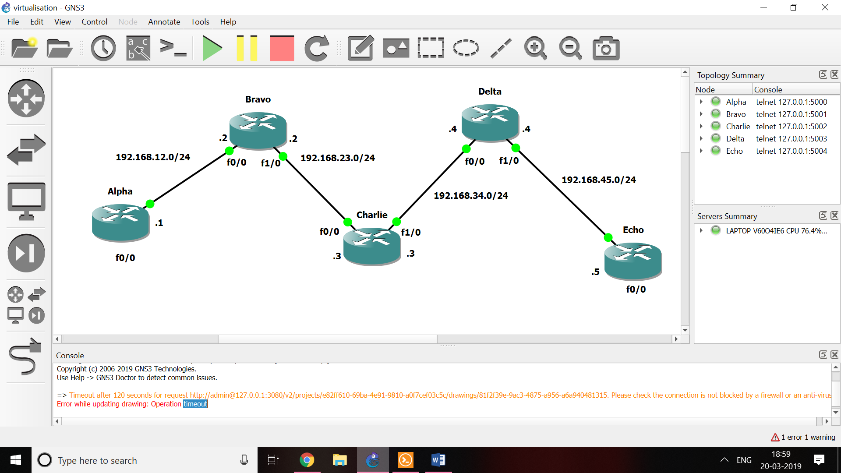

**Alpha**

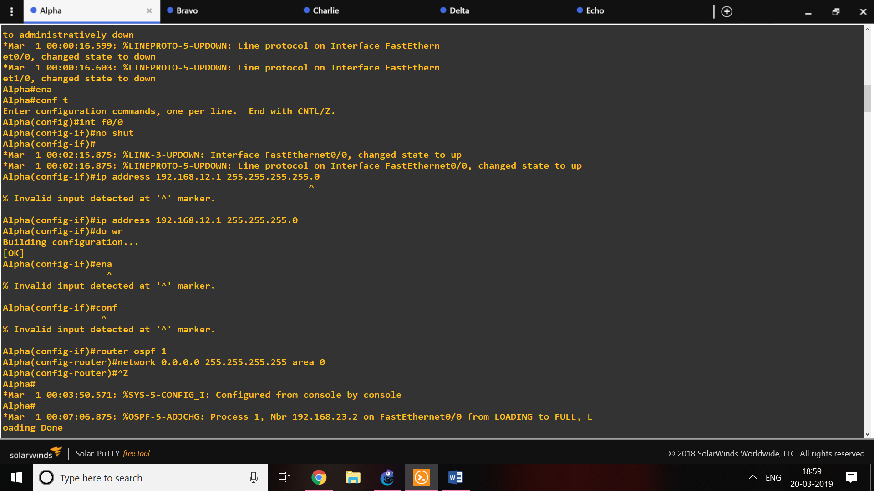

**Output:**

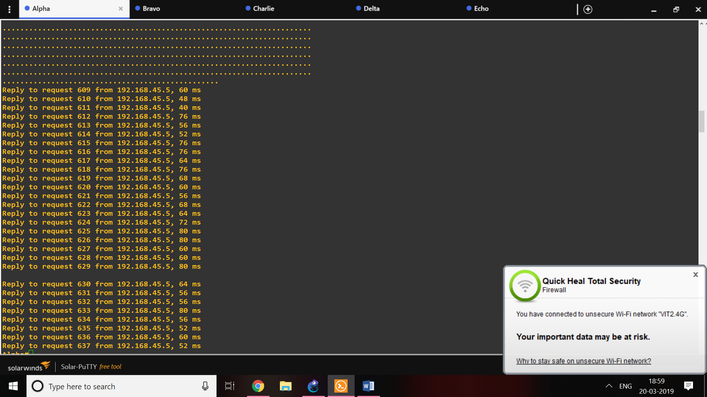

**Bravo**

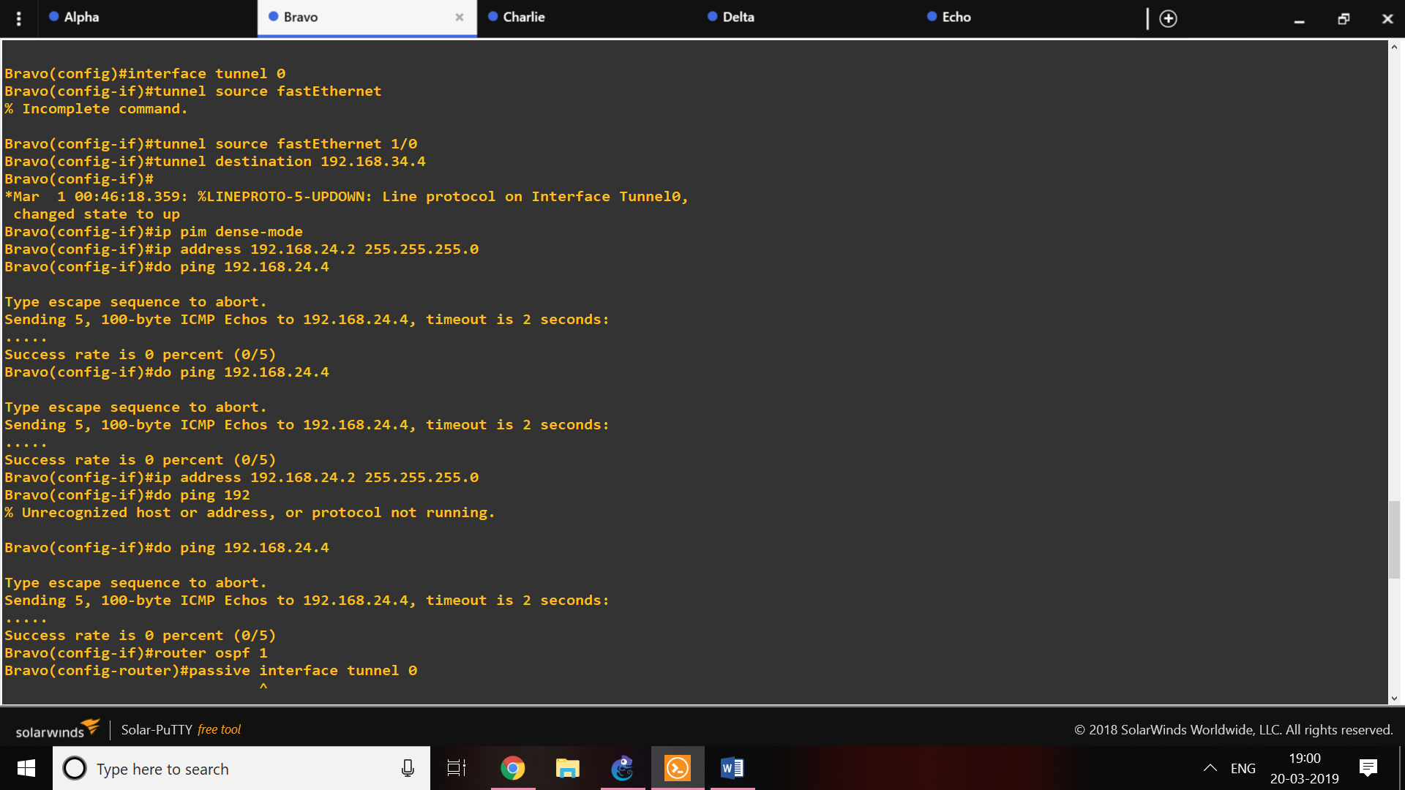

**Output:**

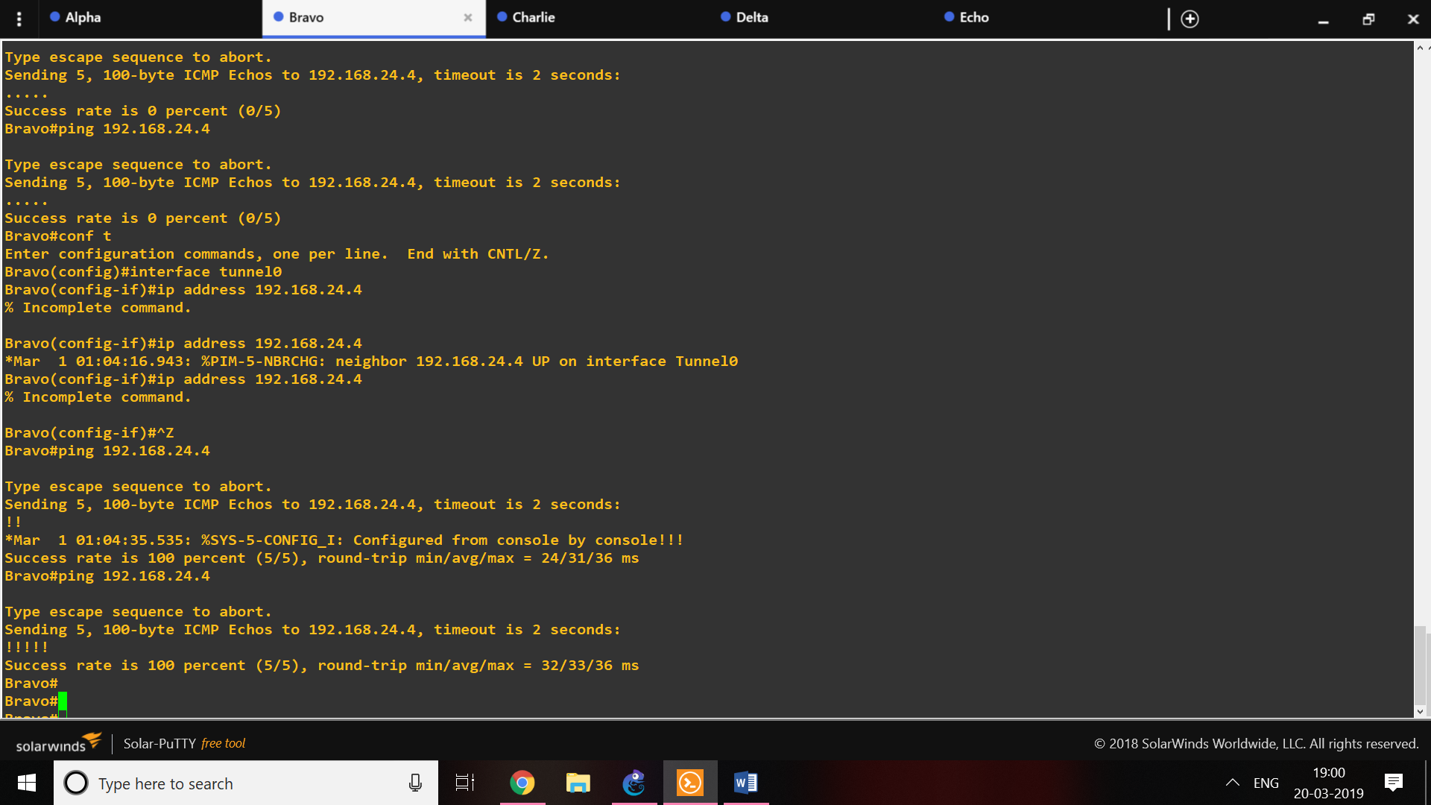

**Charlie**

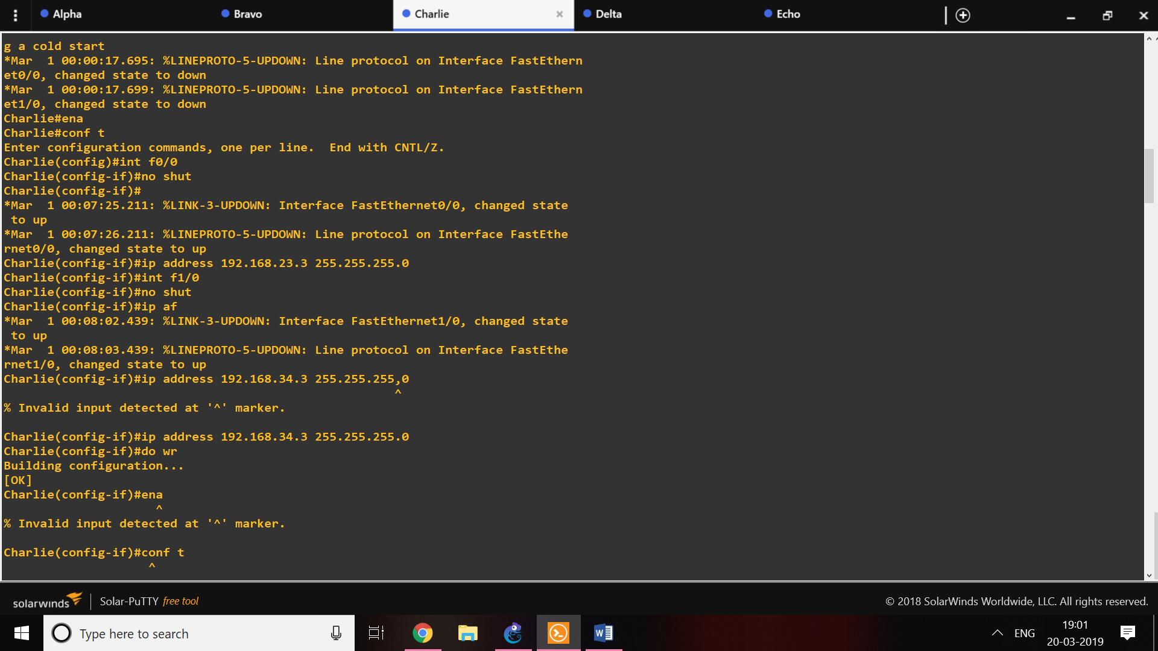

**Delta**

Code

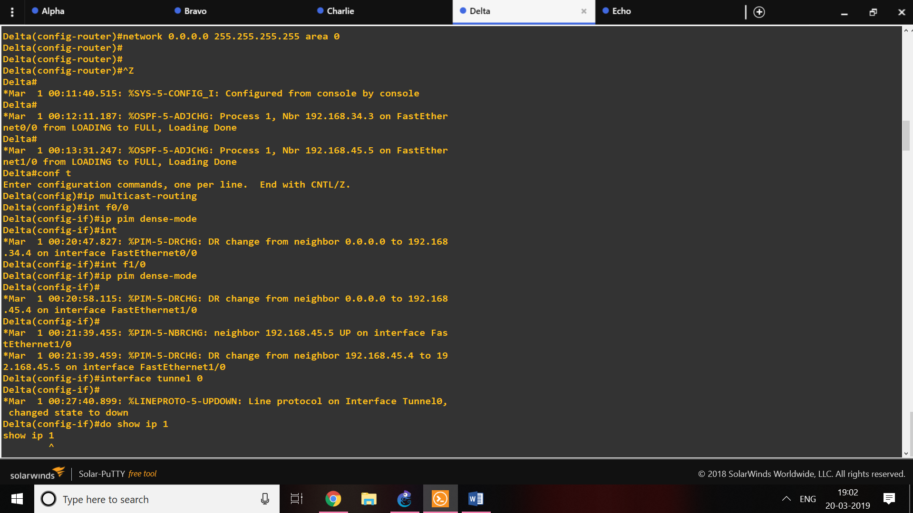

Output:

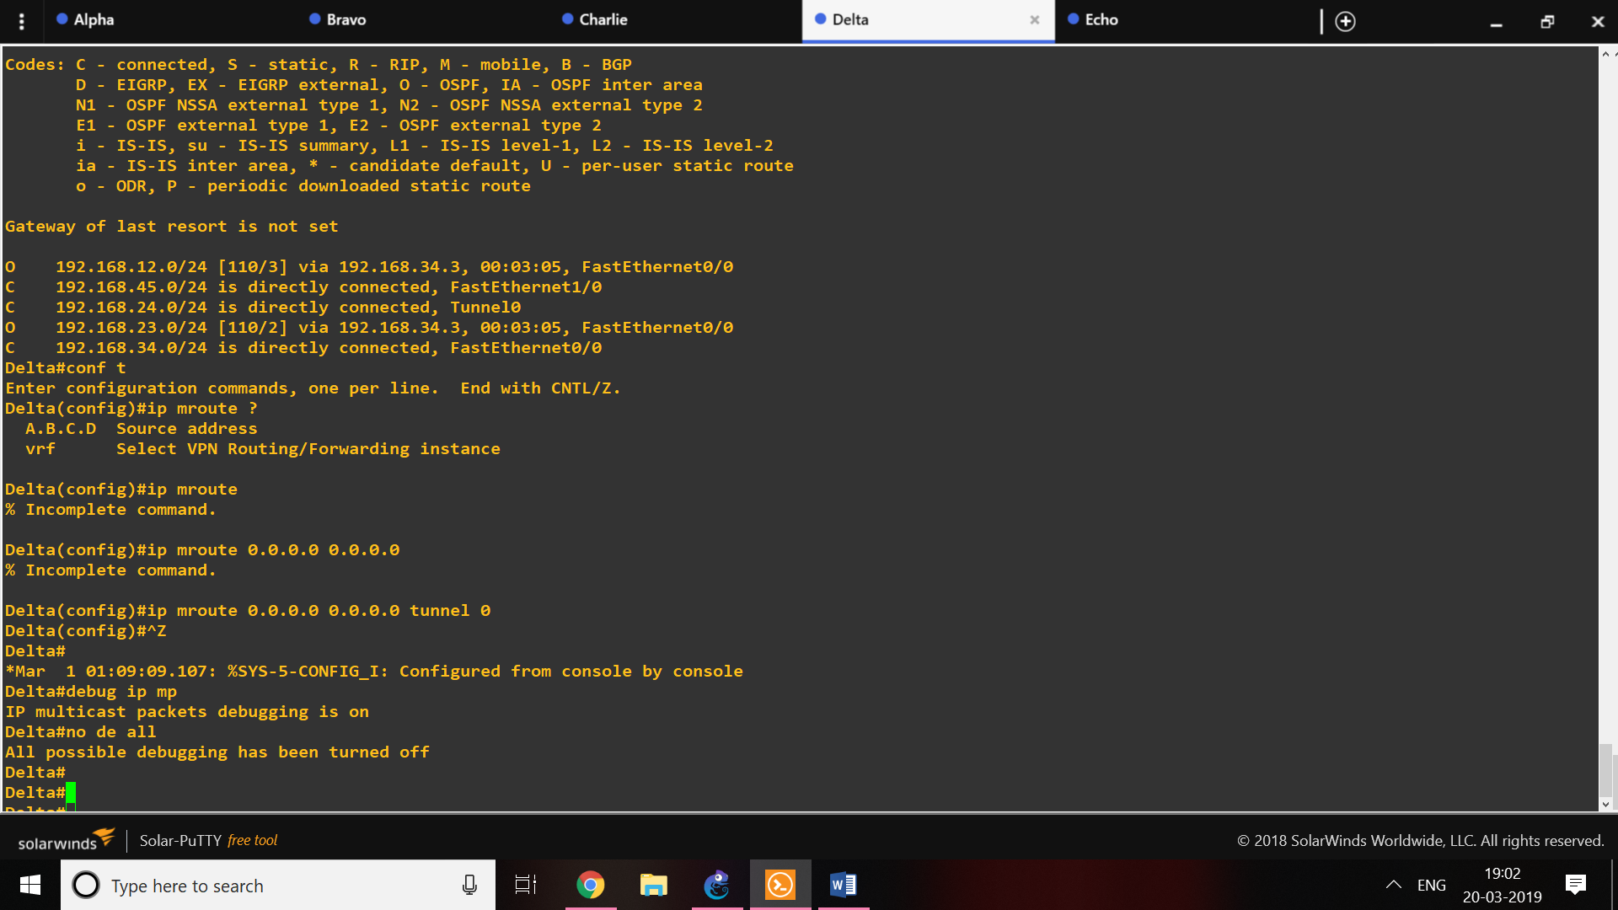

**Echo**

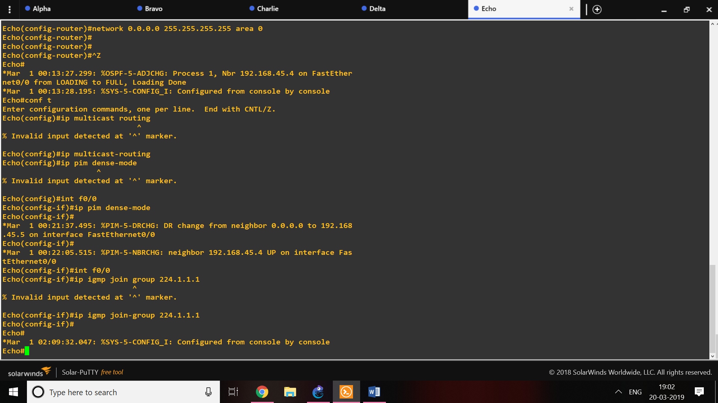

**Conclusion:**

The Router1(Alpha) was able to receive the message from router5(echo) using the multicast tunnelling.