Student Name |  | Student Number
Mansoud Mansouri |  | 1916829

Portfolio Introduction
Workshop Activities 50% Weighting
Mini Project 50% Weighting
This completed portfolio will need submitting to Canvas by the due date.

Questions please email

Dr Sarah Slater
s.i.slater@wlv.ac.uk

Portfolio

Contents
Workbook 1 4
Activity 1.1: Actual voltage across 5V breadboard pins. 4
Activity 1.2: Actual voltage across 3.3V breadboard pins. 4
Activity 1.3: Potential Divider Calculations 5
Activity 1.4: 3V Calculations from either the 5V supply or 3.3V supply 6
Activity 1.5: Voltage Divider circuit readings from Breadboard circuit. 6
Activity 1.6: LED Circuits 7
Activity 1.7: Current Measurement 8
Activity 1.8: Fritzing for 4 switches & LEDS 9
Activity 1.9: Fritzing for Number 0-7 10
Workbook 2 11
Activity 2.1: LED Flashing to show decimal number 63 as binary. 11
Activity 2.2: 4 LED’s for counting up in binary from 0 to 15. 12
Workbook 3 14
Activity 3.1: Circuit Diagram of Button & LED 14
Activity 3.2: 3 Switches & Led 15
Activity 3.3: 8 Buttons & LEDs (SWITCH STATEMENTS) 17
Workbook 4 19
Activity 4.1: Serial Port 19
Activity 4.2: Serial Port binary to decimal 22
Activity 4.3: Calibrating Analogue Information 24
Activity 4.4: Temperature Sensor & Serial Port 27
Workbook 5 29
Activity 5.1: RGB Led and switches 29
Activity 5.2: LED Matrix MAZE 31
Activity 5.3: 1602 LCD Display 33
Workbook 6 36
Activity 6.1: PWM 36
Workbook 7 38
Activity 7.1: Windscreen Wiper Code using Servos & Temperature Sensor 38
Individual Project (50%) 39
Rationale 39
Timescales 39
Equipment 39
The Project 39
Step 1 produce a detailed description of your project. 39
Step 2 Circuit Diagram & Fritzing Schematic 39
Step 3 A Program 40
Step 4 Testing 40
Step 5 Conclusions 40
Layout 40
Demonstrations 40
Marking 40
All sections carry equal marks. 40

Workbook 1

Activity 1.1: Actual voltage across 5V breadboard pins.
Enter the Value you got here from Step 5.

Activity 1.2: Actual voltage across 3.3V breadboard pins.

Explain in around 100 words why you think the value read by a multi meter on a circuit, may be different to a simulator value such as TinkerCad.

If the read value is 4.84V on a 5V supply, what would be a sensible tolerance to quote, explain your answer.
Given that 4.84V is 3% less that the actual 5 volt, then it is saver to quote a tolerance of 5%. To allow a tolerance of +/- 5% would a sensible tolerance to quote.

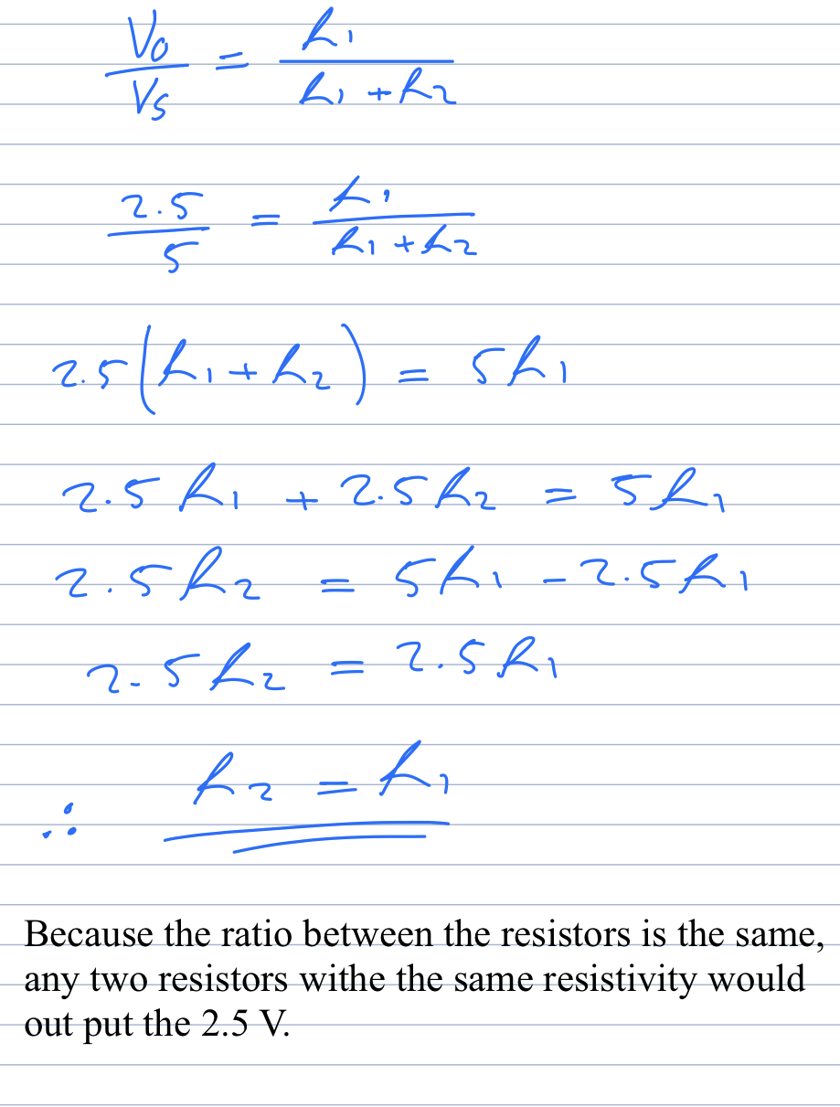
Activity 1.3: Potential Divider Calculations

Show the working on how you achieved 2.5V

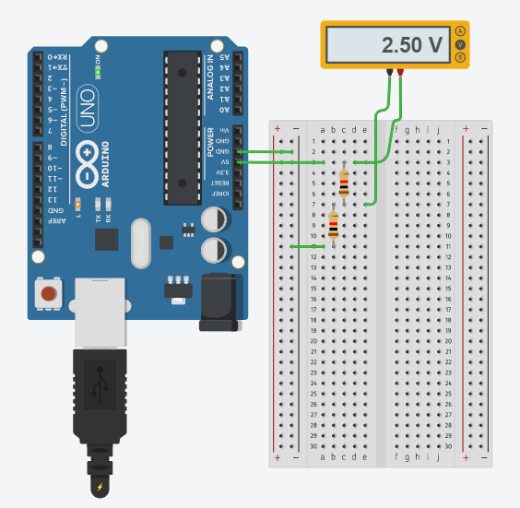
Showing the 2.5 V in TinkerCad with the same value resistors.

Activity 1.4: 3V Calculations from either the 5V supply or 3.3V supply

Activity 1.5: Voltage Divider circuit readings from Breadboard circuit.

Activity 1.6: LED Circuits

Each resistor Value
1 kohm
1 Kohm

Total resistance Calculation

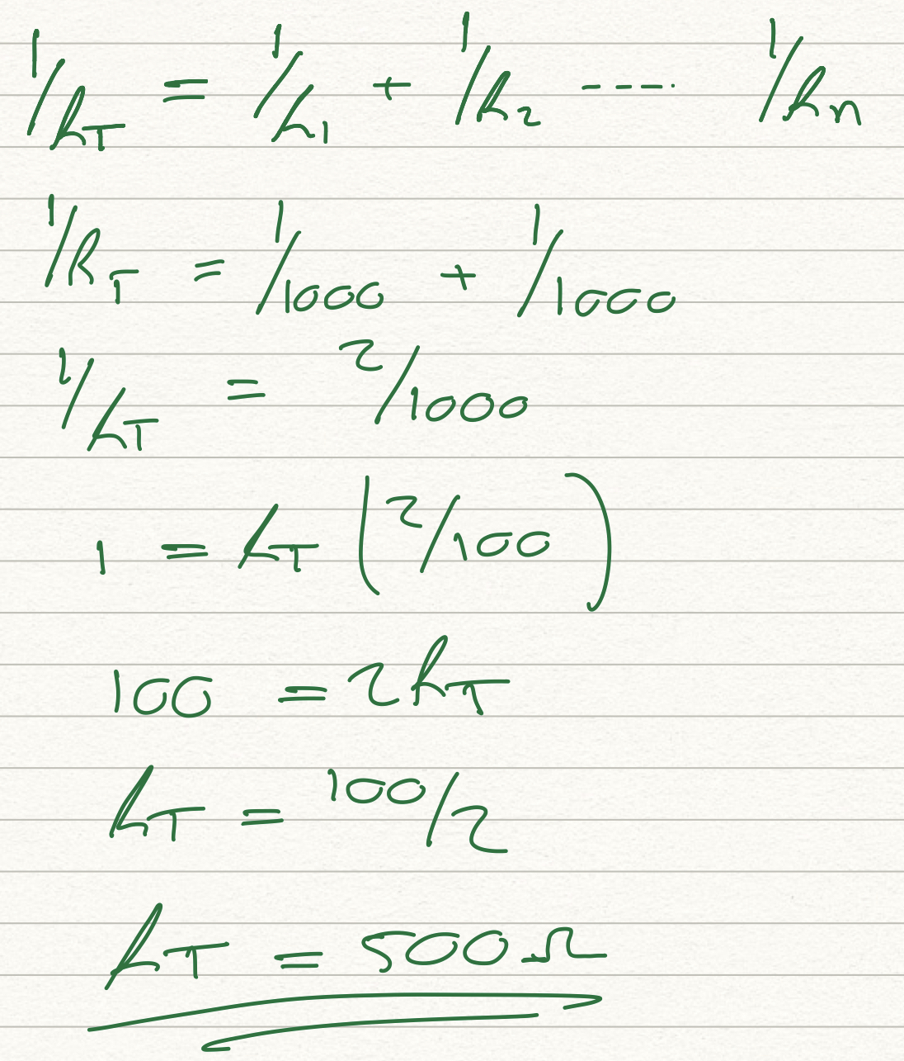

Measured Resistance
500 ohm

If measured resistance is not the same, why not? If you simulated this, why might the real value be different.
The values are the same. If this got simulated and the connection is not the correct then you will get different reading. While measuring the resistance the resistors must not be connected to any other components or circuits.

Activity 1.7: Current Measurement
Calculation of current flowing into LED
2.50 mA

Actual measured value of current
2.5 mA

Why might they be different?
If the wiring is not done correctly, positive and negative terminals, the display values going to be negative.

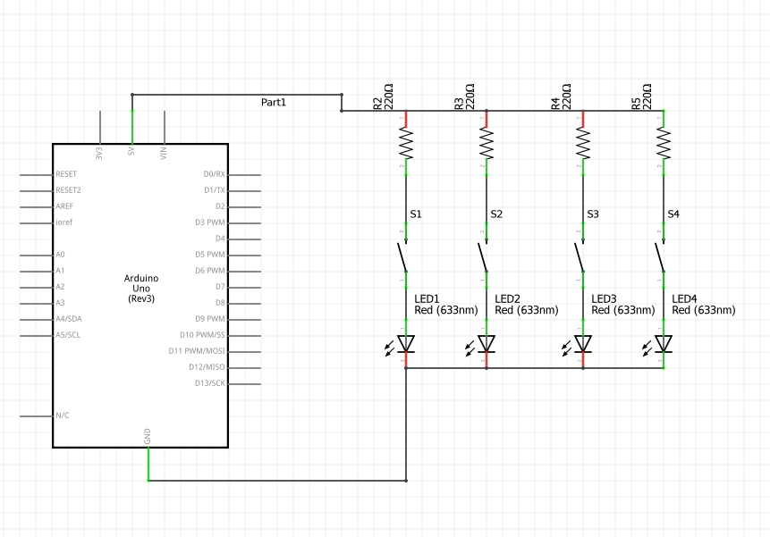
Activity 1.8: Fritzing for 4 switches & LEDS

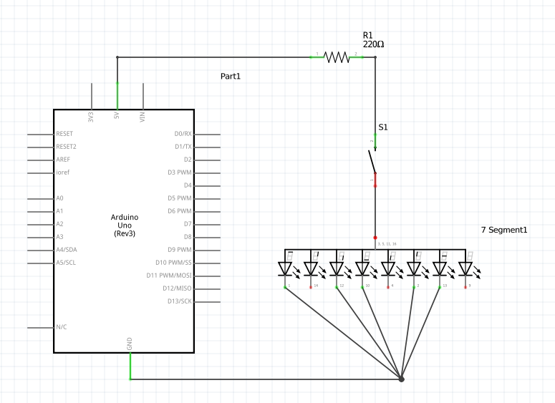
Activity 1.9: Fritzing for Number 0-7

Workbook 2

Activity 2.1: LED Flashing to show decimal number 63 as binary.
63 as binary, including working

Copy & Post your code with a suitable comment at the top of code with your nam & student number ☺
63 = 111111 in binary

// Name: Mansoud Mansouri
// Student ID: 1916829

// choosing or setting the output pin as variable
// and also setting the delay time as variable.
int pinLive = 13;
int delaytime = 5000;

// the main setup
void setup()
{
pinMode(pinLive, OUTPUT);
}

// the infinite loop of blinking leds :D
void loop()
{
digitalWrite(pinLive, HIGH); // setting pin 13 high
delay(delaytime); // time for leds to stay on
digitalWrite(pinLive, LOW); // setting the pin 13 to low/ leds off
delay(delaytime); //time for leds to stay off
}

Activity 2.2: 4 LED’s for counting up in binary from 0 to 15.
Fritzing Circuit diagram for Step 4 i.e. 4 LEDs
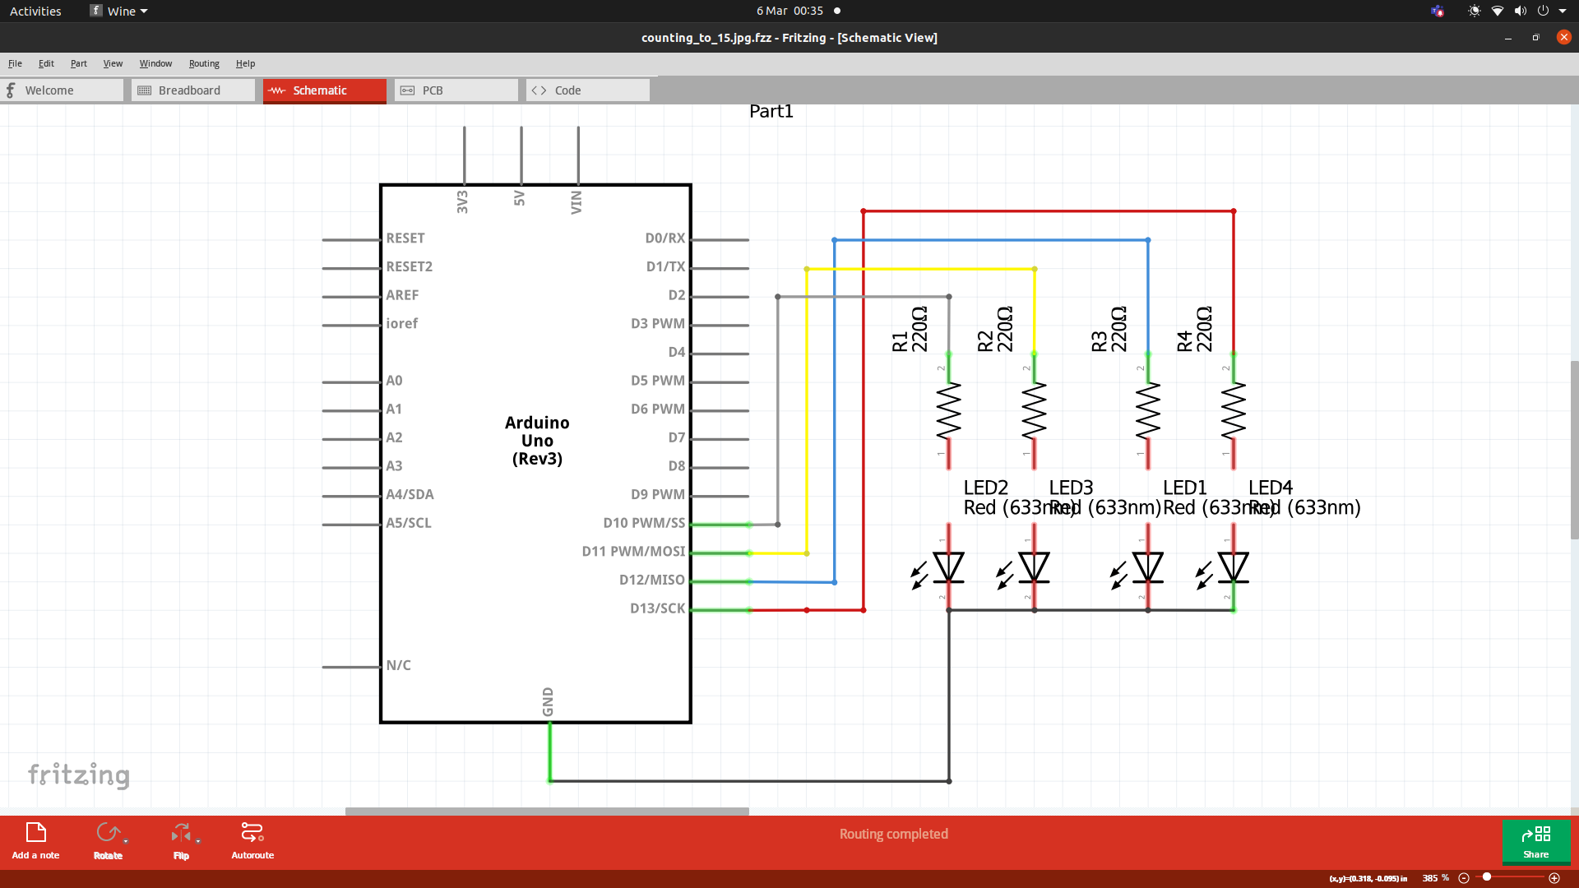

Arduino Program for Step 4 i.e. 4 LEDs
// choosing the output pins and setting up global veriables
int ledOne = 13;
int ledTwo = 12;
int ledThree = 11;
int ledFour = 10;

int delayTime = 500;
int delayTimeEnd = 2000;

// SETTING UP THE MAIN
// setting up ledOne, ledTwo, ledThree and ledFour as output.
void setup()
{
pinMode(ledOne, OUTPUT);
pinMode(ledTwo, OUTPUT);
pinMode(ledThree, OUTPUT);
pinMode(ledFour, OUTPUT);
}

// the main loop of the program
// to count up to forteen and then start all over again!
// got nothing to do!
void loop()
{
// 0000
digitalWrite(ledOne, LOW);
digitalWrite(ledTwo, LOW);
digitalWrite(ledThree, LOW);
digitalWrite(ledFour, LOW);
delay(delayTime);

// 0001
digitalWrite(ledOne, HIGH);
digitalWrite(ledTwo, LOW);
digitalWrite(ledThree, LOW);
digitalWrite(ledFour, LOW);
delay(delayTime);

// 0010
digitalWrite(ledOne, LOW);
digitalWrite(ledTwo, HIGH);
digitalWrite(ledThree, LOW);
digitalWrite(ledFour, LOW);
delay(delayTime);

// 0011
digitalWrite(ledOne, HIGH);
digitalWrite(ledTwo, HIGH);
digitalWrite(ledThree, LOW);
digitalWrite(ledFour, LOW);
delay(delayTime);

// 0100
digitalWrite(ledOne, LOW);
digitalWrite(ledTwo, LOW);
digitalWrite(ledThree, HIGH);
digitalWrite(ledFour, LOW);

// 0101
digitalWrite(ledOne, HIGH);
digitalWrite(ledTwo, LOW);
digitalWrite(ledThree, HIGH);
digitalWrite(ledFour, LOW);
delay(delayTime);

// 0110
digitalWrite(ledOne, LOW);
digitalWrite(ledTwo, HIGH);
digitalWrite(ledThree, HIGH);
digitalWrite(ledFour, LOW);
delay(delayTime);

// 0111
digitalWrite(ledOne, HIGH);
digitalWrite(ledTwo, HIGH);
digitalWrite(ledThree, HIGH);
digitalWrite(ledFour, LOW);
delay(delayTime);

// 1000
digitalWrite(ledOne, LOW);
digitalWrite(ledTwo, LOW);
digitalWrite(ledThree, LOW);
digitalWrite(ledFour, HIGH);
delay(delayTime);

// 1001
digitalWrite(ledOne, HIGH);
digitalWrite(ledTwo, LOW);
digitalWrite(ledThree, LOW);
digitalWrite(ledFour, HIGH);
delay(delayTime);

// 1010
digitalWrite(ledOne, LOW);
digitalWrite(ledTwo, HIGH);
digitalWrite(ledThree, LOW);
digitalWrite(ledFour, HIGH);
delay(delayTime);

// 1011
digitalWrite(ledOne, HIGH);
digitalWrite(ledTwo, HIGH);
digitalWrite(ledThree, LOW);
digitalWrite(ledFour, HIGH);
delay(delayTime);

// 1100
digitalWrite(ledOne, LOW);
digitalWrite(ledTwo, LOW);
digitalWrite(ledThree, HIGH);
digitalWrite(ledFour, HIGH);
delay(delayTime);

// 1101
digitalWrite(ledOne, HIGH);
digitalWrite(ledTwo, LOW);
digitalWrite(ledThree, HIGH);
digitalWrite(ledFour, HIGH);
delay(delayTime);

// 1110
digitalWrite(ledOne, LOW);
digitalWrite(ledTwo, HIGH);
digitalWrite(ledThree, HIGH);
digitalWrite(ledFour, HIGH);
delay(delayTime);

// 1111
digitalWrite(ledOne, HIGH);
digitalWrite(ledTwo, HIGH);
digitalWrite(ledThree, HIGH);
digitalWrite(ledFour, HIGH);
delay(delayTimeEnd);

}

Workbook 3

Activity 3.1: Circuit Diagram of Button & LED
Fritzing

Activity 3.2: 3 Switches & Led
Fritzing Circuit Diagram
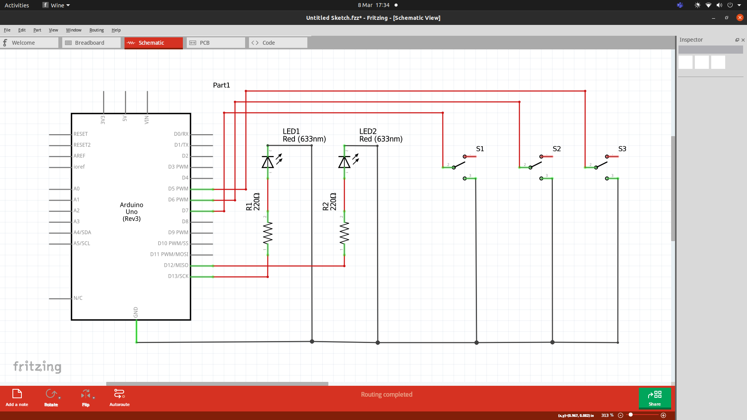
Arduino Program

// setting three variables for the three output pins;
const int ledOne = 13;
const int ledTwo = 12;
const int ledThree = 11;

// setting three variable for the three input pins;
const int inputOne = 7;
const int inputTwo = 6;
const int inputThree = 5;

// setting up three variables for delay time
const int oneSec = 1000;
const int twoSec = 2000;
const int threeSec = 3000;

void setup()
{
// setting the three pins as output pins;
pinMode(ledOne, OUTPUT);
pinMode(ledTwo, OUTPUT);
pinMode(ledThree, OUTPUT);
// setting the three pins as input pins;
pinMode(inputOne, INPUT_PULLUP);
pinMode(inputTwo, INPUT_PULLUP);
pinMode(inputThree, INPUT_PULLUP);
}

void loop()
{
int switchOne = digitalRead(inputOne);
int switchTwo = digitalRead(inputTwo);
int switchThree = digitalRead(inputThree);

// check the state of swtichOne and if its high turn ledOne on
// and if its low turn ledOne off;
if (switchOne == HIGH){
digitalWrite(ledOne, HIGH);
delay(oneSec);
}
else {
digitalWrite(ledOne, LOW);
}

// checking the state of switchTwo and if its high turnn ledTwo on
// and if its low turn ledTwo off;
if (switchTwo == HIGH){
digitalWrite(ledTwo, HIGH);
delay(twoSec);
}
else {
digitalWrite(ledTwo, LOW);
}

// check the sate of switchThree and if its high turn ledThree on
// and if its low turn ledThree off;
if (switchThree == HIGH){
digitalWrite(ledOne, HIGH);
delay(threeSec);
}
else {
digitalWrite(ledOne, LOW);
}
}

Activity 3.3: 8 Buttons & LEDs (SWITCH STATEMENTS)
Fritzing

Arduino Program

Workbook 4

Activity 4.1: Serial Port
Fritzing

Arduino Program

Screen Shot of Serial Port

Activity 4.2: Serial Port binary to decimal
Code

Screen Shot of Serial Port

Activity 4.3: Calibrating Analogue Information
Code

Pot Resistance Clockwise

Pot Resistance Anti-clockwise

Sample of Values
Pot Resistance against Voltage change
Pot Resitance | Voltage Measured

Screen Shot of Meaningful Serial Port Output, not just numbers

Activity 4.4: Temperature Sensor & Serial Port
Code - Centigrade to Serial port, but when button Pressed Fahrenheit Displayed Instead

Screen Shot of Serial Port

Workbook 5

Activity 5.1: RGB Led and switches
Fritzing

Arduino Program

Activity 5.2: LED Matrix MAZE
Arduino Code

Take a picture of your LED Matrix Maze and include it here, please reduce the size and quality as it will be too large else ☺

Activity 5.3: 1602 LCD Display
Fritzing

Arduino Program

Take a picture of your LCD and include it here, please reduce the size and quality as it will be too large else ☺

Workbook 6

Activity 6.1: PWM
Fritzing

Arduino Program

Workbook 7

Activity 7.1: Windscreen Wiper Code using Servos & Temperature Sensor
Arduino Code

Individual Project (50%)

Rationale
Throughout the module you have used a range of sensors and actuators with an Arduino to complete weekly tasks. For the mini project we would like you to research and create a small embedded project in an area of your choice, such as:
- Games
- Networking
- IT Security
- Systems Engineering
- Smart Technology
- Artificial Intelligence
Previous projects have included a reaction game that gives a score depending on how fast you hit a button, this has buttons to restart the application, and an LCD to show scores, and information.

This project should be your own work.

Timescales
This project should be started around week 5 and continue until the deadline, when it will be submitted in the Portfolio.

Equipment
You are free to use Tinkercad, or your own kit.

The Project

Step 1 produce a detailed description of your project.
This should clearly describe what you are intending to build and may contain some diagrams of how the sensor/switches input is to be processed by the Arduino. Then what kind of output is intended to be seen or heard by the user.

Step 2 Circuit Diagram & Fritzing Schematic
You are required to produce a circuit diagram of your work showing any calculations you made, so these might be suitable resistor values for any LED’s you use. These calculations are covered on the module. The circuit diagram should not be hand drawn but should follow the format of circuits from the module.

Step 3 A Program
You will need to write some software for this project and a listing of the code with suitable comments will need to be included.

Step 4 Testing
You will be required to produce some suitable test data that you would expect to be able to measure such as voltages, test code.
Once your prototype is complete you will be expected to test your circuit and compare the actual values to your initial test data, and comment on the results.

Step 5 Conclusions
You are required to write a summary of the work along with a short half page reflection on how you found the work.

Layout
The report should be suitably laid out for a report, using headings, references if required in Harvard style, and appendices used for any lengthy code. All diagrams should be produced on a PC, and hand-written work is not acceptable.

Marking

All sections carry equal marks.

