# 4CS015 Fundamentals of Computing – Workshop #6

This is a marked workshop. It forms the second part of your portfolio. You will need to complete the workshop and then submit a copy of this document with a title that follows the following format (“DENNETT 1234567 wsp6.docx”), via CANVAS, by the deadline. The Von Neumann Simulator can be found on canvas

**Workshop tasks:**

1. Von Neumann Simulator. This program simulates a very simple computer with the von Neumann architecture.
   1. Download the von Neumann Simulator (VonNeumann.exe) program from WOLF in the Week 5 folder. Save it in your Documents folder and run it. You will see a window similar to this:

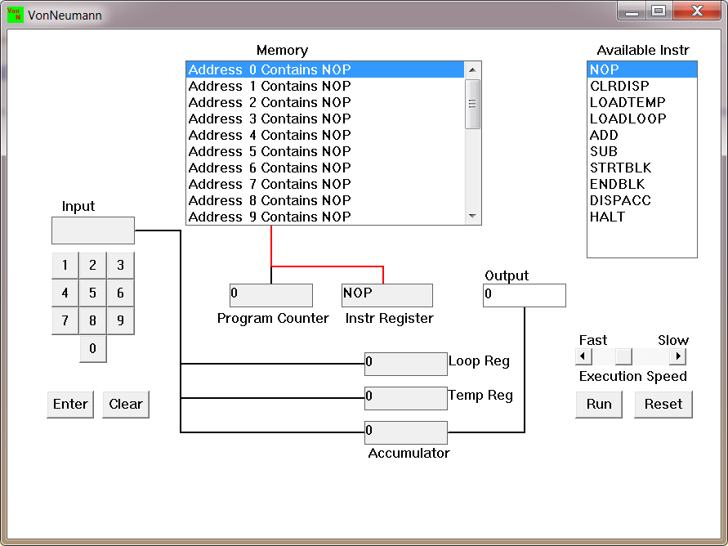  
The simulator has a small program memory area which is available for programming. To enter your program instructions simply click on the “Available” instruction on the list on the right and then click on the “Memory” location you wish to put it in.

This simulator understands only the following ten instructions:

|  |  |
| --- | --- |
| NOP | No Operation, i.e. do nothing. |
| LOADTEMP | Get a number from the keypad, completed by the Enter key, into the Temporary Register. |
| LOADLOOP | Get a number from the keypad, completed by the Enter key, into the Loop Register. |
| CLRDISP | Clear the Display. |
| ADD | Add the Temporary Register to the Accumulator |
| SUB | Subtract the Temporary Register from the Accumulator |
| DISPACC | Display the contents of the Accumulator |
| STRTBLK | Start of Loop Block |
| ENDBLK | End of Loop Block |
| HALT | Halt. Stop Program |

* 1. Load the following program into the memory:  
     LOADTEMP  
     ADD  
     DISPACC  
     HALT  
       
     To do this, first click on the “LOADTEMP” in the list of instructions on the right of simulator window. Then click on Memory location with “Address 0 Contains NOP”. This will then change into “Address 0 Contains LOADTEMP”. Repeat the process with “Address 1” and so on until the whole program is loaded.
  2. Run the program by clicking on the “Run” button. The simulator would highlight the Address 0 location and then pause. It is executing the instruction “LOADTEMP” which requires you to input a number into the keypad.   
       
     Click 2 or 3 numbers on the keypad and then click the “Enter” button. The simulator will then resume running the program and execute the instruction “ADD”. This adds the number that you just entered, to the zero in the accumulator.   
       
     The next instruction is “DISPACC” which stands for “Display Accumulator”, and it does exactly that. After than the simulator stops running the program when it executes the instruction “HALT”.
  3. Load the following program into the simulator:  
     LOADTEMP  
     ADD  
     LOADTEMP  
     ADD  
     DISPACC  
     HALT  
       
     What do you think it does? Write your answer below (10 marks)

This will add the first number to the second number.

* 1. Write a program to add 3 numbers together. List your program below (10 marks)

LOADTEMP

ADD

LOADTEMP

ADD

LOADTEMP

ADD

DISPACC

HALT

* 1. Write a program to subtract a number from another. List your program below (10 marks)

LOADTEMP

ADD

LOADTEMP

SUB

DISPACC

HALT

* 1. Load the following program into the simulator:  
     LOADTEMP  
     ADD  
     LOADLOOP  
     STRTBLK  
     ADD  
     DISPACC  
     ENDBLK  
     HALT  
       
     Run it and when it reach the LOADTEMP instruction, enter 5 on the keypad and click the “Enter” button. When it reaches the LOADLOOP instruction, enter 6. What do you think the program does? Write your answer below in the form of an equation (10 marks)

THE PROGRAM ADDS THE FIRST NUMBER ENTERED TO IT SELF WHATEVER THE SECOND NUMBER IS.

SO THIS PROGRAM DOES:

5 + 5 + 5 + 5 + 5 + 5 == 35

SO THE EQUATION IS:

5 * 6 = 35

OR

X * Y = XY

* 1. Write a program that will let you add 5, or 10 or 20 numbers together. List your program below and explain how it works (25 marks)

LOADTEMP

ADD

LOADTEMP

ADD

LOADTEMP

ADD

LOADTEMP

ADD

LOADTEMP

ADD

DISPACC

HALT

This program will ask for five number, will add them together. The first number entered will be loaded to temporary register and will be added to the accumulator. The second number will be loaded to temporary register and then will be added to the number that is in accumulator. This step will we repeated three times. At the end of it the number in accumulator will be displayed in output and program terminate.

* 1. Write a program that will let you multiply 2 numbers together. List your program below and explain how it works (35 marks)

LOADTEMP

LOADLOOP

STRTBLK

ADD

ENDBLK

DISPACC

HALT

The program will ask for a number and loads the number into temporary register. Then the program start a loop and ask for the second number. Whatever number is in loop register, the program will add the number in temporary register to accumulator that many times, there it gives you the impression of multiplication where it really adding the number so many times.