## 4CS015 – Portfolio Submission #4

**STUDENT NAME**:

**STUDENT NUMBER**:

This forms the final part of your portfolio. You will need to complete the workshop and then submit this Word file, complete with your answers, via Canvas.

For this assignment (workshop) you will show you how to navigate and create file systems from command prompts in both Windows (os) and Linux(os) or Mac(os).

This year, we face some technical issues, in that we are working from home. I am aware that some of you are using mac machines, as opposed to Windows or Linux machines. Mac is Unix based. You’ll learn about this in future modules, but this means that it shares 99% of its instruction sets and commands with Linux. Although you may need to do a bit of research yourselves (I don’t have a mac, so can give limited advice only), you should be able to follow the Linux methods to create the same directory structure. You’re looking to use ‘Terminal’ on your mac.

**To complete this assignment, I require an example of the directory structure, created by you, using your student number in ONE of three operating systems, Windows, Linux or Mac.**

**TASK 1 and TASK 3 describe Windows and Linux methods.**

**SUBMIT TASK 2 or TASK 4 (or Mac version of task 4)**

Task 1

1. Start the "Command Prompt" from the Windows Start Menu (Start -> Accessories -> Command Promtp).
2. To create a directory "test", type :  
     
   md test  
     
   in the Command Prompt window and press the Return or Enter key.
3. To see the files and directories in the Command Prompt window, type:  
     
   dir  
     
   and press the Return key. You should see a list of all the files and directories in the window.  
     
   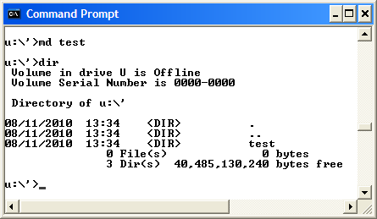
4. To create a file "hello.txt" containing the word "Hello", type the following into the Command Prompt window:  
     
   echo Hello > hello.txt  
     
   Check that it is there by using the "dir" command.
5. You can "type out" the content of the file by entering the following:  
     
   type hello.txt  
     
   You should get the content of the file displayed in the window.  
     
   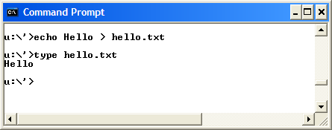
6. You can make a copy of the file and put it the "test" directory that you created earlier by typing:  
     
   copy hello.txt test
7. Now delete the file hello.txt in the current directory by typing:  
     
   del hello.txt  
     
   It may ask you if you are sure. If it does ask, type y and the "Return" key. Verify that the file is gone by using the "dir" command.
8. Change into the test directory by entering:  
     
   cd test
9. Check that you are in the correct directory by entering just:  
     
   cd
10. Check that your earlier copy of the hello.txt was copied into this directory by using the "dir" command.  
      
    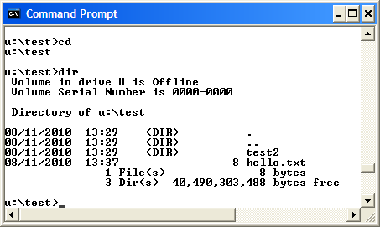
11. Now rename the file to hello2.txt by typing:  
      
    ren hello.txt hello2.txt  
      
    Verify that it has been changed by using the dir command.
12. Now create a sub-directory "test2" by typing:  
      
    md test2
13. Move the hello2.txt file into the directory test2:  
      
    move hello2.txt test2
14. Use the "cd" command to change into the test2 directory and then use the dir command to verify that the file hello2.txt is indeed there. You should see something like:  
      
    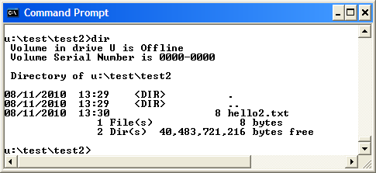
15. Now change to the directory above test2 by typing:  
      
    cd ..  
      
    That's two dots, one after another. You should get:  
      
    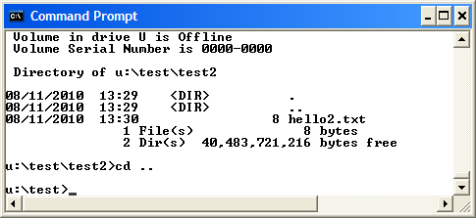
16. Change to the directory above that by entering :  
      
    cd ..  
      
    again.
17. Now to check that you have created the correct structure, type:  
      
    tree test /f  
      
    You should get:  
      
    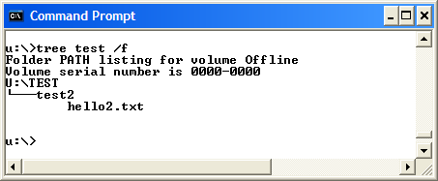
18. If it is correct, press ALT Print Screen to copy the Command Prompt window, and then paste it below:  
    [insert your picture here]

Task 2 **COMPLETE THIS TASK OR TASK 4 correctly for 100% mark**

Using all the above commands, create the following directory structure and paste it after this picture:

U:\Modules*YOURSTUDENTNUMBER*

4MM006

Lecturers

Ruth.txt

4CC001

Lecturers

Ian.txt

Chris.txt

4CC002

Lecturers

Alix.txt

[Insert your screenshot here]

Task 3

1. Boot into Linux at system start-up (reboot to OS choice)
2. Start the "Terminal" program from the top Menu bar (Applications -> Accessories -> Terminal).  
     
   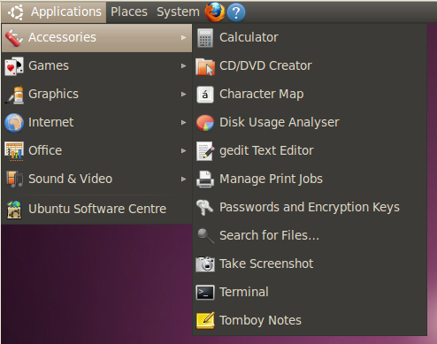
3. To **m**a**k**e a **dir**ectory "test", type :  
     
   mkdir test  
     
   in the Terminal window and press the Return or Enter key.
4. To **l**i**s**t the files and directories in the Terminal window, type:  
     
   ls   
     
   and press the Return key. You should see a list of all the files and directories in the window.
5. To get a more informative listing of the files and directories, you can use:  
     
   ls -l  
     
   The "-l" stands for "long".
6. To create a file "hello.txt" containing the word "Hello", type the following into the Terminal window:  
     
   echo Hello > hello.txt  
     
   Check that it is there by using the "ls" command.
7. You can view the content of the file by entering the following:  
     
   more hello.txt  
     
   You should get the content of the file displayed in the window.
8. You can make a **c**o**p**y of the file and put it the "test" directory that you created earlier by typing:  
     
   cp hello.txt test
9. Now **r**e**m**ove the file hello.txt in the current directory by typing:  
     
   rm hello.txt  
     
   Verify that the file is gone by using the "ls" command.
10. Change into the test directory by using the **c**hange **d**irectory command:  
      
    cd test
11. Check that you are in the correct directory by using the **p**rint **w**orking **d**irectory:  
      
    pwd
12. Check that your earlier copy of the hello.txt was copied into this directory by using the "ls" command.  
      
    Now rename the file to hello2.txt by **m**o**v**ing it from hello.txt to hello2.txt:  
      
    mv hello.txt hello2.txt  
      
    Verify that it has been changed by using the ls command.
13. Now create a sub-directory "test2" by typing:  
      
    mkdir test2
14. Move the hello2.txt file into the directory test2:  
      
    mv hello2.txt test2
15. Use the "cd" command to change into the test2 directory and then use the ls command to verify that the file hello2.txt is indeed there.
16. Now change to the directory above test2 by typing:  
      
    cd ..  
      
    That's two dots, one after another.
17. Change to the directory above that by entering :  
      
    cd ..  
      
    again.
18. Now to check that you have created the correct structure, enter:  
      
    ls -R test  
      
    You should get:  
      
    test:  
    test2  
      
    test/test2:  
    hello2.txt
19. If it is correct, press ALT Print Screen to capture the Terminal window as a picture, save it and then insert it below :  
    [insert your picture here]

Task 4 **COMPLETE THIS TASK OR TASK 2 correctly for 100% mark**

Using all the above commands, create the following directory structure (identical to the one that you created in Windows Command Prompt):

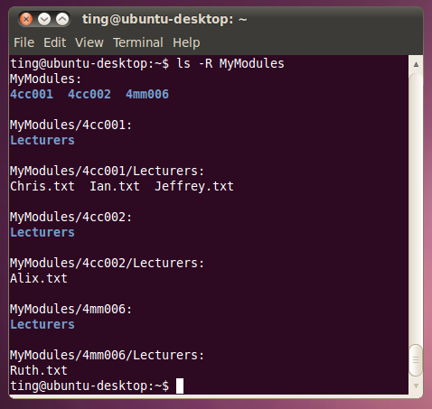

and insert it below:

[Insert your picture here]