# 4CS017 – Internet Software Architecture tutorial

## Python and APIs

*What will you learn today?*

Use a different programming language to access the same Weather API.

## Part 1 – Calling the Weather API from Python

One of the benefits of our Service-Oriented Architecture is that several clients (phones, smart TVs, computers, consoles etc.) using a variety of operating systems and programming languages can access the same API… let’s demonstrate the point by calling the same Weather API as before, but with a language you learned in semester 1: Python!

1. Type and run the code below (in either Idle or Pyzo):

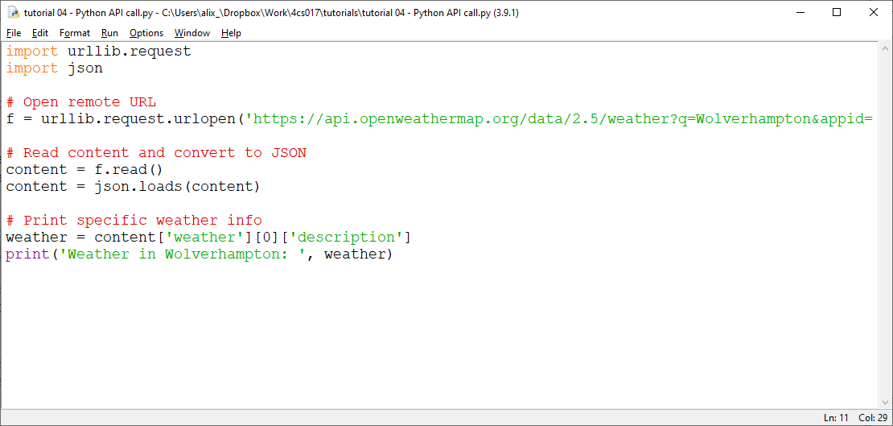

Notice how the code is similar to JavaScript (get data, convert to JSON object, display)

## Part 2 – Updating our Deployment Diagram

Update your UML Deployment Diagram by adding your Python artefact running in the Python runtime environment (on the same node, since it still runs on your PC).

## Part 3 – Going further (important: for fun - **not** required for the assessment)

*“I have finished all the work above, what shall I do next?”*

Improvement to your Python script:

1. Ask the user to enter a city name (using the **input** function)
2. Deal with exceptions (e.g. the user misspells the name of the city)
3. Run the code on your **Raspberry Pi** and turn on red/ember/green LEDs depending on the severity of the weather, or coldness of temperature 😊 Add Raspberry Pi to your diagram.